|  |  |
| --- | --- |
| **Name** | Abdulaziz Hamid Ebrahim |
| **ID** | 1946282 |

**Exercise 1:**

**Changes made:**

|  |  |  |
| --- | --- | --- |
| **Line number** | **Before** | **After** |
| 64 |  |  |
| 71- 77 |  |  |

**Output:**

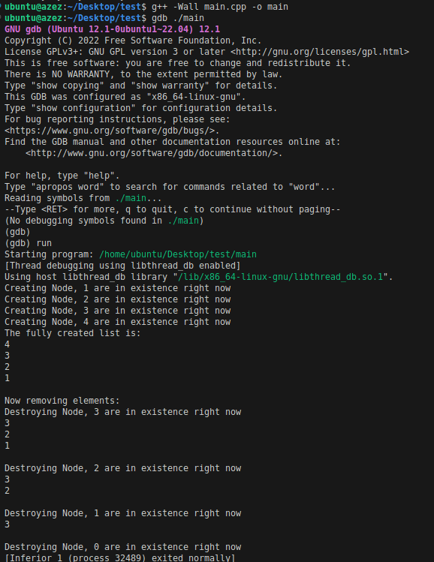

**Explanations:**when removing the first element, an new node was created and assigned as the head, resulting in a memory leak. So to fix this we can update the **head_ pointer** to point to the next marker, thus, removing the first element from the list.   
Additionally, the change from **delete temp**; to **delete marker**; ensures better deletion of the current marker node. Setting **marker to 0** afterwards prevents any potential misuse of the deleted memory.

**Exercise 2:**

By fixing the bug in exercise 1, this bug also has been fixed, the next output shows that there is no bugs in the code, although I followed the sequence mentioned , which is inserting 1,2,3,4 then removing 2.

**Output:**

