Regime-Stratified Sensitivity Analysis
Level 5L6 · workflow document

1. Purpose & context
The Level 5L6 hydrogen-permeation model has 40 input parameters — 36 after fixing the four reference temperatures T_ref_*, which are redundant with the corresponding *_ref prefactors and were behaving as a free dial in the original 40-parameter setup. A standard sensitivity analysis treats the entire parameter space as one population and reports a single ranking of which parameters drive the flux. That is what the existing workflow in Application/sensitivity_L5L6.ipynb does.
The problem with that view is physical: the model has three rate-limiting regimes — surface-limited, oxide-limited, and metal-limited — and the parameters that drive the flux are not the same in each. Asking which parameters matter without first asking which regime are we in averages over physically different systems and blurs the answer.
This workflow does the stratified version. Every model evaluation is labelled with the regime that actually dominated it — the argmax of the three flux-weighted resistance fractions frac_surface, frac_oxide, frac_metal — and the sensitivity analysis is then carried out within each regime cluster. The output is a per-regime ranking: in the surface-limited regime the dominant driver is X; in oxide-limited it is Y; in metal-limited it is Z.
There is a methodological wrinkle. Structured sensitivity methods — Elementary Effects / Morris, and Saltelli–Sobol — depend on the geometric structure of the sample design (trajectories for Morris, paired A / B / AB_i matrices for Sobol). That structure is destroyed if rows are deleted after the fact, so a regime-filtered subset of a global Morris or Sobol sample is not a valid input to those estimators. The workflow handles this by routing each method to a sample design where it is valid:
- Global Morris screen runs over the full 36-D space — the design is intact, so it is valid. It produces a per-parameter μ* ranking used only to pick a top-k working set.
- Per-regime Saltelli–Sobol runs over a small top-k sub-box near the cluster's centre of mass — the sample design is intact inside that sub-box. Off-regime contamination is measured and reported (accept-and-report), not removed.
- Per-regime PAWN and Borgonovo-δ run on the actual regime clusters — these are given-data methods, valid on arbitrary scattered points, with no design assumptions.
PAWN and Borgonovo-δ on the true clusters are the primary result. Sobol on the top-k sub-box is the secondary, comparison view.

2. The high-level workflow
The pipeline is six stages, executed top to bottom, with one side branch where regime clusters come out under-populated and need a targeted top-up sample.
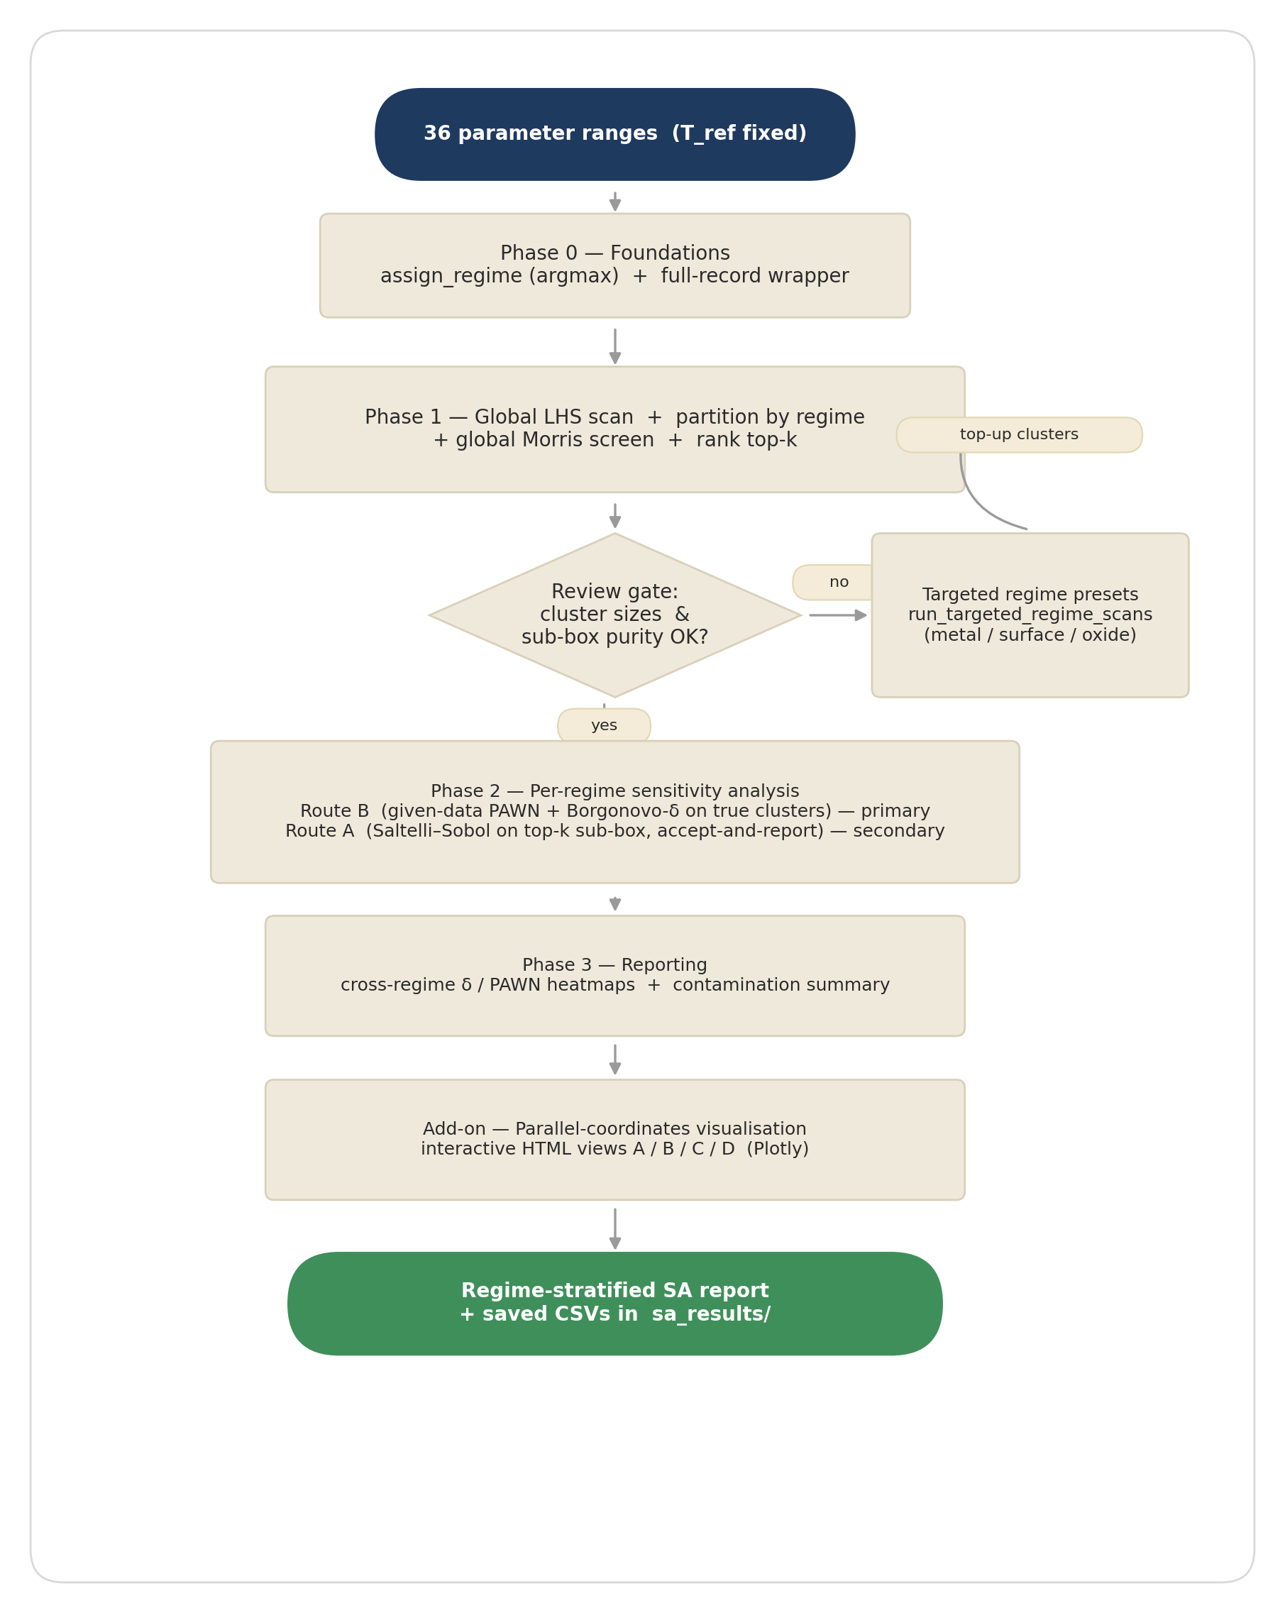
Figure 1. End-to-end pipeline. Phases 0–3 plus the parallel-coordinates add-on. The review gate branches to a regime-targeted resample loop when any cluster is too small for stable given-data indices.
Phase 0 · Foundations. Two small changes to the existing module make everything else possible: a single canonical regime-labelling function (assign_regime, argmax rule), and an extension of the model wrapper that returns the full result dictionary rather than one scalar. After Phase 0, every model evaluation can be tagged with its regime and persisted to a tidy DataFrame.
Phase 1 · Global foundation, partition, screen. A single LHS pass over the full 36-D parameter space generates the master DataFrame — this is the foundation reused by everything downstream. It is partitioned by regime (the cluster sizes are the first sanity check), a global Morris screen ranks the parameters by μ*, and a review-gate diagnostic estimates how cleanly the top-k cluster sub-boxes sit inside each regime.
Phase 2 · Per-regime sensitivity. Two routes in parallel. Route B (primary) takes each true regime cluster from Phase 1 and runs PAWN and Borgonovo-δ on it — zero new model evaluations needed, since the cluster rows are already evaluated. Route A (secondary) draws a new Saltelli–Sobol sample inside each regime's top-k sub-box, re-labels every point, and reports the off-regime contamination.
Phase 3 · Reporting. Both routes are flattened into tidy long DataFrames, a regime-by-parameter sensitivity matrix is built and rendered as a heatmap, and the contamination summary is tabulated. Everything is persisted as CSV to sa_results/ so the next stage runs from disk.
Add-on · Parallel-coordinates visualisation. Four interactive Plotly views are generated from the saved CSVs — no recompute. They give a quick visual feel for which parameter regions sit in which regime, where the heavy-tailed outputs concentrate, and how the sensitivity ranking shifts across regimes.
The side loop. At the review gate the rarest regime cluster sometimes comes out below ~300 points — too sparse for stable given-data indices. The targeted-presets sub-routine runs an additional LHS draw using REGIME_PRESETS — preset ranges that bias the sampling toward the under-populated regime — and merges the in-regime rows back into the partition. The presets are not used for Phase 2 sensitivity directly; they are only a sampling device to populate the cluster. The given-data validity of PAWN and δ is preserved because each cluster is still a space-filling sample over its own sub-region, and the argmax label does the final filtering.

3. Phase 0 — Foundations
Phase 0 is the small, surgical layer that lets every model evaluation downstream carry its regime label and full result dictionary. There are two new pieces:
- assign_regime(frac_surface, frac_oxide, frac_metal, rule='argmax') — single source of truth for the regime label. Returns 'surface' | 'oxide' | 'metal', or 'undefined' if any of the three fractions is NaN (failed solve). An optional rule='threshold' mode with a 0.5-dominant rule and a 'mixed' fallback exists for compatibility with the existing notebook's classifier; the workflow uses argmax by default.
- level5L6_model_wrapper(params, return_full_record=True) — when this new keyword is set, the wrapper returns the entire result dictionary (all metrics, frac_*, theta, and a regime field via assign_regime) instead of one scalar. Existing scalar callers default to return_full_record=False and are unaffected. This single change is what enables the unified-scan pattern used by every later phase.
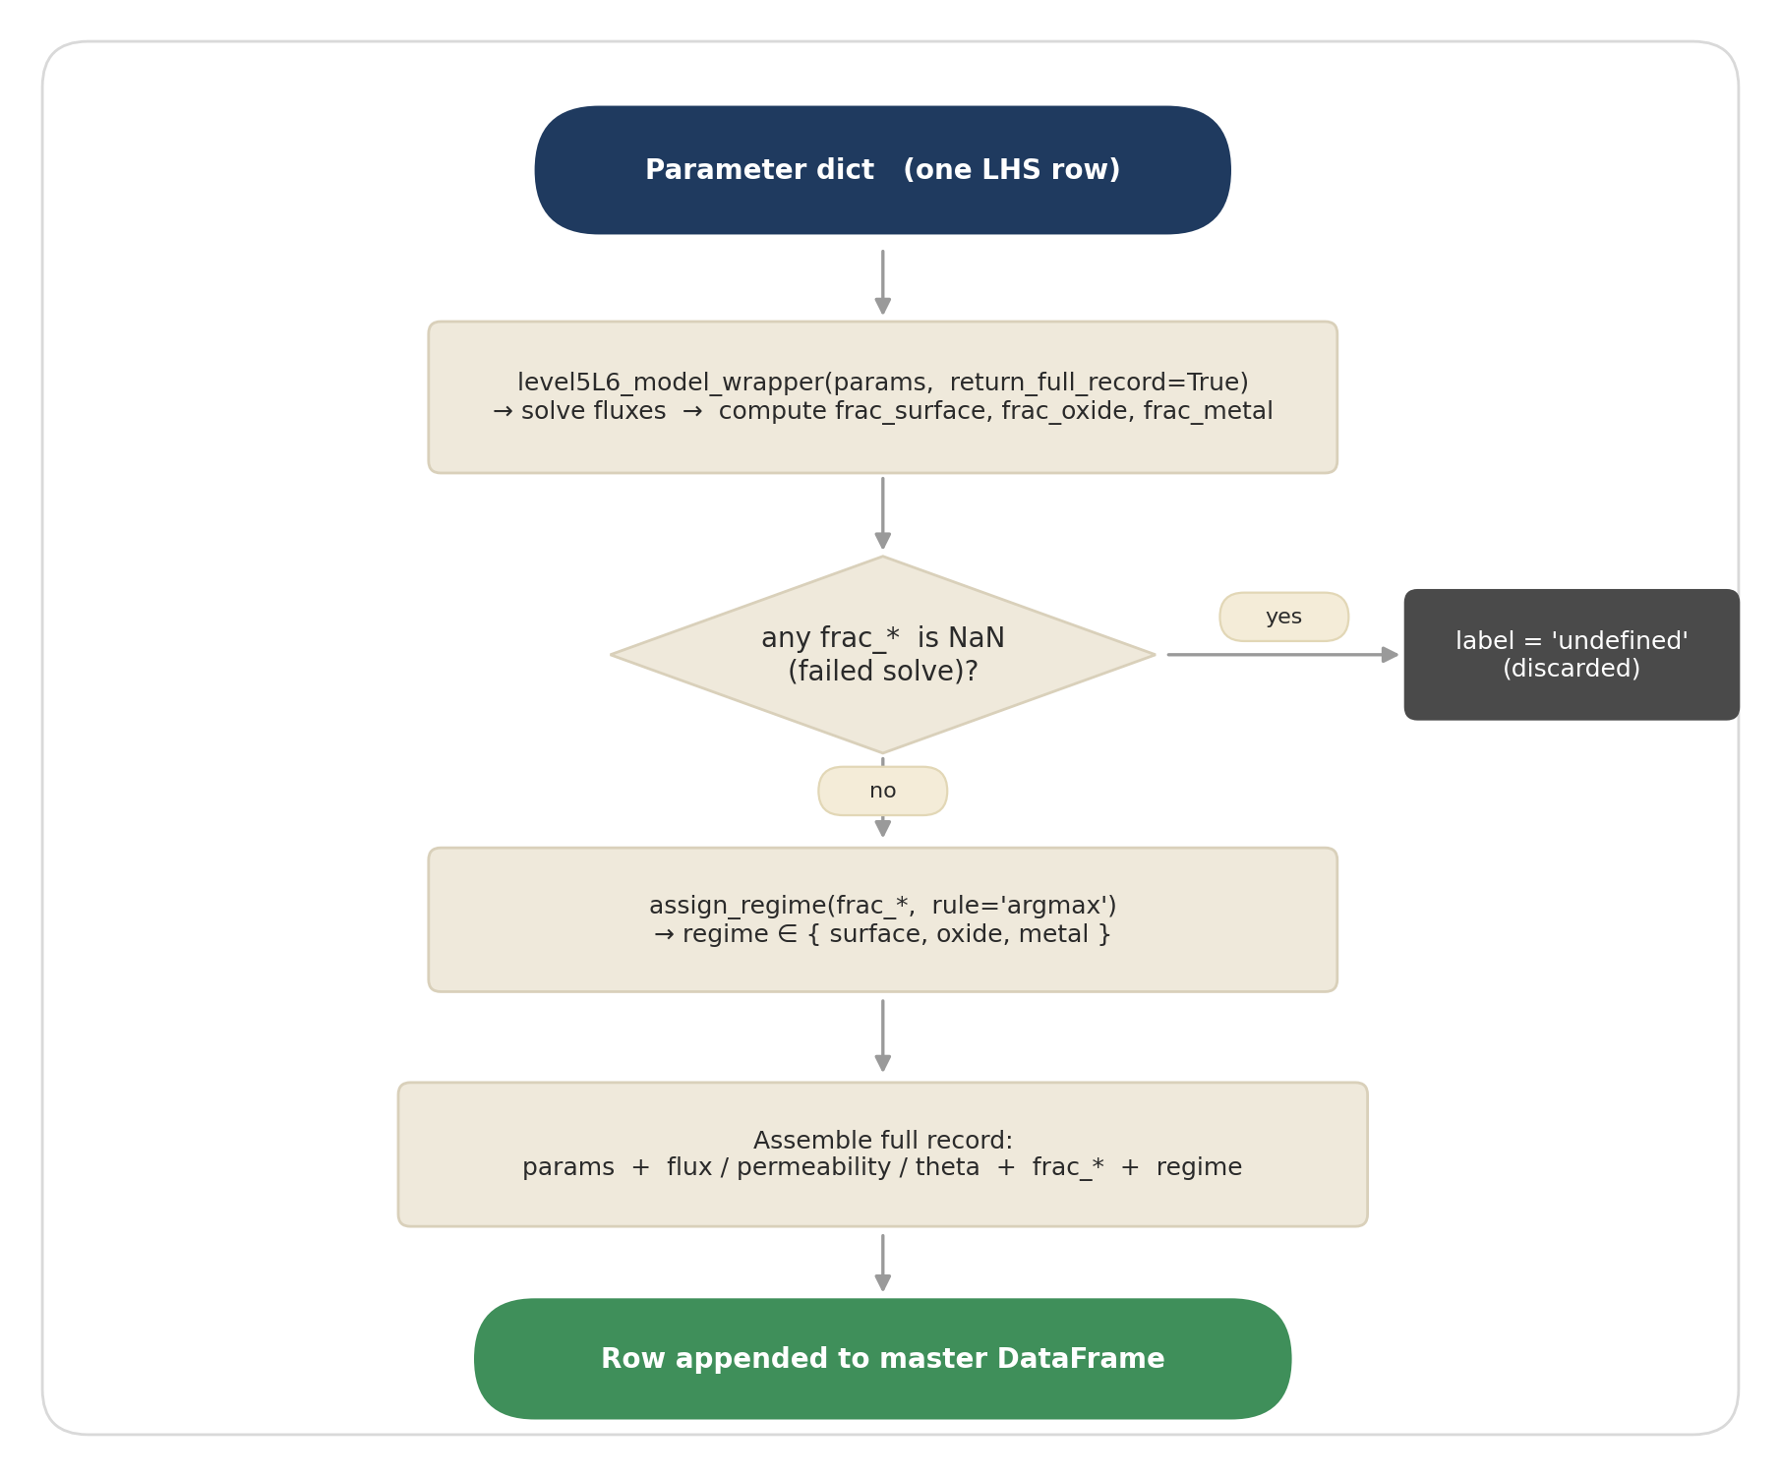
Figure 2. Phase 0 sub-workflow. One LHS row → solver → regime label → full record.
The argmax rule is deliberate. The regime label is then exclusive (a single label per point, no 'mixed' bucket), which is what makes the clusters disjoint and the partition exhaustive. The 'undefined' bucket is separate and dropped from the clusters; failed solves do not contaminate any regime.
Sanity check that runs after every scan: frac_surface + frac_oxide + frac_metal sums to exactly 1.0000 on all valid rows, and the argmax regime label agrees with the solver's own system_rate_limiting diagnostic field. Both pass in the production runs.

4. Phase 1 — Global LHS foundation, partition & screen
Phase 1 does the heavy LHS evaluation that everything else reuses. It produces three things: the master DataFrame (the foundation), the per-regime partition (input to Route B), and the global Morris ranking (input to Route A's top-k sub-box).
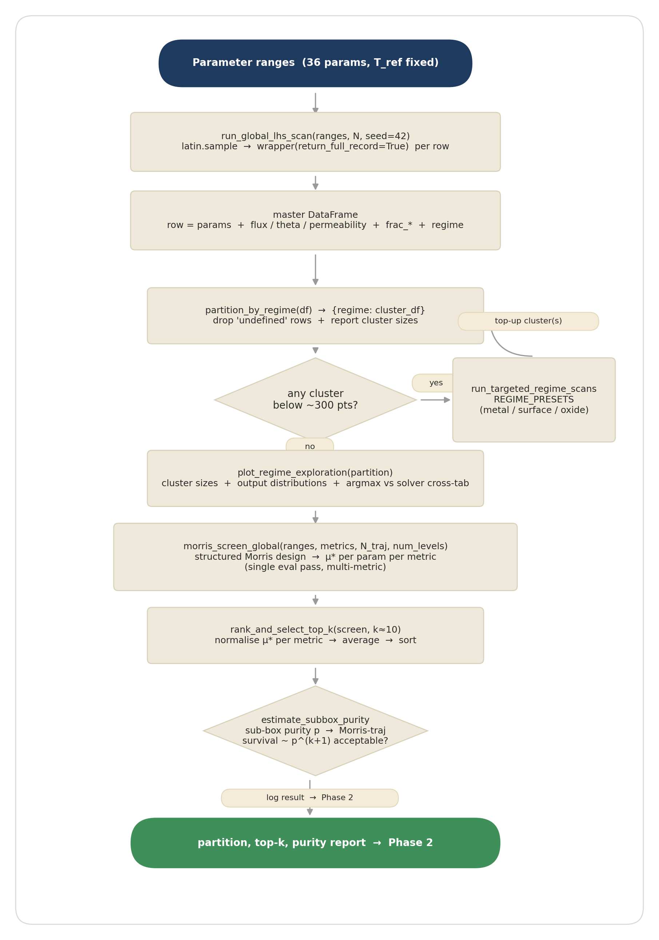
Figure 3. Phase 1 sub-workflow. Global LHS → partition → cluster-size check → descriptive plots → Morris screen → top-k → review-gate purity diagnostic.

Steps
- Global LHS scan. run_global_lhs_scan(ranges, N, seed=42) draws an N-point Latin Hypercube over the 36 parameters and evaluates the model wrapper once per row with return_full_record=True. The result is a tidy DataFrame, one row per draw, columns = sampled parameter values + all output metrics + frac_* + regime label. This single pass is reused by the descriptive view and by Route B — zero further model evaluations are needed for given-data SA.
- Partition by regime. partition_by_regime(df) splits the DataFrame into {regime: cluster_df}. Rows labelled 'undefined' are dropped and reported separately. The function warns when a cluster falls below ~300 points — δ and PAWN noise up below that floor.
- Cluster-size decision. If any regime cluster is below the floor, the side loop fires run_targeted_regime_scans with the REGIME_PRESETS (regime-targeted range overrides — see below) and merges the in-regime rows back into the partition. If all clusters clear the floor, the workflow proceeds to the descriptive view.
- Descriptive plots. plot_regime_exploration produces a per-regime cluster-size bar, output-metric box plots by regime, and prints a cross-tab of argmax-regime against the solver's system_rate_limiting field. This is the visual sanity check.
- Global Morris screen. morris_screen_global(ranges, metrics, N_traj, num_levels) generates a structured Morris design over the full 36-D space and evaluates it once. The Morris design is valid here because no regime filtering is applied — it runs across the whole space. The estimator analyses each output metric separately on the same shared sample (the multi-metric efficiency win) and returns μ* per parameter per metric. Heavy-tailed metrics (flux, permeability) are analysed on log10; theta stays linear.
- Rank and select top-k. rank_and_select_top_k normalises μ* per metric (so the metric with the largest absolute scale does not dominate), averages the normalised columns, sorts, and picks the top-k (k ≈ 10). This top-k is the reduced working set used by Route A's sub-box, and the union of all regimes' top-k is the row axis of Phase 3's heatmap.
- Review gate — sub-box purity. estimate_subbox_purity builds each regime's top-k percentile-band box from existing scan data and counts the fraction of points inside the box that are actually labelled as the target regime. This is a free diagnostic (no new model evaluations). Low purity means the regime boundary is curved and a rectangular sub-box leaks — Route A is then a 'neighbourhood' sensitivity, not a strictly in-regime one, and any optional per-regime Morris-with-discard over that sub-box would starve (trajectory survival scales as p^(k+1)). The gate decides whether to add the optional Morris-with-discard later; Routes A and B always run.

The targeted-presets side loop
A uniform LHS over the default ranges only produces a usable cluster for the metal-limited regime (~97% of points at N = 1500). Surface-limited and oxide-limited are reachable only in narrower corners of parameter space:
- Surface-limited is reachable at low pressure and slow surface kinetics (low P_upstream, low k_diss_ref, low k_diss_metal_ref). Verified yield ~32% in-regime under these ranges.
- Oxide-limited is stubborn — even a thick, slow oxide gives only ~1.4% yield under default ranges because the flux re-routes through metal-surface-limited defects. The oxide preset suppresses defect bypass (f_pinhole / f_crack / f_gb_defect pushed to 10⁻⁷–10⁻⁵), uses a thick slow oxide, and a fast surface and fast metal. Verified yield ~11% in-regime.
- Metal-limited already dominates the default ranges; the metal preset is the default ranges.
Each preset is the default ranges with only the regime-controlling parameters overridden, kept as broad as physically reasonable. The per-regime SA still reflects genuine sensitivity rather than the targeting itself, because the argmax label does the final filtering and each scan is space-filling over its own sub-region. Default per-regime sample sizes are chosen from the verified yields to clear the 300-point floor: metal 1200, surface 3000, oxide 6000.

5. Phase 2 — Per-regime sensitivity analysis
Phase 2 is the actual sensitivity analysis. Two routes run in parallel and feed a single per-regime result block. Route B is the primary, methodologically clean result; Route A is the secondary, structured-method comparison.
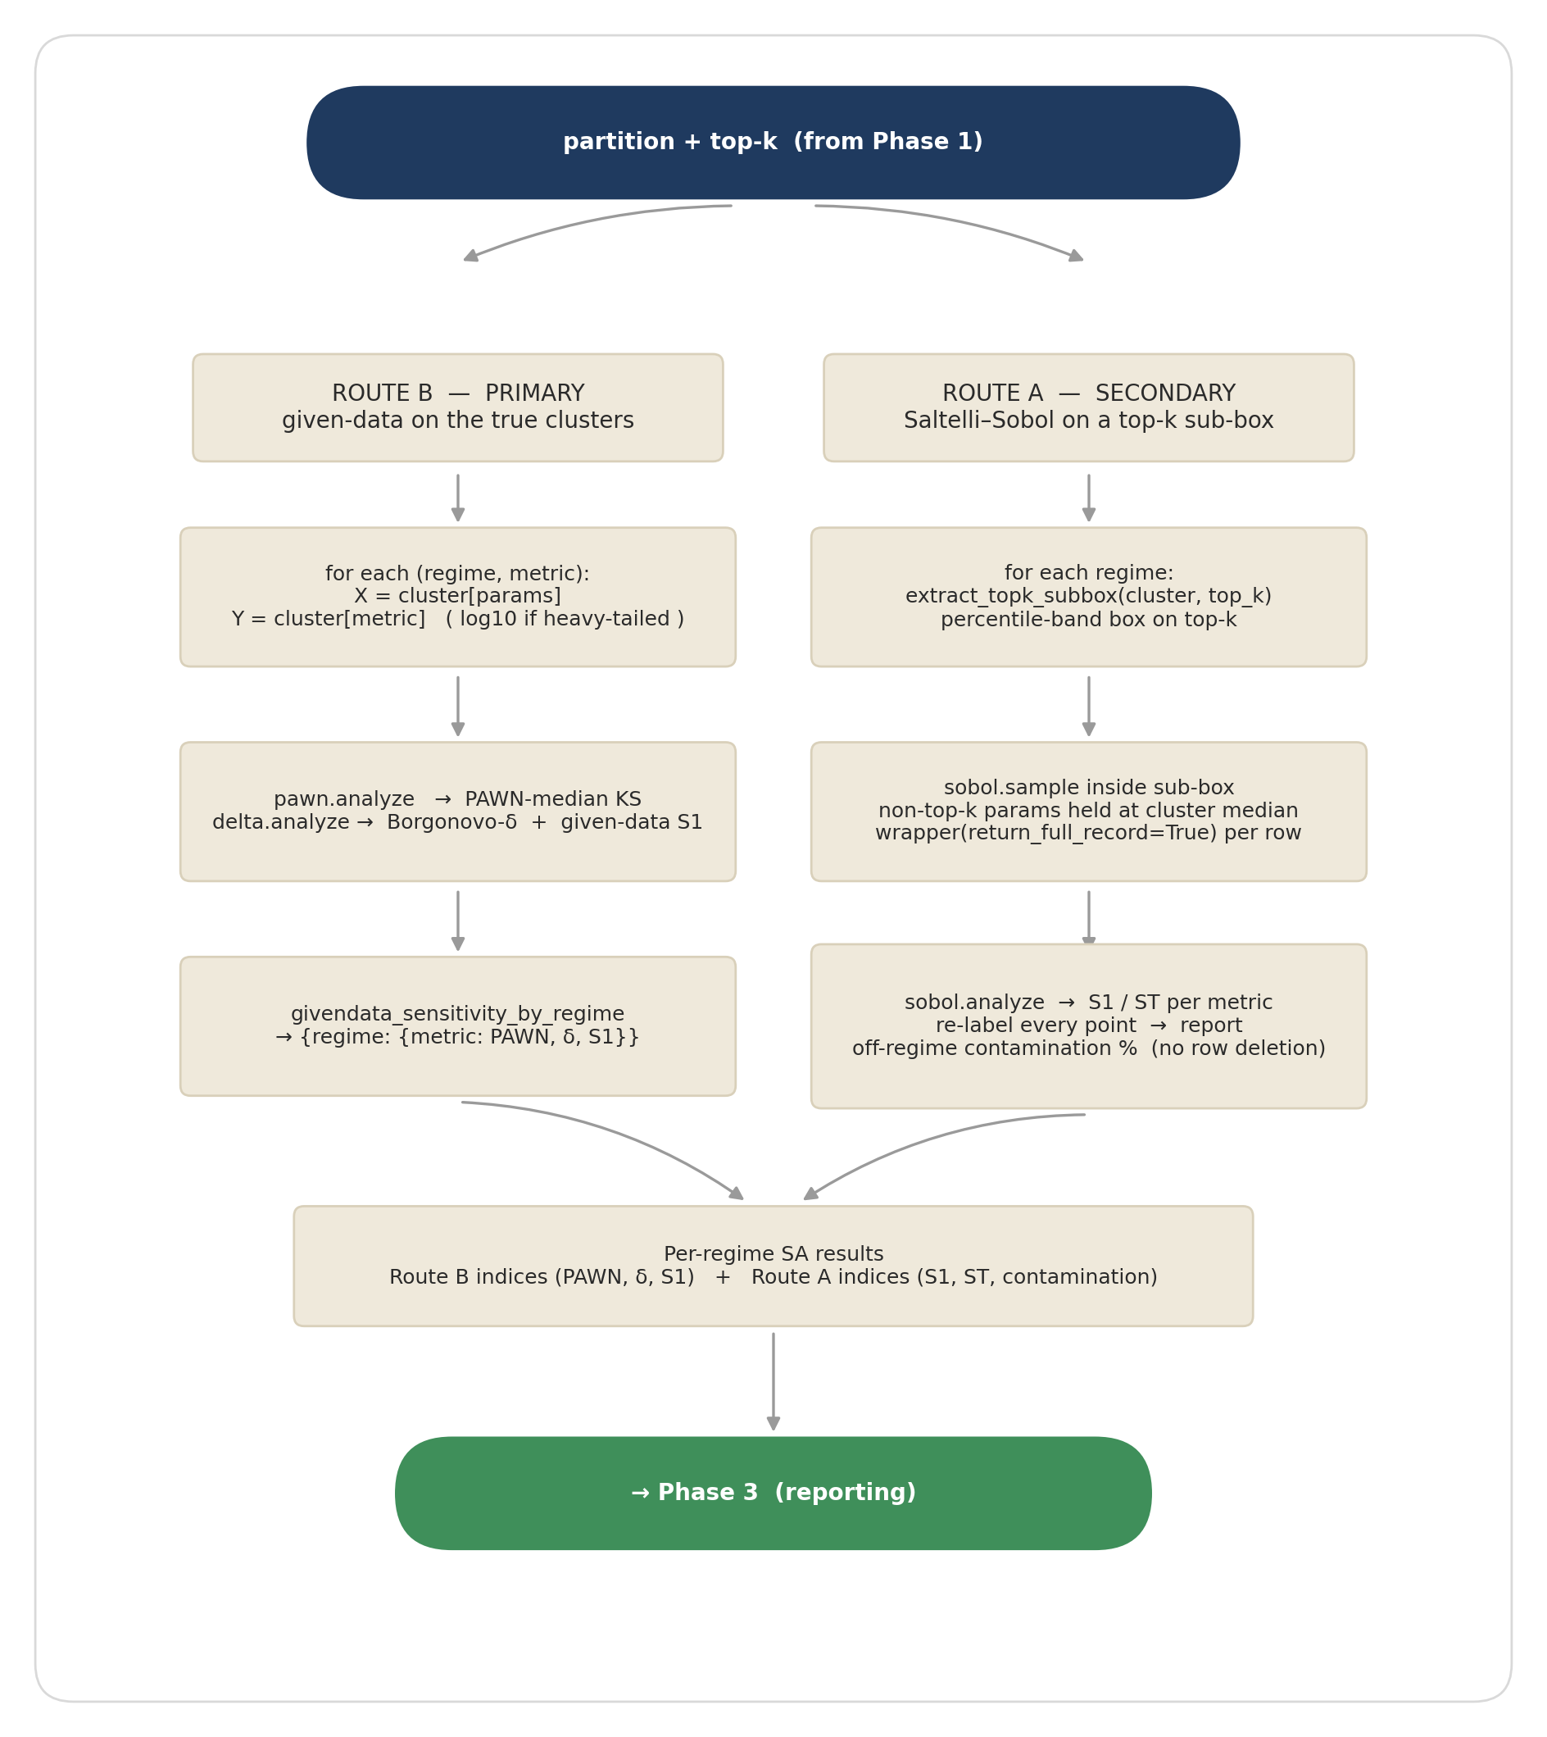
Figure 4. Phase 2 sub-workflow. Route B (given-data on the true clusters) and Route A (Saltelli–Sobol on a top-k sub-box, accept-and-report) run in parallel.

5.1 Route B — given-data sensitivity on the true clusters (primary)
givendata_sensitivity_by_regime(partition, param_names, output_metrics) loops over every (regime, metric) pair and runs PAWN and Borgonovo-δ on the cluster as it stands. For each pair it slices X = cluster[param_names] and Y = cluster[metric], applies the log10 transform if the metric is in LOG_METRICS_DEFAULT (flux and permeability are heavy-tailed and were blowing δ outside [0, 1] before this fix; theta stays linear), and calls pawn.analyze and delta.analyze from SALib. Per pair it reports:
- PAWN median — Kolmogorov–Smirnov-based moment-independent measure; a robust ranking that is insensitive to the shape of the output distribution.
- Borgonovo δ — moment-independent importance, with a bootstrap confidence interval (delta_conf).
- Given-data S₁ — a first-order Sobol-like index recovered by the same δ routine from the same sample. Useful as a cross-check but less reliable than δ on scattered data.
Both estimators are valid on arbitrary scattered points — they have no design assumptions — so the workflow can drop them straight on the regime clusters with zero new model evaluations. The output metrics analysed per cluster are flux (primary; the only metric that responds to surface kinetics), permeability (secondary; bulk-only, surface-insensitive by construction — flagged in reporting), and theta (surface coverage). The regime-defining frac_* fractions are deliberately excluded as per-cluster metrics — they are degenerate within their own cluster.
Output: a nested dict {regime: {metric: {n, pawn, delta}}}, flattened to a tidy long DataFrame by summarize_givendata for downstream plotting and CSV export. A cluster that is too small or has a degenerate output (zero-range Y) is skipped with a 'skipped' flag rather than silently producing nonsense.

5.2 Route A — Saltelli–Sobol on the top-k sub-box (secondary)
sobol_regime_subbox(cluster_df, top_k, target_regime, output_metrics, N) runs a focused Saltelli–Sobol sample inside each regime's top-k percentile-band box. The non-top-k parameters are held at the cluster's median (focused-Sobol style — they contribute zero variance, which is fine for the secondary view). The Saltelli sample is generated by sobol.sample inside the sub-box, evaluated through the same full-record wrapper, and analysed by sobol.analyze for S₁ (first-order) and S_T (total-order) indices per metric. Heavy-tailed metrics are analysed on log10.
The accept-and-report rule. Every Saltelli point is re-labelled using assign_regime — so we know whether each draw actually landed in the target regime or leaked into an adjacent one. The contamination fraction (the percentage of points labelled as something other than the target regime) is then reported alongside the indices. The points themselves are not deleted — row deletion would destroy the row-aligned A / B / AB_i structure that Saltelli depends on, invalidating the estimator. This is why the route is called accept-and-report: we accept that the sub-box leaks, run the estimator on the intact design, and surface the leak as a diagnostic.
Route A's value is therefore conditional. If the sub-box purity is high (~90%+), Route A is close to a strictly in-regime Sobol decomposition. If purity is low, Route A is neighbourhood sensitivity around the cluster's centre of mass — still useful for cross-checking Route B's ranking, but not a clean in-regime Sobol result. The contamination percentage tells the reader which interpretation applies.
Both routes write their sample-and-evaluation cache to CSV (cache_csv argument), so an analysis can be replayed from disk without re-running the (expensive) model evaluations.

6. Phase 3 — Reporting
Phase 3 turns the two routes' raw output dicts into the comparison views and the CSV bundle. Two short pipelines run in parallel, then converge on a save step.
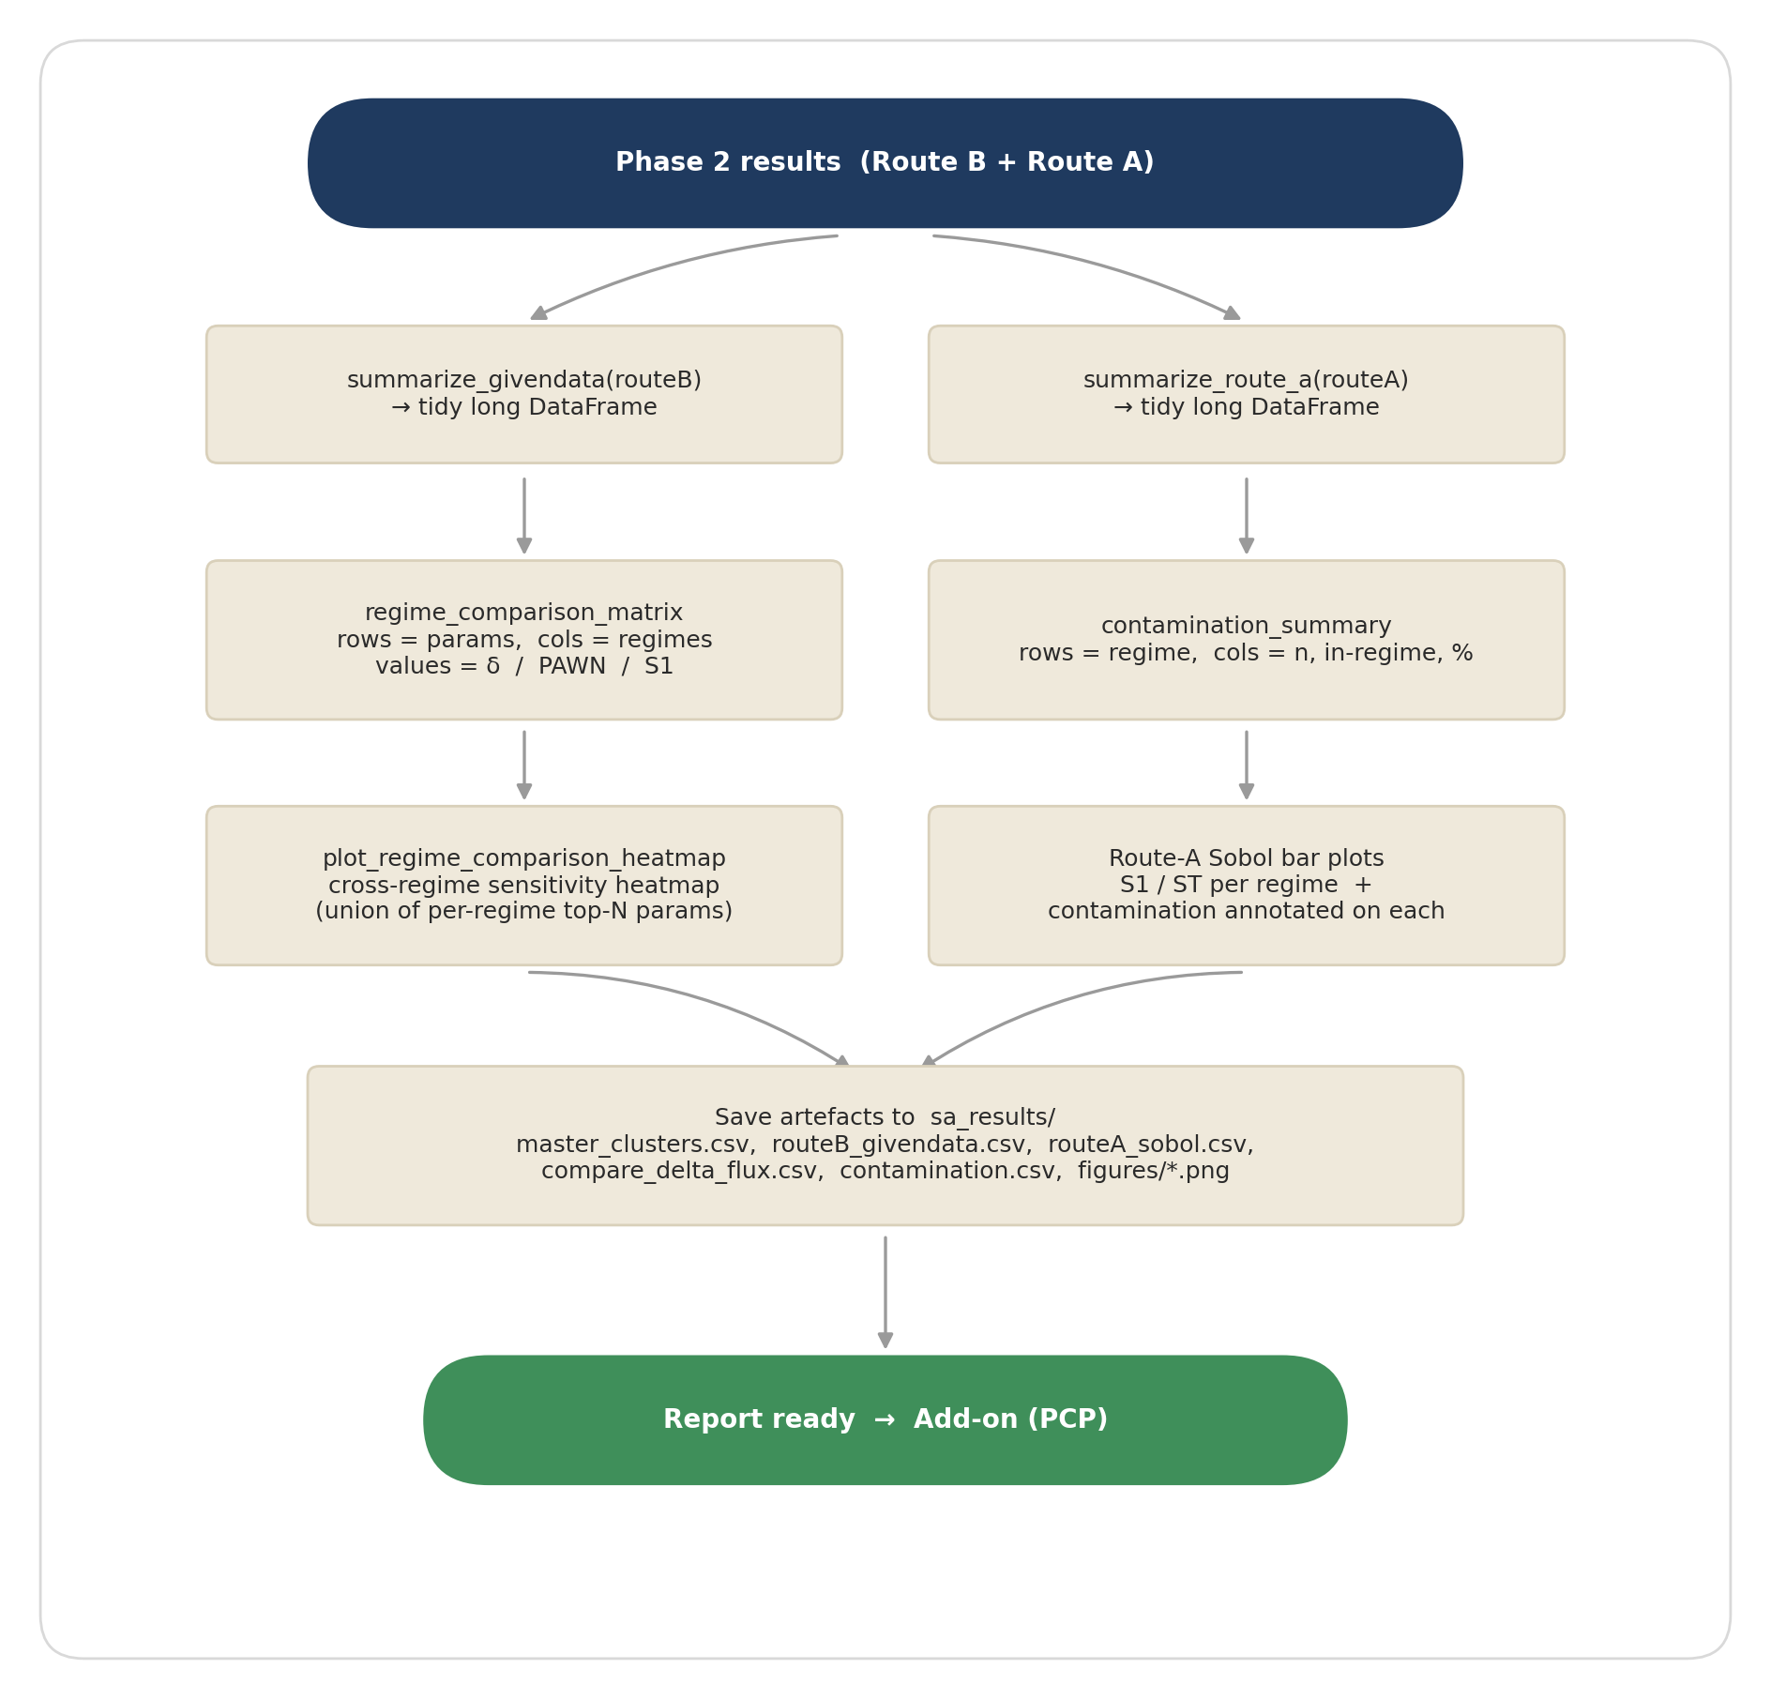
Figure 5. Phase 3 sub-workflow. Summarise → comparison matrix / contamination → render → save.
- summarize_givendata flattens Route B's nested dict into one long row per (regime, metric, parameter), with columns pawn_median, delta, S1_givendata, n.
- summarize_route_a does the same for Route A, with columns S1, S1_conf, ST, ST_conf, log, contamination_%.
- regime_comparison_matrix pivots the Route-B long table into a parameter × regime matrix for one chosen metric and one chosen index (delta, pawn_median, or S1_givendata). The row axis is restricted to the union of each regime's top-N parameters so the matrix is compact but every regime's leading drivers are present.
- plot_regime_comparison_heatmap renders that matrix as a YlOrRd heatmap with numeric annotations — the headline visual of the whole analysis, showing at a glance which parameters dominate in which regime.
- contamination_summary tabulates Route A's per-regime in-regime counts and contamination percentages — read alongside the heatmap so the reader can weight the Sobol indices appropriately.
All artefacts are persisted to Application/sa_results/: master_clusters.csv, routeB_givendata.csv, routeA_sobol.csv, compare_delta_flux.csv, contamination.csv, and figures/*.png. The add-on stage reads these from disk; the analysis notebook does not need to re-run.

7. Add-on — Parallel-coordinates visualisation
The add-on is a standalone notebook (Application/regime_parallel_coords.ipynb) that reads the saved CSVs and emits four interactive Plotly parallel-coordinates HTML files. No model evaluation, no recompute — pure plotting from disk, runs in seconds.
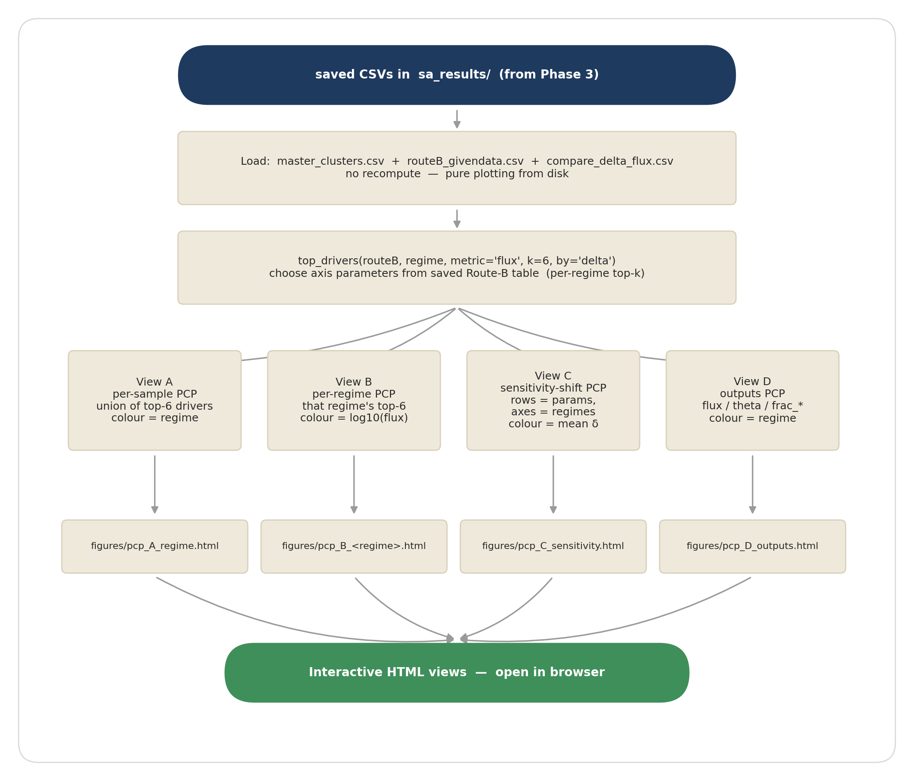
Figure 6. Add-on sub-workflow. Load CSVs → pick per-regime top-6 driver axes → four views (A / B / C / D) → four HTML files.
- View A · per-sample, coloured by regime. Axes are the union of each regime's top-6 δ-drivers plus log10(flux). Each line is one LHS draw, coloured by its regime label. Reading this view shows directly which parameter ranges sit in which regime — the regime boundary as a curved manifold projected into a handful of axes.
- View B · per regime, coloured by log10(flux). For each regime, axes are that regime's top-6 drivers and colour is log10(flux). One HTML per regime (pcp_B_metal.html, pcp_B_surface.html, pcp_B_oxide.html). Reading this view shows which combinations of the regime's drivers give high vs low flux within that regime — the within-cluster gradient that the sensitivity indices summarise as one number per parameter.
- View C · sensitivity-shift across regimes. One line per parameter, axes are the three regimes, axis value is δ from compare_delta_flux.csv. A leftmost categorical axis labels each line with its parameter name (sorted by mean importance, highest at top) so individual parameters can be identified. Line colour is mean importance. Reading this view shows how the ranking re-orders across regimes — parameters that matter everywhere line up horizontally; parameters that matter only in one regime are diagonal.
- View D · outputs across regimes. Axes are the model outputs (flux, theta, frac_surface / oxide / metal, permeability), colour is regime. Heavy-tailed outputs shown as log10. Reading this view shows the output-space structure of each regime — where each cluster lives in flux/theta/permeability terms.
Heavy-tailed axes (P_upstream, k_diss_ref, oxide_thickness, metal_thickness, D_ref, flux, permeability) are rendered as log10 throughout so the axes are not dominated by a handful of extreme values.

8. Key design decisions — recap
The decisions below were locked during the planning phase and are baked into the implementation. They are recorded here so the workflow's why is on the same page as its what.
Regime label | argmax of the three flux-weighted resistance fractions frac_*. Single label per point, no 'mixed' bucket. NaN → 'undefined', dropped from clusters.
36 vs 40 params | The four T_ref_* temperatures are fixed; they are measurement metadata and redundant with the *_ref prefactors via A = X_ref · exp(E/(R·T_ref)). Varying them injected a spurious ~10³–10⁴ prefactor sweep that dominated the earlier 40-param ranking. Uncertainty in those properties is now expressed through the *_ref and E_* ranges instead.
Both routes | Route B (given-data, true clusters) is the primary result. Route A (Saltelli–Sobol, top-k sub-box, accept-and-report) is the secondary, structured-method comparison. Neither replaces the other.
Accept-and-report | Saltelli–Sobol cannot have rows deleted after sampling — the row-aligned A / B / AB_i structure is what the estimator reads. Off-regime contamination is reported as a diagnostic, not removed.
Log10 for heavy-tailed | Flux and permeability span ~10 decades. The variance/density estimators behind Morris, Sobol, and δ are dominated by the tail otherwise — and δ blew out of [0, 1]. Both are analysed on log10 throughout. Theta stays linear.
Targeted presets | Uniform LHS over the default ranges yields ~97% metal-limited. Surface and oxide regimes only populate in specific corners of parameter space; REGIME_PRESETS override only the regime-controlling parameters and leave everything else as broad as possible.
Notebook layout | New, separate notebook (Application/sensitivity_regime_L5L6.ipynb); the existing sensitivity_L5L6.ipynb stays untouched.
Env | All production runs go through the mace_env conda kernel. The anaconda3 base env has a NumPy 2.x vs SALib/pandas-built-for-1.x conflict that breaks import SALib.

