E-commerce Returns: Diagnostic and Performance Analysis

Executive Summary
This project evaluates the performance of an e-commerce business during January–December 2025, with particular focus on sales performance, profitability, customer returns, product-level performance and the underlying drivers of returns.
The business generated approximately $21.36 million in revenue from 3,100 orders and 6,175 units sold during the period. However, 1,113 units were returned, resulting in an overall return rate of 24.03% and $3.82 million in refund value. After refunds, net revenue was approximately $17.54 million, while reported profit was approximately $3.25 million.
At category level, Electronics generated the highest revenue at $8.21 million, but its financial performance requires closer attention. Although Electronics generated approximately ₦482,385 in overall profit, several products within the category generated negative profit, including SonicBay Bluetooth Speaker ($&79,973.59), PlusTech Over-Ear Headphone (-$35,239.30), PixelNest Streaming Stick (-$34,465.89), and HomeSync Digital PhotoFrame (-$22,678.08).
The monthly analysis provides an additional diagnostic finding. December recorded the highest sales volume, with 398 orders, but did not translate into equally strong profitability. December generated approximately $252,801.17 in revenue, while Electronics recorded a -$16,112.56 profit during the month. Similar negative Electronics profitability occurred in November (-$6,710.75) and May (-$801.68). This suggests that higher sales volume does not necessarily translate into stronger financial performance and that Electronics profitability should be monitored at both product and monthly levels.
Return behaviour also varies substantially by product category. Product Not as Expected, Wrong Size and Damaged Product were the leading overall return reasons. However, Fashion was predominantly associated with sizing problems, while Electronics was more strongly associated with defective and damaged products
The findings indicate that return management should not rely on a single company-wide intervention. Instead, the business should prioritise product-level profitability monitoring, category-specific return interventions, quality control for Electronics, improved sizing information for Fashion, and continuous monitoring of high-return products and channels.

Project Overview
Returns are an important operational and financial concern for e-commerce businesses. Although a returned order may initially appear to be only a customer-service issue, frequent returns can affect revenue realization, refunds, profitability, inventory management and customer experience.
This project was developed to investigate the business impact of product returns and identify the categories, products, customer segments, channels and return reasons associated with return activity.
Rather than evaluating returns solely by their quantity, the analysis considers returns alongside sales, refund value and profitability. This allows the project to distinguish between areas with high return frequency and areas where returns create greater financial risk.
Objectives
- Measure the scale and financial impact of returns.
- Identify the categories, products, customer segments, channels, and payment methods with the highest return exposure.
- Diagnose the reasons behind returns at category and subcategory level.
- Recommend evidence-based actions to reduce returns and protect profit.

Data Sources
The analysis was conducted using six related tables:
fact_orders
- Order_Line_ID : unique identifier of the order line
- Order_ID : identifier of the customer order.
- Order_Date : date the order was placed.
- Customer_ID : customer who placed the order unique identifier.
- Product_ID : product on the line, and the foreign key to product.
- Sales_Channel : channel through which the order was placed.
- Payment_Method : payment method used, and the foreign key to payment method.
- Quantity : units ordered on the line.
- Unit_Price : list price per unit before discount.
- Unit_Cost: cost to the business per unit.
- Discount_Pct : discount applied to the unit price
- .Shipping_Fee : shipping fee charged on the line.
- Delivery_Date: date the order was delivered.
- Return_Flag : whether the line was returned.
- Return_Date : date the return was recorded.
- Return_Reason : reason given for the return, and the foreign key to return reasons. Return_Quantity: units returned from the line
- Refund_Deduction_Pct: share of the refund withheld on a return.
- Product_Rating : customer rating of the product.

product
- Product_ID : unique product identifier
- Product_Name : display name of the product.
- Category : top level of the product hierarchy. Six values: Fashion, Electronics, Home & Kitchen, Beauty, Sports, and Books.
- Subcategory : second level of the product hierarchy.
- Brand : brand of the product.
customer
- Customer_ID : unique customer identifier
- Customer_Segment : customer type. Consumer , Corporate , and Home Office, with one segment per customer.
- Customer_City : city of the customer.
- Customer_State : state of the customer.
Sale Channel
- Website: orders placed on the company website.
- Mobile App: orders placed in the mobile app.
- Marketplace: orders placed through third-party marketplaces.
- Offline Store: orders placed in physical stores. No shipping fee is charged.

payment method
- Upi: Unified Payments Interface bank transfer.
- Credit Card: credit card payment.
- Debit Card: debit card payment.
- Cash On Delivery: cash paid when the order is delivered.
- Wallet: digital wallet payment.
- Net Banking: online bank transfer.
- Cash: cash paid at purchase.

Return reasons
- Product Not As Expected: the product differs from the listing or the customer's expectation.
- Wrong Size: the size or fit is unsuitable.
- Damaged Product: the product arrived physically damaged.
- Quality Issue: the product works but is below the expected quality.
- Wrong Item: a different item from the one ordered was delivered.
- Defective Product: the product does not function correctly.
- Late Delivery: the order arrived later than promised.
- Changed Mind: the customer no longer wanted the product.

Date (calculated)
A calendar table generated with DAX supports the monthly trend analysis and joins to fact_orders on Order_Date. [List the columns of your date table here, for example Date, Year, Month, Month Number, and Quarter.]

Problem Statement
The business generated substantial sales during 2025, but a significant proportion of purchased units were subsequently returned.
The key business challenge is not simply that returns exist. The more important question is Which products, categories, channels and return reasons are contributing most to return activity and financial risk, and where should the business prioritise corrective action?
This analysis answers five questions:
- How large is the return problem, and what does it cost?
- Which categories and products contribute most to returns and to profit loss?
- Do customer segment, sales channel, or payment method change the likelihood of a return?
- Why do customers return products?
- How do returns and profit behave across the year?

Tools and Methodology
Tools Used
- SQL - Analysis
- Power Query - Initial data exploration, cleaning, and validation
- Power BI - Interactive dashboard development, DAX measures, and data modeling
- DAX (Data Analysis Expressions) - Calculated Metrics, visuals, dynamic insights
Methodology
Data Cleaning & Preparation
The following data quality steps were performed to ensure analytical reliability:
- Validation of date fields — Order Date to ensure chronological integrity
- Standardization of category,return flag,payment method and sales channel by capitalizing the values
- Enforcement of naming consistency across all tables and fields
- Validation and correction of data types and formats to ensure compatibility with analytical operations
- Identification and treatment of duplicate records across tables where necessary
- Application of appropriate data formatting to enhance data quality and usability
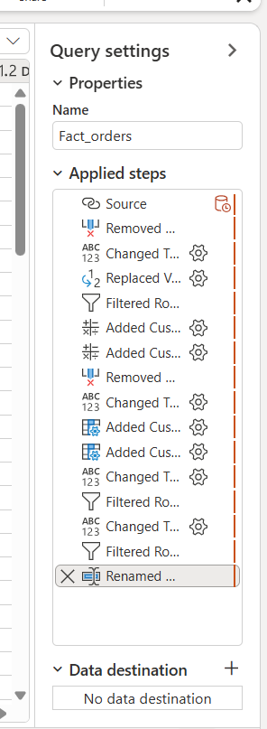
Data Transformation & DAX Measures
- Revenue: Quantity × Unit_Price × (1 − Discount_Pct).
- Refund Amount: Return_Quantity × Unit_Price × (1 − Discount_Pct) × (1 − Refund_Deduction_Pct).
- Net Revenue: Revenue − Refund Amount
- Cost of Goods: Quantity × Unit_Cost.
- Profit: Revenue − Cost of Goods − Refund Amount.
- Profit Margin: Profit ÷ Revenue.
- Total Orders: distinct count of Order_ID.
- Returned Orders: distinct count of Order_ID where Return_Flag is Yes.
- Return Rate:DIVIDE(Total returned, total orders) × 100
- Units Sold and Units Returned: sum of Quantity and sum of Return_Quantity
Data Model
A star schema model was designed in Power BI by transforming the original retail order dataset in Power Query into a structured data model. This involved creating a central Fact Table supported by multiple Dimension Tables, including Customer, product, channel, return reason, and payment method.
One-to-many relationships were established between the fact table and each dimension table to ensure efficient data organization, improved query performance, and accurate aggregations during analysis.
Additionally, a dedicated Calendar Table was created and linked to the fact table via the Order Date field. This enabled the use of time intelligence functions such as month-over-month comparisons, calculations, enhancing the depth and flexibility of the analysis.
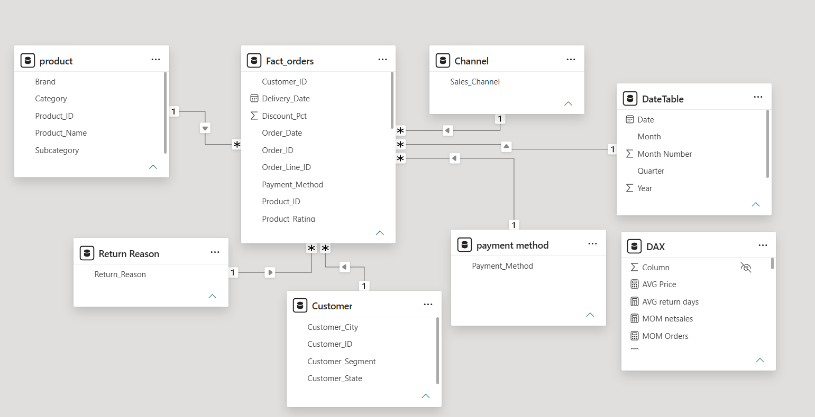

Exploratory Data Analysis (EDA)
Overall Business Performance
The business processed 3,100 orders and sold 6,175 units during 2025. Total revenue was approximately ₦21.36 million, while total refunds amounted to approximately ₦3.82 million. The resulting return rate was 24.03%, with 1,113 units returned.After accounting for refunds, net revenue was approximately ₦17.54 million, while reported profit stood at approximately ₦3.25 million.The figures indicate that returns represent a material component of the business's financial performance rather than a minor operational issue.
- Category profile
Fashion 1,048 orders; 1,646 units, Electronics 906 orders,1,421, and Home & Kitchen 735orders,1,111 are the three largest categories by volume, followed by Beauty, Sports, and Books. Fashion leads on volume but ranks third on revenue, reflecting a lower average order value.Electronics is the largest category by revenue $8.21M but earns the thinnest margin (5.9%), with $482,381.82 in profit alongside $1.56M in refunds. Home & Kitchen follows with $4.97M in revenue, $965,028.71 in profit (19.4% margin), and $753,112.53 in refunds. Fashion generated $3.88M in revenue, $881,162.71 in refunds, and $593,095.78 in profit (15.3%). Sports $2.26M revenue, $498,56.75 profit, (22.0%) margin and Beauty $1.51M, $468,513.24 profits, (31.0%) are mid-sized with healthy margins. Books is the smallest category $521,206.45 revenue, $244,576.14 profit with the highest margin at 46.9%.
- Channel and payment method
Website is the largest channel, with 1,019 orders (32.9%) and a 21.39% return rate. Mobile App follows with 968 orders (31.2%) and 25.83%, then Marketplace with 806 orders (26.0%) and 26.67%, and Offline Store with 307 orders (9.9%) and 20.20%.
UPI dominates payment volume with 1,268 orders and a 23.82% return rate. Credit Card follows with 711 orders (27.14%), then Debit Card with 498 (21.29%), Cash on Delivery with 311 (23.15%), Wallet with 181 (23.76%), Net Banking with 96 (23.96%), and Cash with 35 (17.14%).
The Marketplace and Mobile App therefore warrant closer monitoring because their return rates are higher than the Website and Offline Store.
- Customer Analysis
Consumers represented approximately 59% of customers and orders, while Corporate customers accounted for approximately 26% and Home Office customers approximately 14%. Consumers also contributed approximately 60.14% of profit. Return behaviour, however, was relatively similar across segments:Consumer: 24.4%, Corporate: 24.17%, Home Office: 22.25%.This suggests that the return problem is not concentrated in one customer segment.
- Return Drivers
4.94% of the product where return because the Product is not as Expected, Wrong Size (4.77%), Damaged Product(4.19%), Quality Issues(3.19%), Wrong Item(2.65%), Defective Product (2.13%), Late Delivery(1.77%) Changed Mind(1.74).However, the reasons vary significantly by category ,Wrong size is the dominant issue, particularly among Men's Clothing and Footwear. Men's Clothing recorded a 15.63% wrong-size return rate, while Footwear recorded 11.86% ,Electronics shows a different pattern. Defective products and damaged products are more prominent, with defective products accounting for 7.28% and damaged products 6.29% ,Damaged products and products not meeting customer expectations are particularly important. Product expectations and quality issues are more prominent.
This demonstrates that a single company-wide return strategy would probably be less effective than category-specific interventions.
Monthly Profitability
December recorded the highest order volume, with 398 orders, and was also the peak month in sales quantity. However, its higher sales activity did not correspond to equally strong profitability.
December generated approximately $252,801.17 in revenue, and has a loss of -$16,112.56 in profit which is from Electronic products.The same pattern appeared November Electronics profit = -$6,710.75, although the highest profit was generated in May there was still a loss in profit from some product in Electronics -$801.68.there should be further investigation into product-level cost, pricing, discounting and return activity during these months.
- Product and Profitability Analysis
Electronics generated approximately $8.21 million, making it the highest-revenue category. However, the category contained several loss-making products.The five identified loss-making Electronics products were,SonicBay Bluetooth Speaker (-$79,973.59), PlusTech Over-Ear Headphone (-$35,239.30), PixelNest Streaming Stick (-$34,465.89), HomeSync Digital PhotoFrame (-$22,678.08), SonicBay Studio Headphone (-$1,218.89).

Key Insights

1. Returns represent a material financial exposure
A 24.03% return rate and ₦3.82 million in refunds indicate that returns have a meaningful effect on the company's financial performance.
Business implication: Return management should be treated as a profitability issue, not solely as a customer-service issue.
2. High revenue does not guarantee strong profitability
Electronics generated the highest revenue but contained multiple loss-making products.
Business implication: Management should evaluate products using profitability alongside sales volume.
3. Electronics shows recurring monthly profitability weakness
Electronics recorded negative profit in May, November and December, with the largest identified monthly loss occurring in December at -$16,112.56.
Business implication: Electronics should be investigated at product-month level rather than evaluated only using annual category totals.
4. Return problems are category-specific
Fashion is primarily associated with sizing issues, Electronics has stronger exposure to defective and damaged products, Home & kitchen is associated with Damaged product and Product not as expected,Beauty has strong exposure to product not as expected and quality issue,while Books are associated with wrong items and damaged product.
Business implication: Return reduction strategies should be tailored to category-specific causes.
5. A small number of Electronics products create disproportionate risk
The negative profitability of products such as SonicBay Bluetooth Speaker, PlusTech Over-Ear Headphone and PixelNest Streaming Stick means that product-level monitoring is necessary.
Business implication: Product managers should review the pricing, sourcing cost, quality and return behaviour of these products before expanding their sales.
6. December combines high demand with elevated return pressure
December had the highest order volume and a 32.16% return rate, with Product Not as Expected, Wrong Size and Damaged Product among the major return factors.
Business implication: Peak-period sales campaigns should include stronger quality control and customer expectation management.

Visual

Page 1 - Business Overview
An executive view of performance. It shows six KPI cards (Total Revenue, Refund Amount, Net Revenue, Profit, Total Orders, Return Rate) with month-on-month change, followed by customer mix, most-ordered categories (orders against quantity), orders by sales channel, orders by payment method, revenue against profit by category, and the monthly sales trend.
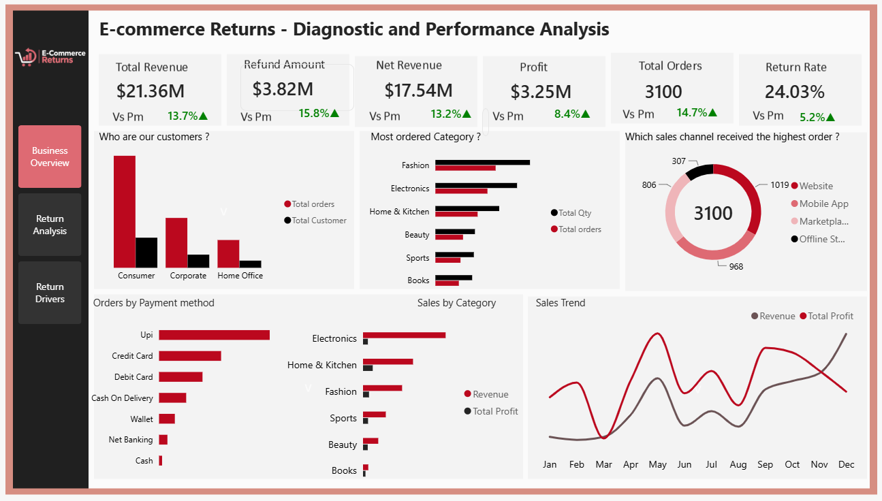

Page 2 - Return Analysis
A diagnostic view of where returns concentrate. It shows return rate by category, customer segment, sales channel, and payment method, alongside a product table (total orders, return orders, revenue, profit, return rate) sorted by profit so return behaviour can be read against value.
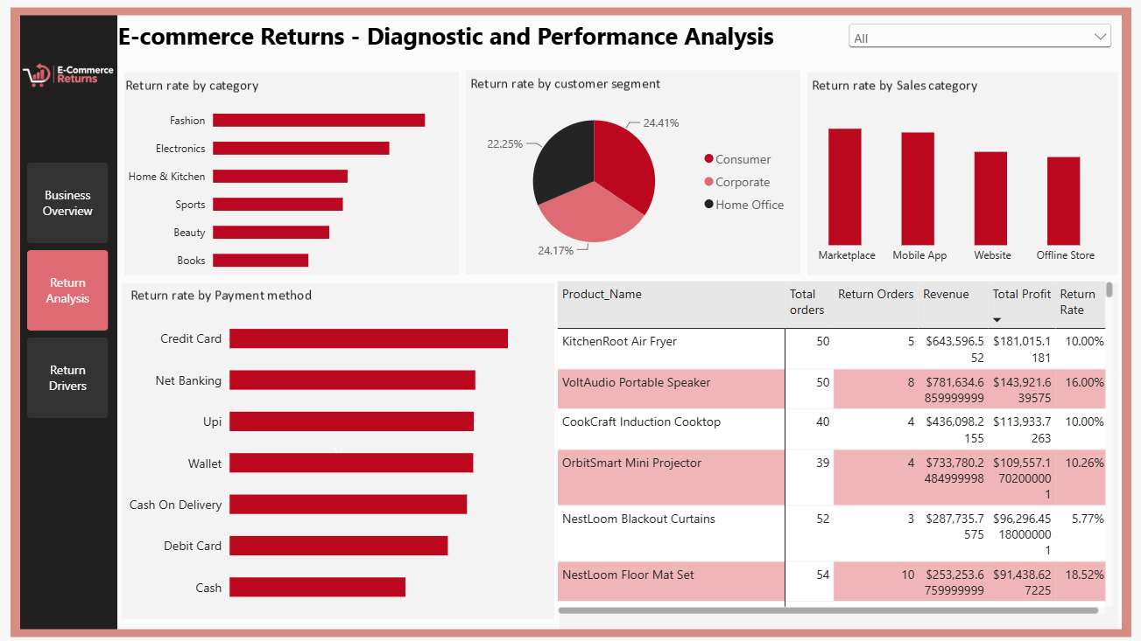

Page 3 - Return Drivers
A root-cause view. It ranks return reasons, tracks the monthly return trend, and cross-tabulates sub-category against reason in a heatmap, with slicers for interactive filtering. The darkest heatmap cells show 'wrong size' in Men's Clothing, Footwear, and Women's Clothing, and defective and damaged shading across the electronics subcategories.
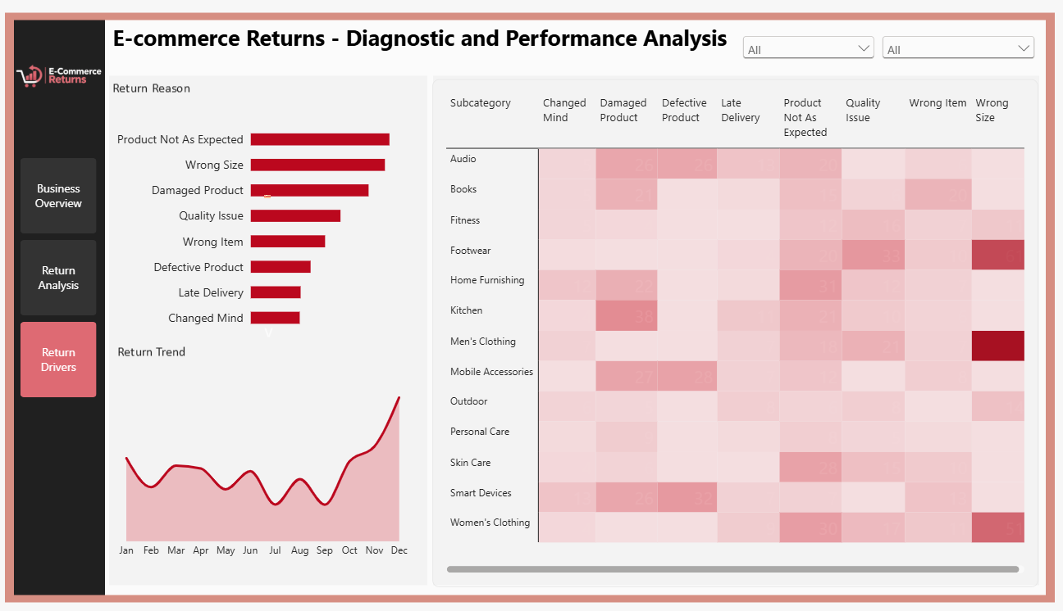

Recommendations
1. Review loss-making Electronics products: Investigate unit costs, selling prices, discounts, refunds and return quantities before deciding whether to reprice, improve quality or discontinue individual products.
2. Add quality gates and protective packaging for electronics. Introduce pre-shipment inspection for Audio, Mobile Accessories, and Smart Devices, recover the cost of defective units through supplier chargebacks, and upgrade packaging for fragile items.
3. Introduce fit guidance across fashion . Add measurement-based size charts, fit notes, and customer fit feedback to every footwear and clothing listing, starting with Men's Clothing and Footwear. Review sizing and quality of StrideX Running Sneakers and Northlane Slim Fit Jeans with suppliers.
4. Close the expectation gap in product content . Audit images, dimensions, materials, and descriptions for Home Furnishing, Personal Care, and Skin Care listings, beginning with DermaNest Night Repair Cream and Casabloom Table Runner Set. Add real-use photos and clear specifications.
5. Improve packaging and order accuracy for Kitchen and Books . Reinforce packaging for Kitchen products and add pick-and-pack verification to reduce damaged and wrong-item shipments.
6. Prepare for the next peak season. Run pre-peak quality checks on electronics, publish sizing and delivery guidance early, add packing capacity, and monitor return rate weekly from October with defined escalation triggers.
7. Align Mobile App and Marketplace with the Website. Bring product content on these channels up to Website standard and review Marketplace listing quality. Analyse returns by product within each channel to separate channel effects from product mix.
8. Protect and promote high-profit, low-return products. Prioritise stock and promotion for the Air Fryer, Induction Cooktop, Blackout Curtains, and FootNest Block Heel Sandal. Fix, rather than delist, profitable high-return items such as MiraMode Cotton Kurta Set and MoveMax Kettlebell.
9. Monitor financial and return performance together: Use return rate, refund amount and profit to identify products that pose the greatest business risk.

Limitations
The analysis is based on the available 2025 dataset and therefore reflects the information contained within that period.

Causality
The analysis identifies patterns and associations but does not establish causation.
For example, the negative Electronics profit observed in May, November and December does not prove that returns caused the losses.

External benchmarking
No external industry benchmark was included. Therefore, the 24.03% return rate describes the business's observed performance within this dataset but should not automatically be classified as above or below industry standards.

Operational variables
The available data does not provide enough information to isolate every possible operational cause of returns, such as individual supplier performance, packaging quality, warehouse handling or delivery partner performance.

Profit interpretation
Profitability is dependent on the definitions and calculations used for revenue, cost, refunds and deductions within the project.

Implementation / Action Plan
The business should implement the following actions based on the findings:
- Improve product quality: Investigate defective and damaged Electronics products, particularly Smart Devices and Audio products. Review supplier quality and strengthen product testing before dispatch.
- Reduce size-related returns: Improve size guides, product measurements, and product descriptions for Fashion items, especially Footwear and Men's Clothing.
- Improve product representation: Use accurate product images, detailed descriptions, and clear specifications to reduce returns caused by products not meeting customer expectations.
- Monitor high-return channels: Track return rates on the Marketplace and Mobile App, identify the products driving returns, and introduce targeted improvements.
- Review loss-making products: Investigate products with negative profit and assess their pricing, costs, refund levels, and return patterns before deciding whether to adjust, improve, or discontinue them.
- Measure progress: Review return rates, refund amounts, and product profitability monthly to determine whether the actions are reducing returns and improving business performance.

Conclusion
This analysis demonstrates that e-commerce returns should be evaluated as a business performance issue rather than solely a customer-service metric.
The business achieved significant sales volume during 2025, but returns represented a substantial financial exposure. More importantly, the analysis revealed that return and profitability problems are concentrated differently across products, categories and periods.
Electronics provides the clearest example. Although it generated the highest revenue, it contained several loss-making products and experienced negative profitability in May, November and December. At the same time, Electronics had a distinct return profile dominated by defective and damaged products.
Fashion presents a different problem: its return rate was the highest among the major categories, with wrong size being the dominant driver.
These findings indicate that the business should move away from a single return-reduction strategy and instead adopt targeted interventions based on product, category, channel and return reason.
The most important management opportunity is therefore not simply to reduce the number of returns. It is to identify which returns are financially significant, why they occur, and which interventions are most likely to improve profitability without unnecessarily restricting sales

