

**C# Programming Project**

**Project made by:**

**Azamat Amanzhol w65388**

**Yeslan Nurzhigitov w65381**

**Bogdan Valishin w63744**

**For Professor**

**Marcin Jagiela**

**Table of contents:**

* **Team members**
* **Introduction**
* **Project Description**
* **Conclusions**

**Team members:**

Azamat Amanzhol w65388

Yeslan Nurzhigitov w65381

Bogdan Valishin w63744

**Introduction:**

This project is a “Snake” game made by Python language.

**Project Description:**

We decided to create a “Snake” game in Python. To create the screen using Pygame, we used the display.set_mode() [function](https://www.edureka.co/blog/python-functions). Also, we used the init()  and the quit() methods to initialize and uninitialize everything at the start and the end of the code. The update() method is used to update any changes made to the screen.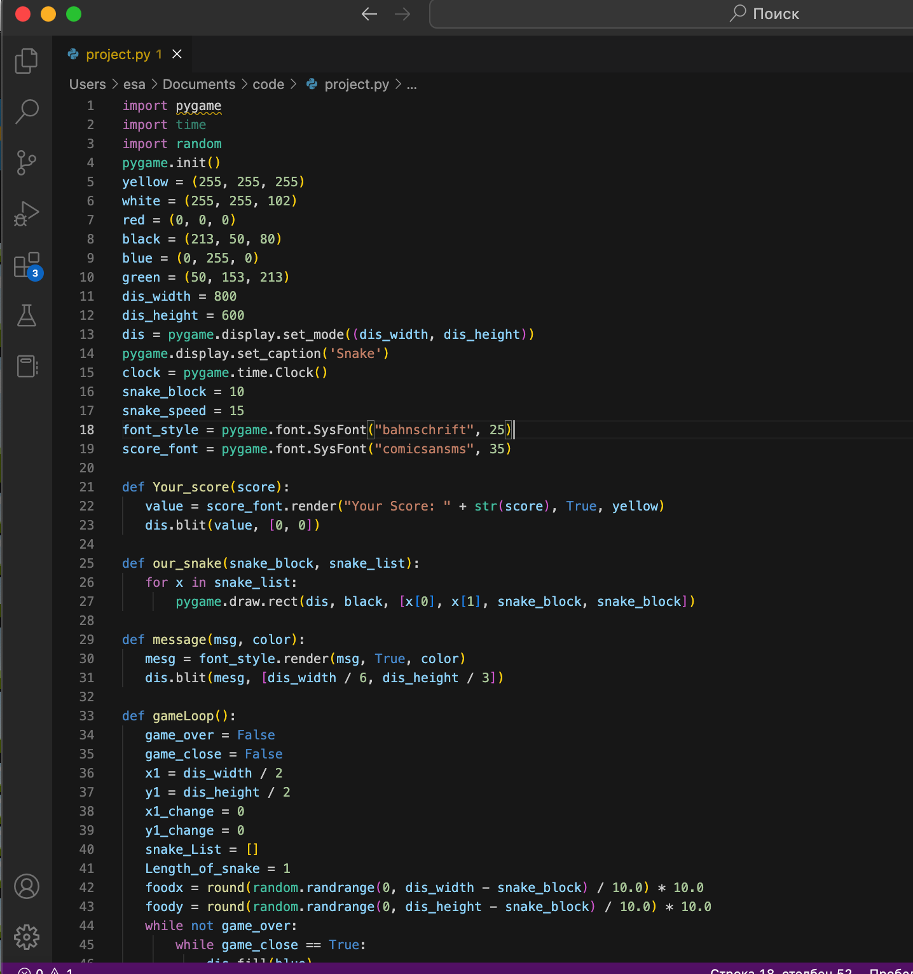

To create the snake, We will first initialize a few color variables in order to color the snake, food, screen, etc. The color scheme used in Pygame is RGB i.e “Red Green Blue”. In case you set all these to 0’s, the color will be black and all 255’s will be white. So our snake will actually be a rectangle. To draw rectangles in Pygame, we used of a function called draw.rect() which help us draw the rectangle with the desired color and size.

To move the snake, we used the key events present in the KEYDOWN class of Pygame. The events that are used over here are, K_UP, K_DOWN, K_LEFT, and K_RIGHT to make the snake move up, down, left and right respectively. Also, the display screen is changed from the default black to white using the fill() method.

We have created new variables x1_change and y1_change in order to hold the updating values of the x and y coordinates.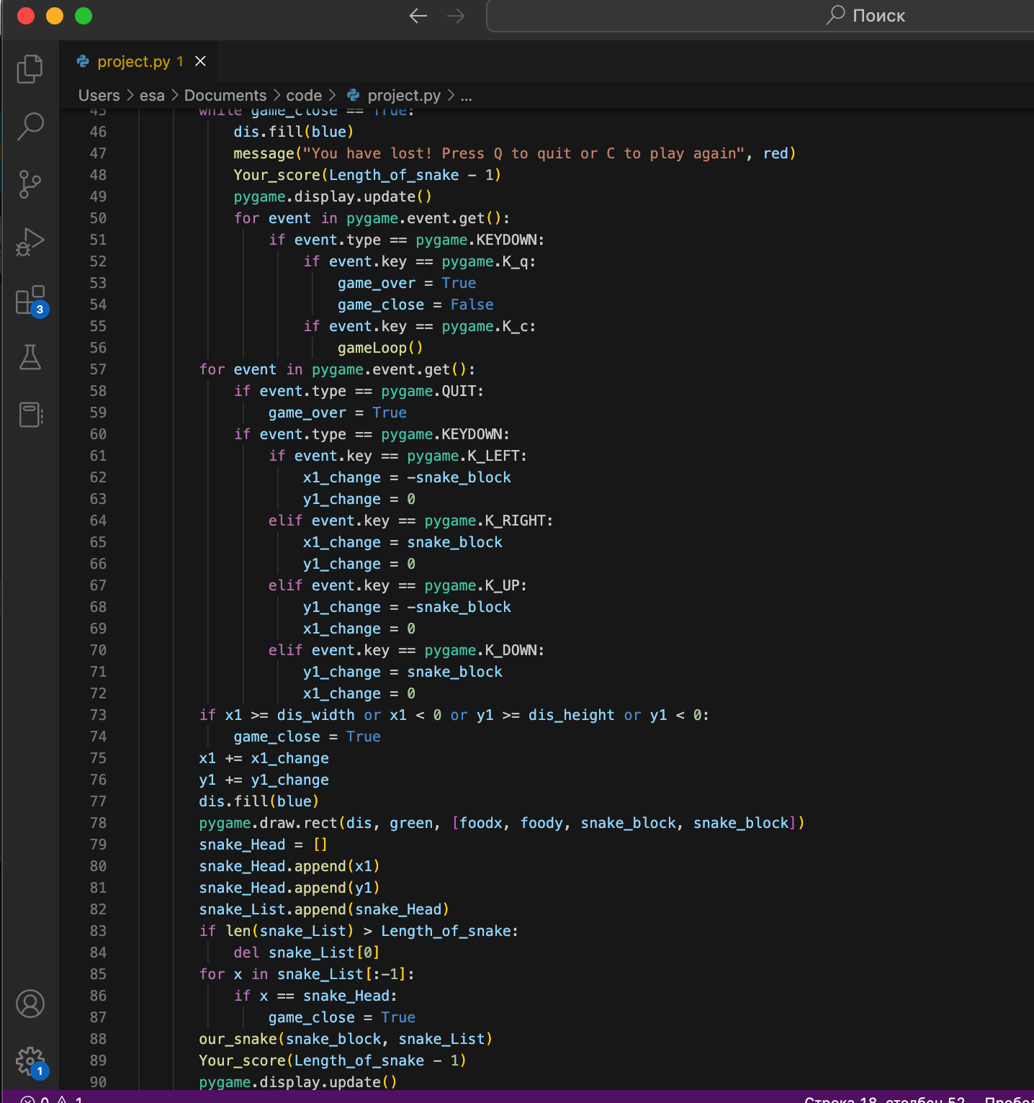

In this snake game, if the player hits the boundaries of the screen, then he loses. To specify that, we have made use of an ‘if’ statement that defines the limits for the x and y coordinates of the snake to be less than or equal to that of the screen.

The following code will increase the size of our snake when it eats the food. Also, if the snake collides with his own body, the game is over and you ill see a message as “You Lost! Press Q-Quit or C-Play Again“. The length of the snake is basically contained in a list and the initial size that is specified in the following code is one block.

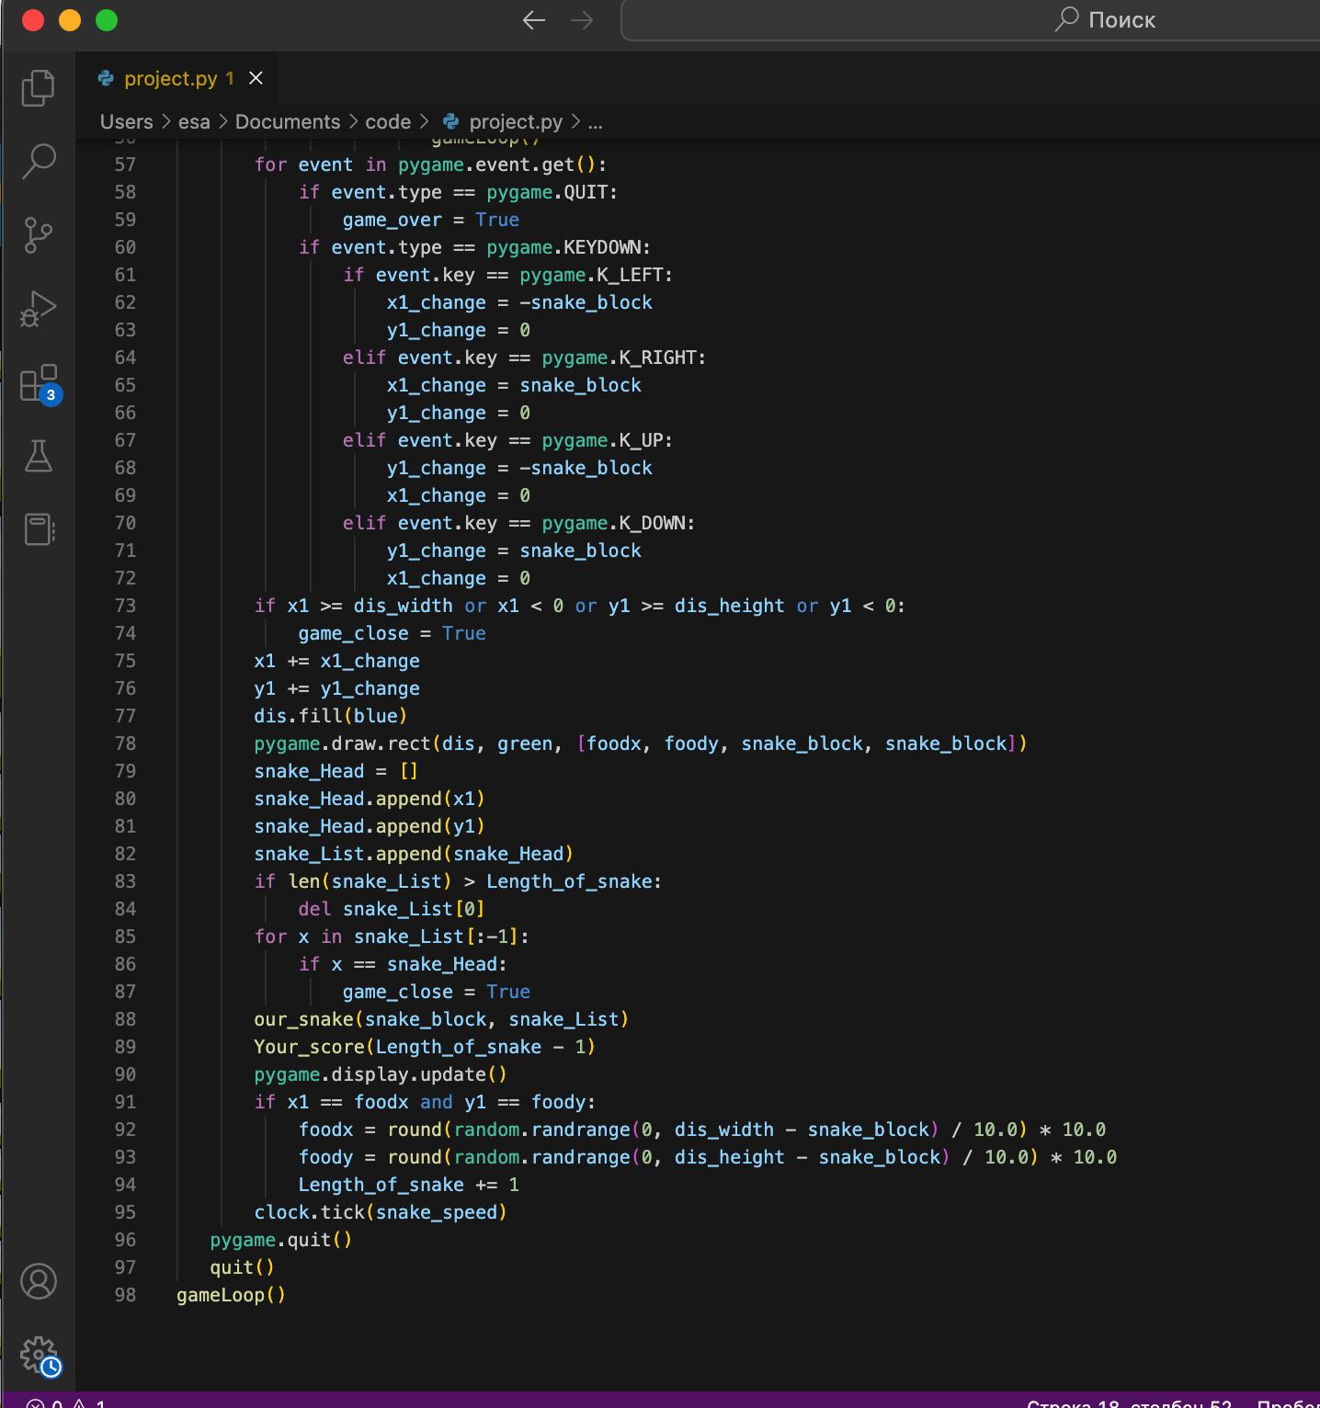

**Conclusions:**

We realized how important something like Github is for developing large projects. Since it allows us to keep track of all code changes, it also allows us to quickly share and merge our code. We all liked to play the snake game as children and so we decided to go back in time and play this beautiful game again.