Centralized Baseline for Federated Learning
ResNet-18 on CIFAR-10
Project: Federated Learning assignment - baseline step
Dataset: CIFAR-10
Architecture: ResNet-18 adapted for 32x32 images
Generated: May 29, 2026

Abstract
This report documents the centralized baseline required before implementing federated-learning strategies. The task is image classification on CIFAR-10 using a full-precision ResNet-18. The resulting model, training curves, validation accuracy, and test accuracy form the reference point for later FedAvg or custom FL strategies.
Baseline role: This is not the federated method itself. It is the standard centralized experiment that establishes the accuracy and loss target for later federated runs on the same dataset and architecture.

1. Problem
The federated-learning project asks for a classification baseline before client-server training is introduced. A centralized baseline is useful because all training samples are available to a single optimizer, so it gives a clean upper reference for convergence and generalization under the selected model architecture.

2. Dataset
CIFAR-10 contains 60,000 RGB images of size 32 by 32 pixels across ten classes: airplane, automobile, bird, cat, deer, dog, frog, horse, ship, and truck. The project uses 45,000 training samples, 5,000 validation samples, and the official 10,000-image test split. Training augmentation consists of random crop with padding 4 and random horizontal flip. Evaluation uses only normalization.

3. Algorithm and Architecture
The classifier is a ResNet-18 adapted for CIFAR resolution. The first layer is a 3x3 convolution with stride 1, and the ImageNet-style initial max-pooling layer is removed so early spatial information is not discarded on 32x32 inputs. The residual stages use two BasicBlock modules each, followed by global average pooling and a ten-way linear classifier.
for epoch = 1 ... E:
train ResNet-18 on augmented CIFAR-10 batches
evaluate validation loss and accuracy
save checkpoint when validation accuracy improves
load best validation checkpoint
evaluate train, validation, and test accuracy/loss
export curves, confusion matrix, and summary table

4. Experimental Setup
Setting | Value
Model | CIFAR-style ResNet-18
Optimizer | SGD with momentum 0.9 and Nesterov acceleration
Learning rate | 0.1 with cosine annealing
Weight decay | 0.0005
Batch size | 128
Epochs | 30 by default
Metric focus | Accuracy and cross-entropy loss

5. Results
Result scope: The table below reflects the latest available smoke-test run, not the full 30-epoch baseline. Run the default command and rebuild the paper to replace these values with full baseline results.

Epochs | Train | Val | Test | Val Acc. | Test Acc. | Test Loss
3 | 5000 | 1000 | 1000 | 34.50% | 36.80% | 1.707

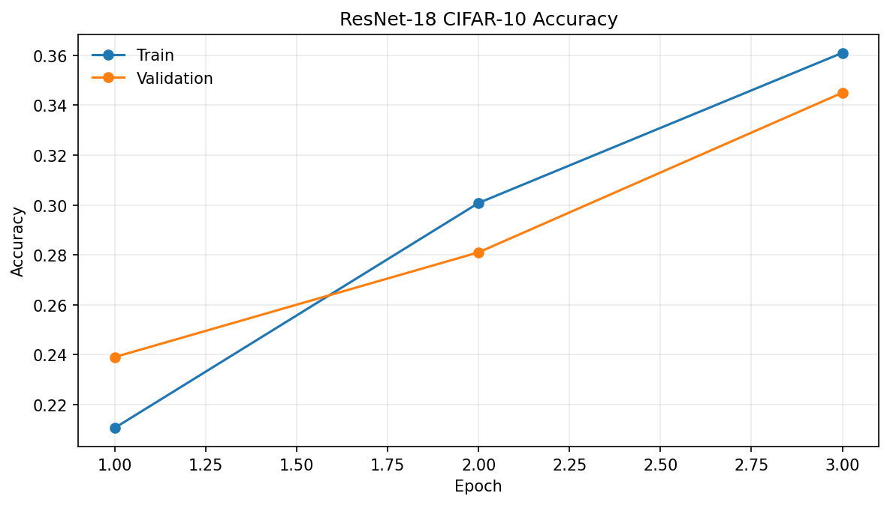
Figure 1. Training and validation accuracy by epoch.
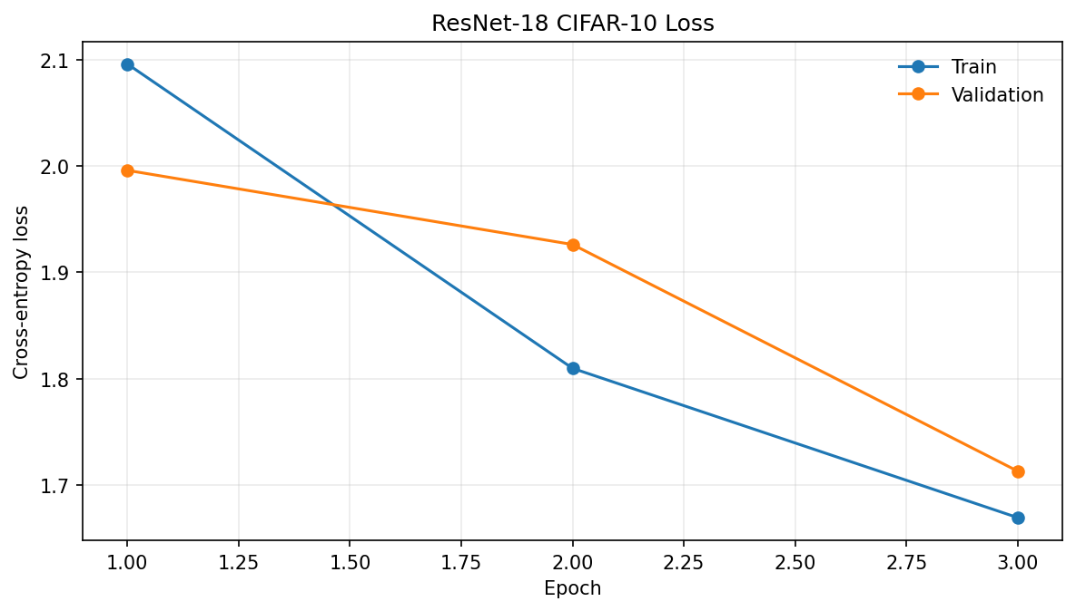
Figure 2. Training and validation loss by epoch.
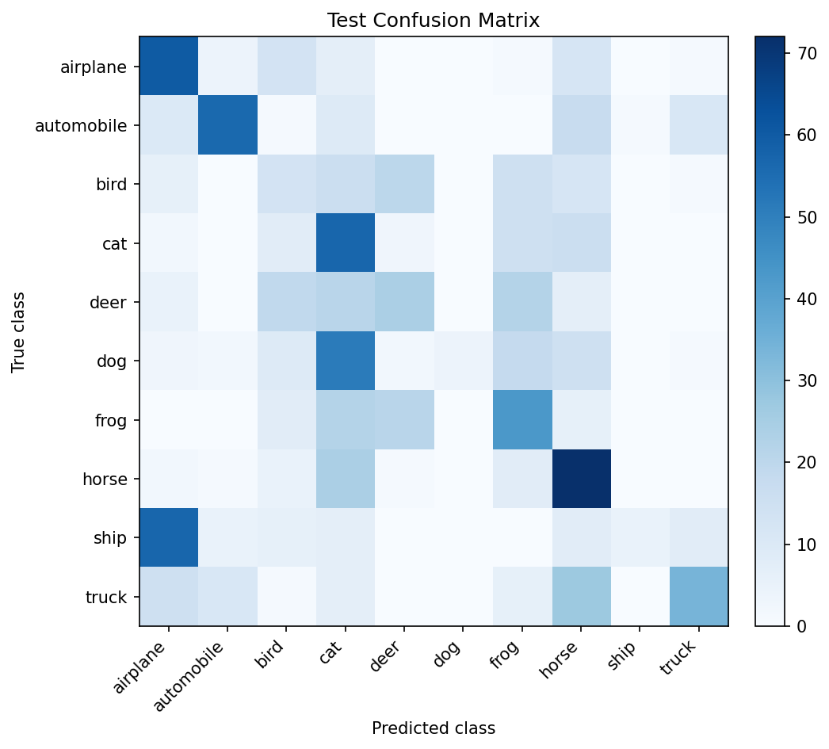
Figure 3. Test confusion matrix.

6. Discussion
For the federated-learning project, the important property of this baseline is repeatability. The same CIFAR-10 split, model, optimizer, and metrics can be reused when later replacing centralized data access with client partitions. Any federated method should be compared against the centralized test accuracy and loss reported here.
A centralized ResNet-18 should converge faster and usually reach a higher final accuracy than non-IID federated runs because every batch is sampled from the full training distribution. If a future FL strategy approaches this baseline with fewer communication rounds or lower instability, it is evidence that the strategy handles decentralized data well.

7. Reproducibility
Run the full baseline with:
PYTHONPATH=src python3 scripts/run_baseline.py --config configs/default.json

Run a quick smoke test with:
PYTHONPATH=src python3 scripts/run_baseline.py --config configs/default.json --epochs 1 --max-train-samples 512 --max-val-samples 256 --max-test-samples 256

References
[1] Federated Learning Project Handout, Revision 1.
[2] K. He, X. Zhang, S. Ren, and J. Sun. Deep residual learning for image recognition. CVPR, 2016.
[3] A. Krizhevsky. Learning multiple layers of features from tiny images. Technical report, 2009.
[4] B. McMahan, E. Moore, D. Ramage, S. Hampson, and B. Aguera y Arcas. Communication-efficient learning of deep networks from decentralized data. AISTATS, 2017.

