SDC HACKATHON 2026
Technical & Tools Declaration
Hosted by Xiamen University Malaysia (XMUM) AI Club
Submission Deadline: 1st November 2026
Instructions: Declare every API, cloud service, AI tool, dataset, model, and sponsor resource your team used to build the project. Complete every section; where a category does not apply, tick “No” or write “None” – do not leave it blank. Submit as a single PDF document named “SDC2026_TeamName_TechDeclaration.pdf” together with your project submission. Undeclared third-party resources discovered at judging may affect your score or eligibility.

1. Team & Project Overview
Team Name | HRISSA
Project / Solution Name | Gesir.AI
Name (Leader) | Azer Hamdaoui
Email & Phone (Leader) | azer.hamdaoui.07@gmail.com  what’sapp: +21656138490
University Affiliation(s) | Xiamen University Malaysia (XMUM)
Live Prototype URL | https://gesir-ai.replit.app (the dashboard is at /app; the sign-in password is given to the judges separately)
Code Repository URL (public / access granted to judges) | https://github.com/Azer884/Bridge-app

2. Architecture & Technology Stack

2.1 System Architecture Overview
Describe how the components declared in this document connect end-to-end (e.g., user interface → backend → AI model/API → database → cloud hosting). Attach a system block diagram as an appendix if available.
[Maximum 200 words]
A customer writes to the business on WhatsApp. The Meta WhatsApp Cloud API passes each message to a signed webhook on our FastAPI backend, written in Python and hosted on Replit with a PostgreSQL database.
The backend runs the conversation. It asks for PDPA consent first, works out which job details are missing, and checks dates against the crew's working hours and holidays and addresses against the service area.
Models are used only to read what the customer writes or sends. Qwen2.5-7B-Instruct writes the reply and picks out the job details, and Qwen2.5-VL-7B-Instruct reads photos of the walls. Both run on RunPod serverless GPUs with vLLM. Whisper (faster-whisper) turns voice notes into text. A value a model extracts is stored only if it matches what the customer wrote.
The price is calculated by code from a rate table (config/painting_prices_malaysia_2026.csv), so it is the same every time for the same job.
The owner approves or rejects each estimate in a React dashboard with an Orbyte-style layout, or in an Expo mobile app. The customer receives the price only after approval.
WhatsApp calls go through LiveKit (voice_worker/). The owner gets Expo push notifications, and an Orbyte hub gets signed events.

2.2 Languages, Frameworks & Libraries
List the main programming languages, frameworks, and third-party libraries that your team did not create. Open-source use is permitted provided it is declared and properly licensed/attributed.
Name & Version | Purpose in Project | License
Python 3.12 | Backend language | PSF License
FastAPI, Uvicorn | Web API and web server | MIT, BSD-3-Clause
Pydantic 2 | Checking request bodies | MIT
psycopg 3 (with pool) | PostgreSQL driver | LGPL-3.0
faster-whisper 1.2 (CTranslate2), PyAV | Voice-note transcription and audio decoding | MIT, BSD-3-Clause
livekit-api 1.2, livekit-agents 1.2 | WhatsApp voice calls | Apache-2.0
python-dotenv | Loading settings in the voice worker and test scripts | BSD-3-Clause
httpx | HTTP client used by the automated tests | BSD-3-Clause
vLLM (RunPod worker 2.29) | Serving the Qwen models | Apache-2.0
TypeScript 7, React 19, React Router 7, Vite 8 | Web dashboard | Apache-2.0, MIT
GSAP 3, @gsap/react | Animation library, still listed in package.json | GSAP Standard License (free)
Expo SDK 58, React Native 0.88, React Navigation 7, expo-notifications | Mobile app and push notifications | MIT
Public Sans, Figtree, Barlow, Bricolage Grotesque (Google Fonts) | Typefaces | SIL Open Font License 1.1

3. APIs & Cloud Services

3.1 External APIs
List every external API your solution calls (GenAI, maps, payments, messaging, data feeds, etc.). Do not include API keys or secrets in this document.
API & Provider | Purpose in Project | Access Tier (free / paid / sponsor-provided)
WhatsApp Business Cloud API (Meta) | Receive and send customer messages, photos and voice notes; voice calls | Free (Meta test number)
RunPod Serverless API (RunPod) | Runs the chat, photo and speech models | Paid, per second of GPU time
LiveKit Cloud and LiveKit Inference (LiveKit), with Deepgram Nova-3 speech-to-text and Cartesia Sonic-3.5 text-to-speech | Live voice calls on WhatsApp | Billed through LiveKit Cloud (free tier)
Expo Push API (Expo) | Notifications to the owner's phone | Free
Google Fonts (Google) | Web fonts for the dashboard and sign-in page | Free

3.2 Cloud Platforms & Deployment
List every cloud service used for hosting, storage, databases, authentication, or compute, and indicate how the prototype is deployed.
Service & Provider | Purpose in Project | Plan / Region
Replit Deployments (Replit) | Hosts the Gesir backend and dashboard at gesir-ai.replit.app | Paid Replit plan; region managed by Replit
Replit PostgreSQL (Replit) | Database: conversations, quotes, bookings, audit log | Included in the Replit plan
RunPod Serverless GPU (RunPod) | Three endpoints: chat model (24 GB GPU), photo model (24 GB), Whisper (24 GB); they scale to zero when idle | Pay as you go; EU data centres (EUR-IS-2, EUR-NO-1)
LiveKit Cloud (LiveKit) | Real-time audio rooms for calls | Free tier
Expo Application Services (Expo) | Builds the Android app | Free tier
GitHub (Microsoft) | Code repository | Free

4. AI Tools, Models & Datasets

4.1 AI Models Used in the Solution
List every AI model embedded in or called by your application, including pre-trained, fine-tuned, and self-trained models.
Model & Version | Source / Provider | Usage (pre-trained / fine-tuned / self-trained) | License / Terms
Qwen2.5-7B-Instruct | Alibaba Qwen team, from Hugging Face; served on RunPod with vLLM | Pre-trained, used with our prompts (not fine-tuned) | Apache-2.0
Qwen2.5-VL-7B-Instruct | Alibaba Qwen team, from Hugging Face; served on RunPod with vLLM | Pre-trained (reads wall photos) | Apache-2.0
Whisper small and base (faster-whisper) | OpenAI Whisper, CTranslate2 conversion by Systran | Pre-trained (voice notes) | MIT
Deepgram Nova-3 | Deepgram, through LiveKit Inference | Pre-trained, API (speech-to-text in calls) | Deepgram terms of service
Cartesia Sonic-3.5 | Cartesia, through LiveKit Inference | Pre-trained, API (text-to-speech in calls) | Cartesia terms of service

4.2 Datasets
List all datasets used for training, fine-tuning, evaluation, or in the running application. State clearly if a dataset contains personal or sensitive data.
Dataset Name | Source / URL | Type (public / private / self-collected / synthetic) | License | Personal Data? (Y/N)
Malaysian painting price benchmark 2026 | config/painting_prices_malaysia_2026.csv; team research: 10 contractor quotes in Klang Valley, marketplace listings, CIDB N3C portal (sources in docs/PRICING.md) | Self-collected | Team-owned; sources cited | N
Aircon servicing rates (Klang Valley) | config/trades/aircon.json | Self-collected estimates (demo) | Team-owned | N
Malaysian public holidays, Oct to Dec 2026 | Orbyte leave calendar (sponsor platform); config/holidays.json | Public information | Public facts | N
Chat test scenarios and demo records | tests/, scripts/stress_chat.py (about 200 scenarios), src/demo.py | Synthetic | Team-owned | N (made-up names and numbers)
Malaysia outline for the service area | src/geo.py (coarse coordinates drawn by the team) | Self-created | Team-owned | N

4.3 AI-Assisted Development Tools
Tools used to help write code, design, content, or documentation (e.g., chat assistants, code completion tools, image generators). Declaring these tools does not reduce your score; undeclared use may.
Did your team use any generative-AI tool to help create code, design, text, or other project material?
☒ Yes ☐ No
If yes, list them below:
Tool & Version | Used For | Extent of Use (minor / moderate / major)
Claude Code (Anthropic), Claude Opus and Sonnet models | Writing and reviewing code, tests, the dashboard design and documentation | Major
Replit Agent (Replit) | Deployment and database tasks on Replit | Minor

Briefly describe how your team reviewed, tested, and took responsibility for AI-generated output:
[Maximum 100 words]
A team member read each change before we kept it. The backend has 607 automated tests, and all of them must pass before we publish. scripts/stress_chat.py sends about 200 test conversations to the live model, and we read the replies and fixed the wrong ones. We checked dashboard changes in a browser on a local copy first. Prices are calculated by tested code, and the app keeps a model's answer only when it matches the customer's words. The team is responsible for all the code we submit.

5. Sponsor-Provided Resources
Declare any official SDC sponsor-provided GenAI API, cloud credits, tools, mentoring, or data that your team used.
Did your project use any official SDC sponsor-provided resource?
☒ Yes ☐ No
If yes, list them below:
Sponsor | Resource (API / credits / platform / data) | How It Was Used in the Project
Alpha Red Solutions (Orbyte) | Platform: an Orbyte account, and the high-level briefing | We followed the layout of Orbyte's screens for our dashboard, without using Orbyte's code, logo or images, and took the public-holiday dates shown in its leave calendar.

Was the sponsor resource essential to the core functionality of the prototype, or could it be replaced? Explain briefly:
[Maximum 100 words]
It could be replaced. The chat, pricing, approval and dashboard all run without Orbyte. We used the Orbyte account to make the dashboard look and work like the hub it would live in. The holiday dates in config/holidays.json can come from any official calendar. We did not use a sponsor API, credits or data feed.

6. Security, Privacy & Responsible Use

6.1 Data Handling & Privacy
What user or personal data does your application collect, store, or send to third-party services (including AI APIs)? How is it protected, and how long is it kept? State “No user data is collected” if applicable.
[Maximum 150 words]
The app keeps the customer's WhatsApp number and profile name, their messages, photos and voice notes, the address or shared location, the job details and the preferred time. It reads nothing until the customer agrees to a PDPA notice (1 to agree, 2 to decline), and a message that says only "STOP" erases their data.
It is stored in PostgreSQL on Replit. Messages pass through Meta WhatsApp, text, photos and voice notes go to our RunPod model endpoints, call audio goes through LiveKit to Deepgram and Cartesia, and owner notifications go through Expo.
The owner signs in with a password and the server checks each role. API calls need a key, webhooks are signed, and requests from other websites are refused.
Data is kept for the job only. The owner can erase a customer (DELETE /api/customers/{id}/data); nothing expires automatically yet. The demo uses test numbers and made-up data.

6.2 Known Limitations & Risks
Identify the main technical limitations of your AI components (e.g., hallucination, bias, rate limits, dependency on a single provider) and any mitigation you have implemented.
[Maximum 150 words]
The 7B chat model sometimes misreads messy messages, especially transcribed voice notes. The app keeps a value only when it matches the customer's words, asks again when it is unsure, and flags unclear chats for the owner.
Whisper makes mistakes on noisy or mixed-language voice notes, so the assistant asks the customer to repeat rather than guess.
Prices come from code, but the rate data is a 2026 Klang Valley sample. The owner sees the market range, and anything not in the data is labelled as an assumption.
RunPod workers scale to zero and need a few minutes to wake. The assistant sends a waiting message, and we can keep one worker running during the demo.
All models run on RunPod. They are open-weight models, so we could move them to another GPU host.
The Meta test number limits who we can message or call.

7. Compliance & Readiness Checklist
Tick all boxes that apply before submitting.
☒ | All APIs, cloud services, AI tools, models, and datasets used in the project are declared in this document.
☒ | All third-party code, datasets, and models are used in accordance with their licenses, and attribution is provided where required.
☐ | No API keys, passwords, or other credentials are exposed in the code repository, prototype, or this document.
☒ | Any use of generative-AI tools for development has been disclosed and reviewed by the team.
☒ | Any use of official SDC sponsor resources has been declared in Section 5.
☒ | The prototype described here is accessible to judges through the links provided in Section 1.
☒ | All fields in this template have been completed within the word limits stated.

8. Declaration
By submitting this document, the team leader confirms that the information provided is complete and accurate to the best of the team’s knowledge, and that every API, cloud service, AI tool, dataset, model, and sponsor resource used in the project has been declared.


1 November , 2026

Appendix: Proof of use
A1. Replit: the team's Bridge-app project in the team's own Replit account (published app).
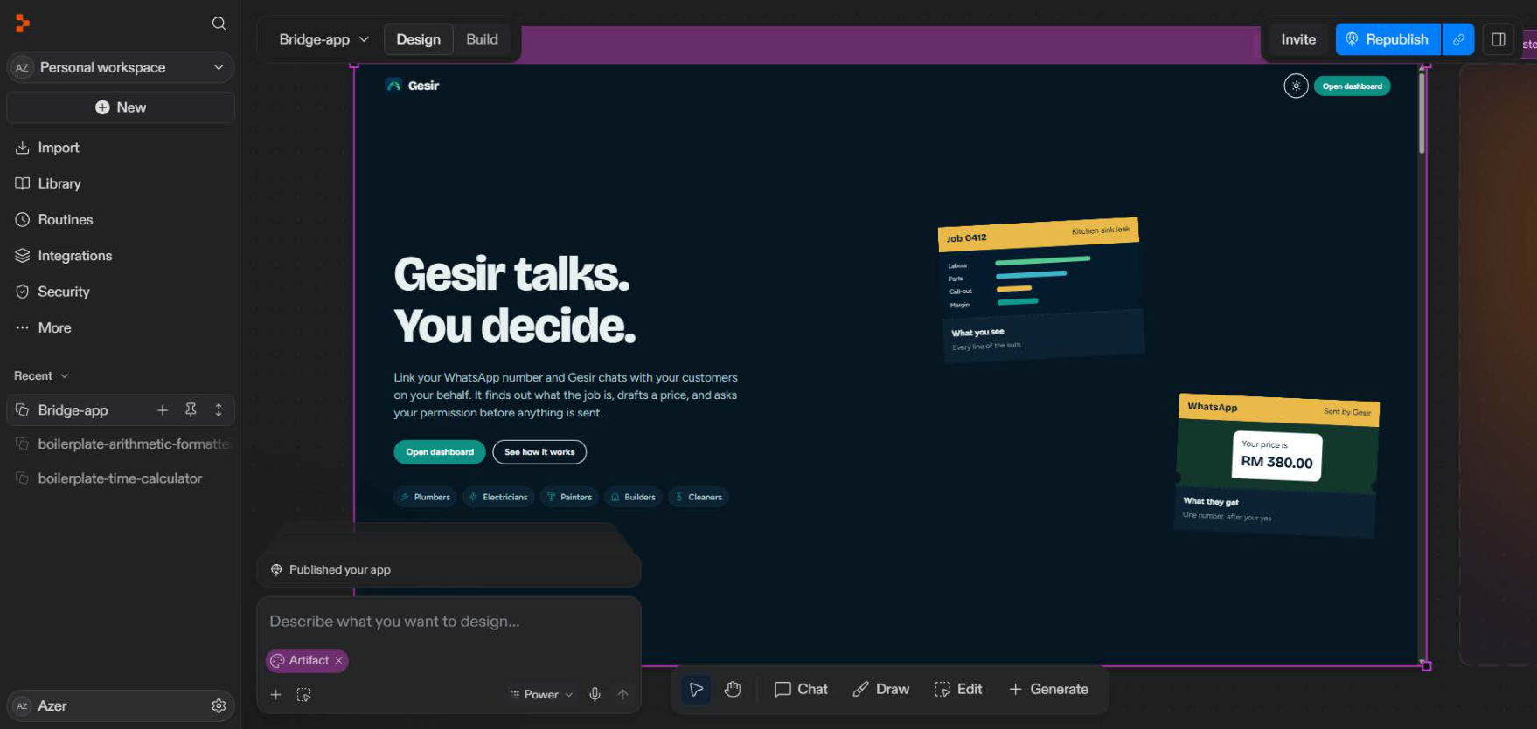
A2. Replit: account usage page (Oct 20 to Nov 19, 2026), showing the team's own spend.
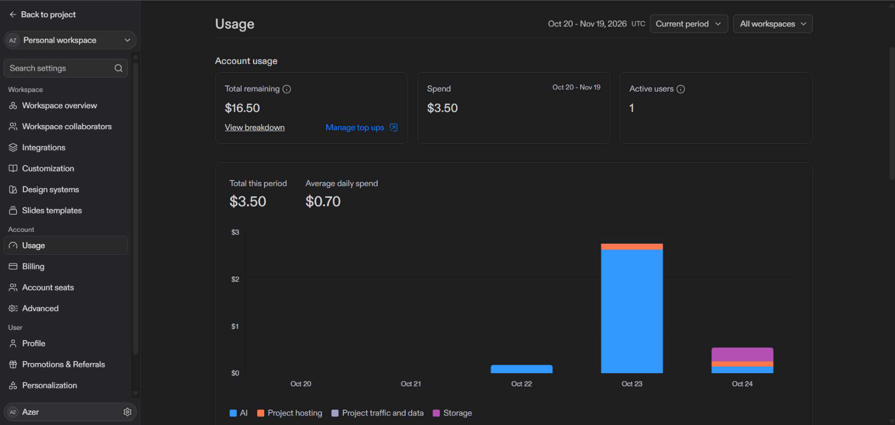

B1. RunPod: chat endpoint ose8agxpb9p1mr (vLLM v2.29.0, Qwen/Qwen2.5-7B-Instruct), GPU type 24 GB, GPU count 1.
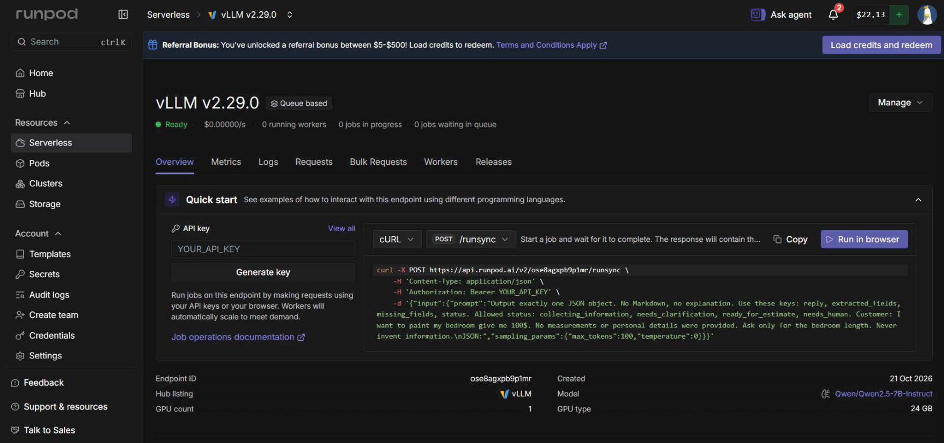
B2. RunPod: photo endpoint m3a8r7m8ebibba (vLLM v2.29.0, Qwen/Qwen2.5-VL-7B-Instruct), GPU type 24 GB, GPU count 1.
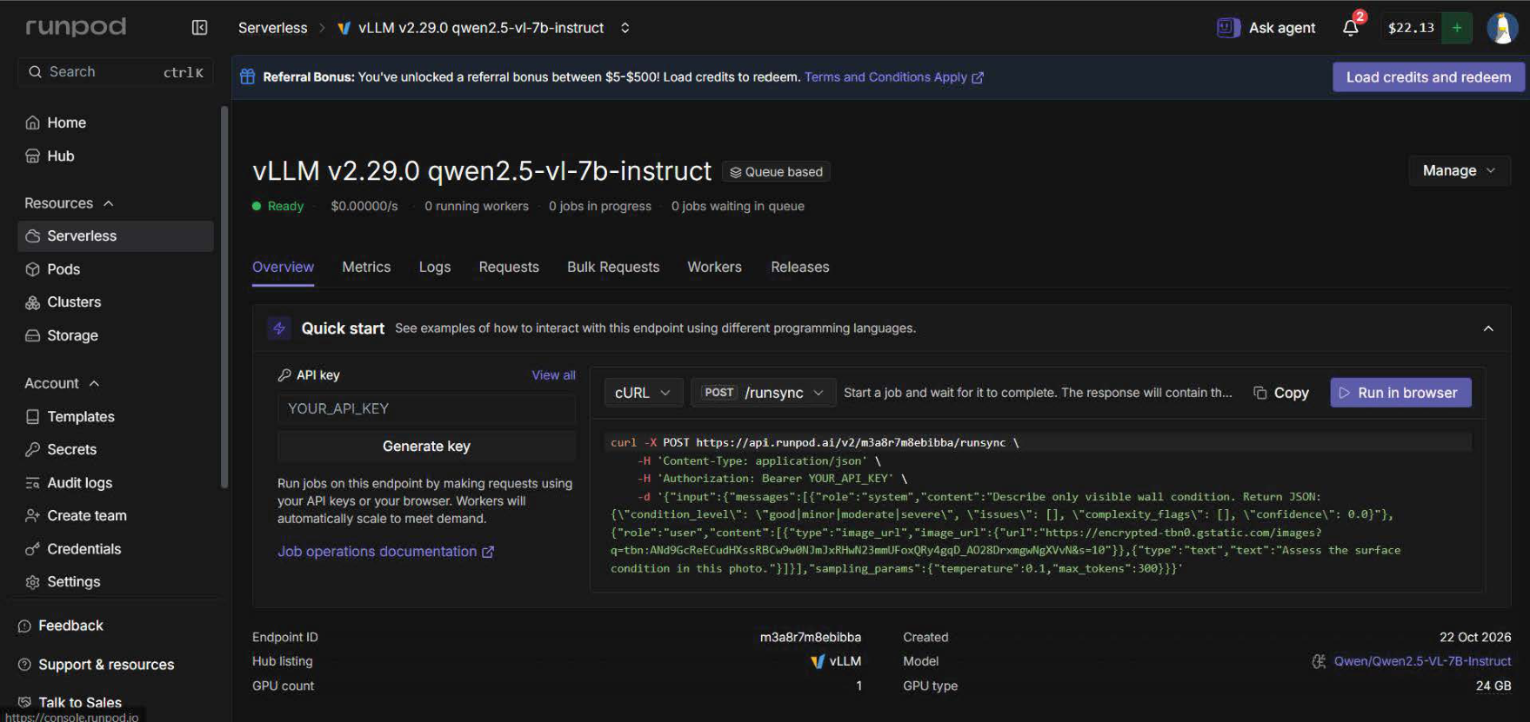

B3. RunPod: speech endpoint nvnrh39cdxgymr (Faster Whisper 1.0.10), GPU type 24 GB Pro, GPU count 1.
