using System;

using System.Collections.Generic;

using System.ComponentModel;

using System.Data;

using System.Drawing;

using System.Linq;

using System.Text;

using System.Threading.Tasks;

using System.Windows.Forms;

namespace WindowsForms

{

public partial class Form1 : Form

{

public Form1()

{

InitializeComponent();

}

private void panel1_Paint(object sender, PaintEventArgs e)

{

}

private void label1_Click(object sender, EventArgs e)

{

}

private void textBox1_TextChanged(object sender, EventArgs e)

{

}

private void backgroundWorker1_DoWork(object sender, DoWorkEventArgs e)

{

}

private void textBox2_TextChanged(object sender, EventArgs e)

{

Application.Exit();

}

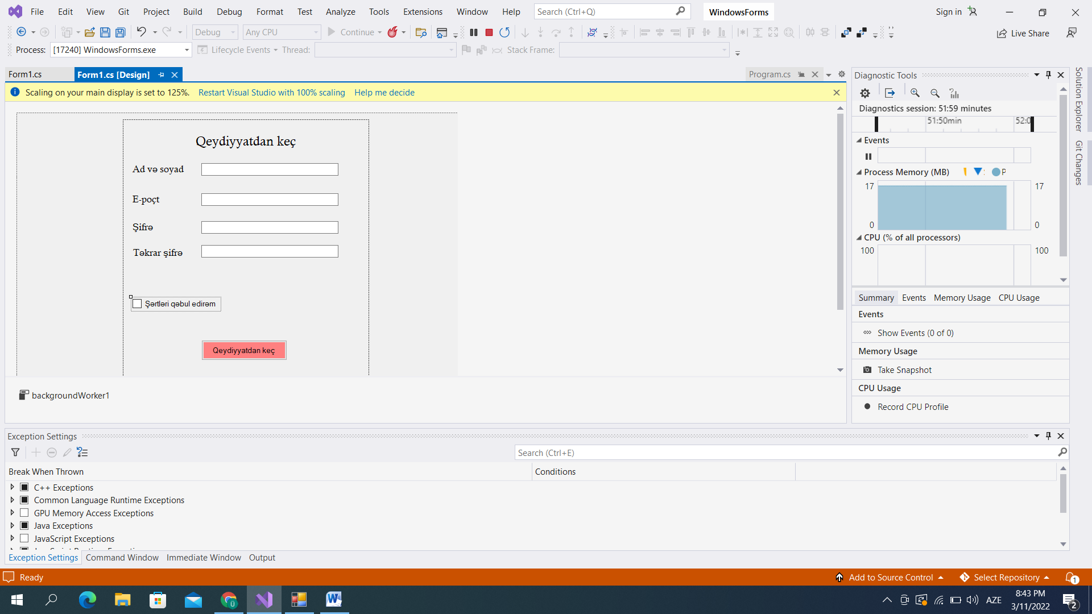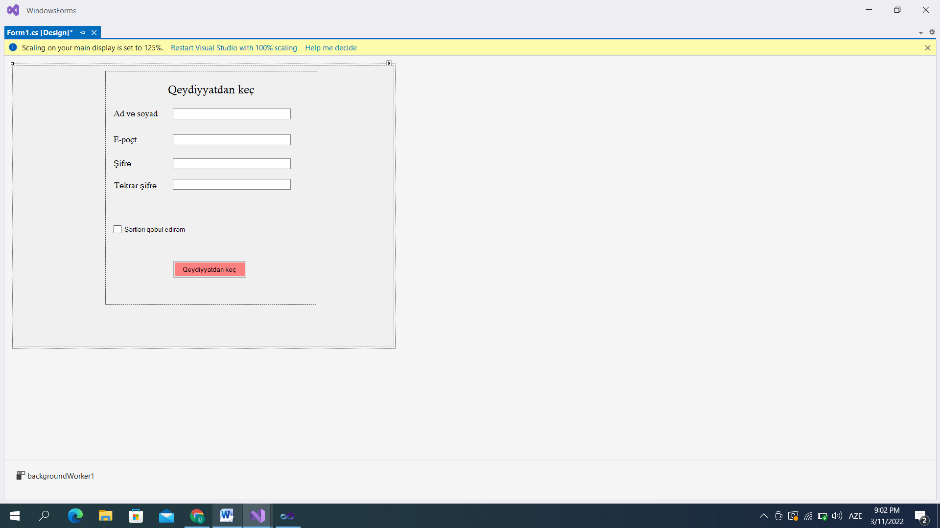

using System;

using System.Collections.Generic;

using System.Linq;

using System.Threading.Tasks;

using System.Windows.Forms;

namespace WindowsForms2

{

internal static class Program

{

/// <summary>

/// The main entry point for the application.

/// </summary>

[STAThread]

static void Main()

{

Application.EnableVisualStyles();

Application.SetCompatibleTextRenderingDefault(false);

Application.Run(new Form1());

}

