**FLOW Sensor**

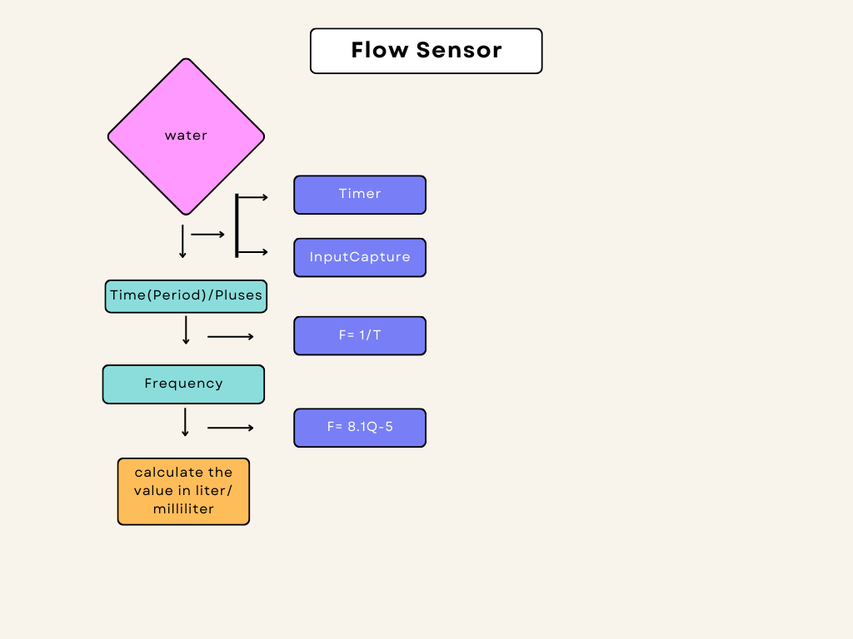

Flow sensor is used the find consume the water level at cooking and washing time

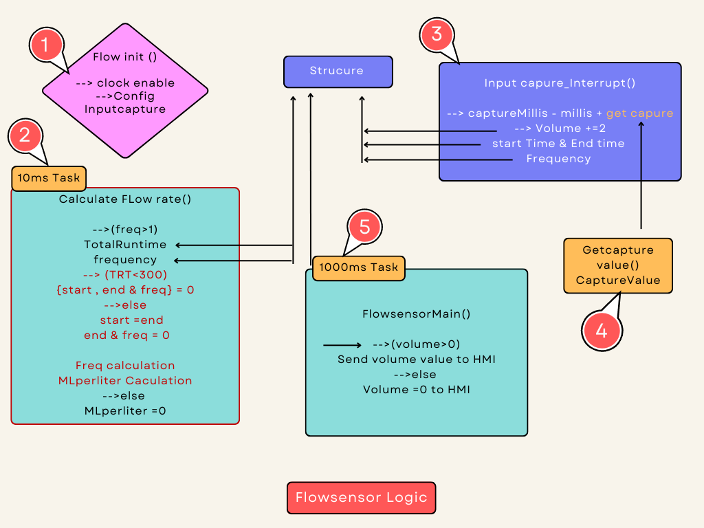

**Using Macros**

* **FLOWRATE_LM_TO_MLM_CONVERTION_FACTOR**
* This macro is used to convert Litre per minute to Mille litre per minute.
* **FLOWRATE_MULTIPLICATION_FACTOR**

**🡪**For using Error corrections

**Using variables**

* **CaptureMillis** 🡪 this variable cantains the total peiod of imcoming water
* **Millis** 🡪
* **NoWaterIndicatorCount** 🡪 this variable is used to find the water is incoming or not;
* **WaterInletOffIndicateCounter** 🡪
* **FrequencyCounter 🡪** It is used to contains the no of pulse.
* **TotalRunTime** 🡪 it used to contains the total time incoming water.

**Flow of State**

* **Flowsensor_init()**
* **Calculate Flowrate()(10ms Task)**
* **Inputcapture_interrupt()**
* **Getcapture_value()**
* **Flow_main()(1000ms task)**

1. **Flowsensor Init()**

Flow sensor Init() function Enable the clock and Config the Inputcapture in the interrupt method.

1. **Calculate flowrate()(10ms task)**

* This function is called by every 10ms task,
* This is calculates and manages flow rate-related information.
* This function is calculated by the Freq calculation

🡪 It calculates the CH1.freqency by dividing FrequencyCounter by TotalRunTime (scaled to thousands) and rounding to the nearest integer using +0.5.

* MLperMinute Calculation.

🡪 It calculates CH1.MLPerMinute based on the frequency and some constants (FLOWRATE_MULTIPLICATION_FACTOR and (FLOWRATE_LM_TO_MLM_CONVERTION_FACTOR).

🡪This calculation seems to convert the frequency into milliliters per minute.

* Totalruntime and freq value are get from theST.
* (IsWaterInletOpenFlag == TRUE)

🡪This likely indicates whether the water inlet valve is open.

🡪If the flag is TRUE, it proceeds to further checks related to water flow.

🡪 **(CH1.MLPerMinute < 500)**

🡪 If CH1.MLPerMinute is less than 500 milliliters per minute, it increments a counter named **NoWaterIndicatorCount**. This counter likely tracks how long the flow rate has been below the threshold.

🡪 **(NoWaterIndicatorCount > 300)**

🡪 If **NoWaterIndicatorCount** exceeds 300 (likely representing 3 seconds of low flow), it takes several actions:

🡪Sets a flag in the MachineStatus structure **(MachineStatus->NWF)** to indicate a "No Water Flow" condition.

🡪Sends a machine status update using **Send_MachineStatus().**

🡪Reports a diagnostic event, possibly indicating a problem with steam

🡪 Adjusts the **washState** and **steamControl** variables based on certain conditions.

🡪Resets the **NoWaterIndicatorCount** to 0.

🡪 **Flow Rate Normalization**

🡪If the flow rate is greater than or equal to 500 milliliters per minute, it resets the **NoWaterIndicatorCount** to 0 and clears the "NWF" flag in MachineStatus.

🡪 **Water Inlet Valve Check**

🡪If the water inlet valve flag (IsWaterInletOpenFlag) is FALSE, it increments a counter named WaterInletOffIndicateCounter.

🡪If this counter exceeds 250 (likely representing a certain time threshold), it checks if the flow rate is still high (greater than 400 milliliters per minute).

🡪If the flow rate is high, it may report an error related to the water inlet valve not turning off.

1. **interrupt handler()**

**🡪** This will be used as the TIM Capture/Compare (CC1) interrupt service routine (ISR). It handles tasks related to this interrupt source.

**🡪** **Update Interrupt Handling**

🡪If the update interrupt flag (TIM_SR_UIF) is set, it increments a global variable Millis by 65,000. This variable likely represents the number of milliseconds elapsed.

🡪**Capture/Compare 1 Interrupt Handling**

🡪If the capture/compare 1 interrupt flag (TIM_SR_CC1IF) is set, it proceeds with the following actions:

🡪Calculates the **CaptureMillis** by adding the current value of **Millis** to the value captured by TIM1's capture/compare channel 1.

🡪Increases the **CH1.volume by 2**. This incrementation is likely related to counting a specific event (2 ml/pulse).

🡪If **CH1.StartTimeStamp** is 0, it sets **CH1.StartTimeStamp** to the calculated **CaptureMillis**. This is presumably the starting timestamp for measuring time intervals.

🡪Sets **CH1.EndTimeStamp** to the calculated CaptureMillis, effectively capturing the end timestamp for time interval measurement.

🡪Increments CH1.freqencyCounter, which is likely counting the frequency of pulses.

🡪 To get Starttime, Endtime, frequency value and Total volume value. these values are stored in the ST.

1. **Get capture value()**

**🡪** This function is retrieves the captured value from a specific capture/compare channel of a timer.

1. **Flow sensor Main () (1000ms task).**

🡪In this function, the data’s are rearranged (volume (data)) is shared with HMI.