3 Phase Line

MAIN

Contactor

MCB

Heater Control Contactor



MCB

Heater

VFD

Transformer

Motor

Relay bank

SMPS

# CONTACTOR

Contractor , which used to control the 3Phase current line , in the project we have use 2 contactor, 1st(control C2) this is control the all over circuit power connections , 2nd (Heater C1) this is used to control the 3phase AC-heater.

Function 🡪 Once contractor get Power It will Conduct the electricity. Otherwise Not.

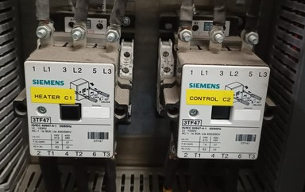

# MCB(miniature circuit breaker)

An MCB is an electrical switch that operates automatically. Miniature circuit breakers are designed to protect against over current damage to an electrical circuit.

* The **DRIVE_MCB** is connect to the VFD and **TRANS_MCB** is connect to transformer.

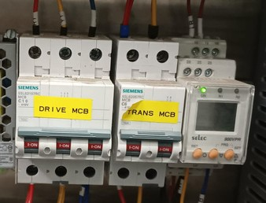

# Transformers

A transformer used to reduce the alternating voltage (3phase-Single phase)is step-down transformer. Step-down voltage (440V to 230 V).

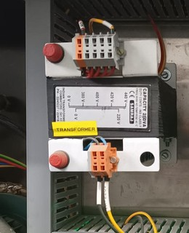

# SMPS(switch mode power supply)

# SMPS is used to reduce the Power supply (Single phase to 24V),because PCB board work in 24 V.

# A switched-mode power supply, sometimes known as a switch-mode power supply or 'SMPS', is an electronic power supply that integrates a switching regulator for efficient electrical power conversion. Like other supplies, an SMPS transfers power from a DC or AC source to DC loads while converting voltage and current.

# WhatsApp Image 2023-08-12 at 12.35.41 PM.jpeg

# VFD(Variable frequency drive)

# VFD is a type of motor controller whose work is to drive an electric motor by varying the frequency and also the voltage supplied to the electric motor.

# The working principle of the variable-frequency drive mainly depends upon the adjustable speeds and soft start or soft stop capabilities.

