**Heater_Logic**

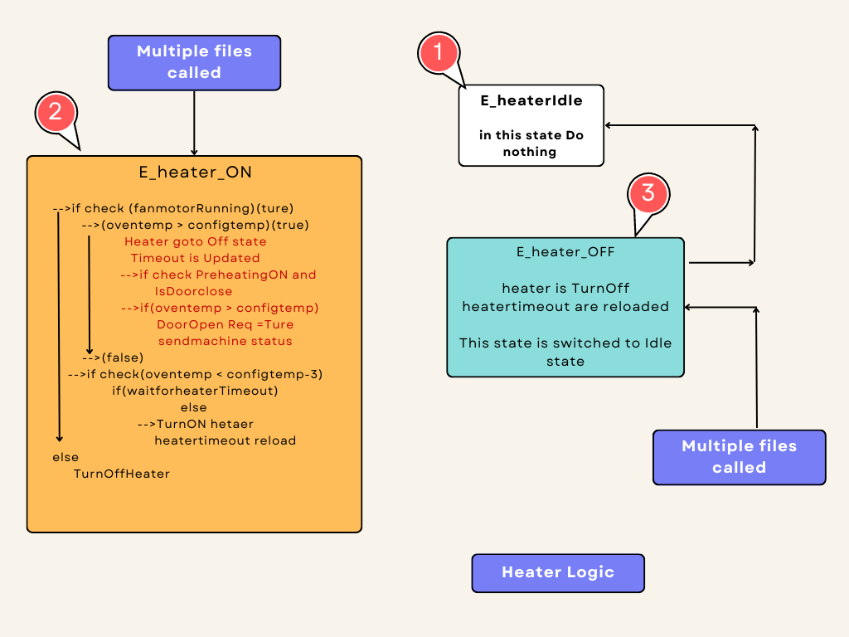

**Using Macros**

* **HEATER_VALIDATE_COUNTER**

🡪This macro is used for the Heater On/Off Time.

* **HEATER_ON_WAIT_TIMEOUT**

🡪This macro is used for HeaterOn waiting Time.

* **FAN_MOTOR_NOT_WORKING,**
* **HEATER_NOT_TURNING_OFF ,**
* **HEATER_NOT_WORKING**

🡪 These macros are used for Diagnostic Report.

**Using variables**

* **heaterControl**

🡪This varible is used to control the Machine states.

* **WaitForHeaterOn**

🡪 This variable is used for HeaterOn waiting Time. it's used to update by this macro HEATER_ON_WAIT_TIMEOUT

* **HeaterTurnOnTimeOutCounter**

🡪 This varible is used for On_Time of the heater.

* **HeaterTurnOffTimeOutCounter**

🡪 This varible is used for Off_Time of the heater.

* **configuredTemprature**

🡪 This variable is used to take values From the HMI Temp_Config value.

* **ovenTemprature**

🡪 This variable is used to take a value from OvenTemp using Max6675 in spi_sensor.

**Flow Of states**

* **Heater Idle**
* **Heater_ON**
* **Heater_OFF**

1. **Heater_Idle**

* In this state heater remains idle, and after that, we will switch to Heater_ON state.

1. **Heater_ON**

* First, will check some conditions, If it’s true go inside the block and turnOn heater and set the heater-on-off timer.
  + **Inside the Conditions**

**🡪 (IsHeaterTurnedOn())**

**🡪 (IsFanMotorRunning())**

**🡪(ovenTemprature > configuredTemprature)**

**🡪 (IsPreheating())**

**🡪(ovenTemprature < (configuredTemprature - 3))**

**Conditions Explanation**

**🡪 (IsHeaterTurnedOn())**

**🡪** This condition is to check whether the heater is ON, if It is True and further action is done. If it's false, this is directly sent to (IsHeaterTurnedOff()) and it is Heater Off and updated by the Timeout_values.

**🡪 (IsFanMotorRunning())**

**🡪** This condition is check finds whether the motor is running or not, after the motor is turned on, the Heater will turnOn.

🡪 Suppose if it's not true, Directly this goes to the heater_turned state.

**🡪 (ovenTemprature > configuredTemprature)**

**🡪**This condition is tells, If the oventemp is greater than the Configtemp the heater status is changed to a turnoff state and also set the heater-on-off timer. And the report send it.

🡪 **(IsPreheating())**

🡪 if this condition is checks that the preheating is enabled in Cooking Mode If it’s true, and the door is in the closed state, machineStatus_DORbit requests to open state.

**🡪**Suppose it's false it goto next block(else). Below the else block

**🡪(ovenTemprature < (configuredTemprature - 3))**

**🡪** This condition is checks for whether ovenTemp is low compared with CongfigTemp in HMI, if it's true, Get some seconds and after heater will be turned On. then Timeout_values are updated.

1. **Heater_OFF**

**🡪** In the state, it goes to turn off the heater, then the heaterTurnOnWaitTime_values are updated.

🡪And finally, this state is switching to the Idle state.