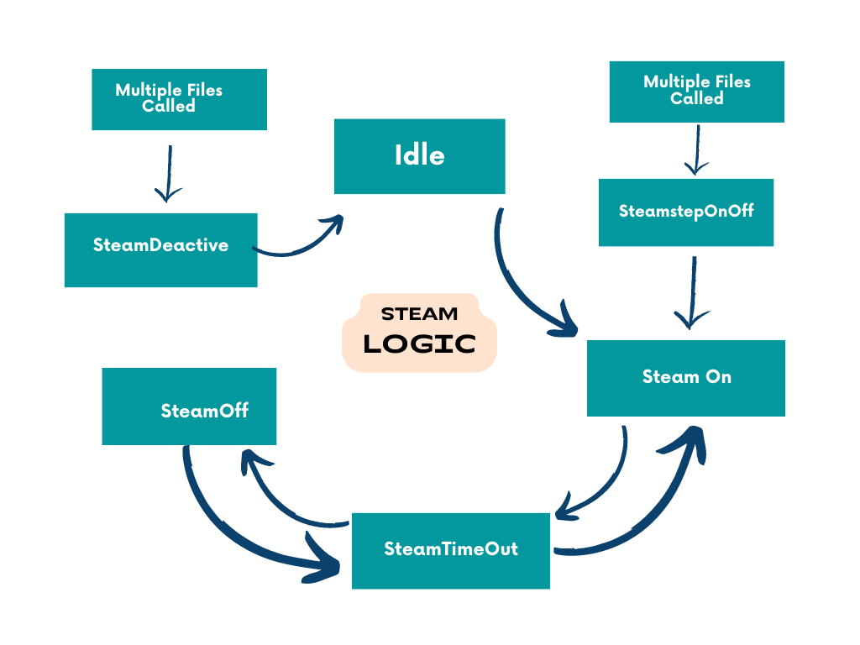**Steam Control Logic**

Flow of states

🡪Steam_Idle

🡪Steam_stepOn/Off / SteamOn

🡪SteamTimeout

🡪SteamOff

🡪SteamTimeout

🡪SteamOn

🡪SteamDeactive.

1. **Idle**
   * In this state, the steam remains Idle.
2. **SteamOn**

* In this state, the water inlet valve is turned on. The SteamLevelTimout is set to steamLevelOnTime, and the control_state is switched to E_steamTimeOut. The prevSteamControl is updated to E_steamOn.

1. **SteamTimeOut**

* This case handles a timeout mechanism. It decrements the SteamLevelTimout variable as long as it's greater than zero. When it reaches zero, it toggles the steamControl state between E_steamOn and E_steamOff based on the previous state stored in prevSteamControl.

1. **SteamOff**

* In this State, the water inlet valve is turned off, and the SteamLevelTimout is set to a value called steamLevelOffTime. The control_state is switched to E_steamTimeOut, and the prevSteamControl is updated to E_steamOff.

**SteamStepOnOff**

* In this state, First TurnOn steam that time water inlet valve is 30s(1 sec ON – 4 sec OFF)- to Switched steamOn/steamOff. because its used to overcome the rampUP.
* In this state, there is a sequence of steps to control a water inlet valve based on the values of onOffStepCount and cycleCount. Depending on the values of these variables, the water inlet valve is turned on or off, and these variables are updated accordingly. If cycleCount exceeds 50, the control_state is switched to E_steamOn, and a timeout value (SteamLevelTimout) is set to steamLevelOnTime.

**SteamDeactivate**

* In this case, the water inlet valve is turned off, and control states are reset. prevSteamControl and steamControl are set to E_steamIdle, and NoWaterReportCount is reset to zero. This state is switched to idle state.