**Door_Controlling Logic**

* Door Control logic is responsible for monitoring the status of a door (Like Opened or closed).
* This is used to Pause all processes in the cooking and Washing Mode, and also resume all processes in the Cooking and Washing Mode.

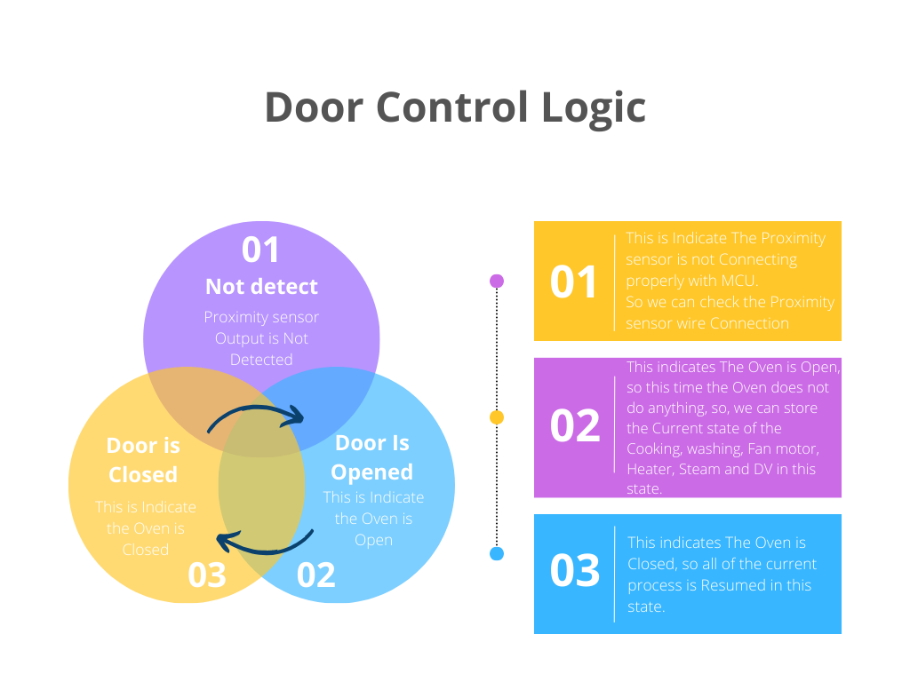

MACRO:

DOOR_STATUS_COUNTER 🡪 This counter is used to find the status of the Door (like Open or Close).

FALG:

Is_Door_ClosedFlag 🡪 This flag is used to manage the Oven Pause and resume.

ENUM_Variables:

prevFanMotorControl, prevDrainValveStatus, prevHeaterControl, prevStControl, prevDrainValveControlState, prevFanMotorRunningStatus 🡪 These Variables Store the Current state of the Oven and the stored values are updated corresponding variable when the door is closed.

**Door Status Check**

* (IS_DOOR_CLOSED() == TRUE) This condition checks whether the door is closed. It appears to be a function call that returns TRUE if the door is closed, and it is FALSE, if it's open.
* DoorStatusCounter is decremented if it's greater than zero, and if it reaches zero, Is_Door_ClosedFlag is set to TRUE, indicating that the door is closed. If it's not zero, the flag remains FALSE, it’s indicating that the door is opened.

**Door Status Actions**

* If Is_Door_ClosedFlag is TRUE, it means the door is closed. In this state, doorStatus is set to E_doorClosed.
* MachineStatus->DOI is set to FALSE, which seems to be an indication that the door is closed.
* A series of checks and actions related to the machine's state and components are performed, including checking the OpenRequest flag and restoring previous states of components if ovenPauseControl is TRUE.

**If the Door Is Open**

* If Is_Door_ClosedFlag is FALSE, it means the door is open. In this state doorStatus is set to E_doorOpen.
* MachineStatus->DOI is set to TRUE, indicating that the door is open.
* A check for OpenRequest is performed, and if it's FALSE and the ovenPauseControl is FALSE, it calls the doorPauseControl function.
* Pause all processes in the cooking and washing mode.
* Note:- Open request Flag is used heater logic file to handle the preheating method

**doorPauseControl Function**

* This function appears to handle the pausing of the cooking process when the door is open and certain conditions are met.
* It stores the current states of various machine components into variables, likely to later restore them.
* It updates MachineStatus->MachineStaus to MS_cookingPaused.
* It performs actions to stop or close certain machine components, such as drain valves, fans, heaters, and water inlet valves.
* It sends the machine status, possibly for monitoring or reporting purposes.

**Door is Closed Actions**

* After that Door is Closed, All of the Process is resumed in the current State of the Heater, Motor, Cooking, and Steam.
* The Machine Status is Furtherly changes to The cooking Process or Washing Process mode.