Assignment 1  
Muhammad Azfar Bin Nadeem  
Section C | 459000  
  
Q1) Write a C++ program to display factors of a number using for loops.  
Code  
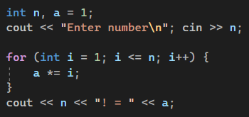  
  
Output  
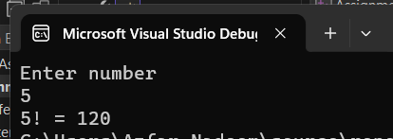  
  
  
  
  
  
Q2) Write output to the following code  
Code  
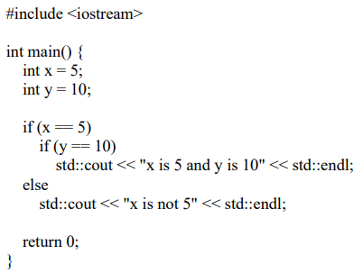  
Output  
x is 5 and y is 10  
  
  
  
  
  
  
  
  
  
Q3) Write a C++ program, take an integer value from user and check if it’s greater than 10 and less than equal to 20. Print 1 if yes and print 0 if no. Use appropriate datatype for output.  
Code  
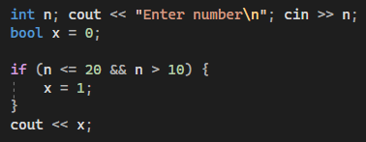  
Output

Q4) Write a C++ program that uses a while loop to find the largest prime number less than a given positive integer N. Your program should take the value of N as

input from the user and then find the largest prime number less than or equal to

N. You are not allowed to use any library or pre-existing functions to check for prime numbers.  
Code  
Output

Q5) Write a C++ program, take two strings as input from user and check if both strings are equal or not. If they are equal, make them unequal by rotating string. e.g., Hello is turned into olleH etc.  
Code  
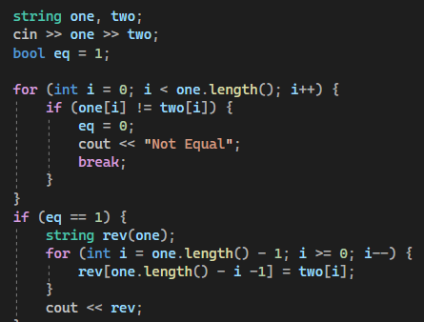  
Output  
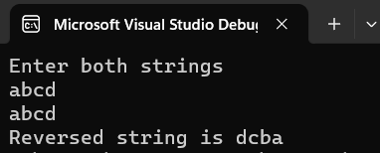

Q6) Perform division in C++ without / using for loops. You can use / only to display the results. Your dividend must be greater than divisor.  
Code  
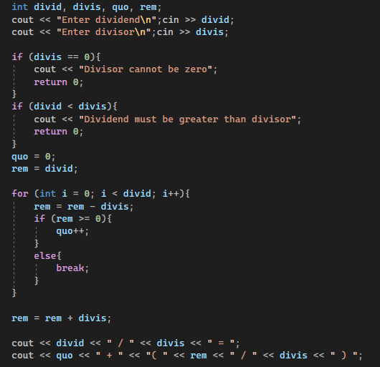  
Output

Q7) Write a C++program for a string which may contain lowercase and uppercase characters. The task is to remove all duplicate characters from the string and find the resultant string.  
Code  
Output

Q8) Suppose an integer array a[5] = {1,2,3,4,5}. Add more elements to it and display them in C++.  
Code  
Output

Q9) Given an integer array and an integer X. Find if there’s a triplet in the array which sums up to the given integer X.  
Code  
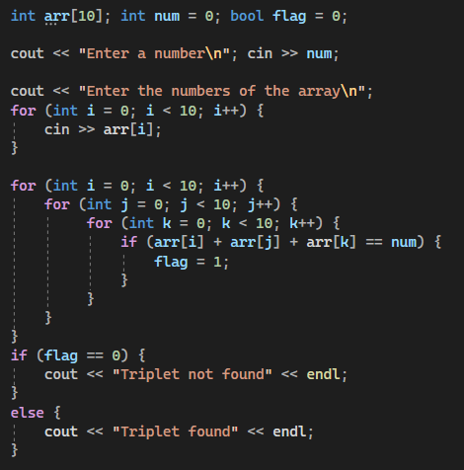  
Output

Q10) Implement Bubble Sort on an array of 6 integers.  
Code  
  
Output  
