Home Task Lab Manual 1  
Muhammad Azfar Bin Nadeem  
Section C | 459000  
  
Q1) Write a C++ program to calculate distance between two points.   
Code   
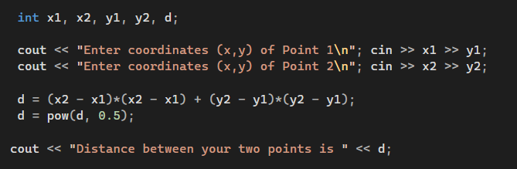  
Output

Q2) Write a code in C++ to take length from user in centimeter and convert it into meter and kilometer.  
Code  
Output

Q3) Write a code in C++ that takes values of a and b from the user and displays result of polynomial 𝑎2 + 2𝑎𝑏 + 𝑏2.  
Code   
Output

Q4) Write a program in C++ to convert temperature in Fahrenheit to Celsius.  
Code   
Output  
