Home Task Lab Manual 2  
Muhammad Azfar Bin Nadeem  
Section C | 459000  
  
Q1) Create a program that takes a student's score as input and assigns a grade based on predefined criteria using logical operators (e.g., A, B, C, D, F). A-Grade: 90-100 Marks, B-Grade: 75-90 Marks, C-Grade: 60-75 Marks, D-Grade: 45-60 Marks, F-Grade: 0-45 Marks  
Code  
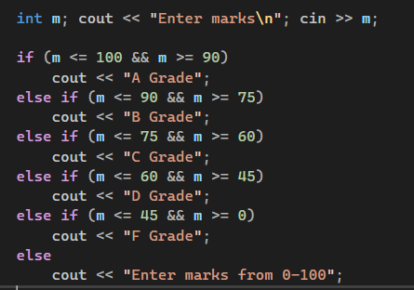  
Output

Q2) Write a program that takes an integer as input and determines if it is both even and divisible by 5.  
  
Code  
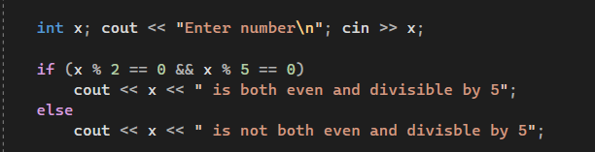  
  
Output

Q3) Create a C++ program that checks if a user-provided year is a leap year.  
Code  
  
Output

Q4) Create a C++ program that determines if a student is eligible for a scholarship based on their GPA (must have GPA >= 3.5) and attendance (must have attended at least 80% of classes).  
  
Code  
  
Output

Q5) Write a program that checks if a given character is a vowel (a, e, i, o, u) or a consonant using logical operators.  
  
Code  
  
Output

