Home Task Lab Manual 8  
Muhammad Azfar Bin Nadeem  
Section C | 459000  
  
Q1) Take an array and find the most repeated element in that array.  
Code  
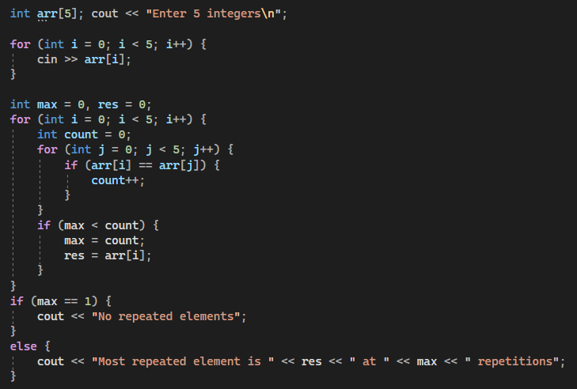  
Output

Q2) Let’s say an array is a [8] = {13, 15, 17, 9, 99, 77, 65, 43}. Find largest and

smallest element.  
Code   
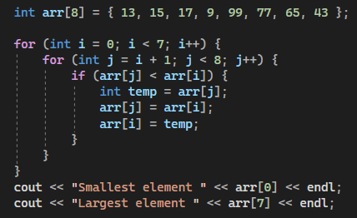  
  
Output  
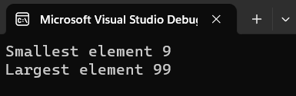  
  
  
  
  
  
  
Q3) Develop a program that takes 5 array elements from user. Swap position [2]

element with position [4] element.  
Code  
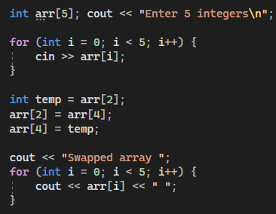  
  
Output  
