Lab Task Lab Manual 8  
Muhammad Azfar Bin Nadeem  
Section C | 459000  
  
Q1) Write a C++ program to calculate average of numbers of array.  
Code  
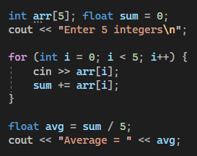  
  
Output

Q2) Implement Bubble sort on an array of 5 integers.  
Code  
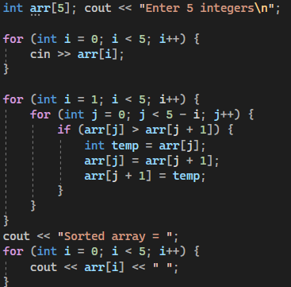  
  
Output  
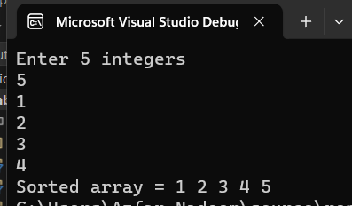

Q3) Implement Selection Sort on an array of 5 integers.  
Code  
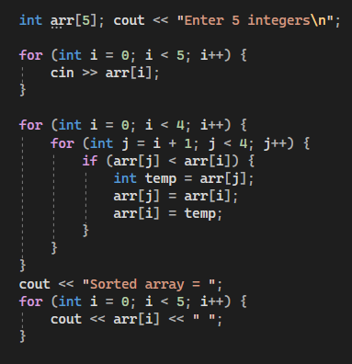  
  
Output  
