Home Task Lab Manual 9  
Muhammad Azfar Bin Nadeem  
Section C | 459000  
  
Q1) Write program take inverse of a 3x3 matrix using its determinant and adjoint.  
Code  
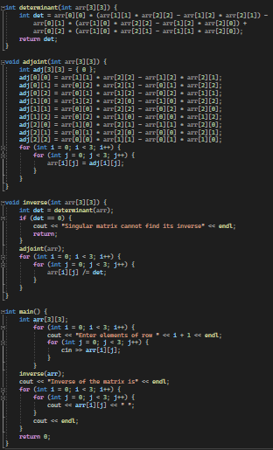  
Output  
