Lab Task Lab Manual 9  
Muhammad Azfar Bin Nadeem  
Section C | 459000  
  
Q1) Make 2D Array and print left diagonal and right diagonal sum of a 3x3 matrix.  
Code  
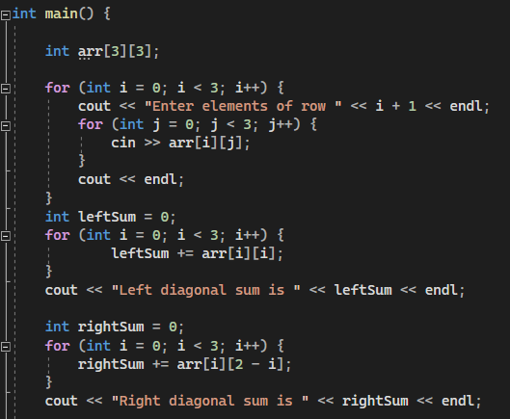  
Output

Q2) Write a function to add two 2D arrays of size 3x3.  
Code  
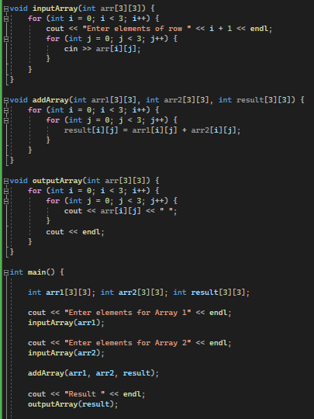  
Output  
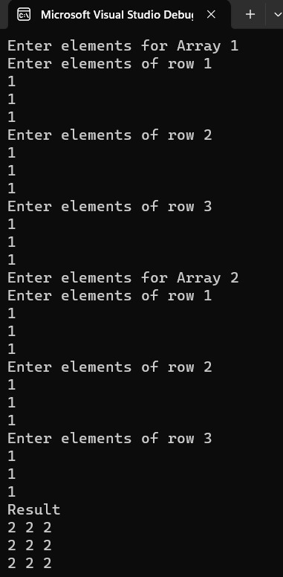

Q3) Using 2D arrays to take transpose of a 3x3 matrix. Make a transpose function.  
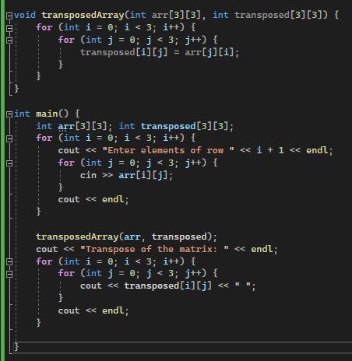  
Output

Q4) Using 2D arrays to implement 3x3 matrix multiplication. Make a function.

Code  
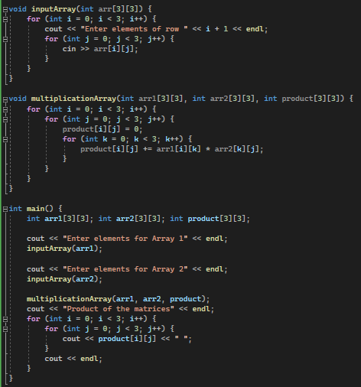  
Output

Q5) Print the multiplication table of 15 using recursion.  
Code  
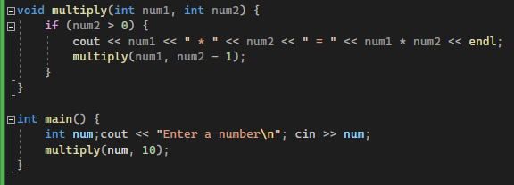  
Output  
