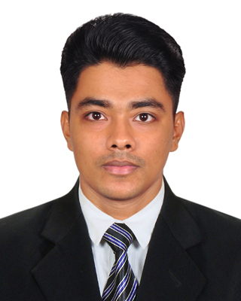

**Azgar Hossen**

2011 - 2012

2013 - 2014

2018

**EDUCATIONAL**

CURICULUM VITAE

**CARRIER OBJECTIVE**

To utilize my knowledge in practical field to increase my efficiency and effectiveness for building my future career.

**CONTACT**

391-mail4.png067-phone.png001-home.png032-book.png016-camera.png018-music.png

Result: CGPA- 3.00 out of 5.00

B.Sc. in Computer Science and Engineering

Result: CGPA- 3.75 out of 5.00

Higher Secondary Certificate

**Principal Kazi Faruki College**

Result: CGPA- 3.10 out of 4.00

Secondary School Certificate

**Munshir Hat S. M. High School**

**Eastern University**

shawonah3@yahoo.com

41/18/1, Hazi Afsar Uddin Lane, Jigatola Dhanmondi, Dhaka.

01625419722

Reading

Music

Photography

**HOBBIES**

* Participated in the Training on **“** [**Digital Content Management**](https://www.facebook.com/groups/438432750331876/?ref=group_header)**”** organized by Bangladesh Hi-Tech Park Authority (BHTPA).

# .

* Participated in the Training on **“Software Testing”** organized by LICT.
* Participated in the Training on **“Web Development”** organized by PeopleNTech Institute of Information Technology, Dhaka.
* Achieve scholarship in class five.

**SCHOLASTIC ACHIEVEMENTS**

**EXTRA-CURRICULAR ACTIVITIES**

* Member of EU cricket team.
* Member of EU Prothom alo bondhu shova.
* Member of EU Engineering club.
* Member of EU Computer club.

Wordpass

|  |  |
| --- | --- |
| HTML CSS |  |
| PHP |  |
| Python |  |
| Java script |  |
| C++ |  |
|  |  |

**SKILL**

* Python
* C++
* HTML5
* CSS
* PHP
* Java script

**Programming Languages Skill**

* Network Security
* Green cloud computing

<https://azgarhossen.github.io/Project_1/>

https://azgarhossen.github.io/Project/

<https://azgarhossen.github.io/newone/>

* Green cloud computing

**Major Thesis Paper**

**TRAINING**

**PROJECT**

https://azgarhossen.github.io/Caseworker_Trade/

**Research Interest**



**PERSONAL INFORMATION**

**LANGUAGE PROFICIENCY**

* **Programming Tool:** Code-Blocks**,**

PyCharm,

Notepad++,

Sublime Text

* **Java Programming :** Net Beans
* **Application Development : Eclipse**
* **Software Testing :** Pycharm,

Katalon,

Selenium IDE

* **Operating System :** Windows **,**

Linux

**Programming Proficiency**

**Azgar Hossen**

|  |  |  |
| --- | --- | --- |
| **Father’s Name** | : | Joynal Abedin |
| **Mother’s Name** | : | Maharun Nessa |
| **Date of Birth** | : | 7-11-1995 |
| **Nationality** | : | Bangladeshi |
| **Home Town** | : | Lakshmipur |
| **Marital Status** | : | Single |
| **Religion** | : | Islam |

|  |  |  |  |  |
| --- | --- | --- | --- | --- |
| Language | Reading | Writing | Speaking | Listening |
| Bangla | Excellent | Excellent | Excellent | Excellent |
| English | Excellent | Good | Good | Good |