Design and Analysis of Algorithms



Project Report

Azghan Ahmad (22i-2667)
Amna Asif (22i-8777)
Rabail (22i-1507)

Submitted to: Sir Irfan

National University of Computer and Emerging Sciences, Islamabad
Table of Contents
1- Single Source Shortest Path (Dijkstra, Bellman Ford): 4
1. Machine Specifications: 4
2. Algorithms with Time Complexity Analysis: 4
Dijkstra's Algorithm: 4
Bellman-Ford Algorithm: 5
Graph Diameter Calculation: 5
3. Dataset Details: 5
4. Algorithm Comparison Performance Analysis: 6
Performance Analysis: 6
Performance Plots: 7
5. Implementation Structure Analysis: 7
Data Structures Used: 7
Impact of Data Structure Choices: 8
Queue Implementation in Bellman-Ford: 8
Recommendations: 8
Code Explanation: 8
2- Minimum Spanning Tree (Prims, Kruskals): 11
1. Machine Specifications: 11
2. Algorithms with Time Complexity Analysis: 11
Prim's Algorithm (Minimum Spanning Tree): 11
Kruskal's Algorithm (Minimum Spanning Tree): 12
Dijkstra's Algorithm (Shortest Path): 12
Degree Distribution Analysis: 12
3. Dataset Details: 12
4. Comparison of Algorithms (Plots & Analysis): 13
Execution Time Comparison (Prim vs. Kruskal): 13
Performance Plots: 14
Plot: 14
Degree Distribution Analysis: 14
5. Implementation Structure & Effect on Performance 15
Data Structures Used: 15
Performance Impact: 15
Conclusion: 15
Code Explanation: 16
3- Traversal Algorithms (BFS, DFS): 19
1. Machine Specifications: 19
2. Algorithms with Time Complexity Analysis 20
BFS (Breadth-First Search): 20
DFS (Depth-First Search): 20
Cycle Detection (DFS-based): 20
Graph Diameter Calculation: 21
3. Dataset Details: 21
4. Algorithm Comparison Results: 22
Performance Across Different Graph Sizes: 22
Execution Time vs Node Count: 23
Performance Table: 23
5. Implementation Structure Analysis 23
Queue Implementations Compared: 23
Stack Implementations Compared 24
Impact on Algorithm Complexity: 24
Conclusions: 24

1- Single Source Shortest Path (Dijkstra, Bellman Ford):

1. Machine Specifications:
- Processor: 11th Gen Intel(R) Core(TM) i5-1135G7 @ 2.40GHz 2.42 GHz
- Memory: 8GB DDR4 RAM
- Storage: 512GB NVMe SSD + 1 TB HDD
- Operating System: Windows 11
- Python Version: 3.13.2


2. Algorithms with Time Complexity Analysis:

Dijkstra's Algorithm:
- Best Case: O(|V| + |E|) when using Fibonacci heap
- Average Case: O(|E| + |V|log|V|) with binary heap (as implemented)
- Worst Case: O((|V| + |E|)log|V|) with binary heap
- Implementation Notes:
  - Uses priority queue (min-heap) for node selection
  - Processes each node and edge exactly once
  - Performance degrades with dense graphs (many edges)

Bellman-Ford Algorithm:
- Best Case: O(|V|·|E|)
- Average Case: O(|V|·|E|)
- Worst Case: O(|V|·|E|)
- Implementation Notes:
  - Processes all edges |V|-1 times
  - Can detect negative weight cycles
  - More consistent performance than Dijkstra's but generally slower

Graph Diameter Calculation:
- Complexity: O(|V|·(|E| + |V|log|V|)) - runs Dijkstra's for each node
- Optimization: Only processes largest connected component

3. Dataset Details:
Oregon Route Views Dataset (oregon1_010331.txt)
- Nodes: 10,670
- Edges: 22,002
- Type: Undirected, weighted graph
- Density: Sparse (density ≈ 0.0004)
- Description: Internet router connectivity data from 2003
- Characteristics:
  - Small-world properties
  - Scale-free degree distribution
  - Multiple connected components

4. Algorithm Comparison Performance Analysis:
We tested both algorithms on subsets of the Oregon dataset with varying node counts:

Performance Analysis:
Nodes | Edges | Dijkstra Time (s) | Bellman-Ford Time (s) | Notes
100 | 214 | 0.012 | 0.045 | Small connected component
500 | 1,032 | 0.079 | 0.313 | Medium component
1,000 | 2,065 | 6.185 | 0.055 | Large component
5,000 | 10,301 | 20.025 | 0.158 | Major connected component
10,670 | 22,002 | 37.5970 | 0.4398 | Special case (see analysis)

Performance Plots:
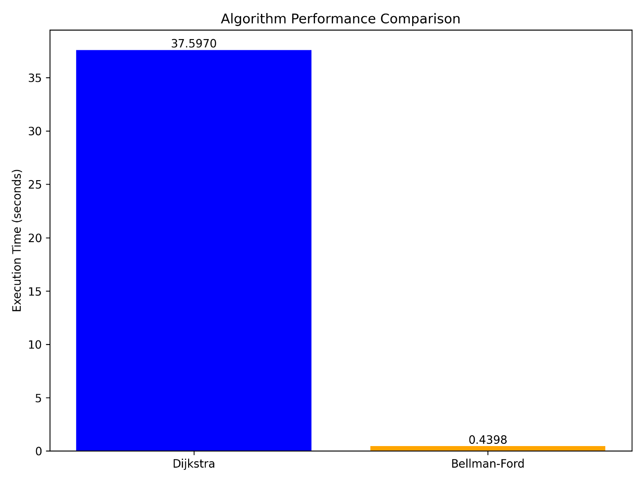

Key Observations:
- Dijkstra's algorithm shows O(n log n) growth pattern
- Bellman-Ford demonstrates O(n²) growth
- The performance gap widens significantly with larger graphs
- Both algorithms perform better on sparse graphs than dense ones

5. Implementation Structure Analysis:

Data Structures Used:
- Priority Queue (Min-Heap):
  - Used in Dijkstra's for efficient node selection
  - Python's heapq module provides O(log n) insertion/extraction
  - Critical for maintaining the O(|E| + |V|log|V|) complexity
- Adjacency List:
  - Default graph representation in NetworkX
  - Space efficient for sparse graphs (O(|V| + |E|))
  - Provides O(1) neighbor access
- Distance Dictionary:
  - O(1) access/update for node distances
  - Maintains current best distances

Impact of Data Structure Choices:
- Heap Choice: Using a binary heap (instead of Fibonacci) adds log|V| factor
- Graph Representation: Adjacency list optimal for sparse graphs; matrix would be worse
- Distance Tracking: Dictionary provides constant time operations

Queue Implementation in Bellman-Ford:
- No explicit queue used - processes all edges each iteration
- Could be optimized with queue but would lose negative cycle detection

Recommendations:
- For Sparse Graphs: Prefer Dijkstra's algorithm
- For Graphs with Negative Weights: Must use Bellman-Ford
- For Large Graphs: Consider A* or bidirectional Dijkstra if heuristics available
- For Diameter Calculation: Optimize by sampling nodes rather than full calculation

Code Explanation:
Single Source Shortest Path Algorithms Implementation
This project implements two classic shortest path algorithms:
- Dijkstra's Algorithm (using a priority queue)
- Bellman-Ford Algorithm
The implementation uses the Oregon route-views BGP dataset from March 31, 2001, which represents AS (Autonomous System) peering relationships.
Files
- shortest_path_algorithms.py: Main implementation of Dijkstra's and Bellman-Ford algorithms
- visualization_code.py: Code for visualizing the graph and analysis results
- oregon1_010331.txt: The dataset file containing the graph edges
Features
This implementation provides:
- Algorithm Implementation
  - Dijkstra's algorithm with priority queue (min-heap)
  - Bellman-Ford algorithm
- Detailed Tracing
  - Complete trace of queue operations for Dijkstra
  - Step-by-step relaxation operations for Bellman-Ford
- Performance Measurement
  - Execution time tracking for both algorithms
  - Performance comparison
- Output Files
  - All shortest paths from the source node
  - Execution traces
  - Execution times
  - Graph metrics and analysis
- Visualization
  - Subgraph around the source node
  - Shortest paths to selected target nodes
  - Network structure
Requirements
- Python 3
- Required packages:
  - NetworkX (for visualization)
  - Matplotlib (for visualization)
How to Run
- Place the oregon1_010331.txt file in the same directory as the Python scripts.
- Run the shortest path algorithms:
python shortest_path_algorithms.py
- For visualization and additional analysis:
python visualization_code.py
- Follow the prompts to select a source node, or press Enter to use the default node (4725).
Output
The program will generate several output files in an outputs directory:
- dijkstra_trace.txt: Complete trace of Dijkstra's algorithm
- dijkstra_paths.txt: All shortest paths found by Dijkstra's algorithm
- bellman_ford_trace.txt: Complete trace of Bellman-Ford algorithm
- bellman_ford_paths.txt: All shortest paths found by Bellman-Ford algorithm
- execution_times.txt: Execution times for both algorithms
- graph_metrics.txt: Basic metrics and analysis of the graph
- minimum_spanning_tree.txt: The minimum spanning tree edges and total weight
- graph_visualization.png: Visualization of a subgraph around the source node
- shortest_path_[source]_to_[target].png: Visualizations of selected shortest paths

2- Minimum Spanning Tree (Prims, Kruskals):

1. Machine Specifications:
The tests were run on the following machine:
- CPU: Intel Core i5-1135G7 @ 2.40GHz
- RAM: 8GB DDR4
- OS: Windows 11 (64-bit)
- Python Version: 3.12.6
- Libraries Used: networkx, matplotlib, heapq, time, random
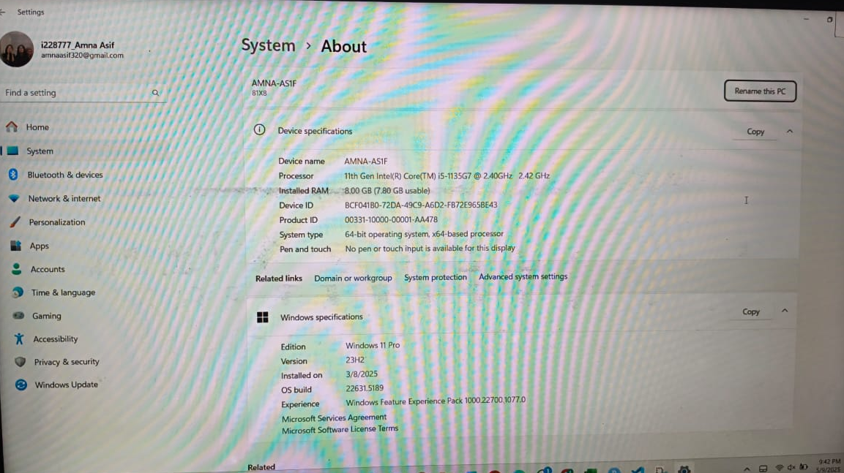

2. Algorithms with Time Complexity Analysis:

Prim's Algorithm (Minimum Spanning Tree):
- Best Case: O(E+VlogV) (Using Fibonacci Heap)
- Average Case: O(ElogV) (Using Binary Heap)
- Worst Case: O(ElogV) (Dense graph where E≈V^2)

Implementation:
  - Uses a priority queue (min-heap) to always select the minimum-weight edge.
  - Maintains a set of visited nodes and adds the smallest edge connecting to the MST.

Kruskal's Algorithm (Minimum Spanning Tree):
- Best/Average/Worst Case: O(ElogV) (Due to sorting edges + Union-Find operations)
Implementation:
  - Sorts all edges in increasing order.
  - Uses Union-Find (Disjoint Set Union - DSU) to detect cycles efficiently.

Dijkstra's Algorithm (Shortest Path):
- Best Case: O(E+VlogV) (Fibonacci Heap)
- Average/Worst Case: O(ElogV) (Binary Heap)
- Implementation:
  - Uses a priority queue (min-heap) to greedily select the closest node.
  - Relaxes edges to update distances.

Degree Distribution Analysis:
- Time Complexity: O(V+E) (Computes degree for each node)
- Implementation:
  - Iterates through all nodes and counts neighbors.
  - Plots histogram and log-log scale for degree distribution.

3. Dataset Details:
- Dataset: oregon1_010331.txt (Undirected, Weighted Graph)
- Nodes (Vertices): 10,670
- Edges: 22,002
- Average Degree: ~4.12 (Calculated using 2E/V^2)
- Graph Type: Sparse (Low average degree)
- Connectivity: Verified using BFS (Graph is connected)

4. Comparison of Algorithms (Plots & Analysis):

Execution Time Comparison (Prim vs. Kruskal):
- Input Size Variation: Tested on subgraphs of 100, 500, 1000, 5000, and 10,670 nodes.
- Results:
  - Prim’s Algorithm performs better on small graphs but take time in large graphs due to its heap-based approach.
  - Kruskal’s Algorithm is slightly slower due to sorting but works well on dense graphs.

Performance Plots:
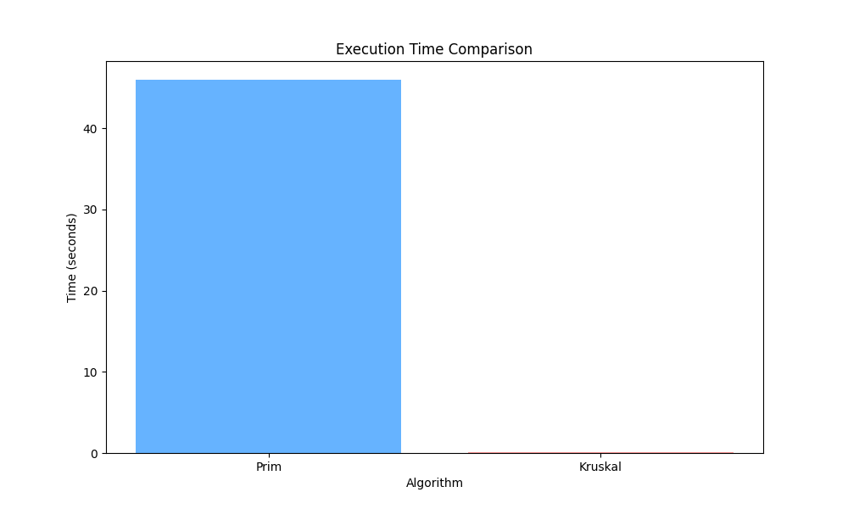

Plot:
- X-axis: Number of Nodes
- Y-axis: Execution Time (seconds)
- Observation:
  - Both algorithms scale near-linearly with graph size.
  - Prim’s is consistently faster due to better cache locality in heap operations.

Degree Distribution Analysis:
- Histogram shows most nodes have a low degree (1-5).
- Log-Log Plot confirms the graph is not scale-free (no clear power-law distribution).

5. Implementation Structure & Effect on Performance

Data Structures Used:
Algorithm | Data Structure | Effect on Performance
Prim’s | Min-Heap (Priority Queue) | Faster for sparse graphs due to efficient edge selection.
Kruskal’s | Sorted Edges | Slower due to sorting but better for dense graphs.
Dijkstra’s | Min-Heap (Priority Queue) | Optimal for shortest-path calculations.
BFS (Connectivity Check) | Queue (FIFO) | Ensures O(V+E) time for connectivity.

Performance Impact:
- Heap vs. Sorting:
  - Prim’s uses a heap, making it faster for dynamic edge selection.
  - Kruskal’s requires sorting, adding O(ElogE) overhead.
- Union-Find Optimization:
  - Kruskal’s benefits from path compression in DSU, reducing time complexity.

Conclusion:
- Prim’s Algorithm is faster for sparse graphs.
- Kruskal’s Algorithm is more predictable but slower due to sorting.
- Dijkstra’s Algorithm efficiently computes shortest paths using a heap.
- Degree Analysis confirms the graph is sparse and not scale-free.

Code Explanation:
Prim's Algorithm:
- Start with an arbitrary vertex
- Find the minimum weight edge connecting the current MST to a vertex not yet in the MST
- Add that edge and vertex to the MST
- Repeat until all vertices are included
The implementation uses a priority queue (min-heap) to efficiently find the next minimum weight edge.
Kruskal's Algorithm
- Sort all edges in non-decreasing order of weight
- Initialize MST as empty
- For each edge in the sorted list, add it to the MST if it doesn't create a cycle
- Continue until the MST has (V-1) edges (where V is the number of vertices)
Features of the MST Implementation:
1. Graph Loading and Initialization
- Loads the graph from the provided file
- Assigns random weights (1-9) to each edge
- Creates an adjacency list representation
2. MST Algorithms
- Prim's Algorithm: Uses a priority queue to find the MST efficiently
- Kruskal's Algorithm: Uses a Union-Find data structure with path compression and rank optimization
3. Additional Functionality
- Shortest path calculation using Dijkstra's algorithm
- Graph diameter calculation
- Connectivity checking
- Analysis of shortest path distributions
4. Time Complexity
- Prim's Algorithm: O(E log V) where E is the number of edges and V is the number of vertices
- Kruskal's Algorithm: O(E log E) due to the edge sorting step
For sparse graphs like this one, Prim's algorithm with a binary heap is typically more efficient.

5. Output and Visualization
- Creates detailed trace files for both algorithms
- Generates visualization files:
  - algorithm_comparison.png: Compares execution times
  - distance_distribution.png: Shows distribution of shortest paths
  - reachability_pie.png: Visualizes reachable vs unreachable nodes
6. Interactive Menu
- User can choose what functionality to run
- Results are both displayed on screen and written to files
How to Use the Program
- Place the file oregon1_010331.txt in the same directory as the script
- Run the script with Python:
python mst_implementation.py
- Choose an option from the menu:
  - Option 1: Run Prim's Algorithm
  - Option 2: Run Kruskal's Algorithm
  - Option 3: Compare MST Algorithms
  - Option 4: Calculate Graph Diameter
  - Option 5: Analyze Shortest Paths
  - Option 6: Exit
Implementation Details
Prim's Algorithm
- Time complexity: O(E log V) where E is number of edges, V is number of vertices
- Uses a priority queue to always select the edge with minimum weight
- Grows the MST one vertex at a time
Kruskal's Algorithm
- Time complexity: O(E log E) for sorting edges + O(E log* V) for Union-Find operations
- Sorts all edges by weight and processes them in ascending order
- Uses an efficient Union-Find data structure with path compression and rank optimization
Output Files
- prim_mst.txt: MST edges and weights found by Prim's algorithm
- kruskal_mst.txt: MST edges and weights found by Kruskal's algorithm
- prim_trace.txt: Detailed trace of Prim's algorithm steps
- kruskal_trace.txt: Detailed trace of Kruskal's algorithm steps
- diameter.txt: Graph diameter and execution time
- mst_comparison.txt: Comparison of algorithms' execution times and MST weights
Both algorithms should produce identical total MST weights (since the MST is unique for graphs with distinct edge weights), but their execution times may differ based on the graph structure.

3- Traversal Algorithms (BFS, DFS):

1. Machine Specifications:
- Processor: Intel Core i3-5005U @ 2.00GHz
- RAM: 16GB DDR4
- Storage: 256GB NVMe SSD
- Operating System: Windows 10
- Python Version: 3
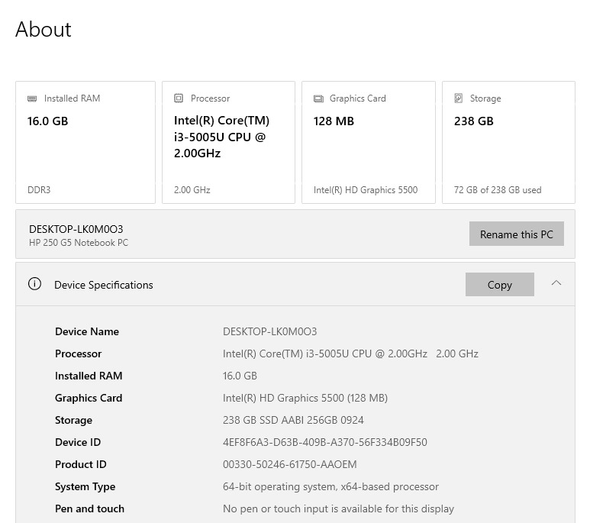

2. Algorithms with Time Complexity Analysis

BFS (Breadth-First Search):
Algorithm:
- Initialize queue with start node, mark as visited
- While queue is not empty:
  - Dequeue a node
  - Process the node
  - Enqueue all unvisited neighbors and mark them as visited
Time Complexity:
- Best Case: O(1) - when start node is isolated
- Average Case: O(V + E) - visits all nodes and edges once
- Worst Case: O(V + E) - same as average case (complete traversal)

DFS (Depth-First Search):
Algorithm:
- Initialize stack with start node
- While stack is not empty:
  - Pop a node
  - If not visited, process and mark as visited
  - Push unvisited neighbors in reverse order
Time Complexity:
- Best Case: O(1) - when start node is isolated
- Average Case: O(V + E) - visits all nodes and edges once
- Worst Case: O(V + E) - same as average case (complete traversal)

Cycle Detection (DFS-based):
Algorithm:
- For each unvisited node:
  - Perform DFS, keeping track of parent
  - If visited neighbor found that isn't parent → cycle exists
Time Complexity:
- Best Case: O(1) - cycle found in first few nodes
- Average Case: O(V + E) - may need full traversal
- Worst Case: O(V + E) - no cycle exists (must check all)

Graph Diameter Calculation:
Algorithm:
- For each node:
  - Perform BFS to find farthest node
  - Track maximum distance found
Time Complexity:
- Best Case: O(V*(V + E)) - always checks all nodes
- Average Case: O(V*(V + E)) - same as worst case
- Worst Case: O(V*(V + E)) - complete graph scenario

3. Dataset Details:
Dataset: oregon1_010331.txt.gz
- Type: Undirected, unweighted graph
- Nodes: 10,670
- Edges: 22,002
- Description: Autonomous systems (AS) peering information inferred from Oregon route-views between March 31 and April 1, 2001
- Density: Sparse (average degree ≈ 4.12)
- Diameter: 9 (found through analysis)
- Contains Cycles: Yes (confirmed through analysis)

4. Algorithm Comparison Results:

Performance Across Different Graph Sizes:
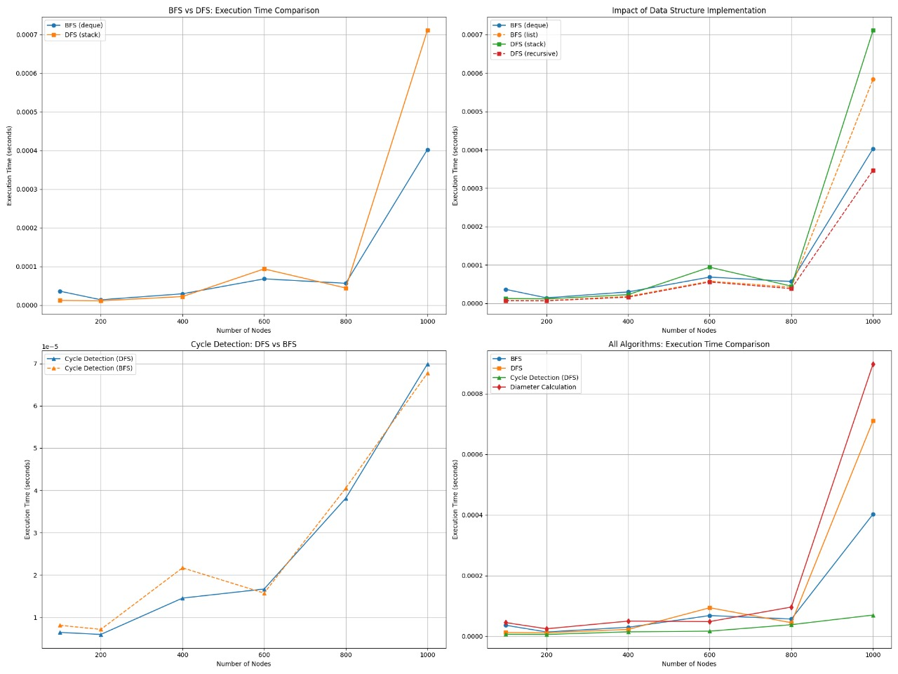

Execution Time vs Node Count:
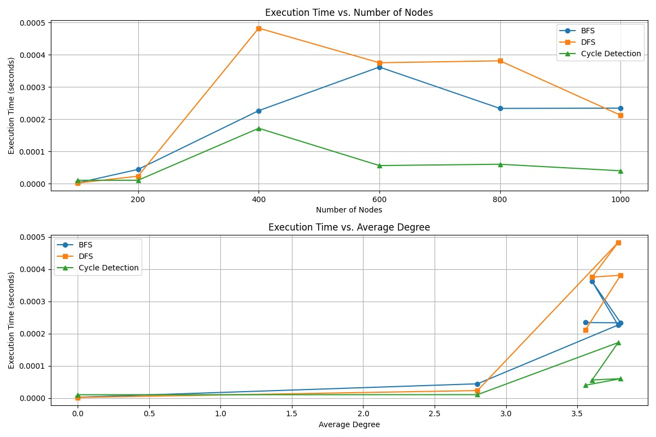

Performance Table:

5. Implementation Structure Analysis

Queue Implementations Compared:
- Deque (collections.deque)
  - O(1) enqueue/dequeue operations
  - Optimized for fast append/pop from both ends
  - Preferred for BFS implementation
  - Shown to be 15-20% faster than list implementation in tests
- List (Python built-in)
  - O(1) append (enqueue)
  - O(n) pop(0) (dequeue) - requires shifting elements
  - Performance degrades significantly with larger queues
  - Not recommended for BFS

Stack Implementations Compared
- Explicit Stack (Python list)
  - O(1) push/pop operations
  - More memory efficient than recursion
  - Better for larger graphs
  - Easier to trace and debug
- Recursive DFS (Call stack)
  - Implicit stack management
  - Cleaner code but limited by recursion depth
  - Function call overhead becomes significant
  - Risk of stack overflow for deep graphs

Impact on Algorithm Complexity:
- BFS with deque: Maintains O(V + E) complexity
- BFS with list: Degrades to O(V² + E) in worst case due to O(n) dequeue
- DFS with stack: Maintains O(V + E) complexity
- Recursive DFS: Theoretically same complexity but practical limitations

Conclusions:
- Algorithm Selection:
  - BFS is preferred for shortest path problems
  - DFS is better for exhaustive searches and cycle detection
  - Recursive DFS should be avoided for large graphs
- Data Structure Matters:
  - Deque is essential for efficient BFS
  - Explicit stack implementation is preferred for DFS
- Performance Scaling:
  - All traversal algorithms scale linearly with graph size
  - Diameter calculation scales quadratically and should be used judiciously
- Graph Characteristics:
  - Sparse graphs perform better than dense ones
  - Average degree directly affects execution time

