# Case Study Assignment: Deploying a Spring Boot Project using AWS Elastic Beanstalk

-------------------------SERVICE ROLE IN IAM --------------------------------------------------

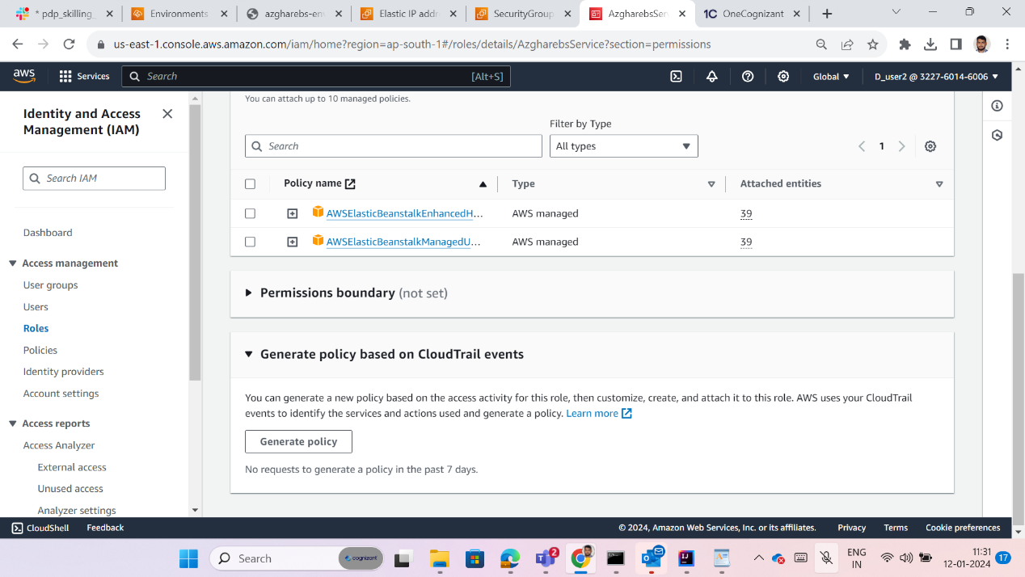

-------------------------------------Instance role IAM-------------------------------------------------

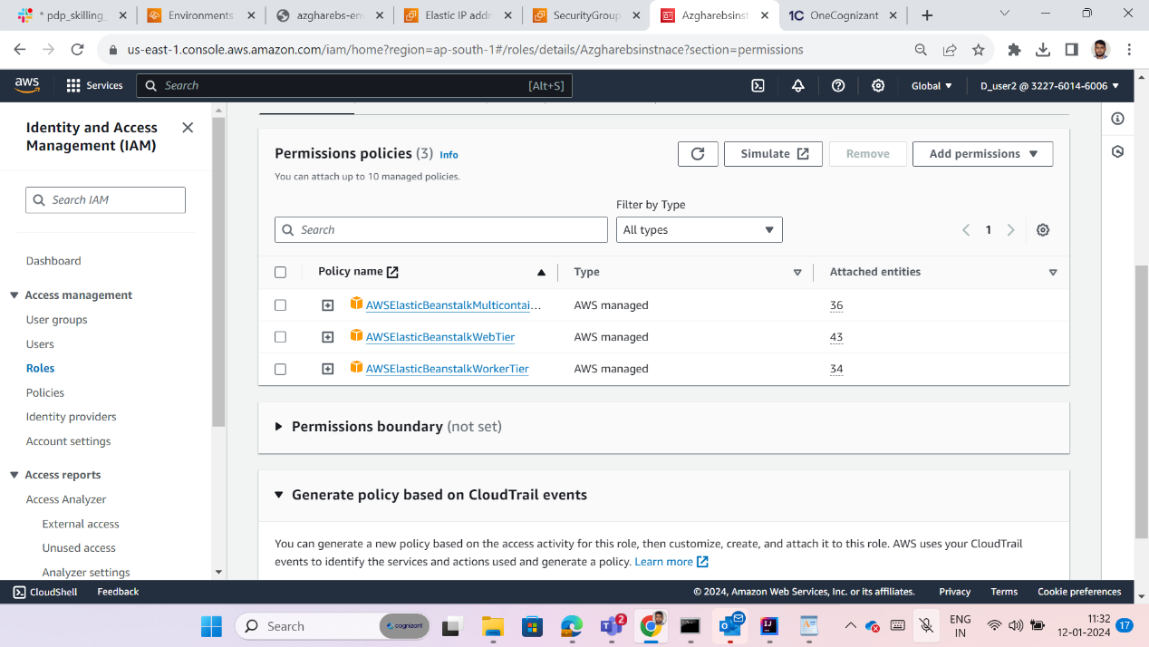

---------------------------------EBS Creation------------------------------------------------------



