# Case Study Assignment: S3 Bucket Implementation for E-commerce Platform

Step 1: Create a static Html page index.html and image folder.

Step 2: Login in to your AWS account with right credentials .

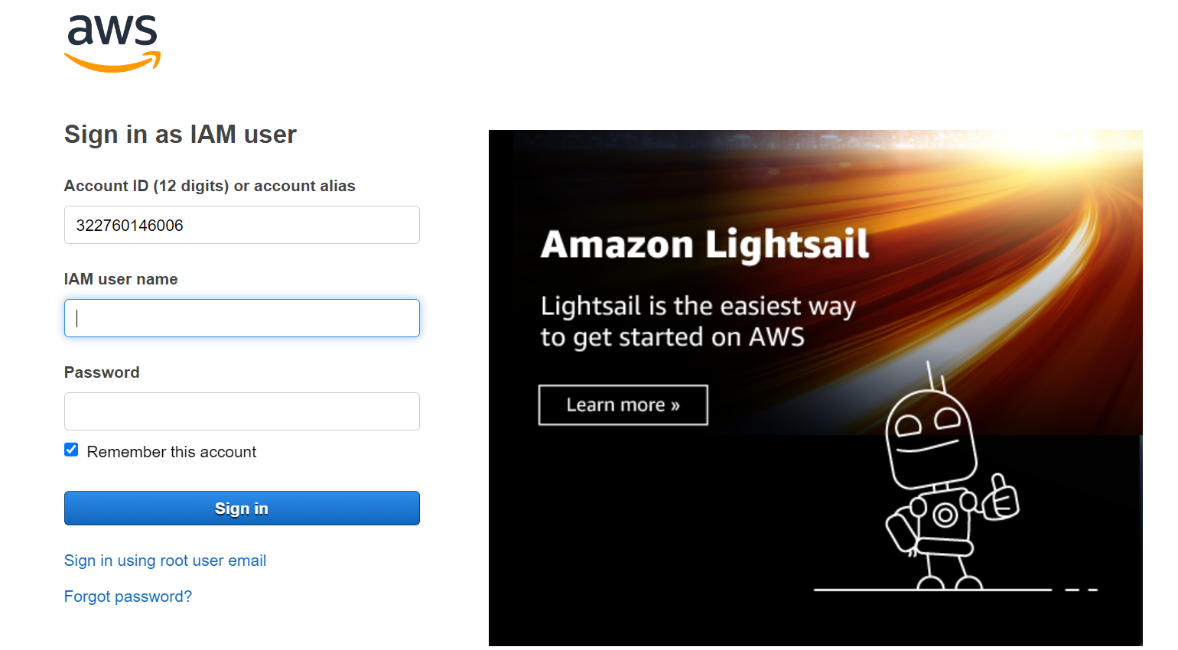

Step:3 you will see home page as below

Step 4: In search go for S3 bucket you will see as below image select the s3 bucket.

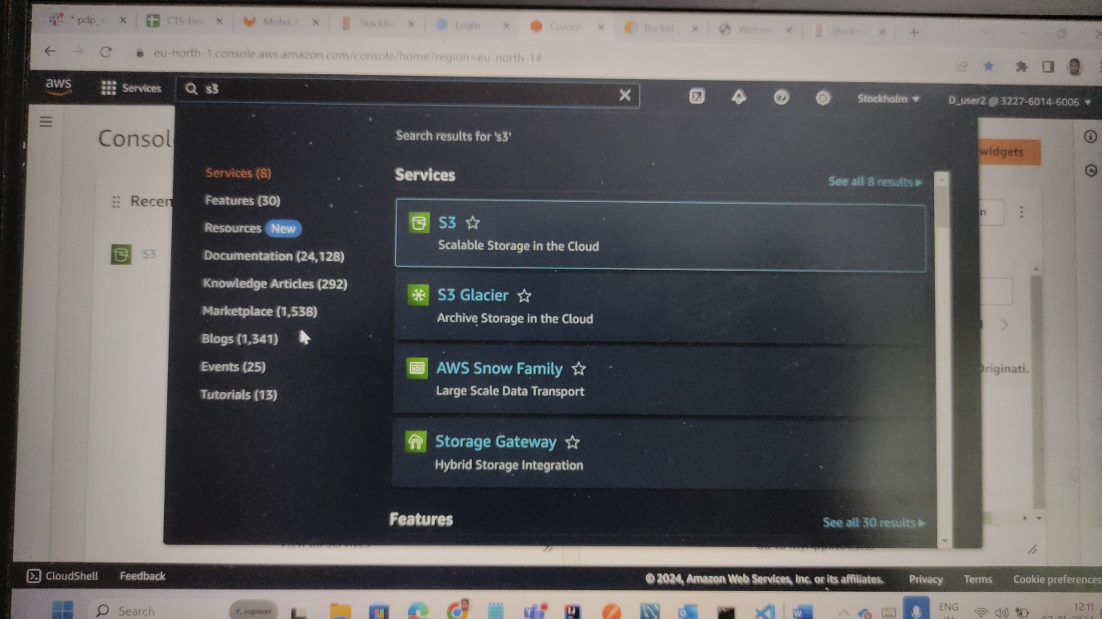

Step 5: after selecting the s3 bucket . you will be directed to page where we can see all buckets that were created by us. Click on create bucket option.

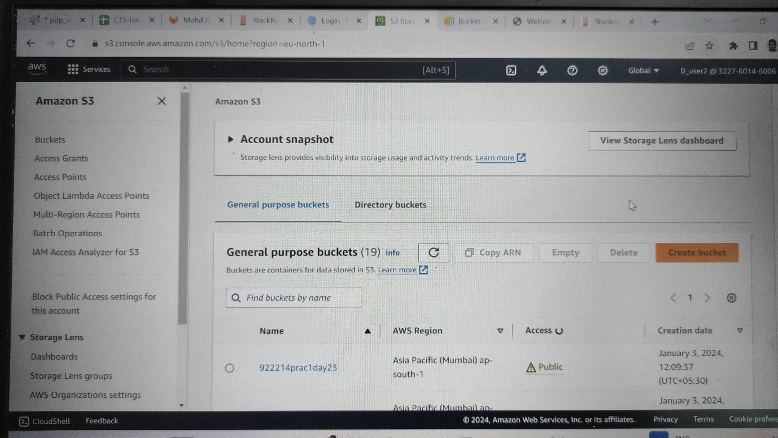

Step6: after clicking you wll get a page as below . provide uniquie name in bucket name . uncheck the security box .



Stpe7: keep all other options as it is and click on create bucket option at last as shown in below.

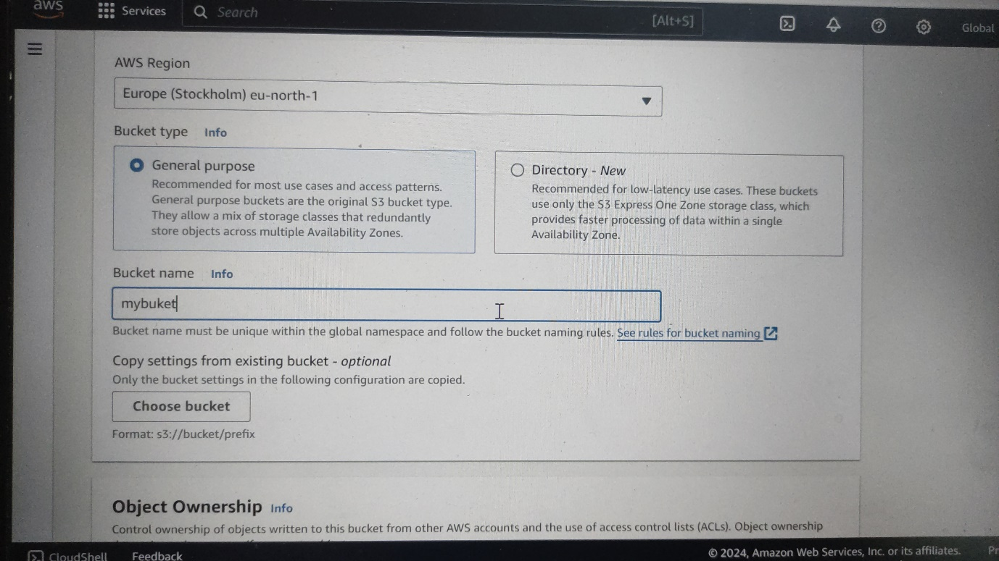

Step8: you will be redirected to buckets page in s3 . select your bucket name and open it .

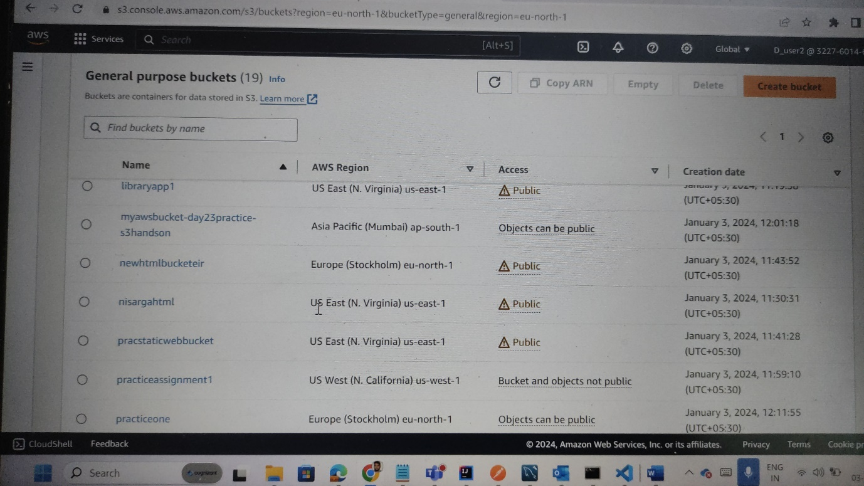

Step9: after selecting the bucket name . In object option . there is Upload option . where we can upload files and folders .after selecting and uploading required files and folders. In our case we have index.html and images folder . after uploading we can see all our files as below image.

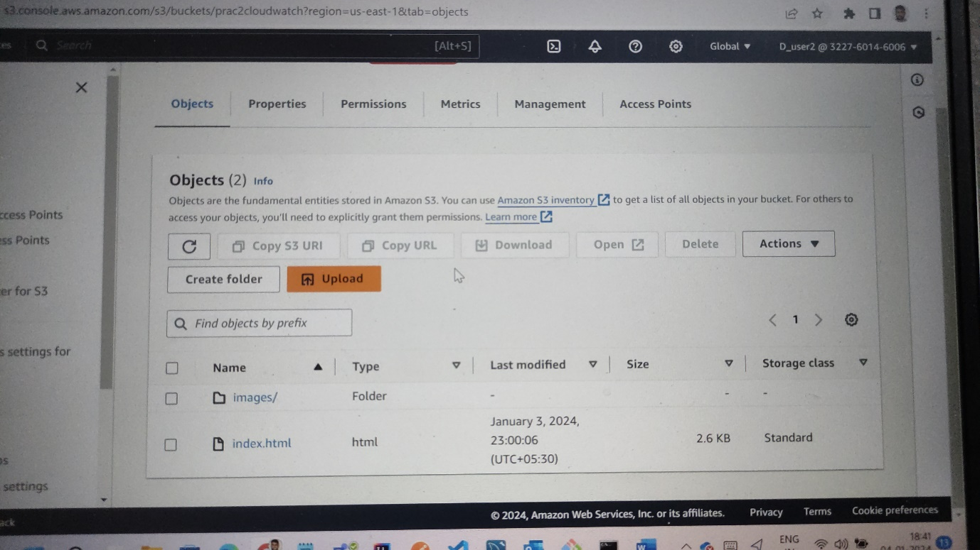

Step10:Go to the properties option and click on that . if you scroll down to bottom . you can find static web hosting as shown in the image below. Firstly it will be in disable option click on and enable it .

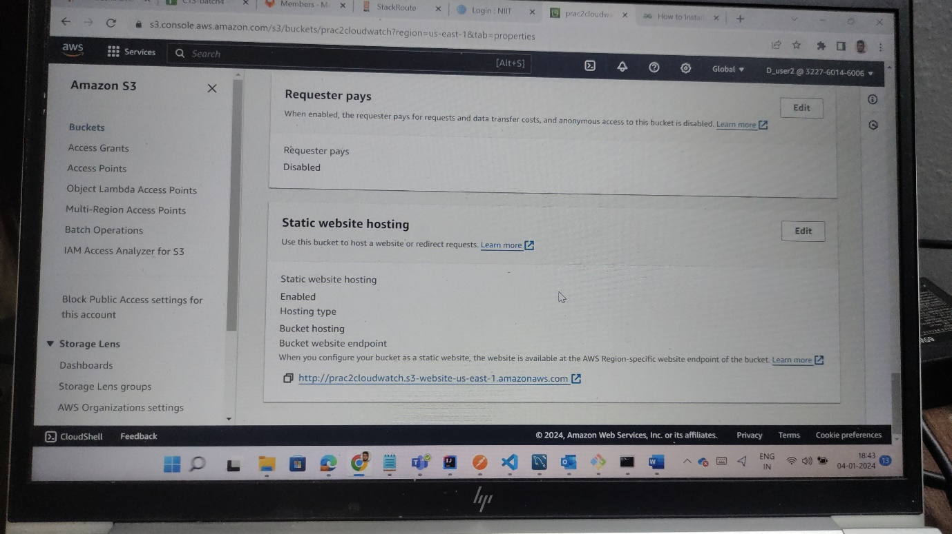

Step11: copy the url paste it in any browser . we can see as below image . it shows as not secure .

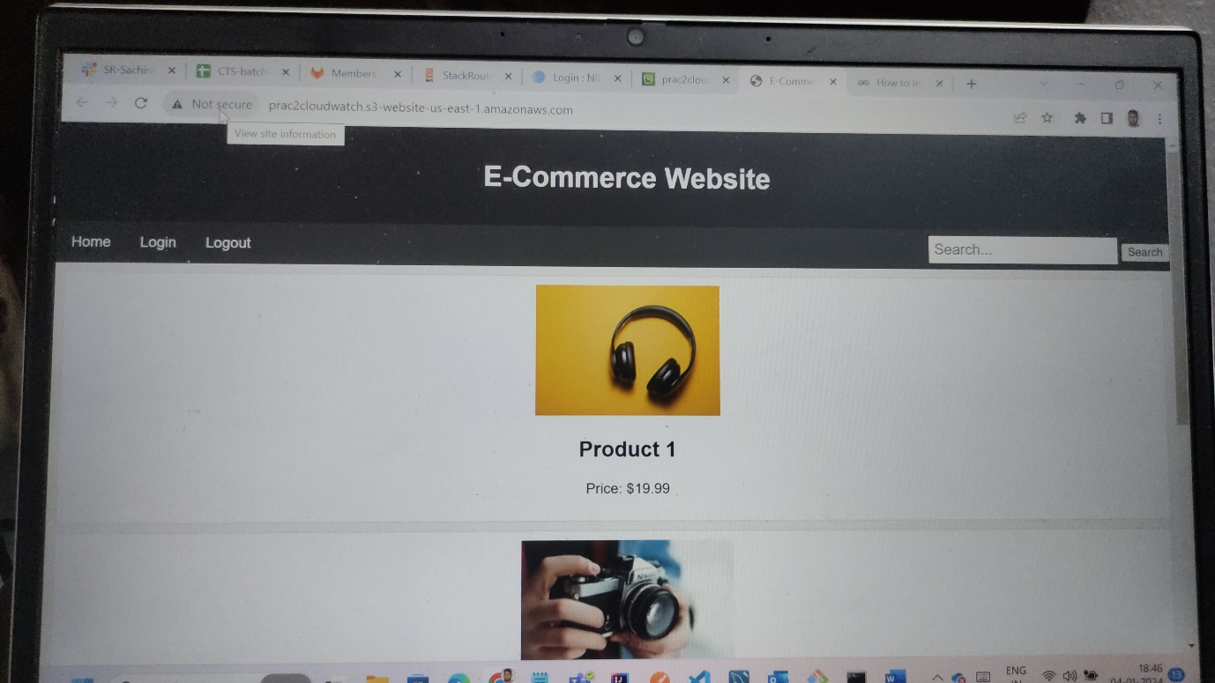

Step12:to make the above page secure and use it as domain name . we use cloudfront technology in the AWS cloud that generated domain name links in secure format . go to the console and type cloud front you can see as image below.

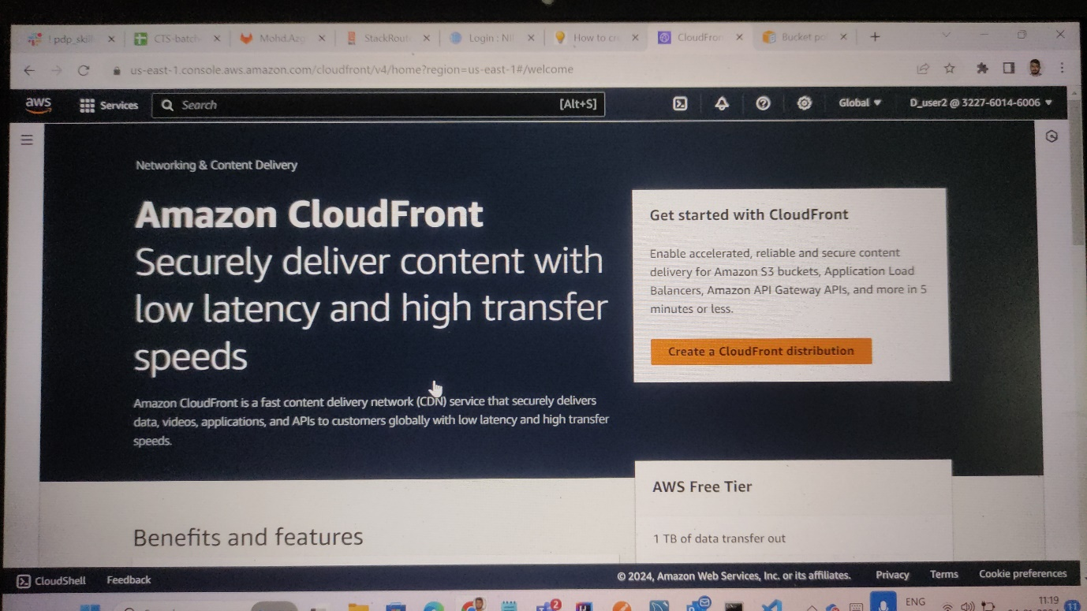

Step13: click on the create a cloud front distribution . the page will be opened as below image. Choose our origin name that we added in s3 bucket .

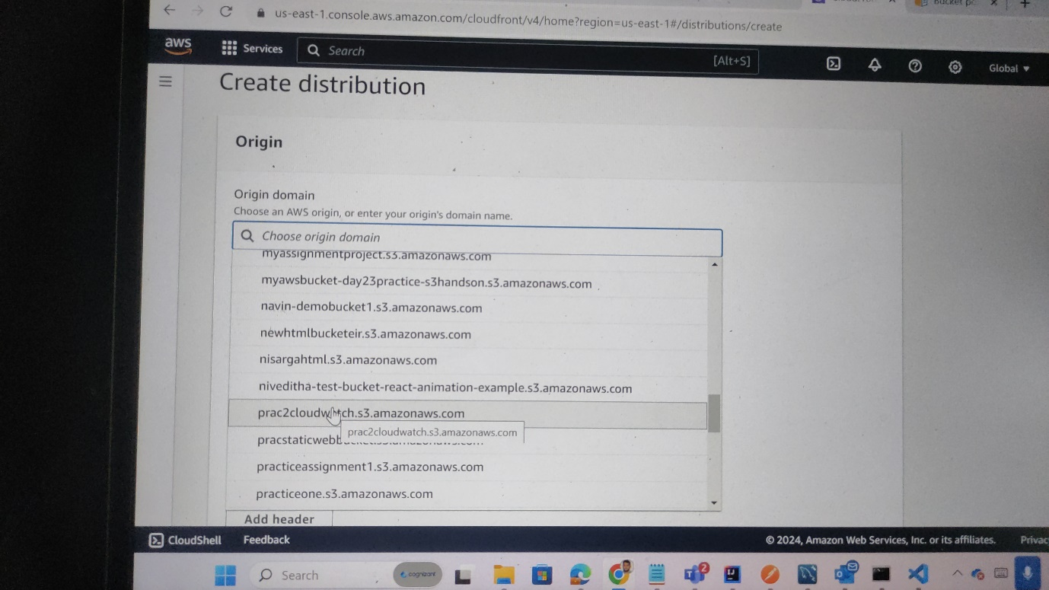

Step14:after selecting and scroll down we have option to enable security . we should check the box as shown below,

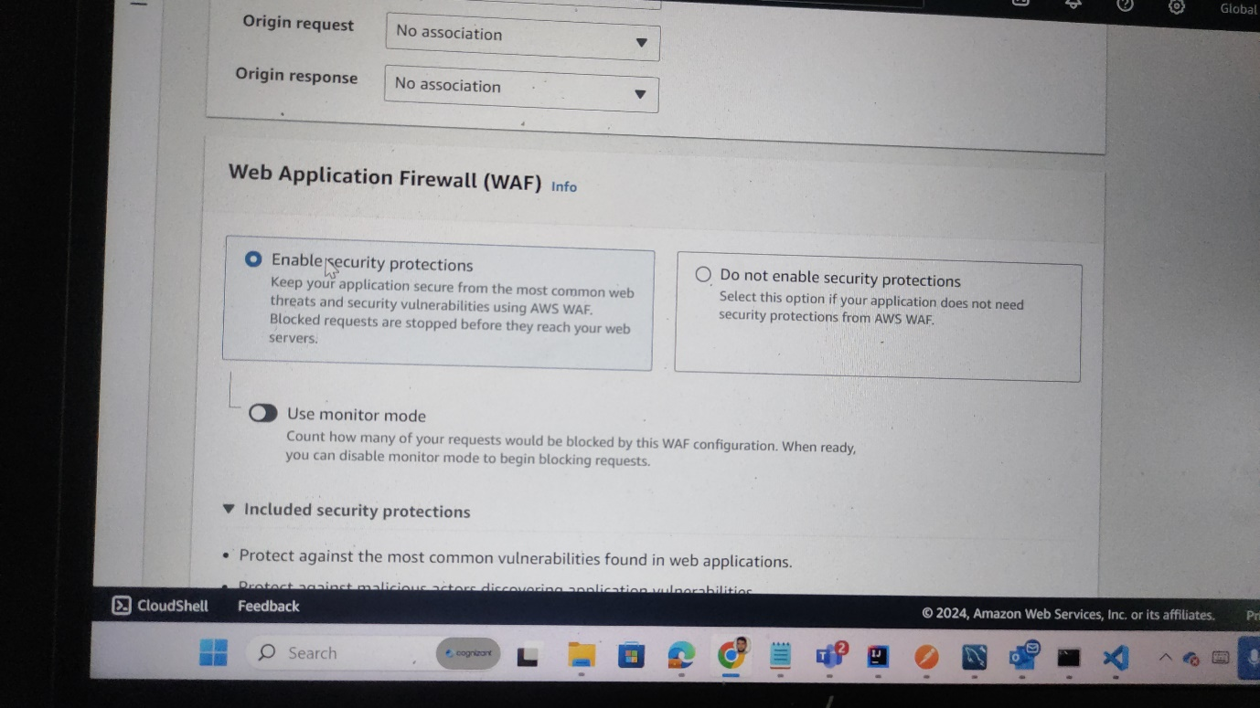

Step15:again scroll down you will find to enter default root object as show below . in that provide index.html and click on create distribution.

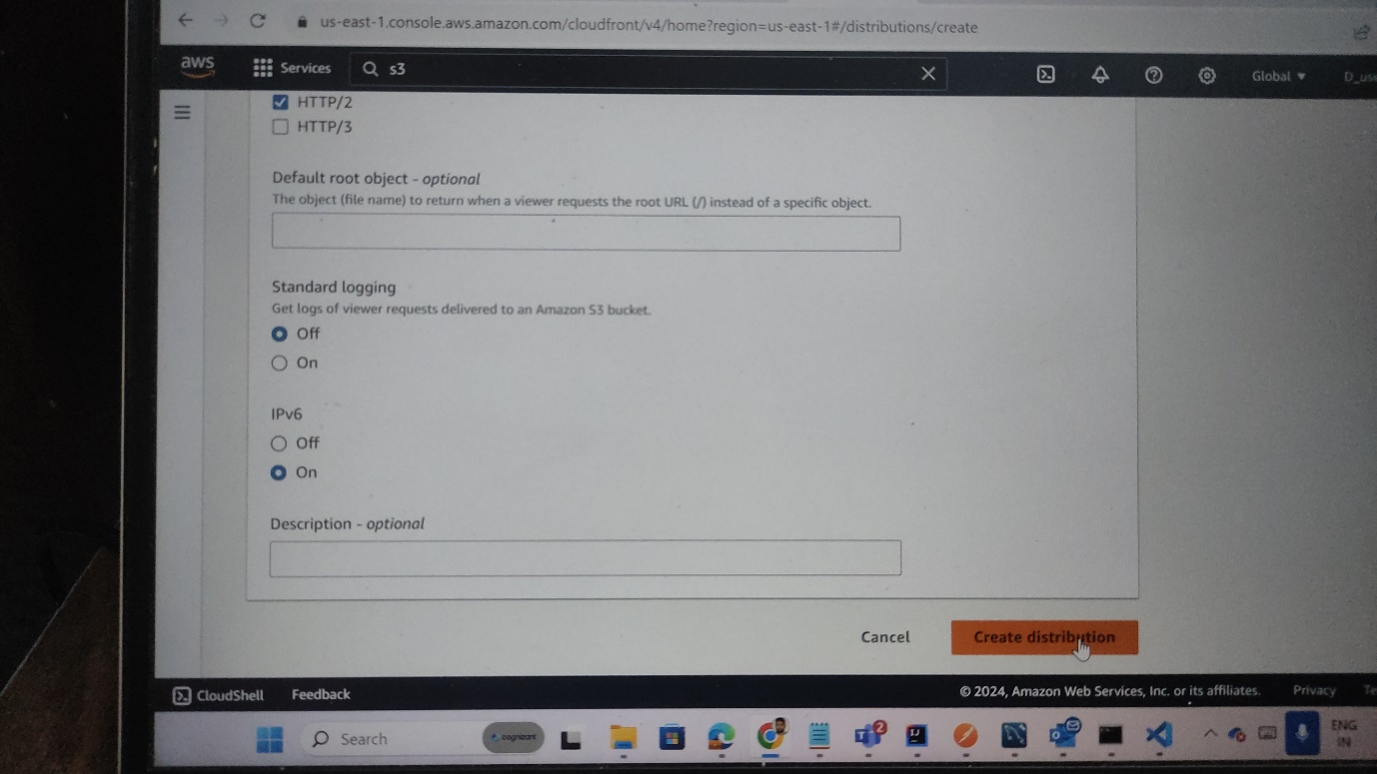

Step16:after creating you can see your window as below image .select your created distribution

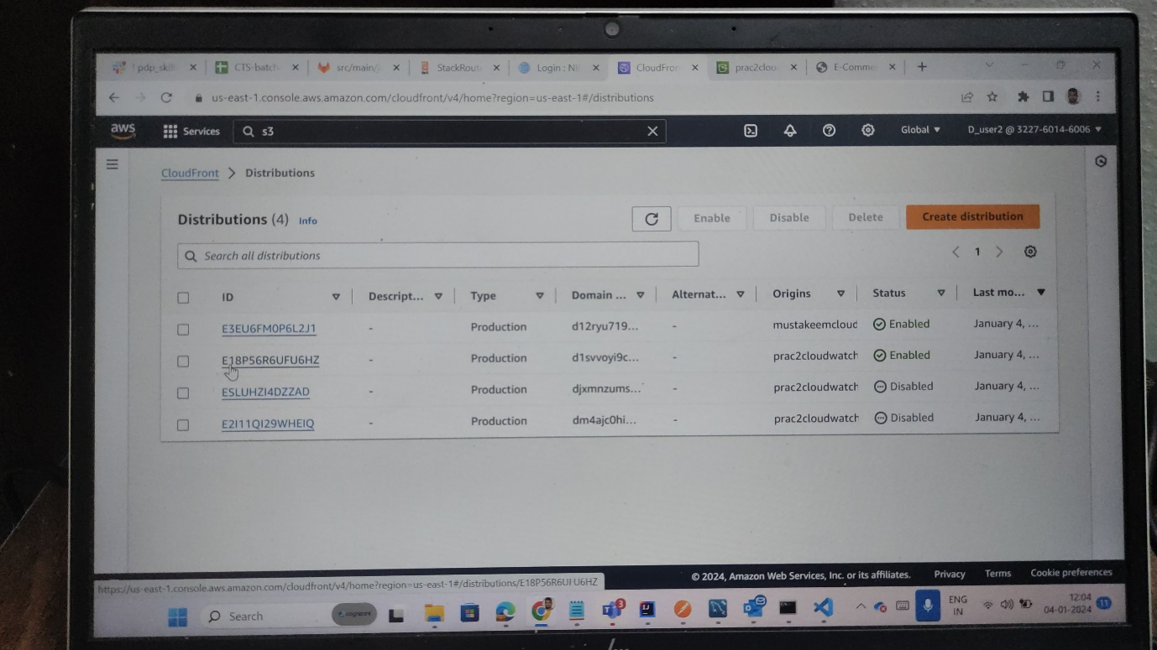

Step17: copy the domain name as shown In below image.



Step18:paste that in any browser you will a secure website and changed domain name. as shown below.

