# Case Study Assignment on AWS: Building a Static Website with S3

Step 1: Create a static Html page index.html, contact.html and about.html.

Step 2: Login in to your AWS account with right credentials .

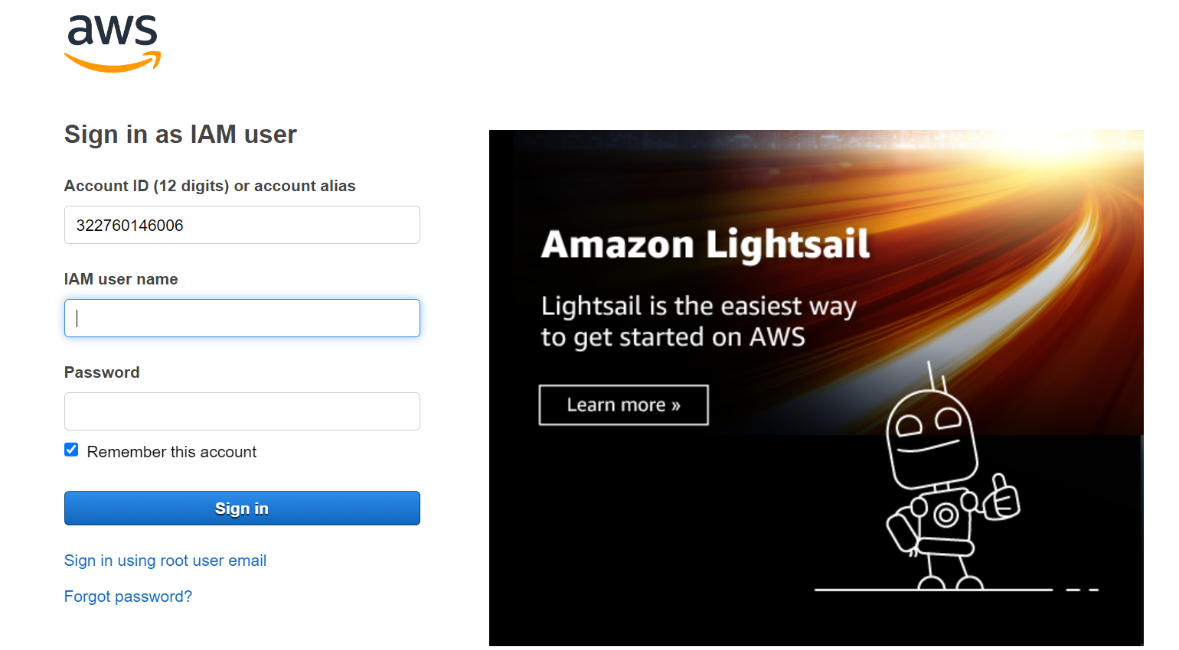

Step:3 you will see home page as below

Step 4: In search go for S3 bucket you will see as below image select the s3 bucket.

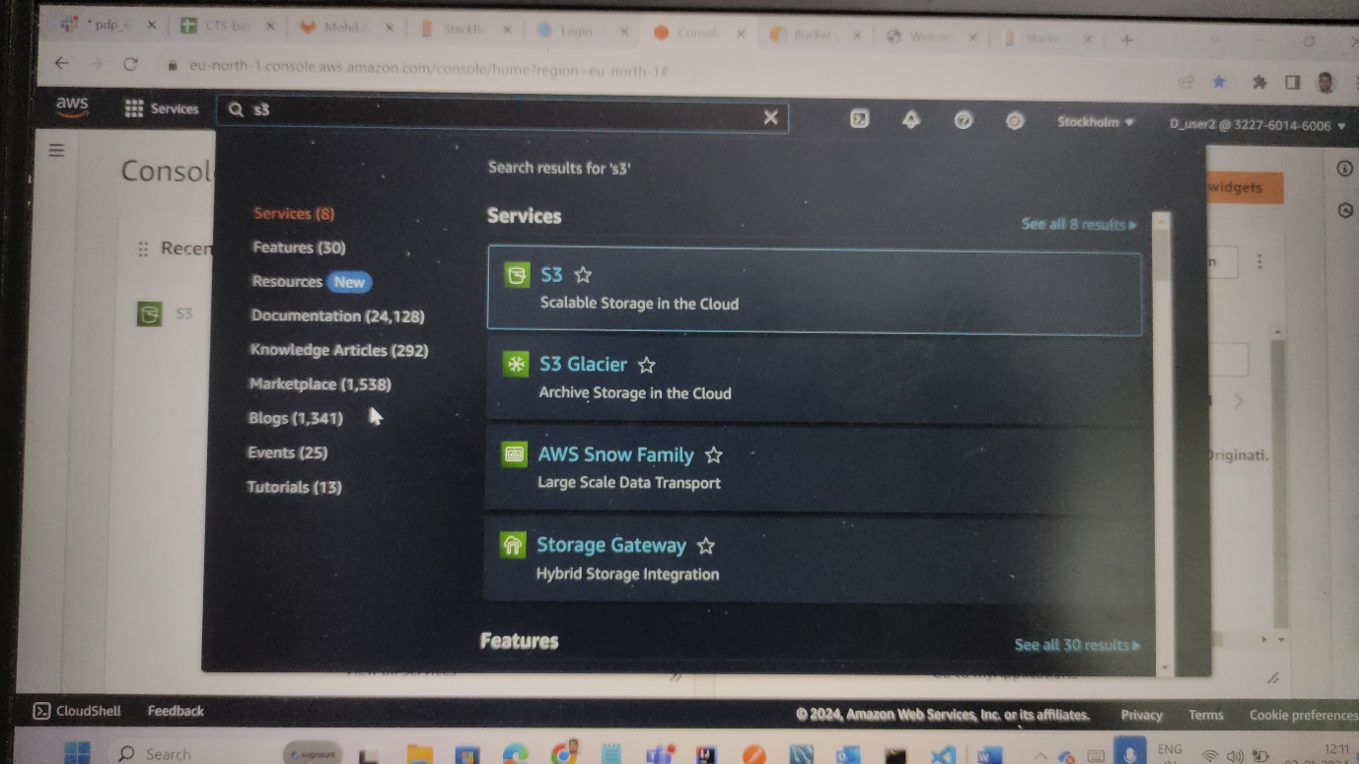

Step 5: after selecting the s3 bucket . you will be directed to page where we can see all buckets that were created by us. Click on create bucket option.

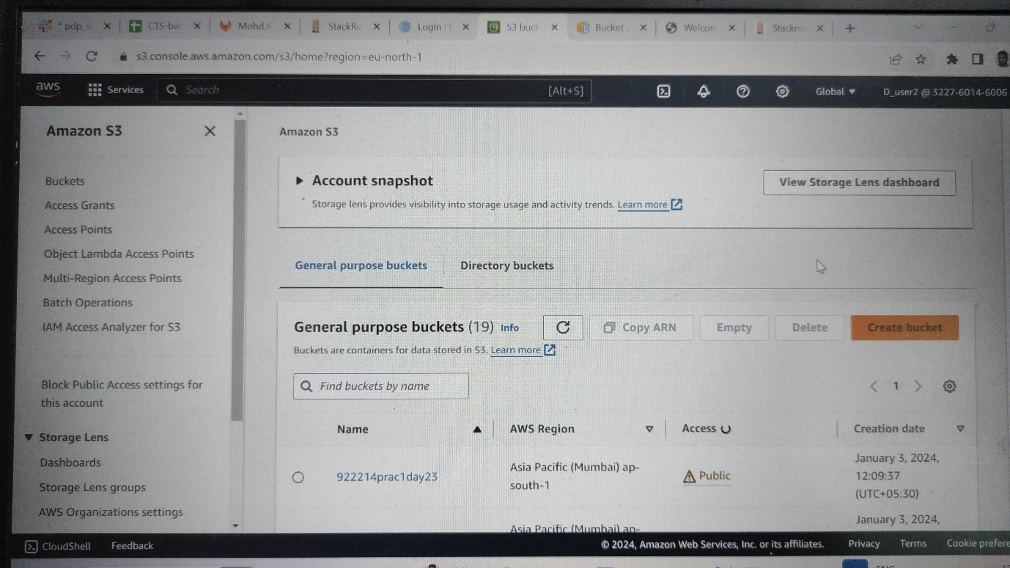

Step6: after clicking you wll get a page as below . provide uniquie name in bucket name . uncheck the security box .



Stpe7: keep all other options as it is and click on create bucket option at last as shown in below.

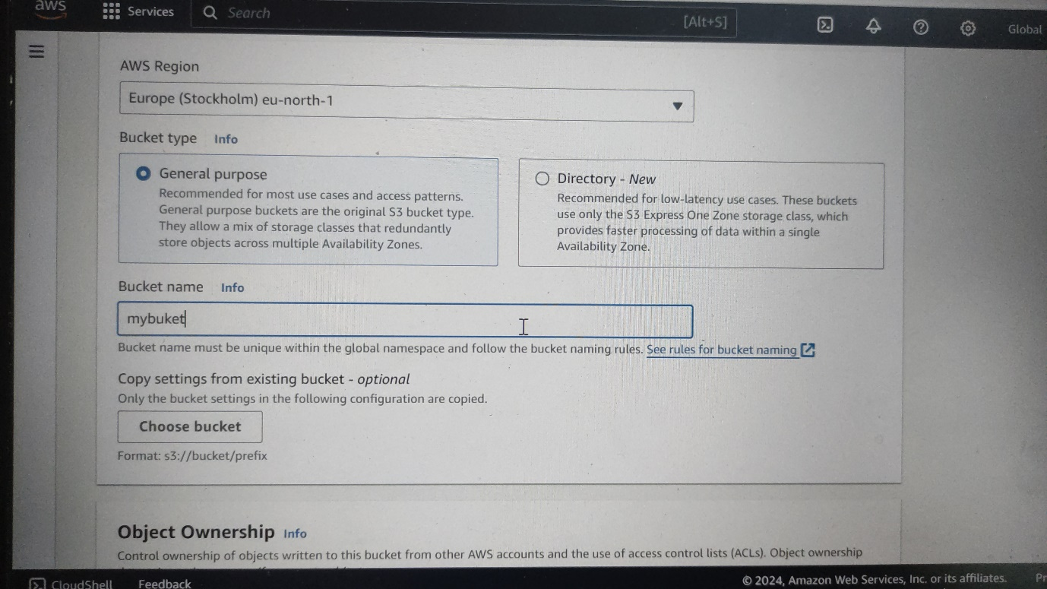

Step8: you will be redirected to buckets page in s3 . select your bucket name and open it .

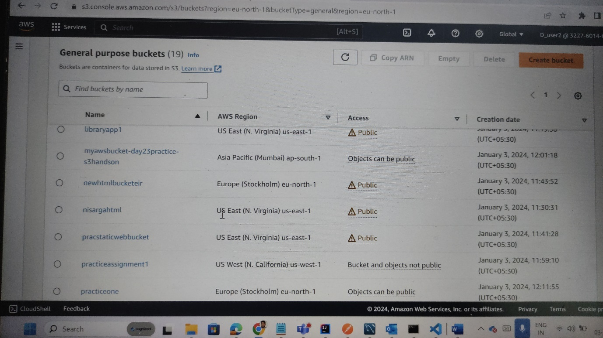

Step9: after selecting the bucket name . In object option . there is Upload option . where we can upload files and folders .after selecting and uploading required files and folders. In our case we have index.html, contact.html , about.html files and images folder . after uploading we can see all our files as below image.



Step10: after uploading go to permissions and in bucket policy add policy . like image below. The policy we have written is to get the pages and it should be accessed by all.

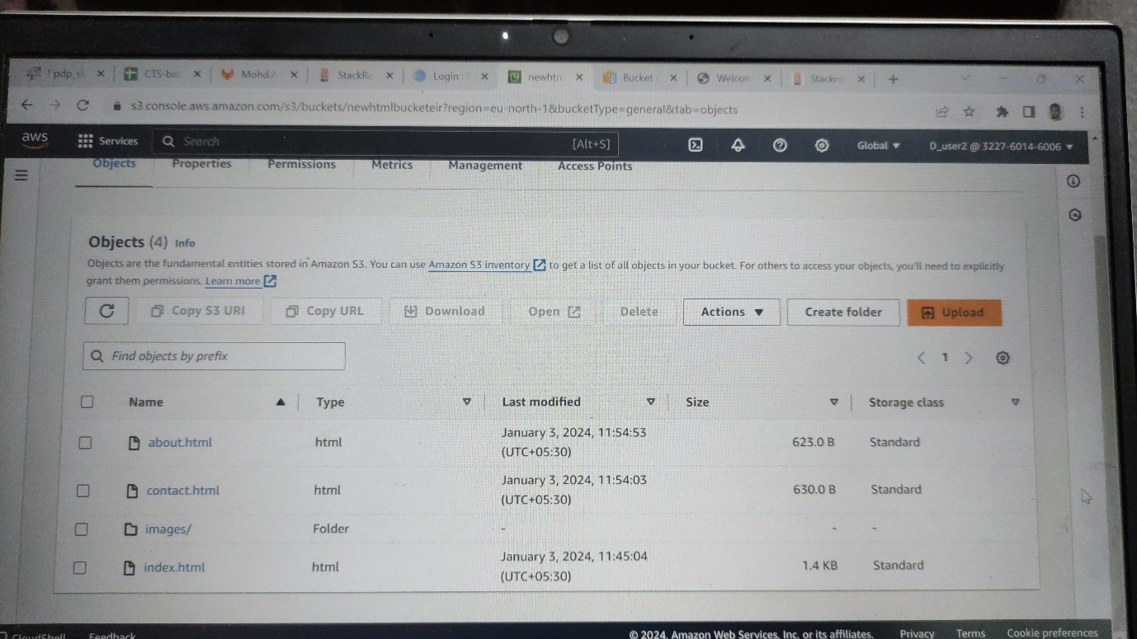

Step 11: after adding the policy . go to you bucket and in that click on index.html you can see the url as image below.

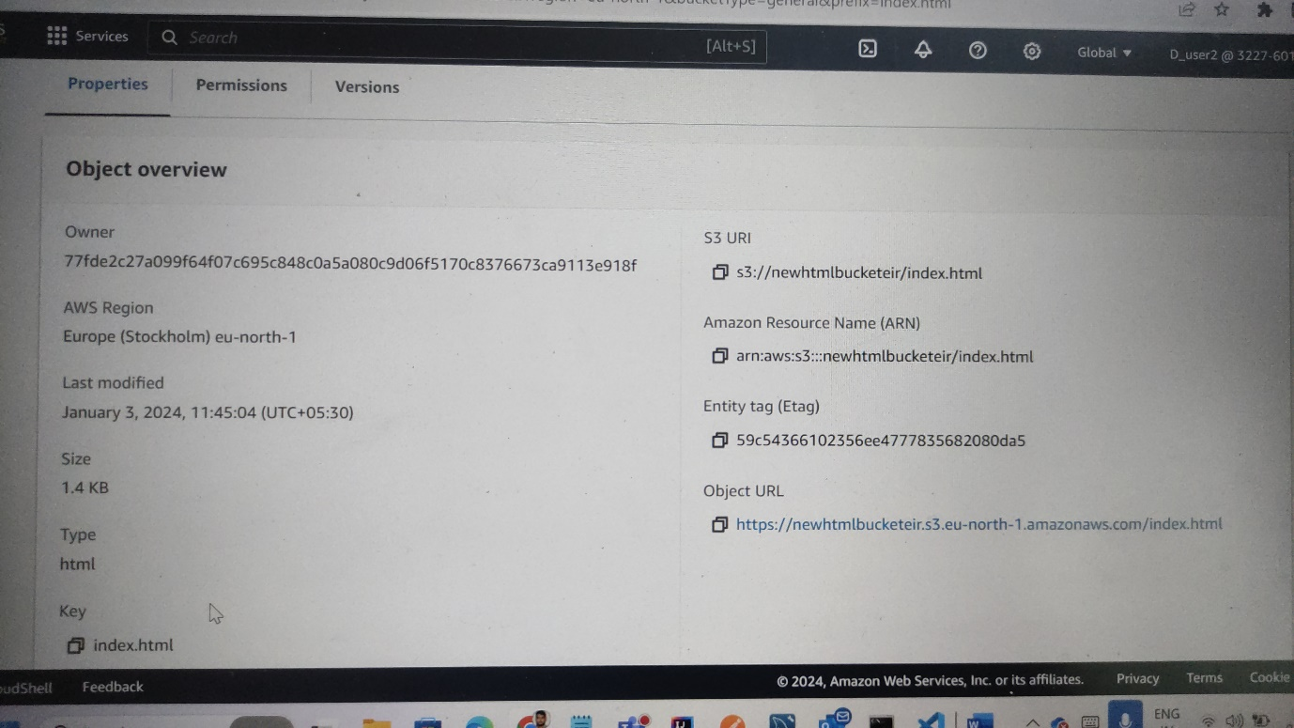

Step 12:copy that Object URL and paste in any browser like chrome , edge and mozilla. We should the page as below .

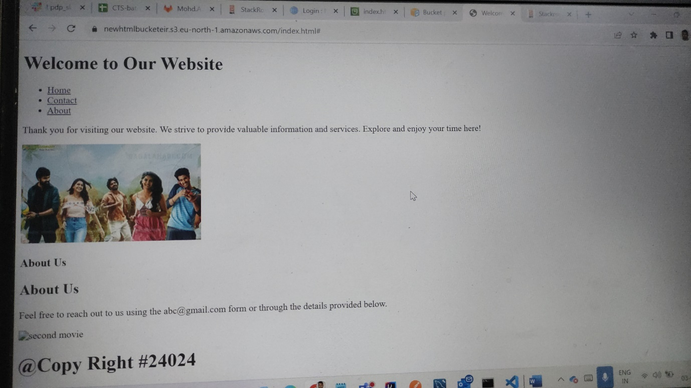

Step13: check the hyperlinks working and also images are displayed .

Step14: By following above steps we can create pages and deploy in AWS S3 bucket .