Final Year Project Proposal
Session FALL 2025
Group Members:
Syed Wali Mohsin Naqvi 22K-4550
Syed Ghalib Hussain Zaidi 22K-4536
Syed Azhaan Ali 22K-4140
Bachelor’s in Computer Science


Department of Computer Science
Fast School of Computing
National University of Computer & Emerging Sciences, Karachi Campus
22 September 2025s
Project Registration
Project ID (for office use)
Type of project |  |  | [ ✅ ] Traditional [ ] Industrial [ ] Continuing
Nature of project |  |  | [ ✅ ] Development [ ] Research & Development [ ] Research
Sustainable Development Goals(SDGs) |  |  | [ ] Good Health and Well-Being [ ] Quality Education  [ ✅ ] Industry, Innovation, and Infrastructure [ ] Gender Equality  [ ] Decent Work and Economic Growth [ ] Climate Action
Area of specialization |  |  | [ ✅ ] Artificial Intelligence (AI) [ ] Data Science and Analytics  [ ] Internet of Things (IoT) [ ] Blockchain  [ ] Mobile App Development [ ] Web Development [ ] Cybersecurity  [ ] Game Development [ ] Natural Language Processing (NLP)  [ ] Other
Project Group Members
Sr.# | Reg. # | Student Name |  | CGPA | Email ID | Phone # | Signature
(i) | Group Leader | Syed Wali Moshin Naqvi |  | 3.35 | k224550@nu.edu.pk | 03182350931
(ii) |  | Syed Ghalib Hussain Zaidi |  | 3.53 | k224536@nu.edu.pk | 03052531932
(iii) |  | Syed Azhaan Ali |  | 2.38 | k224140@nu.edu.pk | 03343178177
Declaration: FYP group members have cleared all prerequisite courses For FYP-I as per their degree requirements.

Abstract
With the rapid advancement in artificial intelligence and computer vision, automated vehicle damage detection has emerged as a significant area of research and application. The automation can not only speed up the time consuming process of manual car damage assessment but also effectively reduce human efforts and human errors. This is especially useful in industries such as insurance, vehicle leasing, resale, and fleet management.This project aims to develop an automatic car damage detection system that successfully detects the damaged areas and recommends the estimated repair cost and the respective part to be replaced using various computer vision and deep learning techniques.

Introduction
The rise in vehicle ownership brings with it a regular need for maintenance, repair and if re-selling the car then its valuation. The inspection of a car's condition mainly depends on manual inspection that can be costly, time-consuming and prone to human errors. With this the car owners also struggle to find affordable replacement parts for their vehicles or to determine a fair resale value based on their car’s make, model and condition. The mentioned challenges highlight the need for an automated, reliable system that brings together damage assessment, repair guidance, and valuation in a single platform.
The proposed project addresses the issues mentioned above by developing a smart web-based solution that uses computer vision and data-driven techniques. The system analyzes the images of the car's exterior body to detect dents, scratches, broken components and other defects. After the damage is detected, the system connects to online marketplaces to recommend the best and affordable deals for replacement parts which will save users time and money.
The platform will also estimate the car’s resale value by combining its make, model, year and the severity of detected damage. This feature provides owners with data-backed insights when considering trade-in, private sales or insurance claims with transparency.
The main objective of the project is to make vehicle maintenance and valuation more efficient, transparent and accessible to car owners. The proposed solution offers a comprehensive one-stop solution for automobile owners by bridging the gap between damage detection, repair cost optimization and resale evaluation.
To achieve these objectives, the system will employ convolutional neural networks (CNNs) and object detection algorithms (such as YOLO and Mask R-CNN) for damage localization, semantic search and price-matching techniques for part recommendations, and regression models (Random Forest, XGBoost, or Neural Networks) for predicting resale values.
To achieve these objectives, the system will use convolutional neural networks (CNNs) and object detection algorithms such as YOLO and Mask R-CNN to detect the presence, location and severity of the damage to the vehicle. For part recommendations the system will use semantic search and price matching algorithms, and for predicting the resale values regression models such as Random Forest, XGBoost or Neural Network will be used,
The project itself will be organized into several core components:
- Frontend development for user interaction.
- Backend and API integration to handle communication and data flow.
- Image analysis pipeline for detecting and classifying damage.
- Online data scraping and matching for sourcing part prices.
- Valuation modeling to generate accurate resale estimates.
Together, these components will form a robust and practical application that delivers tangible benefits to automobile owners.

Success Criterion
The success of this project will be measured against three primary benchmarks. First, the system must demonstrate high accuracy in detecting and classifying automobile damage, providing consistent and reliable identification of both exterior and interior defects. Second, it should successfully retrieve relevant replacement parts and present users with competitive pricing by integrating data from multiple online marketplaces. Third, the platform’s resale value estimates must align closely with actual market data, remaining within a clearly defined error margin to ensure practical reliability.
Related Work
Deep learning has significantly advanced research on intact (undamaged) vehicles, including fine-grained vehicle recognition and retrieval [1], [2], vehicle type and component classification [3], [4], and license plate recognition [5], [6]. However, detecting damaged components presents additional challenges. First, a damaged vehicle often appears very different from its original form, making models trained only on undamaged vehicles ineffective. Second, damages differ substantially from common objects typically used in object detection, introducing further difficulties for existing algorithms.
A. Car Damage Related Methods
Early works were heuristic. For example, Jayawardena [7] compared undamaged 3D CAD models with photographs of damaged cars to detect mild deformations. This approach, however, performed poorly in real-world conditions where vehicle appearances constantly change. Similarly, Gontscharov et al. [8] installed structure-borne sound sensors to detect structural damage. While technically effective, this method is impractical due to expensive hardware and complex installation.
Deep learning entered the car damage field in 2017, when Patil et al. [9] applied a CNN to classify damage types (e.g., bumper dent, door dent). Later works by DeDeijn [10] and Balci et al. [11] also used CNNs for limited-type damage classification. However, simple classification suffers two main limitations: (i) vehicles often exhibit multiple simultaneous damages, and (ii) classification cannot localize damage or estimate severity.

To overcome these issues, detection and segmentation approaches emerged. Dwivedi et al. [12] applied YOLOv3 to detect damaged regions, while Singh et al. [13] used Mask R-CNN, PANet, and a transferred VGG16 network to localize car components and damage types. Despite progress, their mean Average Precision (mAP) scores remained relatively low, reflecting the task’s inherent difficulty. More recently, Wang et al. [14] introduced DCN+, which significantly outperformed prior models and provided the foundation for our work.

Beyond academia, commercial applications have also targeted car damage detection. Ant Financial Services Group [15] proposed an automated assessment system combining object detection, instance segmentation, and frame selection algorithms to detect damaged components and generate precise masks. Foundational deep learning object detection frameworks such as YOLO [16] and Mask R-CNN [17] also play crucial roles in enabling these commercial systems. Collectively, these efforts demonstrate both the technical challenge and the urgent industrial demand for reliable vehicle damage detection systems.
B. Car Damage Related Dataset
The proposed project will use a publicly available dataset named CarDD [14]. CarDD offers a variety of potential challenges in car damage detection and segmentation and is the first publicly available dataset [14]. The CarDD dataset is a comprehensive collection designed specifically for car damage analysis, covering six major damage types: dent, scratch, crack, glass shatter, tire flat, and lamp broken. It contains 4,000 high-quality images with over 9,000 labeled instances, making it, to the best of our knowledge, the largest publicly available dataset of its kind. One of its key strengths lies in image quality, with an average resolution of 684,231 pixels [14]. The CarDD comprises four different tasks,classification, object detection, instance segmentation, and salient object detection (SOD). The dataset is fine-grained which means that the dataset is designed to help models learn to distinguish between subtle types of car damage, such as dents vs. scratches. Additionally, the dataset offers a diverse range of images in terms of object scale and shape, reflecting the natural variability of car damage in real-world conditions.

Project Rationale
The increasing number of vehicles and the reliance of industries such as rentals, insurance, maintenance workshops and resale on accurate car assessment have highlighted the limitations of manual car inspection. Following are the limitations of traditional methods:
- significant time and efforts are required
- are prone to human errors
- are resource intensive (may require specialized tools and expertise
- can lead to inconsistent results.
These limitations can lead to financial losses, fraud and customer dissatisfaction.
The purpose of this project is to design an automated car damage detection system using computer vision and artificial intelligence to address the above mentioned problems.
The motivation behind this project is the opportunity to explore the vast AI techniques and implement these techniques to real world problems with significant economic and social relevance. This automated car damage detection system can reduce the time and increase accuracy of damage detection. Furthermore, this will bring transparency to claims and evaluations specifically in insurance claims and rental car services.
By investigating this problem, we aim to enhance our research skills while simultaneously contributing a practical solution for the automotive industry. The project is designed to deepen our technical expertise in computer vision, semantic search, and pricing algorithms. Furthermore, it will provide us with hands-on experience in addressing an industry-relevant challenge, thereby fostering the development of both practical and professional competencies.

Aims and Objectives
The goal of the project and the main focused objectives of the project are discussed in this section.
The advancement of technology has significantly enhanced the capabilities of computer vision, making it a vital area of research within artificial intelligence. These recent advancements have opened pathways for the development of car damage detection systems using computer vision. The application of automatic car damage detection holds value in car resale markets, insurance, rental services, and maintenance workshops.
The goal of our project is to create a general use web-based application that allows the user to upload pictures of their car and our algorithms successfully determine the exterior damaged area of the car based on various computer vision techniques. Further the algorithms must be able to give an estimated cost of the repair/maintenance using semantic search & pricing algorithms.
Objectives:
- Pre-processing datasets of damaged & undamaged car images.
- Designing and training a Convolutional Neural Networks (CNN) models for detecting and classifying external damages.
- Developing a web-based application that enables users to upload car images & view detection results.
- Implementing semantic search and pricing algorithms for repair and maintenance cost estimation.
- Evaluating the system using accuracy, precision, recall and user feedback metrics.

Scope of the Project
Scope defines what needs to be achieved and the work that must be done to deliver a project. It includes specific project goals, deliverables, features, functions, tasks, deadlines, and ultimately costs.
The scope of this project is to design, implement and evaluate an automatic car damage detection system with cost estimation of parts to be replaced/damaged. The system will not focus on any internal mechanical issues such as engine or brake faults and will exclusively deal with external damages.
4.2.1 Project Goals
- Develop a web-based application for automatic car damage detection
- Enable user to upload pictures of their cars
- Successfully detect the damage and gives accurate damage assessment of user’s car
- Provide estimated repair cost and part to be repaired using semantic search and pricing algorithms.
4.2.2 Deliverables
- A functional web application with user-friendly interface for image upload and result visualization
- Trained computer vision models for damage detection
- Integrated cost-estimation module
- Integrated part recommendation module
4.2.3 Features & Functions
- Image upload functionality
- Automated detection of car’s exterior damages
- Cost Estimation for repairing/replacing parts
- Overall damage report/summary feature for user
4.2.4 Tasks
- Data Preprocessing
- Model selection,training & evaluation
- Web application development
- Integration of computer vision & pricing modules
- Testing & validation

Proposed Methodology and Architecture
For Achieving the goals of our project we will be using the following methodology and system architecture.
5.1 Methodology
- Data-Preprocessing:
- This step will involve data cleaning, labeling consistency, augmentation, resizing and normalization.
- Pipeline Creation:
- This step will define how the data will flow from input to output as shown in the diagram:
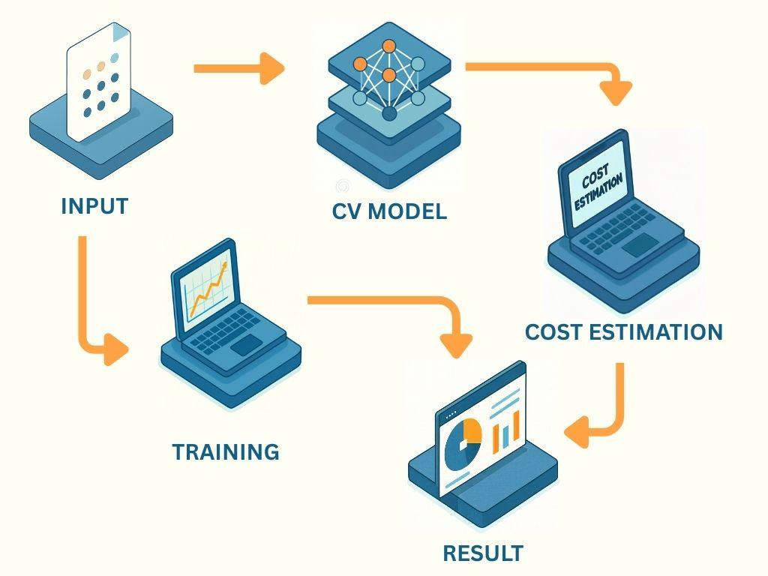
Fig 1: System Pipeline for Automatic Car Damage Detection and Cost Estimation

- Model Training (Computer Vision Module):
- By using computer vision techniques and algorithms we will use CNN models for car damage detection.
- Cost Estimation Module:
- The cost estimation module is divided into two parts, semantic search and pricing algorithms for estimated repair cost prediction
- Web Development:
- In this phase we will be making a front end with React.js/Next.js, backend with Nest.js and database with PostgreSQL with Prisma ORM.
- Web Integration:
- This is where we will be connecting the computer vision module, cost estimation module and web platform.
- Testing & Validation:
- This module will include the performance testing of the models trained, system testing of the web application and usability validation.
5.2 System Architecture
Our proposed system follows Client-Server (Three-Tier Model) architecture where:
- Presentation Tier (Client): The user interface with which the user interacts with the system. In our case it will allow the user to upload car images, view detected damage areas, and show the estimated repair cost.
- Application Tier (Server): This is the middle layer that is responsible for handling logic and also acts as a bridge between the client and database. In our project it will receive the client request, forward the images to the computer vision model, process predictions, apply semantic search and pricing algorithms, and return the result generated to the client.
- Data Tier (Database): The data tier stores and manages the data of the application. Here the database will store the user data, uploaded image reference, model outputs and previous cost estimation records. Further this will also handle the database queries such as insert, update, delete and retrieve.
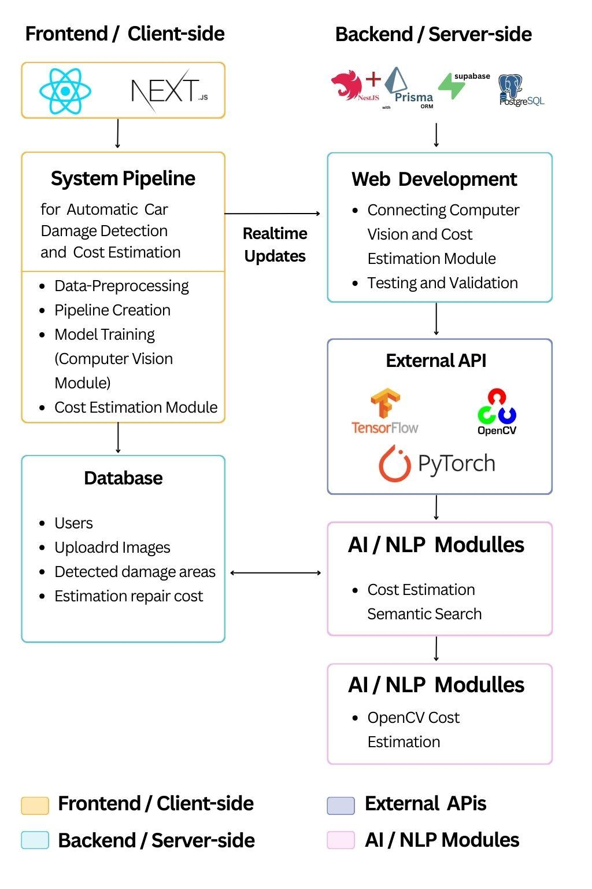
Fig 2: System Architecture Diagram

Gantt Chart (Mandatory)
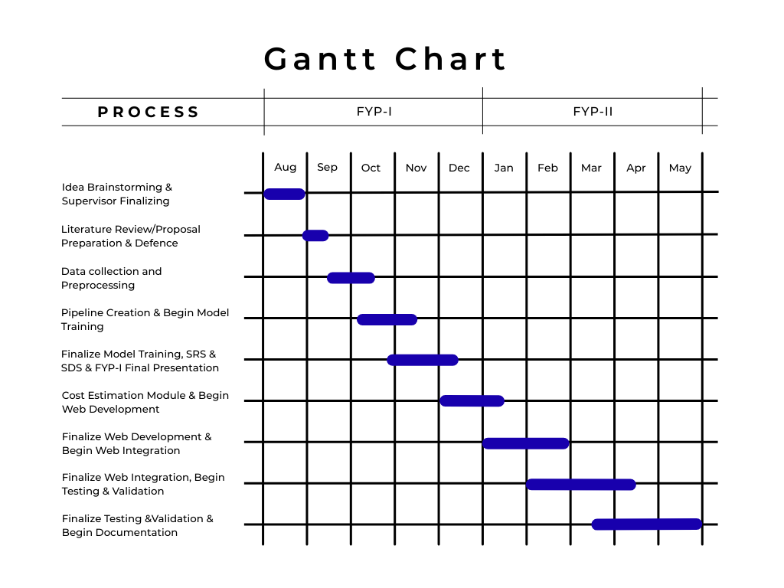

Tools and Technologies
The development of the proposed model will require multiple tools & technologies such as programming languages, frameworks, libraries and platforms to implement the computer vision models, cost-estimation module and web-based application. Following are the tools & technologies that will be used:
1. Programming Languages
- Python – for model development, data preprocessing, and integration of computer vision algorithms.
- JavaScript (PERN stack) – for frontend (React.js/Next) and backend (Node.js + Express.js/Nestjs) web application development.
- Database – postgreSQL with prisma ORM
2. Machine Learning and Computer Vision Frameworks
- TensorFlow / Keras – for building, training, and evaluating deep learning models.
- PyTorch – as an alternative framework for experimentation with CNNs and transfer learning.
- OpenCV – for image preprocessing and manipulation tasks.
3. Data Handling and Storage
- Pandas, NumPy – for dataset handling, analysis, and numerical computations.
- PostgreSQL – for storing user data, image references, and repair cost datasets.
4. Cost Estimation and Semantic Search
- Natural Language Processing (NLP) libraries such as spaCy or NLTK – for semantic search implementation.
- Elasticsearch / FAISS – for semantic search and similarity matching of repair cost data.
5. Web Development Tools
- React.js/Next.js – for frontend development.
- Node.js with Express.js/Nest.js – for backend services and API integration with ML models.
- HTML5, CSS3, Bootstrap/Tailwind CSS – for responsive and user-friendly interface design.
- ORM – Prisma for database interaction
6. Deployment and Hosting
- Docker – for containerization and deployment of models and web services.
- Heroku / AWS / Google Cloud Platform (GCP) – for hosting the web application and ensuring scalability.
7. Version Control and Collaboration
- Git & GitHub – for version control, collaboration, and project management.

References
[1] Y. Xiang, Y. Fu, and H. Huang, “Global topology constraint network for fine-grained vehicle recognition,” IEEE Transactions on Intelligent Transportation Systems, vol. 21, no. 7, pp. 2918–2929, 2019.
[2] X. Zhang, R. Zhang, J. Cao, D. Gong, M. You, and C. Shen, “Part-guided attention learning for vehicle instance retrieval,” IEEE Transactions on Intelligent Transportation Systems, pp. 1–12, 2020.
[3] Y. Huang, Z. Liu, M. Jiang, X. Yu, and X. Ding, “Cost-effective vehicle type recognition in surveillance images with deep active learning and web data,” IEEE Transactions on Intelligent Transportation Systems, vol. 21, no. 1, pp. 79–86, 2019.
[4] H.-J. Jeon, V. D. Nguyen, T. T. Duong, and J. W. Jeon, “A deep learning framework for robust and real-time taillight detection under various road conditions,” IEEE Transactions on Intelligent Transportation Systems, pp. 20061–20072, 2022.
[5] L. Zhang, P. Wang, H. Li, Z. Li, C. Shen, and Y. Zhang, “A robust attentional framework for license plate recognition in the wild,” IEEE Transactions on Intelligent Transportation Systems, vol. 22, no. 11, pp. 6967–6976, 2020.
[6] M. S. Al-Shemarry, Y. Li, and S. Abdulla, “An efficient texture descriptor for the detection of license plates from vehicle images in difficult conditions,” IEEE Transactions on Intelligent Transportation Systems, vol. 21, no. 2, pp. 553–564, 2019.
[7] S. Jayawardena et al., “Image based automatic vehicle damage detection,” 2013.
[8] S. Gontscharov et al., “Algorithm development for minor damage identification in vehicle bodies using adaptive sensor data processing,” Procedia Technology, 2014.
[9] K. Patil et al., “Deep learning based car damage classification,” ICMLA, 2017.
[10] J. DeDeijn, “Automatic car damage recognition using convolutional neural networks,” MSc Report, 2018.
[11] B. Balci et al., “Front-view vehicle damage detection using roadway surveillance camera images,” VEHITS, 2019.
[12] M. Dwivedi et al., “Deep learning-based car damage classification and detection,” Advances in Artificial Intelligence and Data Engineering, Springer, 2021.
[13] R. Singh et al., “Automating car insurance claims using deep learning techniques,” BigMM, 2019.
[14] X. Wang, W. Li, and Z. Wu, “CarDD: A new dataset for vision-based car damage detection,” IEEE Transactions on Intelligent Transportation Systems, vol. 24, no. 7, pp. 7202–7214, 2022.
[15] W. Zhang et al., “Automatic car damage assessment system: Reading and understanding videos as professional insurance inspectors,” AAAI, 2020.
[16] J. Redmon, S. Divvala, R. Girshick, and A. Farhadi, “You only look once: Unified, real-time object detection,” in Proceedings of the IEEE Conference on Computer Vision and Pattern Recognition (CVPR), 2016, pp. 779–788.
[17] K. He, G. Gkioxari, P. Dollár, and R. Girshick, “Mask R-CNN,” in Proceedings of the IEEE International Conference on Computer Vision (ICCV), 2017, pp. 2961–2969.
[18] U. Waqas et al., “Vehicle damage classification and fraudulent image detection including moiré effect using deep learning,” CCECE, 2020.
[19] N. Patel et al., “Automated damage detection in operational vehicles using mask r-cnn,” Advanced Computing Technologies and Applications, 2020.
[20] P. Li et al., “An anti-fraud system for car insurance claim based on visual evidence,” arXiv:1804.11207, 2018.
[21] N. Dhieb et al., “A very deep transfer learning model for vehicle damage detection and localization,” ICM, 2019.
[22] “Car damage detective,” GitHub repo, 2019.
[23] M.-M. Cheng et al., “Global contrast based salient region detection,” IEEE TPAMI, 2014.

