CARPER-THE CAR PROBLEM SOLVER

Submitted By:
Syed Wali Mohsin Naqvi 22K-4550
Syed Ghalib Hussain Zaidi 22K-4536
Syed Azhaan Ali 22K-4140
Project Progress Report

Department of Computer Science
Fast School of Computing
National University of Computer & Emerging Sciences, Karachi Campus
1.Introduction
The rise in vehicle ownership brings with it a regular need for maintenance and repair and if re-selling the car then its valuation. The inspection of a car's condition mainly depends on manual inspection that can be costly, time-consuming and prone to human errors. With this the car owners also struggle to find affordable replacement parts for their vehicles or to determine a fair resale value based on their car’s make, model and condition. The mentioned challenges highlight the need for an automated, reliable system that brings together damage assessment, repair guidance, and valuation in a single platform.
The proposed project addresses the issues mentioned above by developing a smart web-based solution that uses computer vision and data-driven techniques.The dataset used in this project is CarDD, which mainly focuses on external damages on the car surface that can be detected and assessed by computer vision technology. CarDD covers six classes of the most frequent external damage types, including dent, scratch, crack, glass shatter, tire flat, and lamp broken, selected based on frequency of occurrence and clear definition, derived from the statistics of Ping An Insurance Company [1]. After the damage is detected, the system connects to online marketplaces to recommend the best and affordable deals for replacement parts which will save users time and money.
The platform will also estimate the car’s resale value by combining its make, model, year and the severity of detected damage. This feature provides owners with data-backed insights when considering trade-in, private sales or insurance claims with transparency.
The main objective of the project is to make vehicle maintenance and valuation more efficient, transparent and accessible to car owners. The proposed solution offers a comprehensive one-stop solution for automobile owners by bridging the gap between damage detection, repair cost optimization and resale evaluation.
To achieve these objectives, the system will use object detection algorithms such as YOLO to detect the presence, location, and severity of damage to the vehicle. Prior works on vehicle damage detection have employed deep learning-based classification [3], and instance segmentation using Mask R-CNN [5] to localize and classify damage regions. For part recommendations, the system will utilize semantic search and price-matching algorithms to suggest optimal replacement components for which we are using multiple regression models such as Linear Regression, Random Forest, Extra Trees, and Gradient Boosting, will be evaluated and compared.
The project itself will be organized into several core components:
- Frontend development for user interaction.
- Backend and API integration to handle communication and data flow.
- Image analysis pipeline for detecting and classifying damage.
- Online data scraping and matching for sourcing part prices.
- Valuation modeling to generate accurate resale estimates.
Together, these components will form a robust and practical application that delivers tangible benefits to automobile owners.
2.TIMELINE
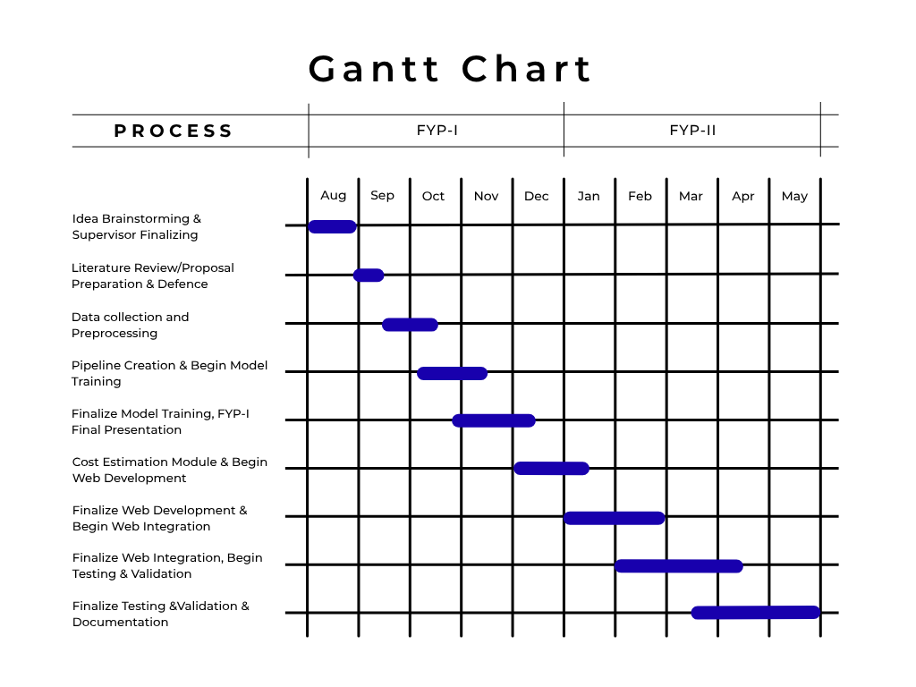3.PROGRESS
This section elaborates the current progress of the project with respect to each milestone. The project involves developing a smart web-based car damage detection and cost estimation system using computer vision.The following milestones reflect the actual progress achieved against the planned schedule.
3.1 MILESTONE 1
Milestone 1 covered the foundational phases of the project during the first half of FYP-I.This included Idea Brainstorming & Supervisor Finalizing, Literature Review and preparing proposal and defending our project. After successfully defending our project we moved forward with the task of data collection and preprocessing. All tasks under Milestone 1 have been completed successfully.
During this phase, the project scope was defined and a comprehensive literature review was conducted. The CarDD dataset, introduced by Wang et al. [1], was identified as the primary dataset for car damage detection, comprising 4,000 high-resolution images across six damage categories. Early automated vehicle damage detection relied on comparing 3D CAD models with photographs [6], while later methods employed structure-borne sound sensors [7] and deep learning classifiers [3] for damage identification. The dataset was acquired, and preprocessed in preparation for model training.
3.2 MILESTONE 2
Milestone 2 spanned from October to December during FYP-I and covered the core model development phases which includes: pipeline creation and model training, and creating SRS, SDS documentation, and the FYP-I Final Presentation.
A complete training pipeline was established using the CarDD dataset. The YOLOv8n (nano) object detection model was selected and successfully trained to detect six classes of car damage: dent, scratch, crack, glass shatter, tire flat, and lamp broken. YOLO-based models, originally introduced by Redmon et al. [2], have become a foundational framework for real-time object detection in automotive applications. The Mask R-CNN architecture [5], proposed by He et al., was also evaluated for instance-level damage segmentation. The trained model was evaluated, optimized, and finalized for deployment and yielded the following results:
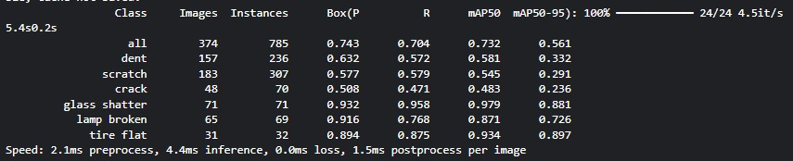

The Software Requirements Specification (SRS) and Software Design Specification (SDS) documents were completed, and the FYP-I final presentation was delivered successfully in December.
3.3 MILESTONE 3
Milestone 3 covers the FYP-II, this phase includes development of cost estimation module, website development and integration, testing, validation, and final documentation. The following is the current status of each task within this milestone:
Cost Estimation Module (January to April): This task involved developing the cost estimation module by integrating our YOLOv8n model to detect the damages on the exterior car body and estimate the repair price using a regression model. Commercial systems for automated damage assessment, such as those developed by Ant Financial Services Group [8], combine object detection and instance segmentation to generate damage masks and cost estimates. Fraud detection approaches using deep learning [9] also informed the robustness design of our pipeline. The cost estimation module has been successfully developed and completed by April.
Finalize Web Integration, Testing & Validation, and Documentation (May: Open House): This phase includes the integration of the cost estimation module with the web-based platform, and then doing an end-to-end system testing, validation, and complete project documentation. All these tasks will be completed and demonstrated at the Open House in May.
In summary, all FYP-I milestones have been accomplished, most notably the successful training of the YOLOv8n detection model. Vehicle recognition techniques such as global topology constraint networks [10] and part-guided attention learning [4] provided complementary insights into feature extraction for automotive applications. In FYP-II, the cost estimation module has been completed by April. The remaining tasks, including web integration, testing, validation, and documentation, are planned to be finalized and presented at the Open House in May.
4.UPDATED TIMELINE
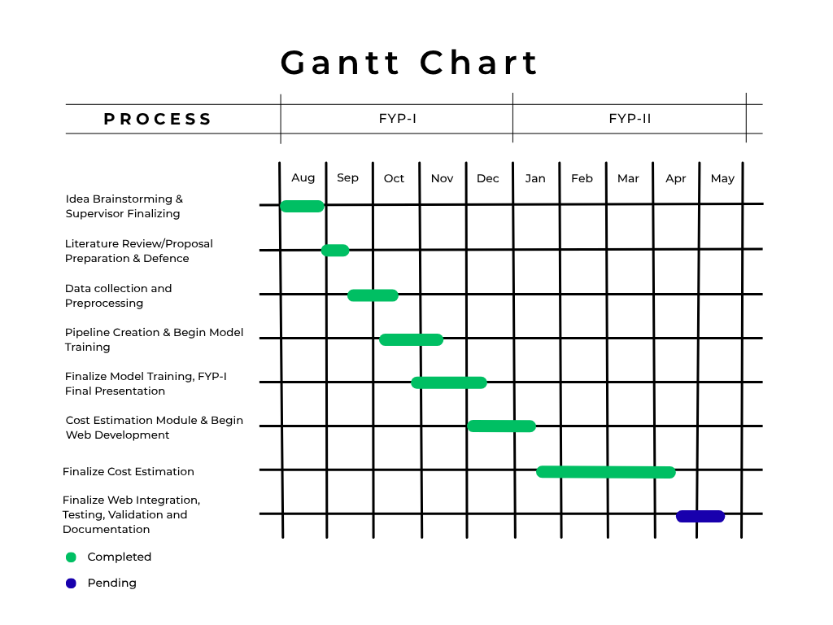

5.REFERENCES
[1] X. Wang, W. Li, and Z. Wu, "CarDD: A new dataset for vision-based car damage detection," IEEE Transactions on Intelligent Transportation Systems, vol. 24, no. 7, pp. 7202–7214, 2022.
[2] J. Redmon, S. Divvala, R. Girshick, and A. Farhadi, "You only look once: Unified, real-time object detection," in Proc. IEEE Conf. Computer Vision and Pattern Recognition (CVPR), 2016, pp. 779–788.
[3] K. Patil et al., "Deep learning based car damage classification," in Proc. IEEE Int. Conf. Machine Learning and Applications (ICMLA), 2017.
[4] X. Zhang, R. Zhang, J. Cao, D. Gong, M. You, and C. Shen, "Part-guided attention learning for vehicle instance retrieval," IEEE Transactions on Intelligent Transportation Systems, pp. 1–12, 2020.
[5] K. He, G. Gkioxari, P. Dollár, and R. Girshick, "Mask R-CNN," in Proc. IEEE Int. Conf. Computer Vision (ICCV), 2017, pp. 2961–2969.
[6] S. Jayawardena et al., "Image based automatic vehicle damage detection," 2013.
[7] S. Gontscharov et al., "Algorithm development for minor damage identification in vehicle bodies using adaptive sensor data processing," Procedia Technology, 2014.
[8] W. Zhang et al., "Automatic car damage assessment system: Reading and understanding videos as professional insurance inspectors," in Proc. AAAI Conf. Artificial Intelligence, 2020.
[9] U. Waqas et al., "Vehicle damage classification and fraudulent image detection including moiré effect using deep learning," in Proc. Canadian Conf. Electrical and Computer Engineering (CCECE), 2020.
[10] Y. Xiang, Y. Fu, and H. Huang, "Global topology constraint network for fine-grained vehicle recognition," IEEE Transactions on Intelligent Transportation Systems, vol. 21, no. 7, pp. 2918–2929, 2019.

