**Market Analysis Report for National Clothing Chain**

The online national clothing chain needs to create a targeted marketing campaign. Sales were steady and they wanted to attract lost customers back, so I did an analysis to determine the best advertising product for each customer.

**conclusions:**   
1. The correlation between sales and income is 0.78 which is a positive and very strong relationship.

2. The correlation between customer ratings and product return rate is 0.69 which is a negative and strong relationship.

3. The linear regression formula to predict customer income from customer sales is X = -722.14 - y / - 0.01

4. The customer that has the highest income is **Jon Little**.

5. The product that will be advertised the most is the Shirt.

6. The scatterplot relationships with R-Squared values between sales and income :

7. The average Return rate is 0.01

8. The average customer rating is 3.79

9. The scatterplot relationships with R-Squared values between customer rating and return rate:

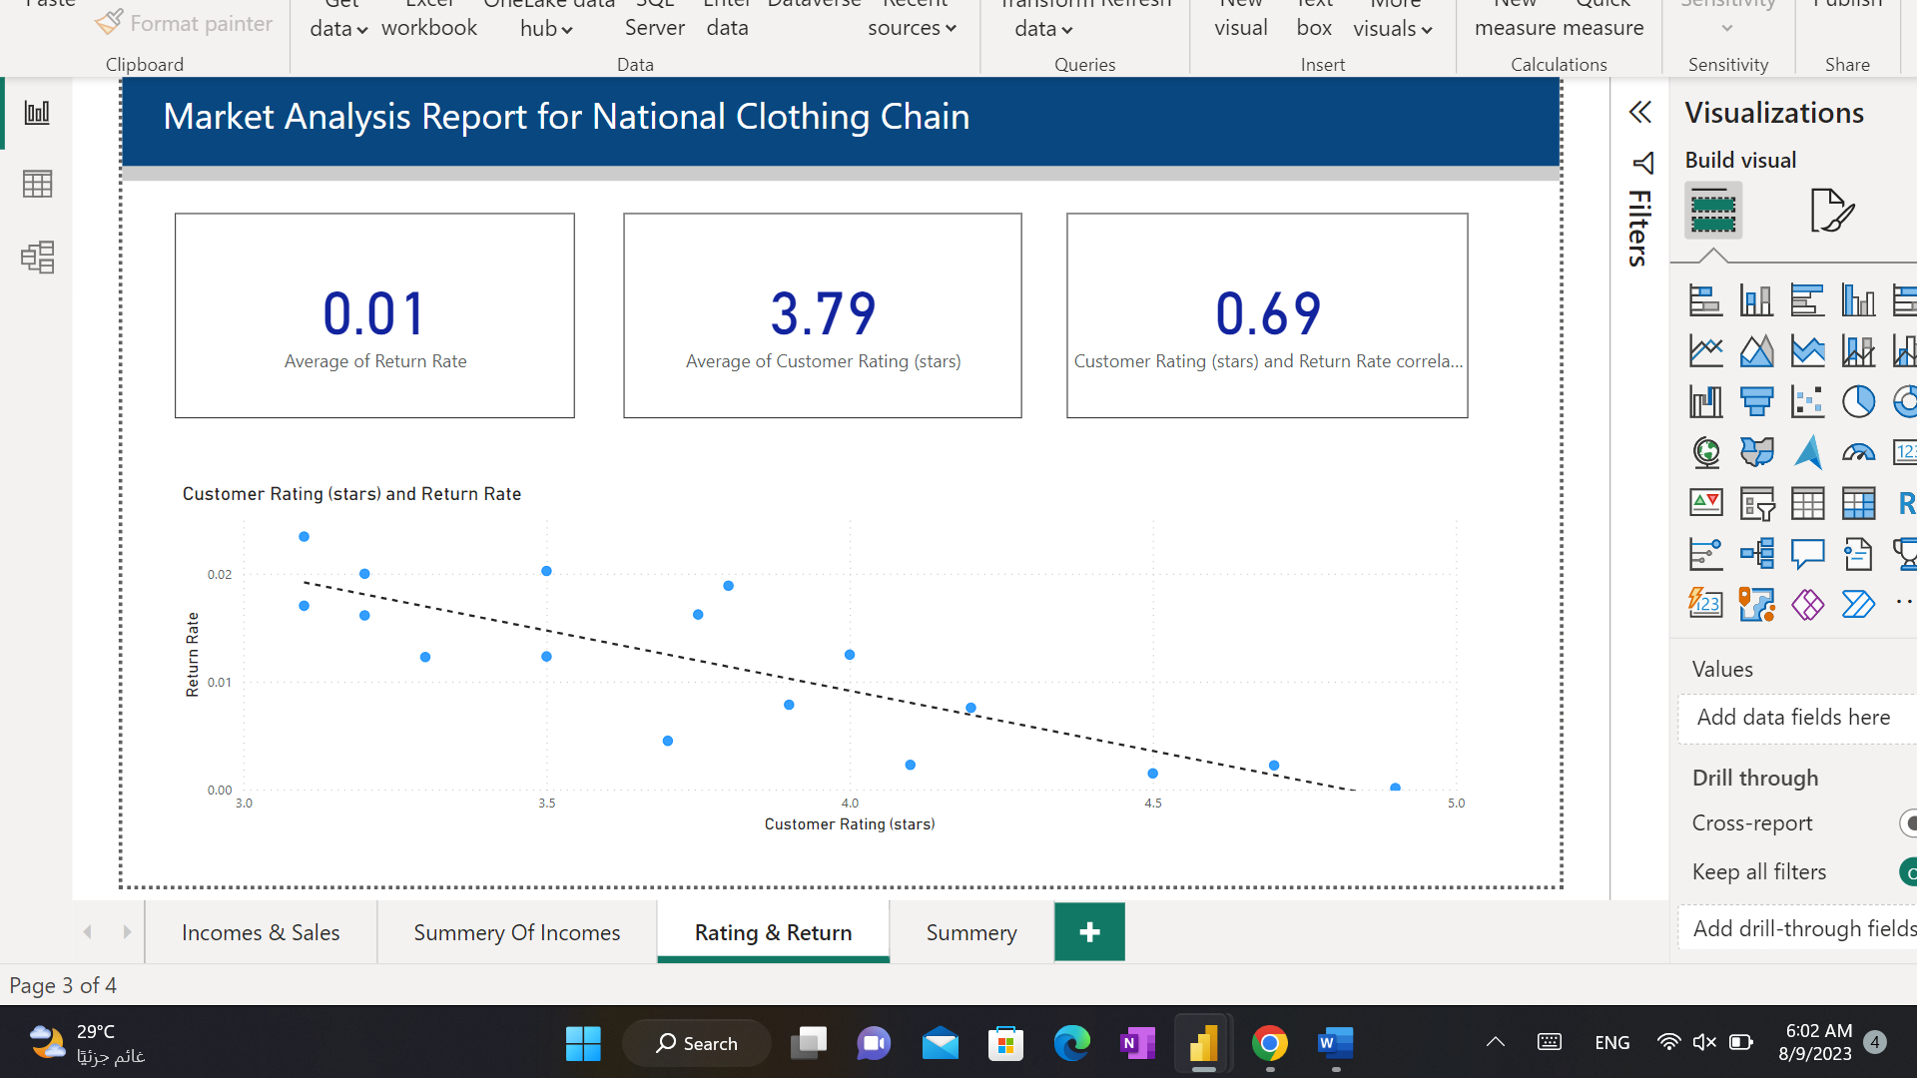

**Recommendation:**

I suggest that each product be announced according to the average income of the residents of the region, and I also find that the price of the leather bag is expensive, so I suggest reducing its price or making discounts for a specific period to make some customers excited about buying it and evaluating it at a higher rating.