EE 436L: Database Project Phase I



Submitted by:
Fahad Anyit 2017-EE-177 2017ee177@student.uet.edu.pk
Azhak Anwar 2017-EE-186 2017ee186@student.uet.edu.pk

Submitted to:
Mr. Umer Shahid

Section D

Department of Electrical Engineering
University of Engineering & Technology Lahore
Parent Teacher Interactive Result Portal
Abstract:
This document shows proposed implementation of Parent, Teacher Online Result Portal where parents can see their children’s performance in all their exams.
Problem Statement:
A good relationship with children’s teachers is a great starting point for handling problems that come up at school. Communicating and building relationships with your children’s teachers is better than having contact with the teachers only when there is a problem. In this busy world, it is quite hard for parents as well to contact to their child’s teacher and taking the current situation of pandemic due to covid-19 into account, it has become more difficult to visit school physically for parents, teacher interactive meeting. Even parents do not know the actual performance of their children in school due to bluffing of children. As a result, parents seem overconfident about their children’s condition.
Solution:
Keeping the above situation in view, it is need of the hour that there must be a lite solution to all these problems. Since it is the era of digitalism, so an online result portal can come in handy which is easily accessible by parents and teachers so they can communicate comfortably and discuss the progress of students. This system will not only build relationship with children’s teachers but also updates parents with their children’s performance which will motivate children to do perform well in school. Parents can see their children’s result anywhere and they do not have to worry about their busy schedule.
This system has four layers.
- Student
- Teacher
- Parents (Guardian)
- Admin (Superuser)
Teacher will update the student test performance on portal where student can view only his result and remarks while parents view the results and remarks of all their children. In this way, they can keep track of performance of all their children.

EER Diagram:

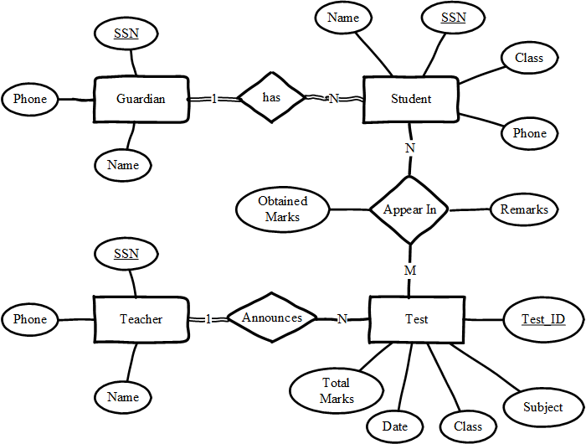

Data Flow Diagram:
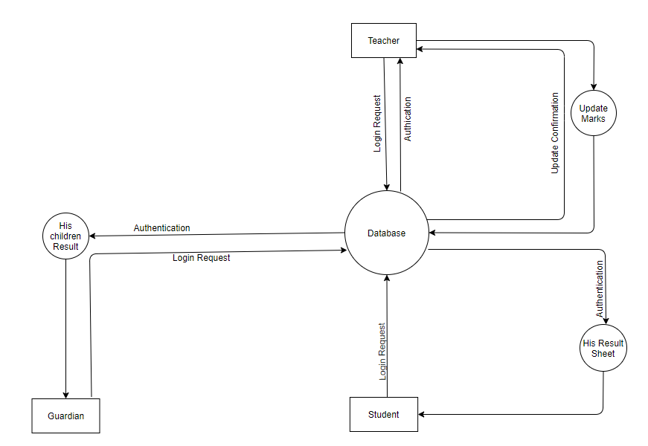

Constraints:
- The teacher can only update marks and reviews of the tests he/she conducted.
- A student can see only his marks and reviews.
- The guardian can see the result and reviews of only his children.
- Only teacher has the right to update marks and reviews.
- The guardian can see contact details of the only teachers who conducted their children’s test.
- The teacher can see contact details of the students and their parent who appeared in his/her test.
- Not everyone can create teacher account. Only a superuser can authorize the teacher.
Assumption:
- None made.
Tasks Performed by Azhak Anwar:
- Idea proposal
- Problem statement
- Assumptions and logical constraints

Tasks Performed by Fahad Anyit:
- Problem Solution
- EER diagram
- Data Flow Diagram

