**SUPERMARKET DATABASE MANAGEMENT**

**SYSTEM**

**ROLL No. 0115-bscs-20**

**NAME : AZHAR UD DIN**

**SECTION: A**

**TEACHER : SIR NADEEM**

**DATABASE LIFE CYCLE(SDLC)**

During super-market management system creation project, I will be performing following (4) four phases of SDLS.

1. Super-market system analysis and initial study.
2. Super-market management system conceptual database design
3. Super-market management system logical database design using relational model.
4. Super-market management System physical database design and implementation using Software Ms-SQl-server 2019.
5. **Super-market management system initial study**

The “Supermarket Database Management System” is **a Database based on the sales transaction of items in a supermarket**. It operates multiple stores on different names. It manages following activities for generating reports about certain entities:

1. Sales management
2. Product management
3. Customer management
4. Stock management
5. Purchasing management
6. Employees management
7. Stores management
8. Payment management.

**Scenario Analysis**

Super-market has multiple stores, each store owns by the owner .each store owns departments, a stock and a manager. Some employees belongs to a department that works for only that department. Some employees belongs to a stock of a store and work for only that stock. Employee owns job titles. Admin assigns login access to employees. Employees assigns logins on admin provided access. At least one admin must be a manager. A manager can only makes admin to the stock employees for manipulation of products in the stock. A manager manages only those employees whose job_tiltle is head of department, and head of department manages all department employees . employees Manages customer orders and makes billing_payment for keeping reports of payment and sells. If order needs shiftment, supplier supplies that order to the customer on the basis of customer purchase record. Customers order/buy products. Stock contains products and products belongs to product_type. If stock employees needs products, employees orders products from Vendors.

**Relationship cardinality Constraints/refrential constraints**

1st ) An owner must owns at least one store. Whereas, one store owned by one and only one owner.

2nd) A Store must have at least one department, one and only one manager, and one and only one stock. Whereas, one department must belongs to one and only one store, one stock must belongs to one and only one store, and each manager must belongs to one and only one store.

3rd) A manager must be an admin, Whereas, at least one admin must be manager.

4th) A manager can make more then on admin only to the stock employees. Whereas, one admin must be made by one and only manager in a store.

5th) An admin can be one and only one stock employee. Whereas, one stock employee can be one and only one admin.

6th) An employee must owns one and only one job_titile, whereas, one job title may be owned by more then one employees.

7th) A manager MAYmanageS MORE THEN one employee, whereas, one employee may be manged by one and only one manager.

8th) An admin can provides login to more then one employees. Whereas, one login can be provided by one and only one admin.

9th) A login can assign to one and only one employee. Whereas, one employee can be assigned one and only one login.

10th) A stock must have/ belonging at least one employee. Whereas, one employee can belongs to one and only one stock in a store.

11th) A department may have/belonging more then one employees. Whereas, one employee may belongs to one and only one department. (*)

12th) An employee may manages to more then one employee. Whereas, one employee may be managed by one and only one employee.

13th) A stock has at least one product. Whereas, one product must belongs to one and only one stock.

14th) A category of product may have more then one product.whereas, one product must belongs to one and only one category.

15th) A product may sells more then one customer. Whereas, one customer may buys/orders more then one product.

16th) a supplier may supplies more then one product to the customers. Whereas, one product must be supplied by one supplier to the customer.

17th) An employee may manages more then one sells_product.whereas, one sells_product must be managed by an employee.

18th) A bill_payement must have atleast one sells_product. Whereas, one sells_product must have one and only one bill_payement.

19th) A stock employee can order product List from more then one vendors. Where from one vendore more then one product List can be ordered.(*).

**Number of entities in ERD and their Properties**

1st) OWNER (owner_id, first_name,last_name,phone_number, address)

2nd) STORE(s_id,s_name,s_location,fk_owner_Id,fk_manager_id,fk_stock_id)

3rd)DEPARTEMENT(d_id,fk_store_id,d_name,d_location,department_type)

4th) STOCK( stk_id,stk_location)

5th)JOB_TITLE(j_id,j_name)

6th)EMPLOYEE(e_id,e_firstName,e_lastName,e_SSN(social security number),e_address,e_email,e_phoneNumber,e_salary,e_dateJoin,fk_job_id,fk_manager_id,fk_emp_id,fk_stock_id,fk_dep_id)

7th)ADMIN(ad_id,fk_emp_id,fk_manag_id)

8th)MANAGER(ma_id,ma_firstName,ma_lastName,ma_email,ma_address,ma_phoneNumber,ma_salary,ma_dateJoin,ma_SSN)

9th) LOGIN(log_id, fk_emp_id, fk_admin_id, log_userName, log_password)

10th)PRODUCT(pr_id,pr_name,pr_price,pr_quantity,fk_stock_id,fk_category_id)

11th) CATEGORY(ca_id,ca_name,)

12th)SALES_PRODUCT(sal_date,sal_quantity,fk_customer_id,fk_product_id,fk_emp_id,fk_supplier_id,sal_dilivery_charge,sal_amount)

13th)CUSTOMER(cus_id,cu_firstName,cus_lastName,cus_phoneNumber,cus_delivery_address,cus_email,cus_accountNo)

14th)SUPPLIER(sup_id,sup_firstName,sup_lastName,sup_phoneNumber,sup_email,sup_address,sup_cnic)

15th)BILL_PAYMENT(bil_id,bil_date)

16th)MAKING_BILL(fk_bil_id,fk _cashier_id,fk_sal_id,)

17th) VENDOR(ven_id,ven_name,ven_product_id,ven_product_name,ven_productcategory,

Ven_pro_manufacturer,ven_address,ven_phoneNumber,ven_email)

18th)ORDER(order_id,fk_vendor_id,fk_product_id,order_quantity,order_date,order_totalPrice,fk_emp_id,order_vendor_payedInAdvance)

**SuperMarket Management System Conceptual Database Design**

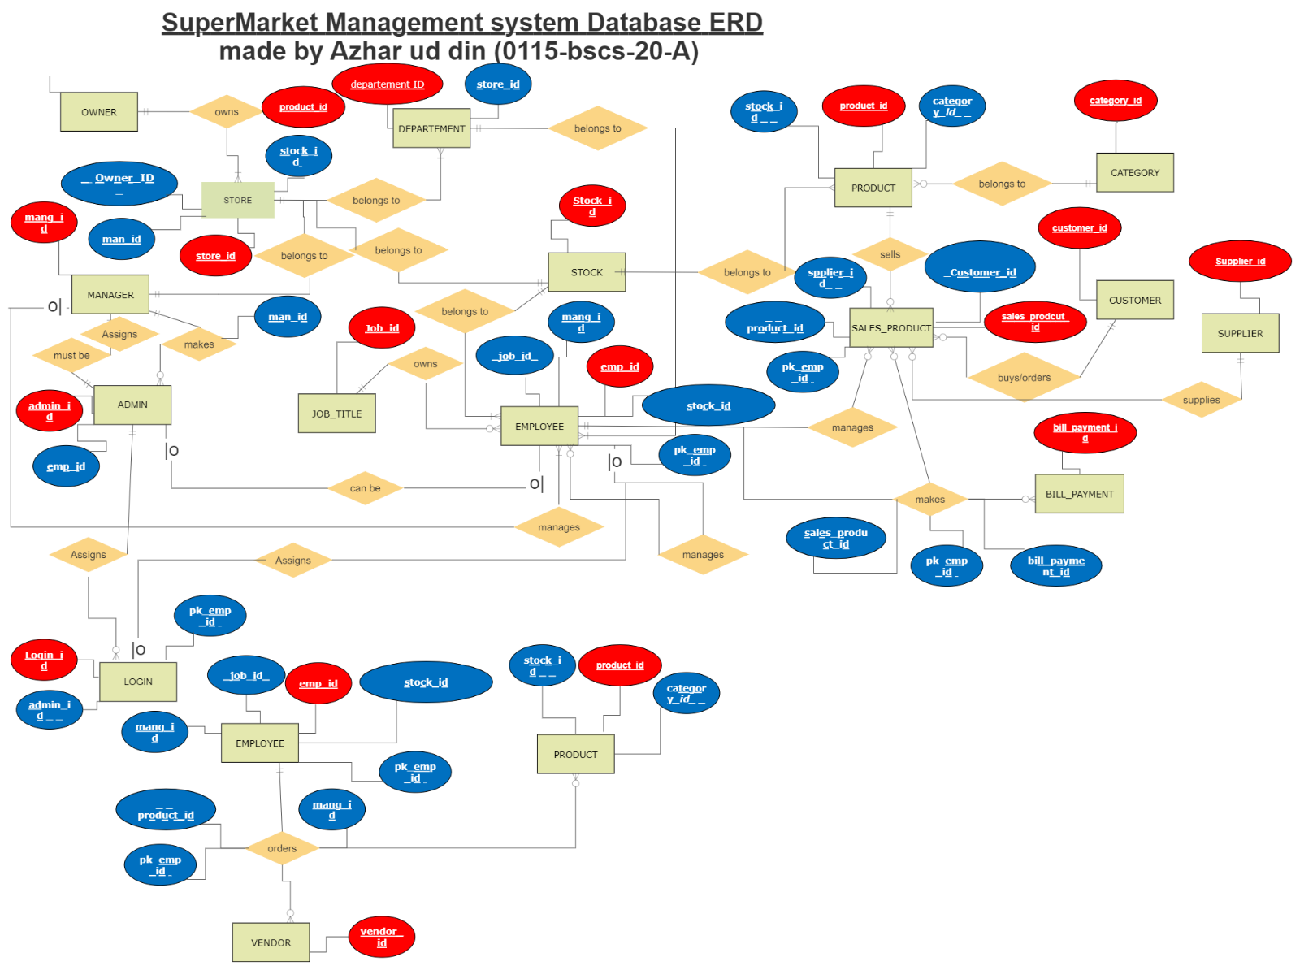

|  |  |  |
| --- | --- | --- |
| OWNER | | |
| COLUMN NAME | DATATYPE | ALLOW NULL |
| Owner_id | Tinyint | Not |
| firstName | Varchar(15) | Not |
| lastName | Varchar(15) | Yes |
| phoneNumber | Varchar(11) | Not |
| Address | Varchar(30) | yes |

|  |  |  |
| --- | --- | --- |
| **STOCK** | | |
| stk_id | **Varchar(8)** | **Not** |
| **Stk_location** | Varchar(8) | not |

|  |  |  |
| --- | --- | --- |
| **STORE** | | |
| Str_id | **Tinyint** | **Not** |
| Str_name | Varchar(15) | **Not** |
| Str_location | **Varchar(10)** | **Not** |
| fk_owner_id | Tinyint | **Not** |
| Fk_manager_id | **tinyint** | **Not** |
| Fk_stock_id | **Varchar(8)** | **Not** |
|  |  |  |

|  |  |  |
| --- | --- | --- |
| **DEPARTEMENT** | | |
| d_id | SmallInt | Not |
| fk_store_id | TinyInt | Not |
| d_name | Varchar(20) | Not |
| d_location | Varchar(20) | Not |
| Department_type | Varchar(15) | not |

|  |  |  |
| --- | --- | --- |
| JOB_TITLE | | |
| j_id | Varchar(8) | Not |
| J_name | Varchar(20) | not |

|  |  |  |
| --- | --- | --- |
| **EMPLOYEE** | | |
| emp_id | INT | NOT |
| emp_firstName | VARCHAR(20) | NOT |
| emp_lastName | VARCHAR(20) | YES |
| emp_SSN | NUMERIC(9) | NOT |
| emp_address | VARCHAR(20) | NOT |
| emp_email | VARCHAR(20) | NOT |
| emp_phoneNumber | VARCHAR(11) | NOT |
| emp_salary | SMALLMONEY | YES |
| emp_dateJoin | DATE | YES |
| fk_job_id | VARCHAR(8) | YES |
| fk_manager_id | TINYINT | YES |
| fk_emp_id | int | NOT |
| fk_stock_id | VARCHAR(8) | NOT |
| fk_dep_id | SMALLINT | NOT |
|  |  |  |

|  |  |  |
| --- | --- | --- |
| ADMIN | | |
| admin_id | varchar(20) | NOT |
| emp_id | int | YES |

|  |  |  |
| --- | --- | --- |
| **LOGIN** | | |
| log_id | varchar(20) | NOT |
| fk_emp_id | int | YES |
| fk_admin_id | varchar(20) | NOT |
| log_userName | varchar(20) | NOT |
| log_password | varchar(20) | NOT |

|  |  |  |
| --- | --- | --- |
| PRODUCT | | |
| pr_id | varchar(30) | NOT |
| pr_name | varchar(30) | NOT |
| pr_price | smallmoney | NOT |
| pr_quantity | int | NOT |
| fk_stock_id | varchar(8) | NOT |
| fk_category_id | varchar(20) | YES |

|  |  |  |
| --- | --- | --- |
| **CUSTOMER** | | |
| cus_id | varchar(10) | NOT |
| cu_firstName | varchar(20) | NOT |
| cus_lastName | varchar(20) | YES |
| cus_phoneNumber | varchar(13) | NOT |
| cus_delivery_address | varchar(25) | YES |
| cus_email | varchar(20) | NOT |
| cus_accountNo | varchar(20) | YES |

|  |  |  |
| --- | --- | --- |
| CATEGORY | | |
| ca_id | varchar(20) | NOT |
| ca_name | varchar(30) | NOT |

|  |  |  |
| --- | --- | --- |
| SELLS_PRODUCT | | |
| sales_product_id | varchar(20) | NOT |
| sal_date | date | NOT |
| sal_quantity | smallint | NOT |
| fk_customer_id | varchar(10) | NOT |
| fk_product_id | varchar(30) | NOT |
| fk_emp_selled_id | int | NOT |
| fk_supplier_id | varchar(10) | YES |
| sal_dilivery_charge | smallmoney | YES |
| sal_amount | smallmoney | NOT |

|  |  |  |
| --- | --- | --- |
| BILL_PAYEMENT | | |
| bil_id | varchar(15) | NOT |
| bil_date | DATETIME | YES |

|  |  |  |
| --- | --- | --- |
| SUPPLIER | | |
| sup_id | varchar(10) | NOT |
| sup_firstName | varchar(20) | NOT |
| sup_lastName | varchar(20) | YES |
| sup_phoneNumber | varchar(15) | NOT |
| sup_email | varchar(20) | NOT |
| sup_address | varchar(20) | NOT |
| sup_cnic | varchar(14) | NOT |

|  |  |  |
| --- | --- | --- |
| MAKING_BILL | | |
| fk_bil_id | varchar(15) | NOT |
| fk_cashier_id | int | NOT |
| fk_sal_product_id | varchar(20) | NOT |
|  |  |  |

|  |  |  |
| --- | --- | --- |
| VENDOR_PRODUCT | | |
| ven_product_id | varchar(30) | NOT |
| ven_product_name | varchar(20) | NOT |
| ven_productcategory | varchar(20) | NOT |

|  |  |  |
| --- | --- | --- |
| VENDOR | | |
| ven_id | varchar(15) | NOT |
| ven_name | varchar(20) | NOT |
| ven_product_ID | varchar(30) | NOT |
| Ven_pro_manufacturer | varchar(30) | NOT |
| ven_address | varchar(30) | NOT |
| ven_phoneNumber | varchar(13) | NOT |
| ven_email | varchar(20) | NOT |

|  |  |  |
| --- | --- | --- |
| ORDER | | |
| order_id | varchar(15) | NOT |
| fk_vendor_id | varchar(15) | NOT |
| fk_product_id | varchar(30) | NOT |
| order_quantity | int | NOT |
| order_date | date | NOT |
| order_totalPrice | smallmoney | NOT |
| fk_emp_id | int | NOT |
| order_vendor_payedIn  Advance | bit | NOT |