**LAB # 4**

Objective: -To get familiar with RMI callback.

Task 01:-

Develop the RMI Callback application of Payroll and PayrollMessage services for calculating the earnings.

**PayrollInterface.java**

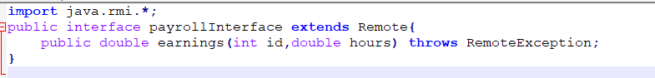

**payrollMessageInterface.java**

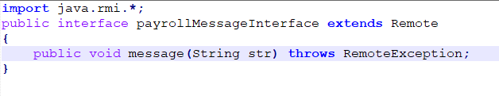

**payrollImpl.java**

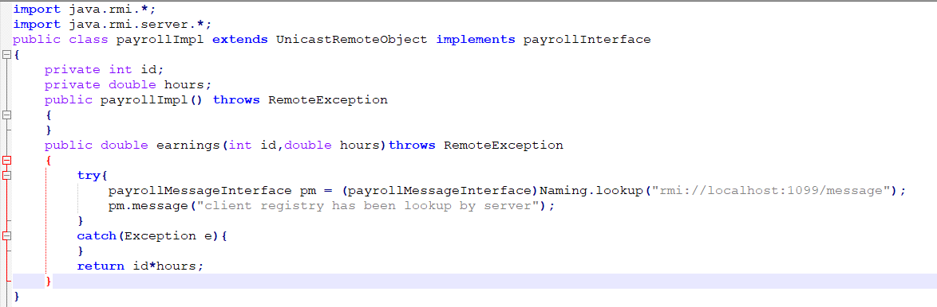

**payrollMessageImpl.java**

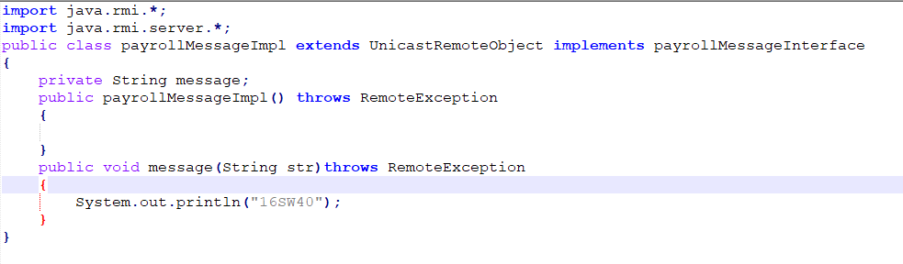

**payrollServer.java**

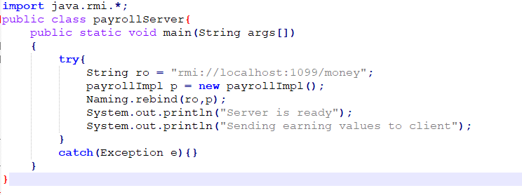

**payrollClient.java**

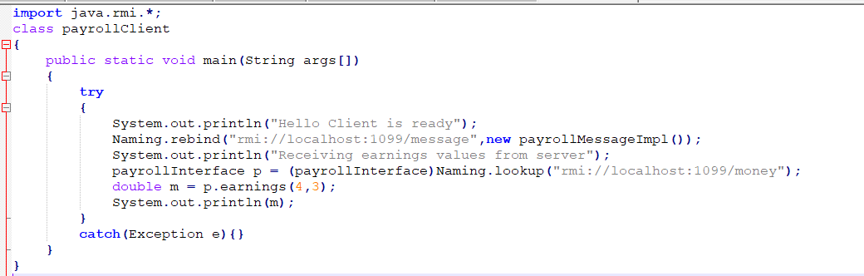

**Output:**

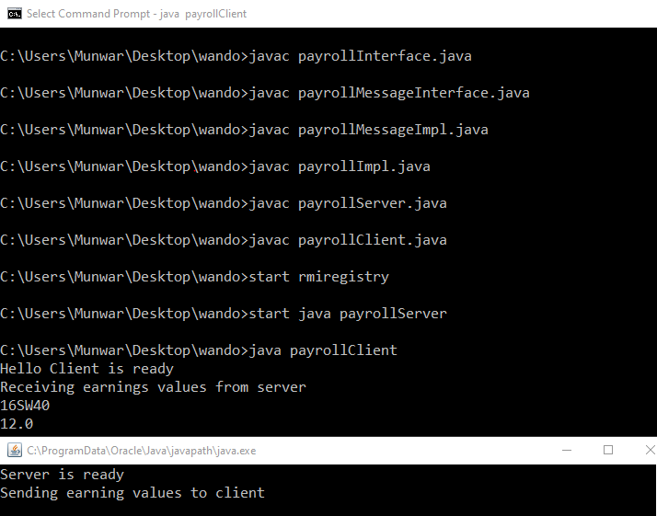

Task 02:-

Optional Task: Develop an RMI application for chatting between client and server, the chatting should stop when both of them say “bye”.

**ClientChatInterface.java**

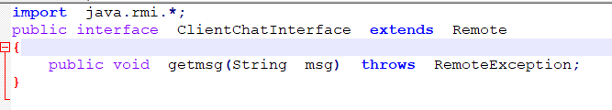

**ServerChatInterface.java**

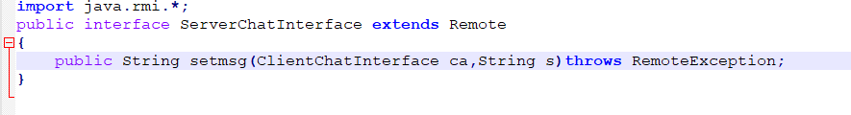 **ChatClient.java**

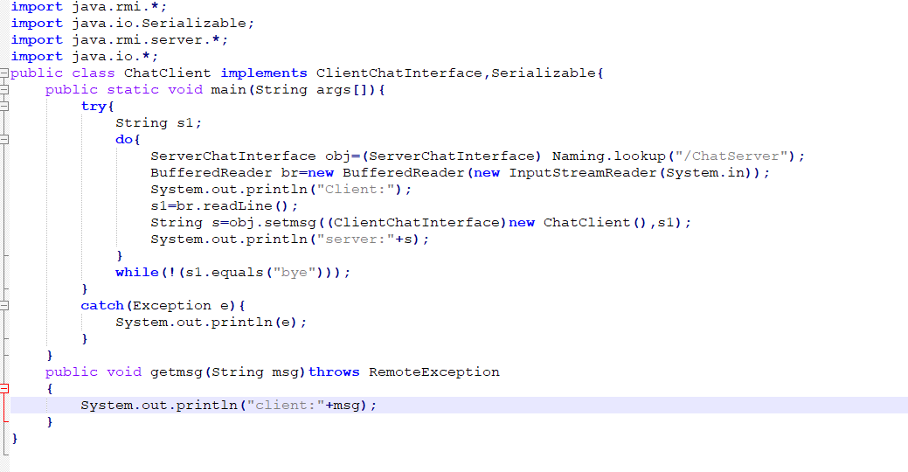

**ChatServer.java**

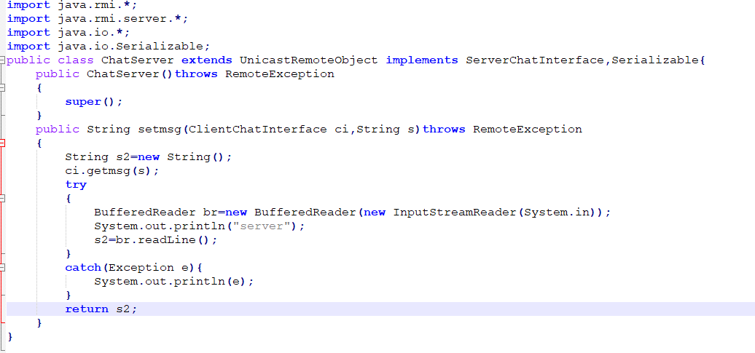

**Reg.java**

