**Lab # 5**

Objective: -To become familiar with RMI Object Serialization.

Class Task 01:-

Create a program in which server sharing an object via RMI and a client calling the shared instance.

**Api.java**

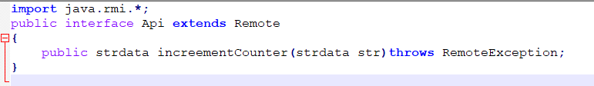

**ApiImpl.java**

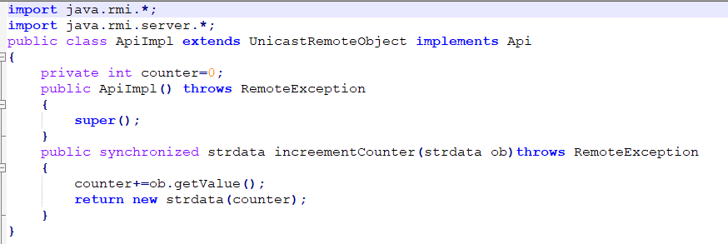

**Strdata.java**

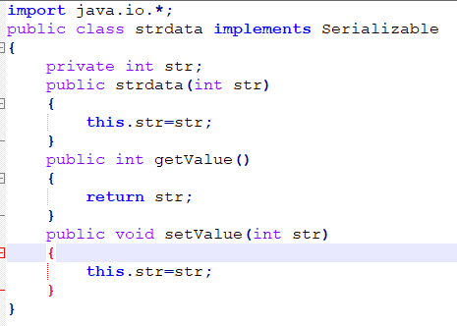

**Server.java**

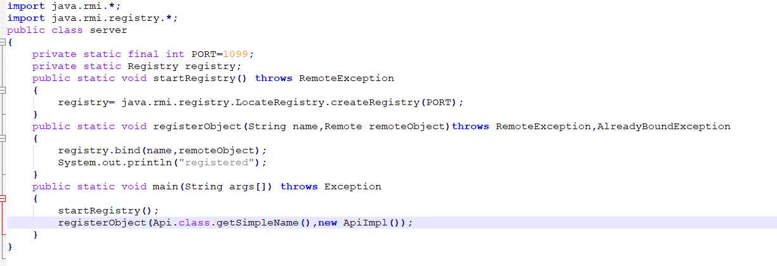

**Client.java**

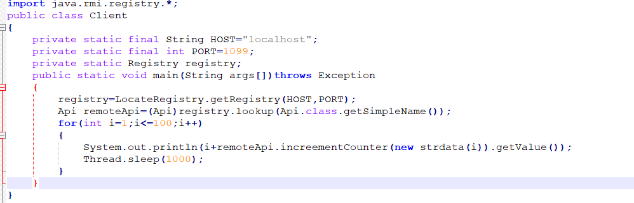

Output:

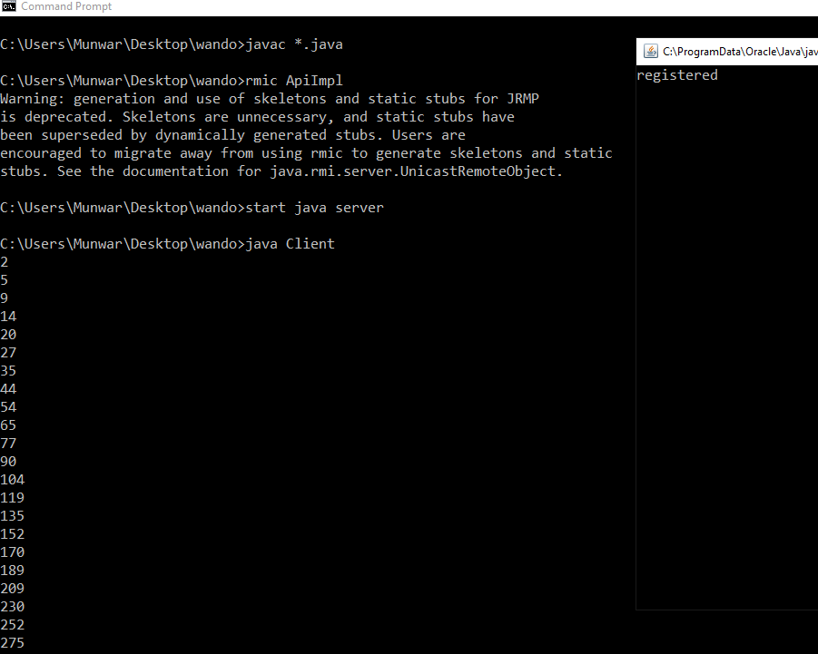

Task 01:-

Develop any simple application to demonstrate object passing in RMI. (Expl: Make a class of your own and use its objects as arguments and return types for RMI).

**Marsh.java**

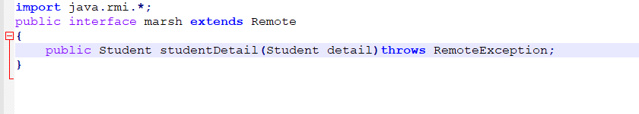

**marshImpl.java**

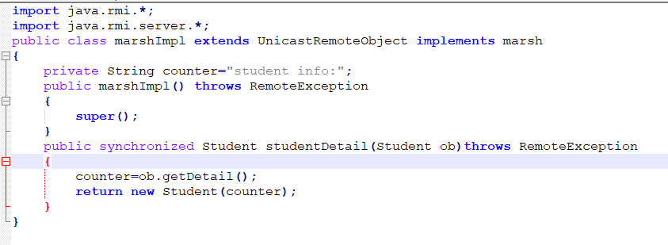

**Student.java**

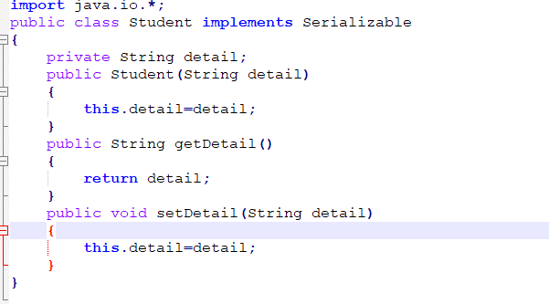

**marshServer.java**

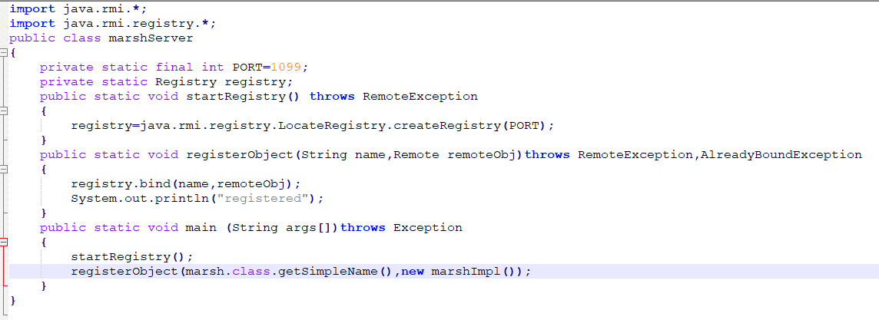

**marshClient.java**

