**LAB # 6**

**Task :- Create RMI IIOP application in which take a sentence at runtime on the client application and let the server return its reverse.**

**E.g. input could be: subject is distributed computing   
output should be: computing distributed is subject.**

**Program:**

**InterfaceReverse.java**

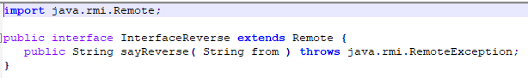

**ReverseImpl.java**

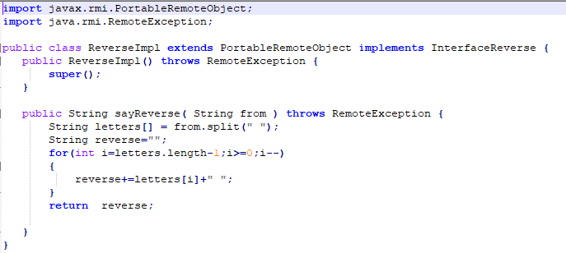

**HelloServer.java**

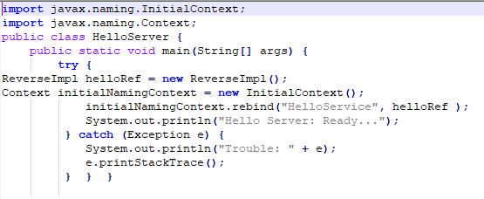

**HelloClientIIOP.java**

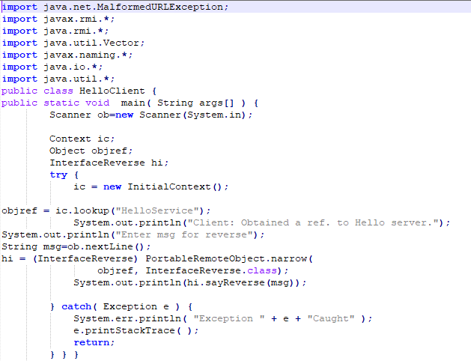

**OUTPUT :**

