**LAB # 7**

**OBJECT : TO UNDERSTAND MULTITHREADING.**

**Write the same code for matrix multiplication and divide the code into ten threads. Also note the timestamp at the start and end of the program. Give your conclusion.**

**Matrix Multiplication using Traditional Method:**

**Program :**

**Multiplication.java**

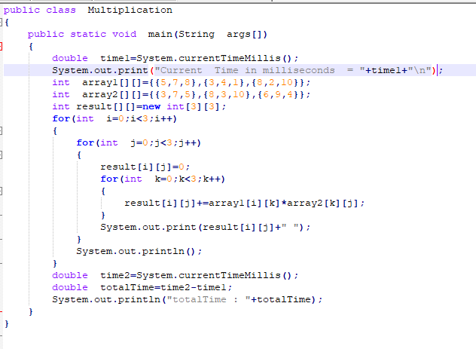

**OUTPUT :**

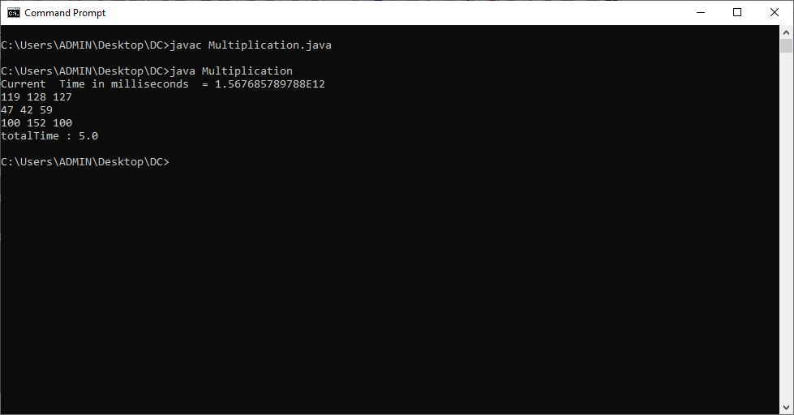

**Matrix Multiplication Using Thread:**

**Program:-**

**MultiplicationUsingThread.java**

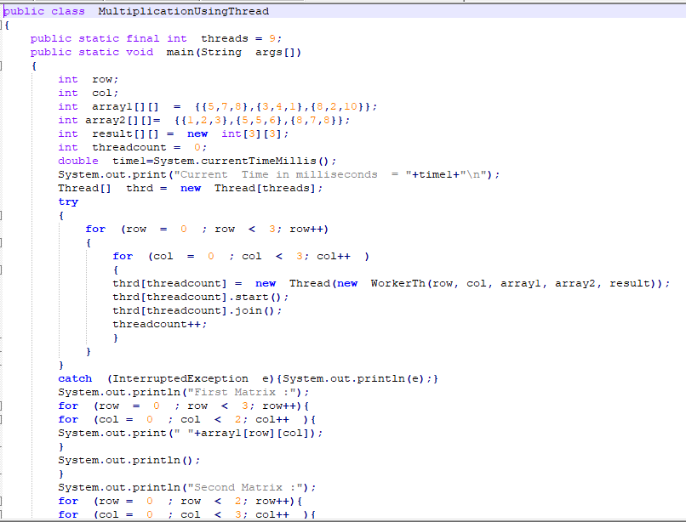 

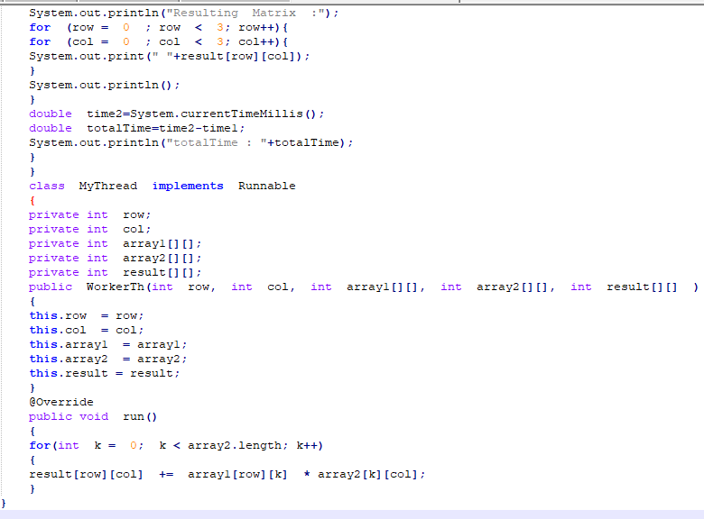

**OUTPUT :**

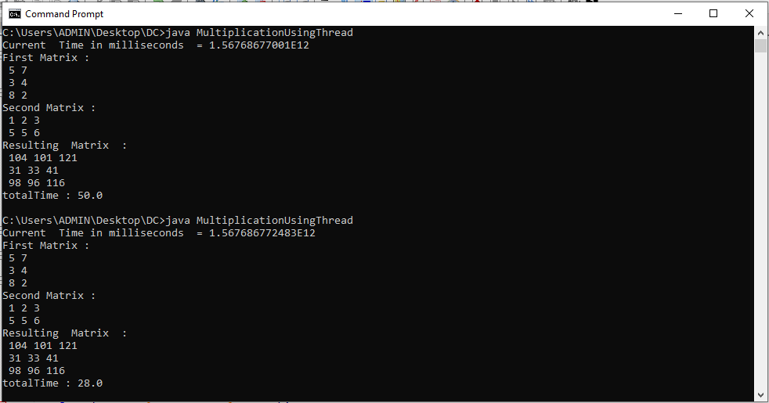

**Conclusion: We Performed Both approaches with Thread and without Thread and from the result we see that time is taken more in Thread approach as compare to without thread approach.**