**LAB # 8**

**TASK: 01**

**Create an XML document structuring information for a store. (Shopping store of your choice)**

<?xml version="1.0" encoding="ISO-8859-1" ?>

<store>

<name>Super Store Online </name>

<openDate>01-04-2010</openDate>

<closeDate>23-03-2018</closeDate>

<product>

<name>Rice</name>

<magDate>20-03-2018</magDate>

<expDate>23-9-2019</expDate>

<price>2000</price>

</product>

<employee>

<name>Munwar</name>

<address>C-17 phase 02 Qasimabad Hyderabad</address>

<salary>20000</salary>

</employee>

</store>

**TASK:02**

**Create DTD for store XML Document. And validate on http://www.w3schools.com/xml/xml_validator.asp**

**DTD: (Validation)**

**<?xml version="1.0" encoding="ISO-8859-1" ?>**

**<!DOCTYPE store**

**[**

**<!ELEMENT store (name,openDate,closeDate,porduct,employee)>**

**<!ELEMENT name (#PCDATA)>**

**<!ELEMENT openDate (#PCDATA)>**

**<!ELEMENT closeDate (#PCDATA)>**

**<!ELEMENT porduct (name,magDate,expDate,price)>**

**<!ELEMENT name (#PCDATA)>**

**<!ELEMENT magDate (#PCDATA)>**

**<!ELEMENT expDate (#PCDATA)>**

**<!ELEMENT price (#PCDATA)>**

**<!ELEMENT employee (name,address,salary)>**

**<!ELEMENT name (#PCDATA)>**

**<!ELEMENT address (#PCDATA)>**

**<!ELEMENT salary (#PCDATA)>**

**]>**

**<store>**

**<name>Super Store Online </name>**

**<openDate>01-04-2010</openDate>**

**<closeDate>23-03-2018</closeDate>**

**<product>**

**<name>Rice</name>**

**<magDate>20-03-2018</magDate>**

**<expDate>23-9-2019</expDate>**

**<price>2000</price>**

**</product>**

**<employee>**

**<name>Munwar</name>**

**<address>C-17 phase 02 Qasimabad Hyderabad</address>**

**<salary>20000</salary>**

**</employee>**

**</store>**

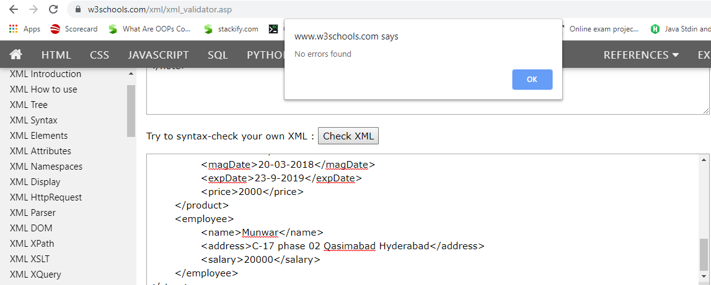

**TASK:03**

**Write XML Schema for the following XML document and then validate the XML document along with its schema on the following website:**

**http://www.utilities-online.info/xsdvalidation/#.UlFx2tKmhIg**

**<?xml version="1.0" encoding="ISO-8859-1" ?>**

**<xs:schema attributeFormDefault="unqualified" elementFormDefault="qualified" xmlns:xs="http://www.w3.org/2001/XMLSchema">**

**<xs:element name="store">**

**<xs:complexType>**

**<xs:sequence>**

**<xs:element type="xs:String" name="name"/>**

**<xs:element type="xs:Date" name="openDate"/>**

**<xs:element type="xs:Date" name="closeDate"/>**

**<xs:element name="product">**

**<xs:complexType>**

**<xs:sequence>**

**<xs:element type="xs:String" name="name"/>**

**<xs:element type="xs:Date" name="magDate"/>**

**<xs:element type="xs:Date" name="expDate"/>**

**<xs:element type="xs:float" name="price"/>**

**</xs:sequence>**

**</xs:complexType>**

**</xs:element>**

**<xs:element name="employee">**

**<xs:complexType>**

**<xs:sequence>**

**<xs:element type="xs:String" name="name"/>**

**<xs:element type="xs:String" name="address"/>**

**<xs:element type="xs:float" name="salary"/>**

**</xs:sequence>**

**</xs:complexType>**

**</xs:element>**

**</xs:sequence>**

**</xs:complexType>**

**</xs:element>**

**</xs:schema>**

**<store>**

**<name>Super Store Online </name>**

**<openDate>01-04-2010</openDate>**

**<closeDate>23-03-2018</closeDate>**

**<product>**

**<name>Rice</name>**

**<magDate>20-03-2018</magDate>**

**<expDate>23-9-2019</expDate>**

**<price>2000</price>**

**</product>**

**<employee>**

**<name>Munwar</name>**

**<address>C-17 phase 02 Qasimabad Hyderabad</address>**

**<salary>20000</salary>**

**</employee>**

**</store>**