**KeePass**

This is a tool to save domain account names, SQL login names and their associated passwords, for the Getty Images environment. To access this tool, go to any server in the Amer domain and then execute the following:

Start 🡪 Run:

[\\SeapDbaSql01\DBA_Docs\utilities\KeyPass\KeePass Password Safe](\\\\SeapDbaSql01\\DBA_Docs\\utilities\\KeyPass\\KeePass Password Safe)

- Run KeePass.exe

- When prompted, enter password yesBao7

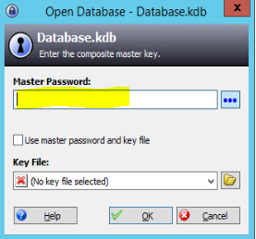

- Repository = [\\SeapDbaSql01\DBA_Docs\utilities\KeyPass\Keypass file\Database.kdb](\\\\SeapDbaSql01\\DBA_Docs\\utilities\\KeyPass\\Keypass file\\Database.kdb)