Fix the phone number on contact and make both email and phone clickable.
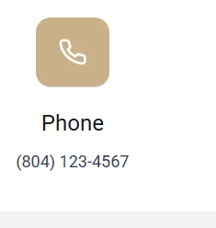
Property address is not optional. Without it, we cannot do much.
I was able to submit an empty form, please validate the form and is this linked with inquire@simplifyrvahomes.com? (we’ll get an email anytime someone enter a new contact) I did not see anything coming in.
HOME
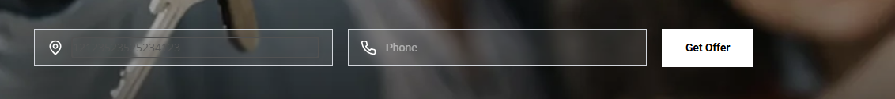
I tried to type in an address, but I couldn’t see or type anything in the box.
There is only 1 review on this carousel:

FAQ
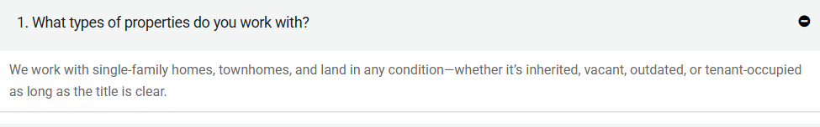
Remove dashes, update, we work with single family homes, multi family homes and land in any condition whether …

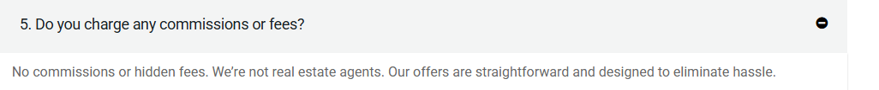
Update this answer to the one I provided on Feb 3
Are there any commissions when selling to Simplify RVA Homes?
No, there are no commissions or hidden fees when you sell directly to Simplify RVA Homes. We’re not listing your house, we’re buying it. You get a simple, cash offer with no agent costs.

However, if you prefer to list your property on the market, we can absolutely help with that too. We’ll walk you through the process and negotiate all fees upfront. No surprises. Transparency is important to us in every step.

Also, I’m not sure where the rest of the Q&A are:
- questionnaires.
Why should I sell my house to Simplify RVA Homes?
We make selling your home fast and stress-free by buying it as-is—no repairs, fees, or cleaning required. Whether you're facing a life transition, inherited a property, or just want to skip the hassle of traditional listings, we offer flexible solutions tailored to your situation.

Will you list my house on the MLS?
We may or may not list your house on the MLS, it depends on your goals. In many cases, we purchase properties directly to avoid listing delays, but if listing is the best option to maximize your return, we can absolutely help you prepare and list it on the MLS through our licensed brokerage partner.

How do you determine the price to offer?
We evaluate several key factors, including the condition of your property, recent comparable sales in the area, needed repairs or updates, and current market trends. Our goal is to make a fair, no-obligation offer that reflects your home’s value while saving you the hassle of listing and showing.

How quickly can I expect to close the sale of my house?
We can typically close in as little as 14 days, depending on title clearance and your timeline. If you need more time, we can work with your schedule. Our goal is to make the process as smooth and stress-free as possible.

Are there any commissions when selling to Simplify RVA Homes?
No, there are no commissions or hidden fees when you sell directly to Simplify RVA Homes. We’re not listing your house, we’re buying it. You get a simple, cash offer with no agent costs.

However, if you prefer to list your property on the market, we can absolutely help with that too. We’ll walk you through the process and negotiate all fees upfront. No surprises. Transparency is important to us in every step.

What conditions does the house have to be in?
We buy houses in any condition whether it’s outdated, needs a full renovation, or has been inherited and left untouched for years. You don’t need to clean, make repairs, or worry about staging.

If it has a clear title, we’ll handle the rest. Even if you’re dealing with code violations, liens, or problem tenants, we can work through it with you.

You also don’t have to worry about constant showings or strangers walking through your home. It's a low-stress, private process tailored for your peace of mind.

Our goal is to make the process simple, even when the property isn’t.

Make all the button actionable

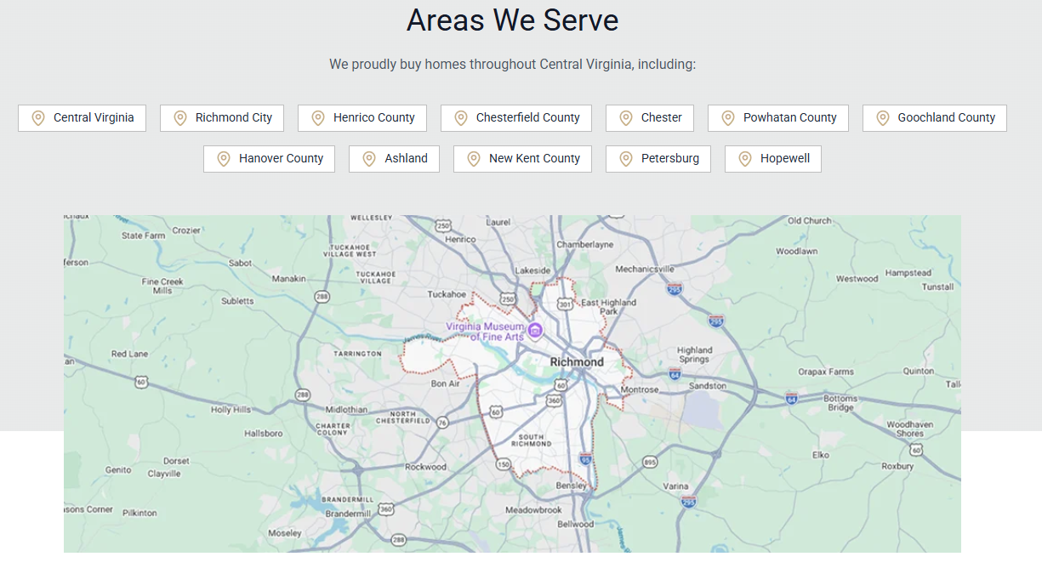
Remove “Central Virginia” from the list. These counties are Central VA counties, on all the maps.
Can you change the houses photos to something more realistic for Central VA homes (example colonial homes)
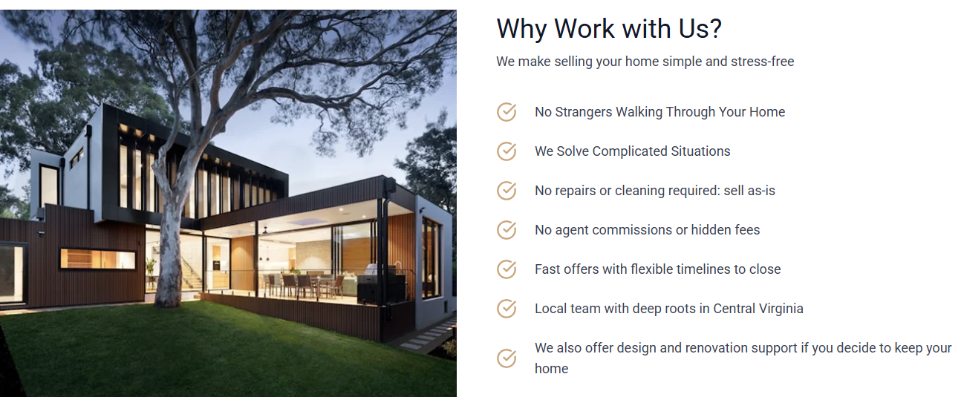

Example:
