Genetic Inverse Design of Polymer Dielectrics Using a Multimodal Multitask Pretrained Framework
ABSTRACT
Polymer dielectrics combining low relative permittivity ($ε_{r}$) with high glass-transition temperature ($T_{g}$) are essential for advanced microelectronics, yet these properties are often inversely coupled, restricting viable candidates to a narrow, hard-to-explore region of chemical space. Here we present GA-MMPolymer, a closed-loop inverse-design framework coupling a multimodal surrogate model with fragment-based genetic optimization. Conventional one-dimensional (1D) sequence representations encode backbone topology effectively but cannot resolve three-dimensional (3D) conformational features—fractional free volume, segmental packing, and dipole-orientation distributions—that critically govern dielectric response. MMPolymer addresses this limitation by aligning a 1D repeat-unit encoder with a 3D conformational encoder via cross-modal contrastive pretraining on over one million polymer structures, then fine-tuning on experimental $T_{g}$ and high-fidelity computed $ε_{r}$ data. The resulting surrogate achieves R² ≈ 0.92 for $T_{g}$ and R² ≈ 0.84 for $ε_{r}$, outperforming unimodal baselines, with the multimodal gain most pronounced for $ε_{r}$ where 3D spatial awareness captures polarization contributions inaccessible to 1D topology. Guided by this surrogate, a BRICS-based genetic algorithm drives the population-mean $T_{g}$ from approximately 150 °C to nearly 300 °C over 50 generations while lowering the mean $ε_{r}$ to approximately 2.5, with elite candidates reaching $ε_{r}$ < 2.3. Density functional theory and all-atom molecular dynamics verification confirms close surrogate–simulator agreement. Top-ranked de novo candidates reveal complementary design strategies—rigid fluorinated backbones and dipole-dilution architectures—occupying sparsely populated regions of the $T_{g}$–$ε_{r}$ Pareto landscape.
Introduction
The widespread deployment of next-generation information technologies, including 5G/6G communications, artificial intelligence, and the Internet of Things, continues to increase data rates and interconnect densities, thereby pushing microelectronic materials into more stringent electrical and thermal operating regimes. In high-density back-end-of-line (BEOL) wiring and high-frequency modules (mmWave/THz), the dielectric layer is no longer a passive component: its permittivity directly controls capacitive loading, signal delay, and crosstalk, and thus influences both power dissipation and thermal management. Consequently, next-generation polymer dielectrics are expected to combine ultra-low relative dielectric permittivity ($ε_{r}$) with high glass-transition temperature () to maintain signal integrity and dimensional stability under aggressive processing and operating conditions.
Meeting these electrical and thermal requirements simultaneously remains difficult because dielectric permittivity and thermal stability are often anticorrelated in polymer design. Approaches that lower $ε_{r}$ typically reduce polarization density and increase fractional free volume, for example by introducing bulky low-polarity substituents or flexible segments that disrupt efficient packing. While such motifs can suppress capacitive loading, they may also weaken intermolecular cohesion and decrease backbone rigidity, thereby reducing . Conversely, strategies aimed at increasing —including rigid aromatic backbones, strong dipolar interactions, and dense packing that restrict segmental motion—often raise polarizability per unit volume and therefore increase . This intrinsic tension confines high-, low- polymers to a narrow sweet spot within a vast chemical space, rendering intuition-driven discovery slow and unreliable.
The search for this sweet spot is further constrained by the high cost of reliable property evaluation. Experimental synthesis and characterization of polymer dielectrics are inherently low throughput, and iterative trial-and-error becomes impractical as the candidate space expands combinatorially. Meanwhile, physics-based computations provide strong mechanistic fidelity but remain too expensive for large-scale screening. Predicting $ε_{r}$ requires capturing both the high-frequency electronic response and the condensed-phase dipolar contribution under realistic morphologies, whereas determining $T_{g}$ demands extensive sampling across nonequilibrium thermal protocols and structural heterogeneity in amorphous cells. These requirements create a persistent speed–accuracy dilemma: high-fidelity DFT/MD workflows provide trustworthy benchmarks for individual candidates, but they cannot be naively applied across broad polymer chemical space.
Recent data-driven inverse-design approaches—including variational autoencoders (VAEs), Bayesian optimization (BO), and reinforcement learning (RL)—have accelerated molecular generation for small molecules and, increasingly, for polymers. However, most of these methods operate on fixed-length SMILES strings or molecular graphs without explicitly encoding three-dimensional conformational effects, and few incorporate synthesizability constraints during the generative process. Fragment-based genetic algorithms offer a complementary route that naturally preserves chemical valence rules through building-block assembly, accommodates variable-length repeat units, and can be directly coupled with domain-specific fitness functions.
To address this bottleneck, we propose GA-MMPolymer, an inverse-design framework that couples a multimodal pretrained surrogate with chemically grounded evolutionary optimization for polymer dielectrics under competing constraints. The core of this approach is MMPolymer, a dual-branch representation model that integrates 1D chemical semantics from polymer repeat-unit sequences with 3D conformational cues and aligns the two modalities through cross-modal contrastive learning to enable conformation-aware prediction of $ε_{r}$ and $T_{g}$. Building on this surrogate, we perform de novo exploration using a fragment-based genetic algorithm operating on BRICS-derived building blocks, which promotes both chemical validity and synthetic plausibility during candidate generation. Candidate polymers are then ranked with a constraint-aware multi-objective criterion that prioritizes thermal stability while penalizing dielectric-target violations, and the most promising designs are subsequently assessed with DFT and all-atom MD.
Our contributions are threefold: (i) a multimodal, conformation-aware surrogate that unifies 1D polymer semantics with 3D structural cues for property prediction; (ii) a synthesizability-aware genetic optimization procedure tailored to polymer repeat-unit design under competing objectives; and (iii) a consistent DFT/MD verification protocol for reliable assessment of top-ranked candidates.
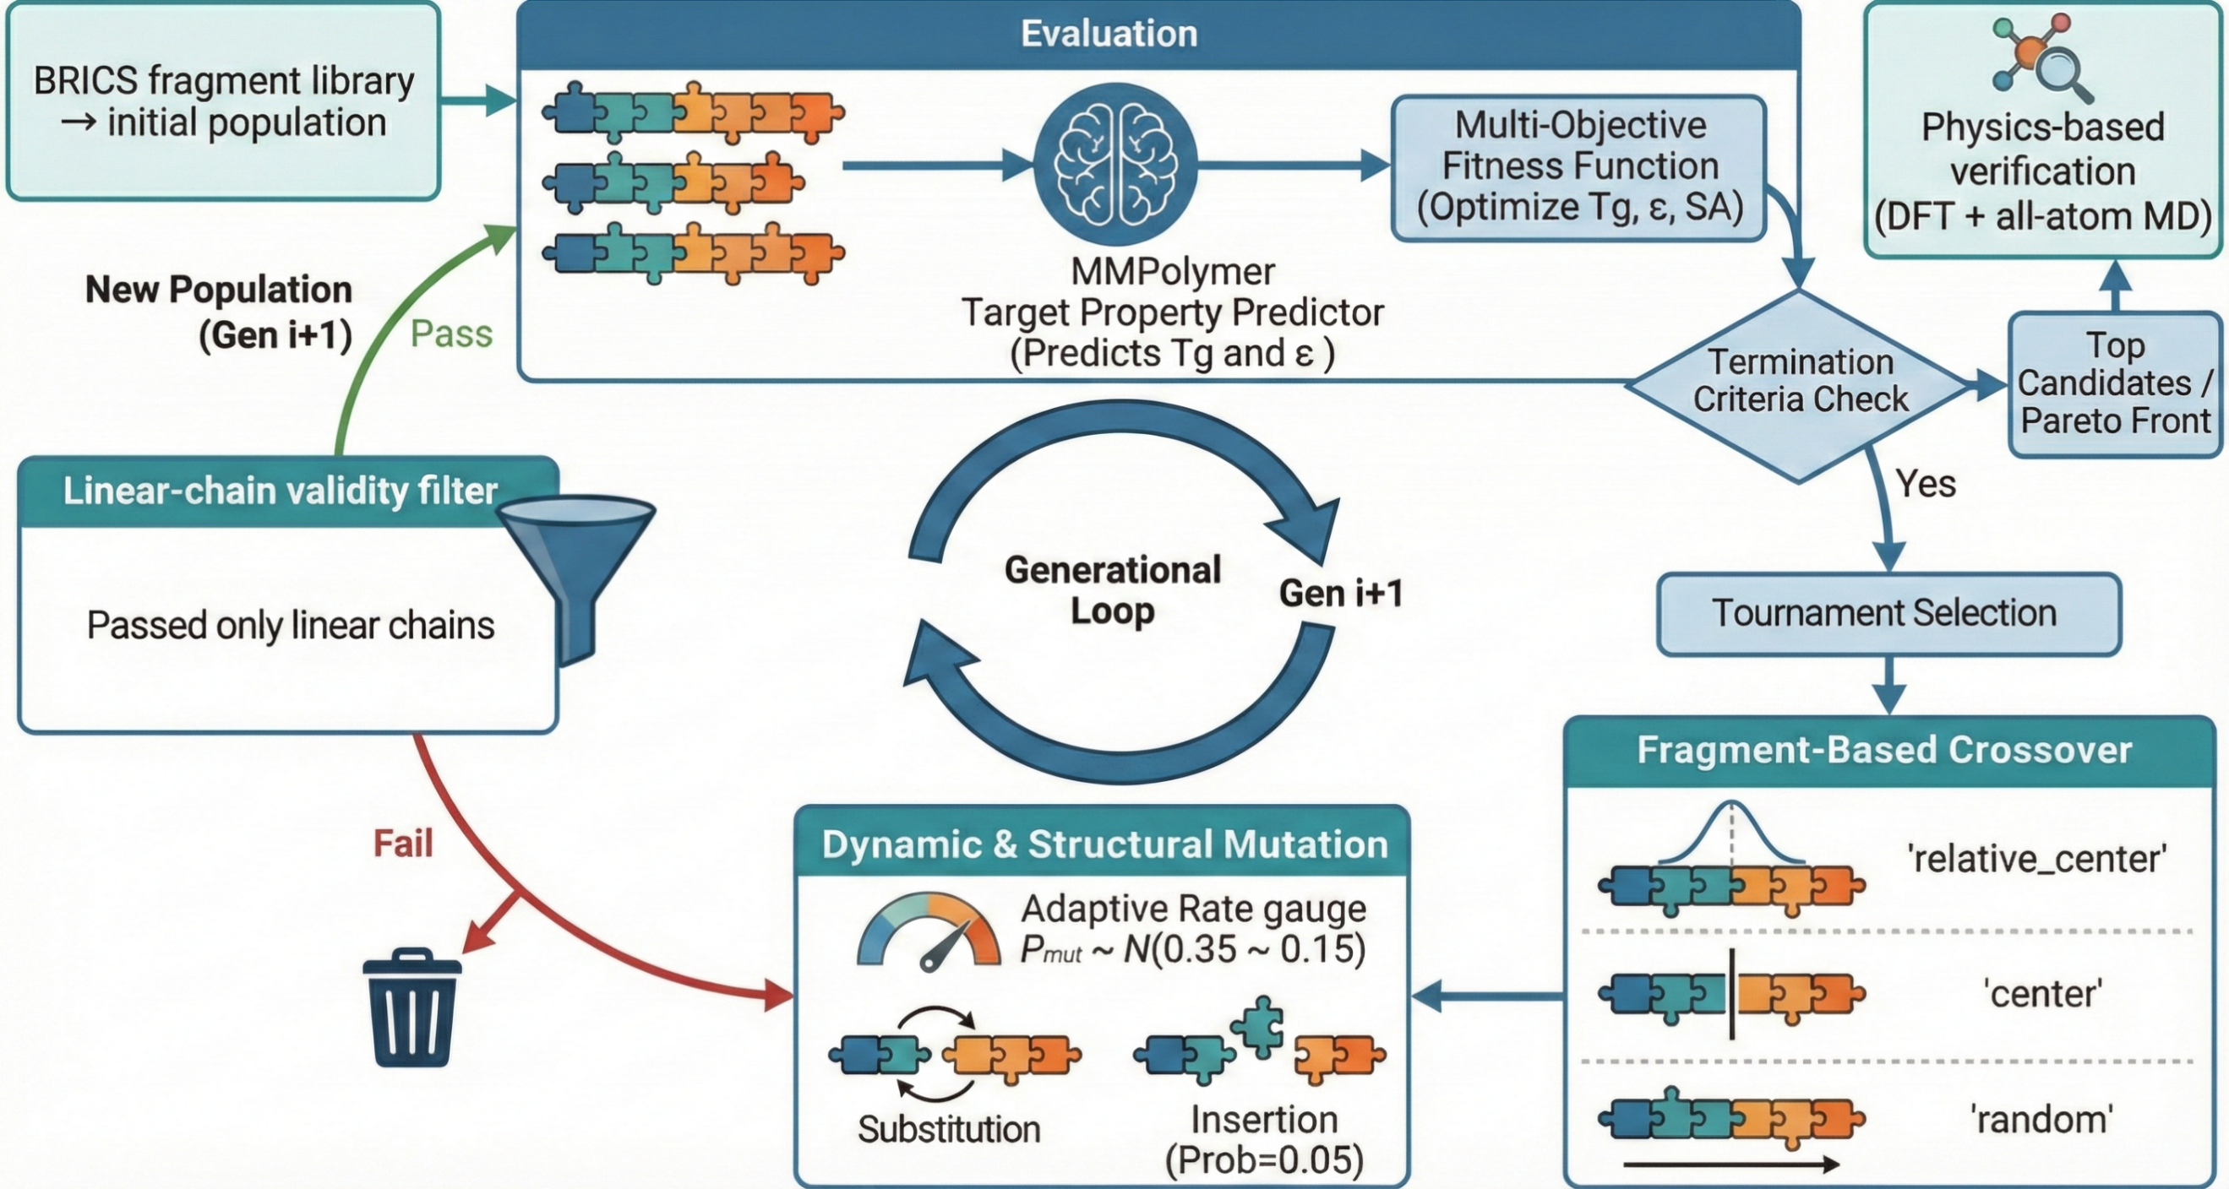
Figure 1. Overview of the GA-MMPolymer closed-loop inverse-design workflow. An initial population is assembled from a BRICS-derived fragment library and iteratively optimized in a generational loop. In each generation, candidates are evaluated by the MMPolymer surrogate to predict $T_{g}$ and $ε_{r}$, which are combined with synthetic accessibility to form a multi-objective fitness function (maximize $T_{g}$, minimize $ε_{r}$, and minimize SA score). Offspring are generated via tournament selection, fragment-based crossover, and adaptive mutation (substitution/insertion), followed by a linear-chain validity filter. Upon termination, top candidates on the Pareto front are subjected to physics-based verification using DFT and all-atom MD.
Results & Discussion
To establish a robust representation space capable of generalizing across diverse polymer architectures, MMPolymer was first pretrained on PI1M, a large-scale repository containing more than one million unlabeled polymer structures. Through masked-atom reconstruction, coordinate denoising, and cross-modal contrastive alignment, this self-supervised stage encodes transferable chemical representations that capture both topological connectivity and spatial arrangement before the downstream regression tasks for $T_{g}$ and $ε_{r}$. The overall MMPolymer architecture and multimodal multitask pretraining scheme are summarized in Figure 2.
Figure 2. Schematic illustration of the multimodal multitask pretraining framework. The model integrates 1D SMILES sequences and 3D conformational data using a RoBERTa encoder and a Transformer encoder, respectively. The central pretraining module employs 15% masking, noise injection, and contrastive alignment to learn robust representations through input reconstruction and cross-modal consistency. A downstream property-prediction head then estimates key material characteristics, including $T_{g}$ and $ε_{r}$.
Following pretraining, the model was fine-tuned on curated, task-specific labeled datasets using a hybrid data strategy in which $T_{g}$ and $ε_{r}$ were supervised against different reference domains. All-atom MD simulations of $T_{g}$ are well known to exhibit substantial systematic bias because the simulated cooling rates exceed experimental differential scanning calorimetry (DSC) conditions by several orders of magnitude; the $T_{g}$ surrogate was therefore trained against experimental measurements so that its predictions remain anchored to the experimental scale. In contrast, $ε_{r}$ was trained against high-fidelity computed data, for which coupled DFT/MD workflows have been shown to agree closely with experiment. This design necessarily introduces a predictable domain shift when $T_{g}$ predictions are later compared with MD-derived external references, but it avoids learning a simulator-specific $T_{g}$ scale that is already biased relative to experiment.
The $T_{g}$ training data comprise 7,969 experimental records extracted from PoLyInfo after applying three quality-control filters: (1) standard DSC protocols with heating/cooling rates between 5 and 20 K min⁻¹; (2) molecular weight $M_{w}$ > 10 kDa to minimize end-group effects; and (3) unambiguous structural annotations verified against reported synthesis routes. For $ε_{r}$, we used 1,070 polymer structures from the RadonPy framework, with values calculated at 1 MHz and 300 K, retaining only entries with converged MD densities (standard deviation < 0.01 g cm⁻³) and DFT self-consistent-field convergence thresholds of 10⁻⁶ a.u. The combined dataset was split into training, validation, and test sets (80%/10%/10%) by stratified random sampling. Full training hyperparameters are provided in Supporting Information Section S1.
As shown in Figure 3, we benchmarked the fine-tuned MMPolymer against a broad set of baselines spanning three categories: traditional machine-learning models (Linear Regression, GBDT, and ExtraTrees) trained on handcrafted fingerprints, unimodal 1D sequence models (Transformer-based encoders), and unimodal 3D geometric models (Uni-Mol with explicit and implicit hydrogen settings). Performance is quantified by the coefficient of determination, R², and the root-mean-square error (RMSE).
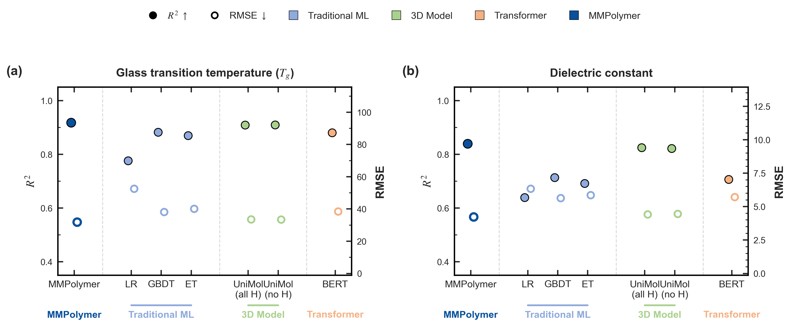
Figure 3. Performance comparison of MMPolymer against baseline models. The charts report the coefficient of determination, R² (solid circles, left axis), and root-mean-square error (RMSE; hollow circles, right axis), for each method. MMPolymer consistently achieves the best overall accuracy relative to traditional machine-learning baselines, 3D pretraining models, and Transformer-based sequence models across both prediction tasks.
The results reveal a clear performance hierarchy. Deep learning approaches consistently outperform traditional machine-learning baselines, which exhibit substantially lower R² values (generally below 0.85) and larger RMSE values across both properties. This gap underscores the limitation of fixed handcrafted descriptors in capturing the nonlinear mapping between polymer structure and thermophysical behavior. More importantly, a modality-dependent divergence emerges among the unimodal models. For $T_{g}$ prediction (Figure 3a), the 1D Transformer achieves competitive accuracy (approximately R² ≈ 0.90), indicating that sequence-encoded topological features—such as backbone rigidity, branching patterns, and aromatic content—remain highly informative for glass-transition behavior. In contrast, this advantage largely disappears for $ε_{r}$ prediction (Figure 3b), where 3D-aware models remain more robust. This pattern reflects a key physical insight: $ε_{r}$ is strongly governed by spatial factors, including fractional free volume, dipole-orientation distributions, and electronic polarizability, that cannot be fully inferred from 1D topology alone.
MMPolymer breaks this unimodal performance ceiling by fusing both modalities. Through contrastive alignment between 1D chemical semantics and 3D conformational features, the model achieves the best overall performance across both tasks, reaching approximately R² ≈ 0.92 for $T_{g}$ and R² ≈ 0.84 for $ε_{r}$, while also delivering the lowest RMSE among the compared baselines. This consistent improvement across both tasks is indicative of complementary information capture rather than redundant feature overlap between the two modalities. For $T_{g}$, the 3D branch refines topology-based predictions by incorporating steric hindrance and local packing density, which modulate segmental mobility beyond what a 1D string can encode. For $ε_{r}$, the model simultaneously captures the distribution of polar groups and their spatial arrangement, enabling a more faithful description of both electronic polarizability and orientational contributions to dielectric response. MMPolymer therefore serves as a robust surrogate for subsequent inverse design.
Equipped with MMPolymer as a high-fidelity surrogate, we extended the framework from passive property prediction to active de novo design via GA-MMPolymer. By rapidly evaluating thousands of virtual candidates, the framework navigates the vast and largely unmapped chemical space of polymer repeat units. Figure 4 tracks the evolution of chemical diversity and population fitness over 50 generations. Early generations (1–10) exhibit high chemical heterogeneity but low mean fitness, reflecting the improbability of randomly assembling candidates that simultaneously satisfy high $T_{g}$ and low $ε_{r}$. This broad initial diversity is nevertheless essential for preventing premature convergence. As evolution proceeds under an elitist selection strategy that preserves the top 10% highest-fitness individuals per generation, favorable structural motifs—particularly those conferring backbone rigidity or increased free volume—are systematically retained. The fitness trajectory (Figure 4a) rises steadily, while the 2D t-SNE map (Figure 4b) reveals a clear funneling from broadly scattered early populations into compact high-performance clusters. This convergence is corroborated by the monotonically increasing average pairwise Tanimoto similarity (Figure 4c), confirming that the population evolves toward a structurally coherent family of elite candidates.
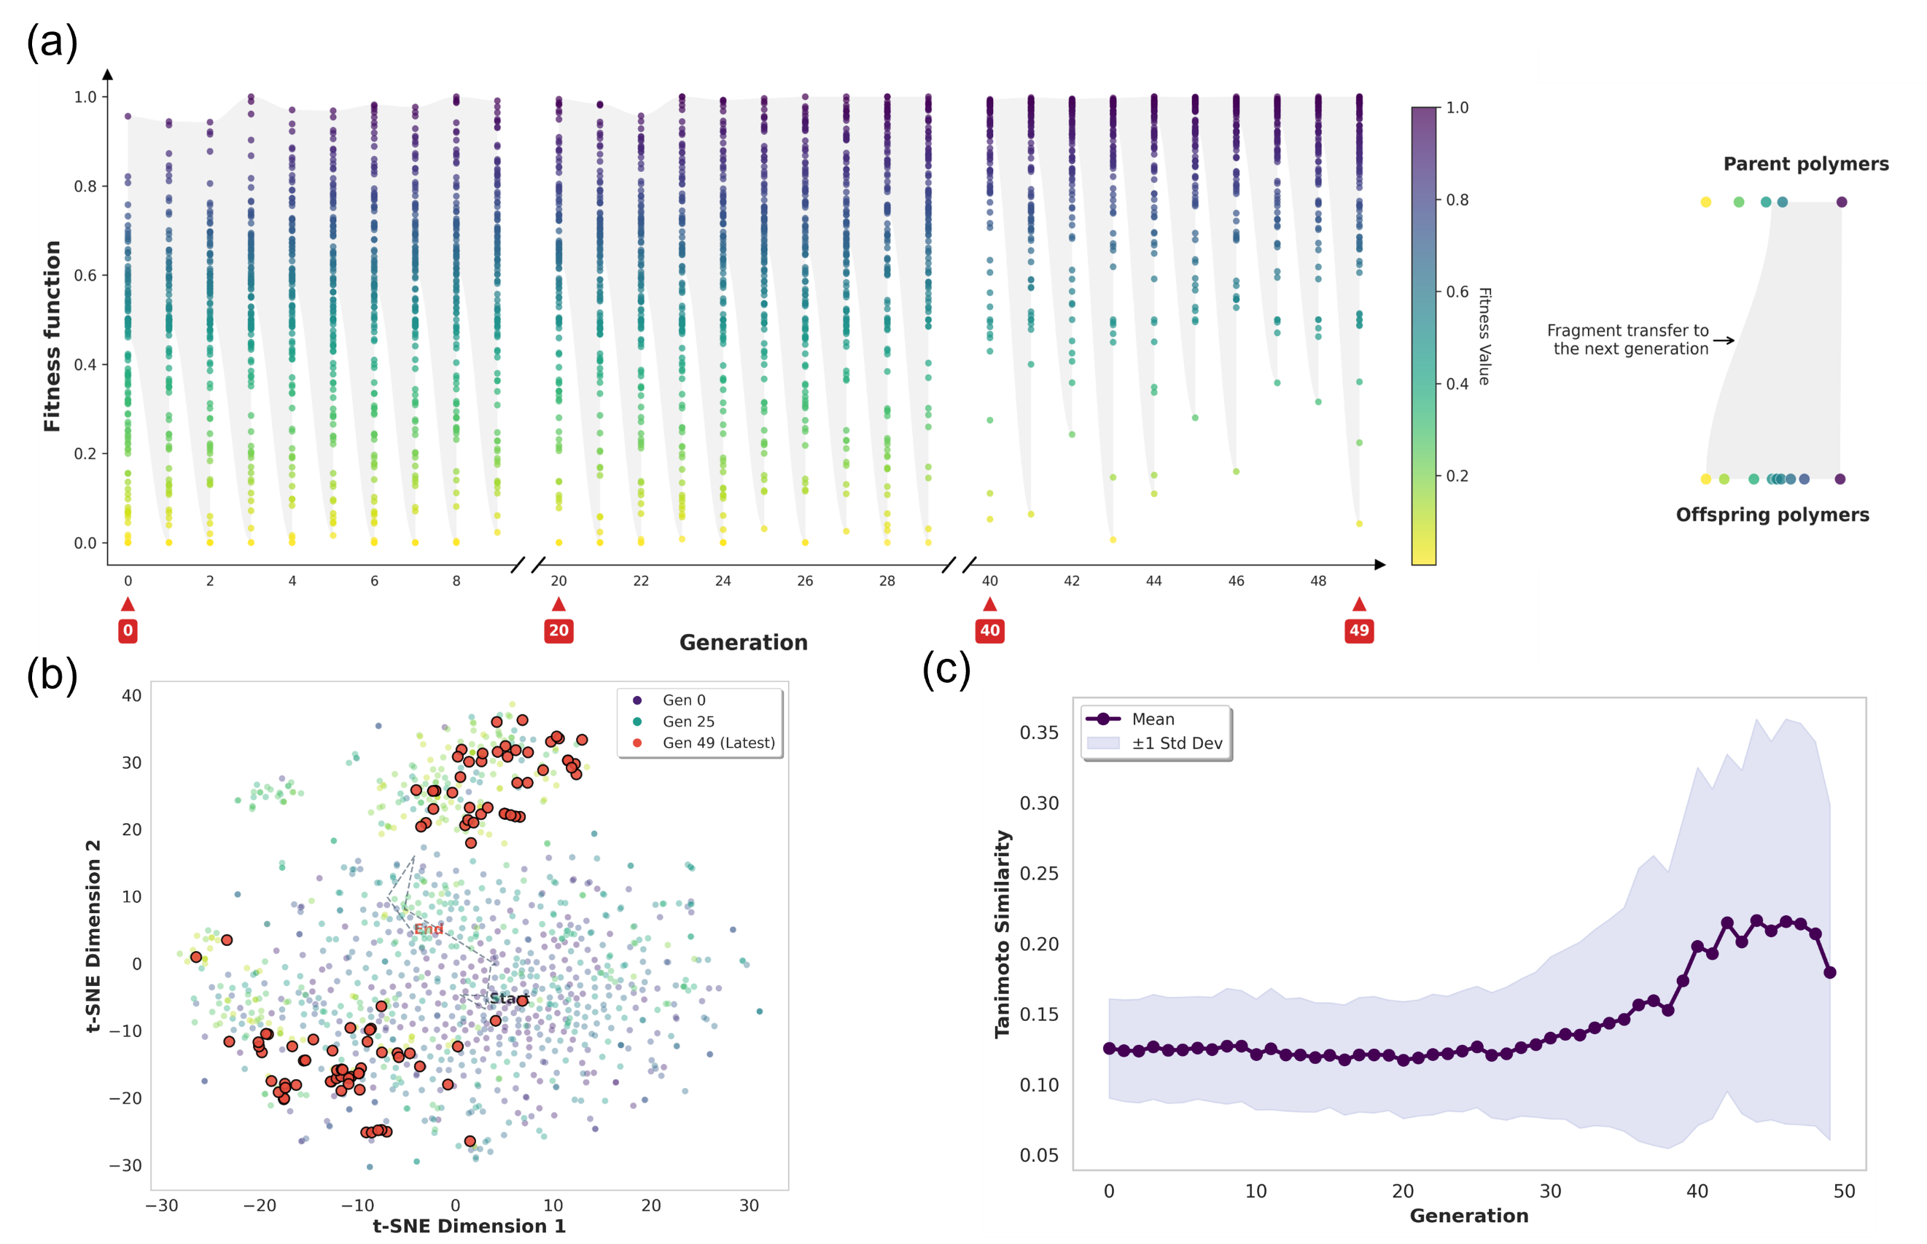
Figure 4. Evolution of population diversity and fitness during genetic optimization. (a) Mean and best fitness values across 50 generations. (b) 2D t-SNE projection of candidate chemical space, colored by generation, showing progressive funneling toward the target region. (c) Average pairwise Tanimoto similarity, indicating structural convergence without premature collapse.

The effectiveness of the evolutionary strategy is further quantified in Figure 5. The population-mean $T_{g}$ (Figure 5a) increases from roughly 150 °C at initialization to nearly 300 °C by generation 50, while the best candidates continually push the upper envelope. In parallel, the mean $ε_{r}$ (Figure 5b) decreases rapidly during the first 20 generations and later stabilizes around $ε_{r}$ ≈ 2.5, with the best candidates reaching $ε_{r}$ < 2.3. The property landscapes in Figures 5c and 5d reveal the shift from a broadly scattered early population to a late-generation population strongly enriched in the target region defined by $T_{g}$ > 260 °C and $ε_{r}$ < 2.8. Many candidates inside this region retain favorable synthetic-accessibility scores (SA score < 5), indicating that the framework enriches for candidates that remain reasonably accessible under this heuristic metric rather than merely idealized structures.
Figure 5. Performance of the dual-objective optimization. (a) Evolution of population-mean and best-candidate $T_{g}$ across generations. (b) Evolution of population-mean and best-candidate $ε_{r}$ across generations. (c) Property landscape for early generations relative to the target region. (d) Property landscape for late generations, showing strong enrichment of candidates in the design window $T_{g}$ > 260 °C and $ε_{r}$ < 2.8. Color indicates synthetic accessibility (SA) score.
To assess the predicted properties of top-ranked candidates within a common simulator-based reference domain (Figure 6), all selected structures were subjected to a multi-scale computational protocol. Polymer chains were constructed by a self-avoiding random walk (SARW) procedure with the degree of polymerization adjusted so that each chain contained roughly 1,000 atoms, thereby minimizing molecular-weight bias. Amorphous cells were equilibrated using a 21-step compression/decompression protocol under the GAFF2 force field, followed by a 5 ns NPT production run at 300 K and 1 atm to ensure convergence. The dielectric response was decomposed into orientational and electronic parts according to
$$ε_{r}=\frac{⟨M^{2}⟩-⟨M⟩^{2}}{3ε_{0}Vk_{B}T}+ε_{el}$$
Here, M is the total dipole moment of the simulation cell, ε₀ is the vacuum permittivity, V is the cell volume, k_{B} is the Boltzmann constant, and T is the temperature. The electronic contribution, ε_{el}, was obtained from the isotropic electronic polarizability, α, via the Lorentz-Lorenz equation, with α computed using the ωB97M-D3BJ functional and a mixed basis-set strategy (6-311+G(2d,p) for common atoms and tailored basis sets for heavier halogens; see Supporting Information Section S2). $T_{g}$ was determined from a nonequilibrium cooling protocol in which the system was first heated to a fully relaxed rubbery state (density < 0.5 g cm⁻³) to erase thermal history and then cooled at 20 K ns⁻¹. Because this MD cooling rate is many orders of magnitude faster than the DSC conditions represented in the experimental training data, MD-derived $T_{g}$ values are expected to be systematically shifted relative to experimental $T_{g}$. $T_{g}$ was identified as the intersection of linear fits to the ρ–T data in the rubbery and glassy regimes. This protocol therefore provides a consistent simulator-based reference for $ε_{r}$ and for comparative $T_{g}$ analysis, but absolute $T_{g}$ agreement with experiment should be interpreted with this rate-induced bias in mind.
Figure 6. Comprehensive computational workflow for polymer modeling. (a) Hierarchical conformer screening and charge assignment. Initial conformers generated from SMILES by ETKDG are screened with MMFF, after which top candidates undergo DFT geometry optimization and RESP charge fitting for amorphous-cell construction. (b) All-atom MD workflow including energy minimization, NVT/NPT equilibration, and annealing for extraction of $T_{g}$ and related dynamic properties.
To assess predictive reliability beyond the supervised fine-tuning domain, we assembled a heterogeneous external validation set comprising five de novo polymers randomly sampled from the final GA-MMPolymer generation and 25 out-of-distribution (OOD) candidates drawn from the PolyOmics database, an omics-scale polymer computational database developed for simulation-to-real AI applications in polymer science. All 30 candidates were evaluated with the physics-based workflow described above to obtain simulator-based reference properties. As summarized in Figure 7a and Figure 7b, $ε_{r}$ predictions remain in close agreement with the simulator-based references across both de novo and OOD candidates. $T_{g}$ predictions show a consistent negative offset relative to the MD-derived benchmarks, with an average underestimation of approximately 56 K, consistent with the expected domain shift between the experimental training labels and the nonequilibrium MD cooling protocol (20 K ns⁻¹) used to generate the external references. Importantly, both candidate classes preserve ranking fidelity and trend consistency, confirming that the surrogate generalizes to unseen chemistries including those produced by the genetic algorithm itself.
Figure 7. Physics-based assessment of MMPolymer predictions for the external validation set, with inset structures of representative de novo candidates. (a) Comparison between predicted and simulator-assessed $T_{g}$, highlighting a systematic offset relative to the MD-derived references that is consistent with experiment-to-simulation mismatch in $T_{g}$ (shaded blue region). The inset shows Polymer A, a representative design emphasizing thermal stability. (b) Comparison between predicted and simulator-assessed $ε_{r}$ for the same external validation set. The inset shows Polymer B, a representative design emphasizing dielectric suppression.
To illustrate the chemical rationality and design diversity of the GA-generated candidates, we highlight the two representative de novo polymers shown as insets in Figure 7: Polymer A, shown as the inset in Figure 7a, emphasizes thermal stability, whereas Polymer B, shown as the inset in Figure 7b, emphasizes dielectric suppression.
Polymer A (P-SMILES: *c1ccc(-c2ccc(C(*)(C)C(F)(F)F)cc2)c(F)c1), shown as the inset structure in Figure 7a, adopts an orthogonal "rigid-backbone/low-polarizability pendant" strategy. The directly linked biphenyl backbone imposes a high rotational energy barrier, resulting in pronounced chain stiffness and a correspondingly elevated $T_{g}$. Meanwhile, the trifluoromethyl (-CF₃) group and ring-fluorine substituent suppress electronic polarizability, as the highly electronegative fluorine atoms tightly confine the surrounding electron density and reduce its response to an external electric field. This design philosophy closely parallels that of established high-performance dielectric materials, such as 6FDA-based polyimides, which similarly exploit fluorinated moieties to preserve high-$T_{g}$ performance while also helping to control dielectric response.
Polymer B (P-SMILES: */C(C#N)=C(\c1ccccc1)c1ccc(*)cc1CCCCCCCCC), shown as the inset structure in Figure 7b, follows a "dipole dilution" strategy. The cyano group (-C≡N) on the backbone introduces a strong local dipole moment along with conformational rigidity; however, the long pendant nonyl chain (-C₉H₁₉) substantially increases the repeat-unit molar volume, thereby reducing the volumetric dipole density and suppressing orientational polarization. This design rationale mirrors classical copolymer principles in which non-polar aliphatic segments are deliberately incorporated to lower the overall dielectric response. This example highlights a low-permittivity design route.
Notably, high-$T_{g}$ polymers present in the out-of-distribution (OOD) evaluation set ($T_{g}$ > 600 K) universally exhibit $ε_{r}$ values exceeding 2.7, as these structures rely heavily on dense heteroaromatic moieties (e.g., benzoxazole, imide, and oxadiazole linkages) that inherently possess high electronic polarizability. In contrast, Polymer A illustrates a design route that preserves thermal stability through a rigid fluorinated aromatic framework, whereas Polymer B emphasizes dielectric suppression through dipole dilution. These examples demonstrate that GA-MMPolymer navigates chemically meaningful trade-offs and uncovers multiple design routes toward balancing low $ε_{r}$ with thermal stability.
Conclusion
In this study, we developed GA-MMPolymer, a closed-loop inverse-design framework that integrates multimodal representation learning with fragment-based evolutionary search for functional polymer discovery. By jointly encoding one-dimensional chemical semantics and three-dimensional conformational information, MMPolymer improves prediction of geometry-sensitive properties relative to unimodal baselines. Guided by this surrogate model, GA-MMPolymer efficiently explored a vast polymer design space and identified a Pareto-optimal family of synthetically plausible candidates that balance thermal stability against low dielectric response. In particular, the framework enriched candidates in the target region defined by $T_{g}$ > 260 °C and $ε_{r}$ < 2.8, and the most promising examples were further examined with a consistent DFT/all-atom MD workflow.
Beyond the specific discovery of low-$ε_{r}$ polymer dielectrics, this work provides a data-driven perspective on polymer design in high-dimensional chemical space. Analysis of the top-performing candidates suggests that the multimodal framework can help identify nontrivial structural motifs—such as sterically constrained conjugated backbones paired with low-polarizability pendants—that balance rigidity and free-volume requirements in ways not easily anticipated by intuition alone. More broadly, the results illustrate how coupled intramolecular and intermolecular effects can be negotiated in a coordinated optimization workflow rather than addressed as isolated design compromises.
Several limitations should nevertheless be acknowledged. First, the present study relies primarily on computational assessment and heuristic synthetic-accessibility estimates; experimental verification remains essential for confirming polymerizability, processability, and device-level dielectric performance. Second, although the hybrid data strategy improves predictive realism for each target property, future models would benefit from tighter integration of uncertainty quantification, synthesis constraints, and experimentally resolved microstructural descriptors. Looking ahead, a particularly promising direction is to couple GA-MMPolymer with automated high-throughput synthesis and characterization platforms, thereby closing the design-make-test-learn loop in a genuinely autonomous manner. More broadly, the architecture introduced here is readily extensible to other polymer design problems governed by competing objectives, such as solid-state polymer electrolytes that must balance ionic conductivity, electrochemical stability, and mechanical integrity, and to other multi-objective polymer discovery campaigns.

