

ASSESSMENT COVERSHEET
Trimester 2620

Attach this coversheet as the cover of your submission. All sections must be completed.

Section A: Submission Details
Programme | : | Bachelor of Computer Science
Course Code & Name | : | LDCW6123 - FUNDAMENTALS OF DIGITAL COMPETENCE FOR PROGRAMMER
Course Lecturer(s) | : | Mr. V Segaran A/L Veeraya
Submission Title | : | Group 13 Netflix Innovation Life Cycle Poster and Interactive Program
Deadline | : | Day | 02 | Month | 10 | Year | 2026 | Time | 23:59
Penalties | : | - Plagiarised work is an Academic Offence in University Rules & Regulations and will be penalised accordingly.  - Failure to fulfil the limits set for plagiarism similarity index and AI-generated content will result in the essay being awarded a score not exceeding 50% of the total score.  - Without Turnitin reports submission is deemed incomplete.
Section B: Academic Integrity

Tick (√) each box below if you agree:
I have read and understood the policy on Plagiarism in University Rules & Regulations.
This submission is my own, unless indicated with proper referencing.
This submission has not been previously submitted or published.
This submission follows the requirements stated in the course.

Section C: Submission Details (Group 13)

Student ID(s) | Student Name(s) | Designation
261UC240LY | Aziel Tan Zheng Chuan | Group leader
261UC240PJ | See Wing Kit | Member
261UC26145 | Soo Kian Rong | Member
261UC2406W | Vincent Lock Chun Kit | Member
253UC255P1 | Wong Kee Yuan | Member
262UC250T8 | Ho Ming Hao | Member

Declaration by group leader
I hereby declare that all group members’ names are correctly included in the above section. I hold a copy of this assignment which I can produce if the original is lost or damaged. I certify that no part of this assignment has been copied from any other student’s work or from any other source except where due acknowledgement is made in the assignment.

Group leader’s signature : _____________________________
Group leader’s name: Aziel Tan Zheng Chuan
Group leader’s student ID: 261UC240LY
Date : _____________________________
Group member declaration
(Each group member, including the group leader, must individually fill up and submit this form)

For the purpose of completing this assignment, I have performed the following tasks (please list):

I hereby declare that I have assessed this submission and I take full responsibility should there be any inaccuracies, incompleteness, omissions, delays or non-submission.

Group member’s signature : ________________________________

Group member’s name: Aziel Tan Zheng Chuan

Group member’s ID: 261UC240LY

Date : ________________________________

Group member declaration
(Each group member, including the group leader, must individually fill up and submit this form)

For the purpose of completing this assignment, I have performed the following tasks (please list):

I hereby declare that I have assessed this submission and I take full responsibility should there be any inaccuracies, incompleteness, omissions, delays or non-submission.

Group member’s signature : ________________________________

Group member’s name: See Wing Kit

Group member’s ID: 261UC240PJ

Date : ________________________________

Group member declaration
(Each group member, including the group leader, must individually fill up and submit this form)

For the purpose of completing this assignment, I have performed the following tasks (please list):

I hereby declare that I have assessed this submission and I take full responsibility should there be any inaccuracies, incompleteness, omissions, delays or non-submission.

Group member’s signature : ________________________________

Group member’s name: Soo Kian Rong

Group member’s ID: 261UC26145

Date : ________________________________

Group member declaration
(Each group member, including the group leader, must individually fill up and submit this form)

For the purpose of completing this assignment, I have performed the following tasks (please list):

I hereby declare that I have assessed this submission and I take full responsibility should there be any inaccuracies, incompleteness, omissions, delays or non-submission.

Group member’s signature : ________________________________

Group member’s name: Vincent Lock Chun Kit

Group member’s ID: 261UC2406W

Date : ________________________________

Group member declaration
(Each group member, including the group leader, must individually fill up and submit this form)

For the purpose of completing this assignment, I have performed the following tasks (please list):

I hereby declare that I have assessed this submission and I take full responsibility should there be any inaccuracies, incompleteness, omissions, delays or non-submission.

Group member’s signature : ________________________________

Group member’s name: Wong Kee Yuan

Group member’s ID: 253UC255P1

Date : ________________________________

Group member declaration
(Each group member, including the group leader, must individually fill up and submit this form)

For the purpose of completing this assignment, I have performed the following tasks (please list):

I hereby declare that I have assessed this submission and I take full responsibility should there be any inaccuracies, incompleteness, omissions, delays or non-submission.

Group member’s signature : ________________________________

Group member’s name: Ho Ming Hao

Group member’s ID: 262UC250T8

Date : ________________________________

Contents
Netflix Innovation Life Cycle Poster and Movie Discovery Assistant
LDCW6123 | Trimester 2620 | Group 13 | Class section: [CONFIRM CLASS SECTION]
Section | Page
Assessment coversheet and six member declarations | 1-7
Part 1 Innovation life cycle poster | 9
Part 1 Model application | 10
Part 1 History impact and critical analysis | 11
Part 1 APA references | 12-13
Part 2 Programme design | 14
Part 2 Code captures | 15-16
Part 2 Actual programme runs | 17
Part 2 Testing and results | 18
Part 2 Git development record | 19
Presentation links and assistance disclosure | 20
Part 1 examines the DVD-by-mail innovation and its later development. Part 2 demonstrates movie discovery with a transparent C++ preference rule. The references and evidence support the analysis and programme behaviour.

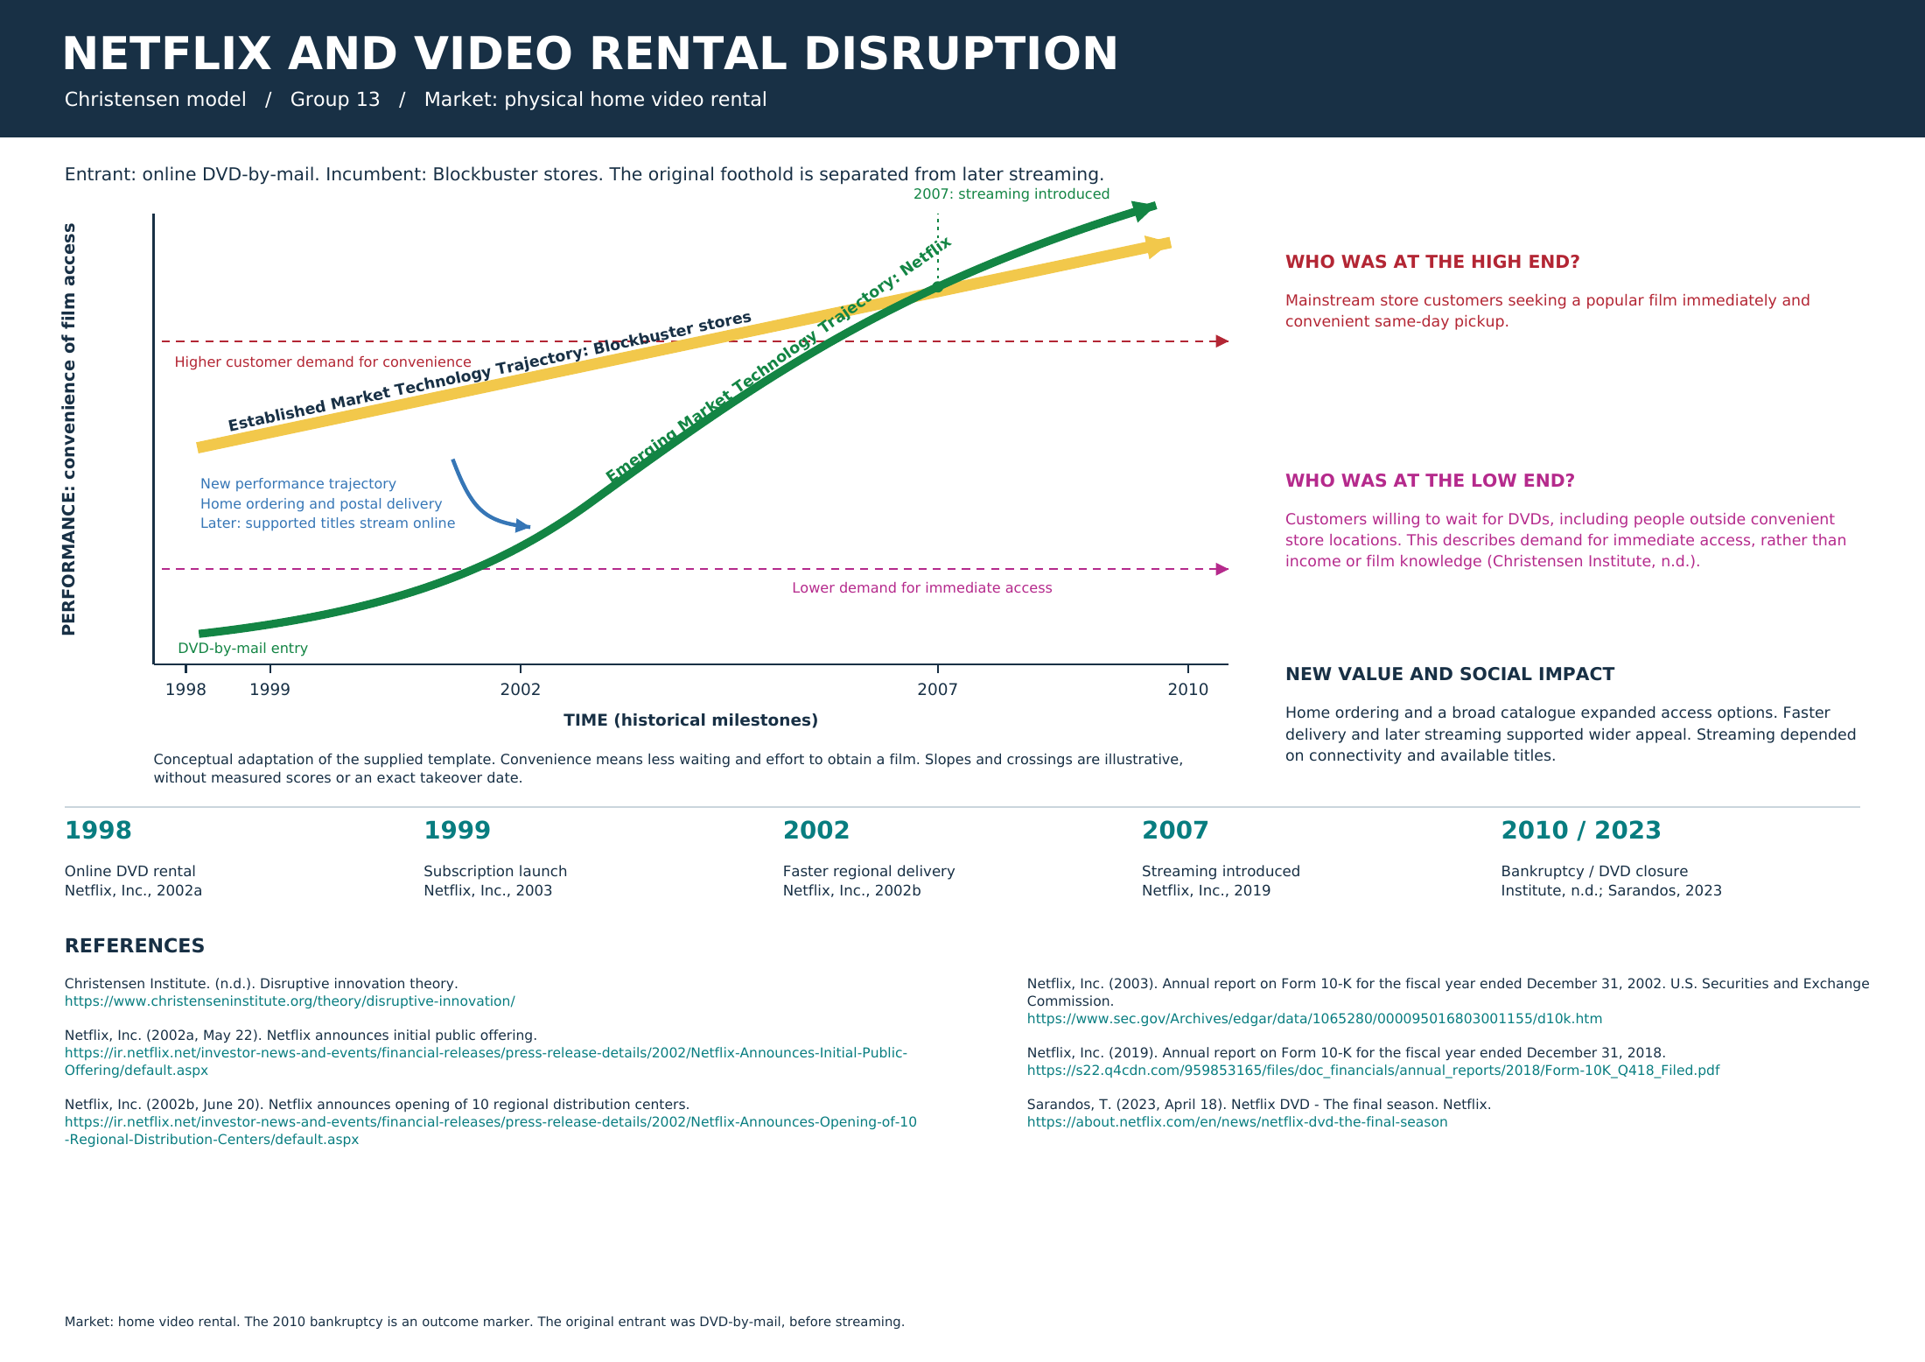

Part 1 Model application

Scope and model
This report examines Netflix's original online DVD-by-mail service relative to physical video-rental stores, especially Blockbuster. The question is how a service that initially required waiting could attract customers and become a wider competitive alternative. Christensen's disruptive innovation model is appropriate because the explanation follows a changing competitive process, rather than treating a new technology as automatically disruptive (Hogg, 2026).

Foothold and customers
The relevant early foothold includes people outside convenient rental-store locations who accepted postal delivery in return for access to a broad catalogue (Christensen Institute, n.d.). This project interprets those preferences as a trade-off between immediacy and access. It does not assume that every early customer was a low-income consumer, a nonconsumer or uninterested in film quality. The claim is specific to the customer needs and performance dimension being compared.

Performance and customer mapping
The poster follows the supplied template with established and emerging trajectories, two dashed customer-demand levels and a new-performance callout. Its vertical metric is convenience of film access: less waiting and effort to obtain a film. The established arrow represents sustaining improvement within store rental. Netflix starts lower because postal delivery lacks immediate pickup, while home ordering provides different value. Faster delivery and later streaming support wider appeal. Customer levels describe differing demands for immediate access. This is a qualitative interpretation. Arrow slopes and crossings establish neither numerical performance nor an exact date of market takeover.

Technological and commercial enablers
Disruptive innovation depends on enabling technology, a business model and a supporting value network (Christensen Institute, 2025). Applied here, the web catalogue, postal service and distribution facilities supported a subscription alternative to a retail-store network. The interpretation concerns how the service was delivered and sustained, alongside the technology used.

Part 1 History impact and critical analysis

Historical development
Netflix launched its online DVD-rental service in 1998 (Netflix, Inc., 2002a). Its subscription service began in September 1999 (Netflix, Inc., 2003). In June 2002, it announced ten regional distribution centres intended to reduce delivery times (Netflix, Inc., 2002b). A March 2002 company announcement describes CineMatch support for title selection (Netflix, Inc., 2002c). Netflix introduced streaming in 2007 (Netflix, Inc., 2019). Blockbuster's 2010 bankruptcy marks an important incumbent outcome (Christensen Institute, n.d.). In April 2023, Netflix announced that its last DVD shipments would be on September 29, 2023 (Sarandos, 2023).

Improvement and mainstream competition
Faster delivery reduced the initial waiting disadvantage. Streaming later changed the access method for supported titles and connected viewers. These developments help explain the move toward broader competition on convenience. The graph treats 2007 as a change in delivery capability, not proof that all customers switched immediately or that every Netflix feature was separately disruptive.

Social impact and trade-offs
Home ordering offered an alternative to travelling to a store. A larger accessible catalogue could serve viewers with fewer convenient local options (Christensen Institute, n.d.). The benefit depended on what the viewer valued. Postal delivery still required waiting, while streaming introduced dependence on connectivity and available content. Early streaming also had catalogue limitations; some customers valued the social experience of visiting stores (Arnett & Young, 2024).

Critical interpretation
The case supports a model of changing customer access and competition. It does not establish that Netflix alone caused Blockbuster's bankruptcy or that the conceptual graph measures market share. Using one performance indicator makes the trade-off clear but cannot represent every dimension of a rental service. Historical outcome and model interpretation should therefore remain distinct.

Connection to Part 2
Netflix's early service included title-selection assistance (Netflix, Inc., 2002c). The C++ programme illustrates this catalogue-discovery benefit through explicit preference rules. Its fictional catalogue and fixed weights make the decision process explainable. It does not recreate CineMatch, operate a streaming service or use Netflix data.

Part 1 References
Arnett, T., & Young, K. (2024, July 26). Taking K-12 education transformation from pipe dream to pipeline. Christensen Institute.
https://www.christenseninstitute.org/blog/taking-k-12-education-transformation-from-pipe-dream-to-pipeline/
Christensen Institute. (n.d.). Disruptive innovation theory.
https://www.christenseninstitute.org/theory/disruptive-innovation/
Christensen Institute. (2025, September 24). What is disruptive innovation? [Video].
https://www.christenseninstitute.org/video/what-is-disruptive-innovation/
Hogg, A. S. (2026, March 18). No, disruption isn't a strategy. Christensen Institute.
https://www.christenseninstitute.org/blog/no-disruption-isnt-a-strategy/
Netflix, Inc. (2002a, May 22). Netflix announces initial public offering.
https://ir.netflix.net/investor-news-and-events/financial-releases/press-release-details/2002/Netflix-Announces-Initial-Public-Offering/default.aspx

Part 1 References continued
Netflix, Inc. (2002b, June 20). Netflix announces opening of 10 regional distribution centers.
https://ir.netflix.net/investor-news-and-events/financial-releases/press-release-details/2002/Netflix-Announces-Opening-of-10-Regional-Distribution-Centers/default.aspx
Netflix, Inc. (2002c, March 6). Netflix files registration statement for initial public offering.
https://ir.netflix.net/investor-news-and-events/financial-releases/press-release-details/2002/Netflix-Files-Registration-Statement-for-Initial-Public-Offering/default.aspx
Netflix, Inc. (2003). Annual report on Form 10-K for the fiscal year ended December 31, 2002. U.S. Securities and Exchange Commission.
https://www.sec.gov/Archives/edgar/data/1065280/000095016803001155/d10k.htm
Netflix, Inc. (2019). Annual report on Form 10-K for the fiscal year ended December 31, 2018.
https://s22.q4cdn.com/959853165/files/doc_financials/annual_reports/2018/Form-10K_Q418_Filed.pdf
Sarandos, T. (2023, April 18). Netflix DVD - The final season. Netflix.
https://about.netflix.com/en/news/netflix-dvd-the-final-season

Part 2 Programme design

Purpose and integration
The Movie Discovery Assistant recommends a fictional film based on genre, mood and preferred duration. It illustrates one customer-facing function associated with a searchable online catalogue: finding a title suited to a user's preferences. It runs offline without login or subscriber information.

Inputs and outputs
Genre choices are Sci-Fi, Comedy and Drama. Mood choices are Relaxed, Exciting and Thoughtful. Duration choices are up to 100 minutes and over 100 minutes. The output contains the selected film's title, duration, description and the preferences it actually matches. A repeat menu lets the user search again or exit.

Selection rule
Genre is a required filter. Within that genre, a mood match adds two points and a duration match adds one point. The highest-scoring film wins; equal scores retain the first title in catalogue order. Mood therefore has priority over duration. A fallback stays within the selected genre and never claims an unmatched preference. A guard handles the absence of titles if the catalogue is later changed.

Input handling and implementation
C++17 is used with a Movie structure, a vector of records and a reusable readChoice function. getline reads the entire input. An istringstream parses a bounded integer and checks for trailing non-whitespace characters. Text, decimals, blank input, overflow and out-of-range entries are rejected. End-of-input exits cleanly. The programme uses conditional statements and loops to produce its recommendation.

Limitations
The catalogue contains 12 fictional titles. Weights are manually chosen and do not learn from preferences or ratings. No user-effectiveness evaluation, account features, persistence or external catalogue integration is included. The automated tests verify expected programme behaviour, rather than the real-world usefulness of recommendations.
Build: g++ -std=c++17 -Wall -Wextra -pedantic src/main.cpp -o movie_assistant

Part 2 Code capture input validation
This extract is generated from the actual source file. The complete source is included in src/main.cpp. Whole-line parsing rejects numeric prefixes followed by letters or decimals.
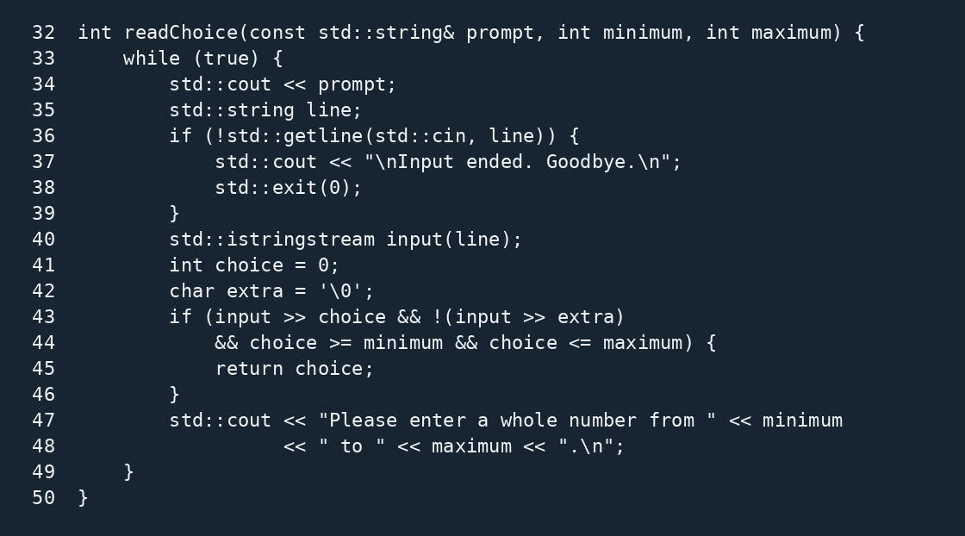
Figure 1. Actual readChoice implementation with source line numbers.

Part 2 Code capture recommendation logic
Genre is required. Mood contributes two points and duration contributes one. Equal scores keep the earlier catalogue entry. The null-result guard protects the output if the catalogue is later changed.
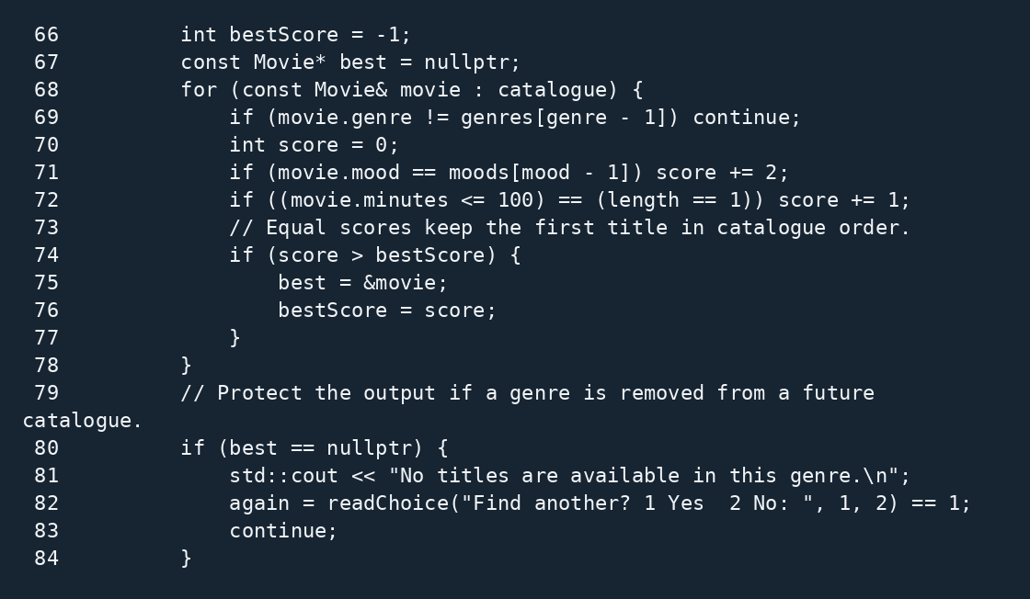
Figure 2. Scoring, tie handling and missing-catalogue guard from the actual source.

Part 2 Actual programme runs
The following capture comes from a real interactive terminal run of the compiled programme. Typed menu values are visible. It demonstrates repeated use and the recommendations Coffee and Clouds and Orbit Station.
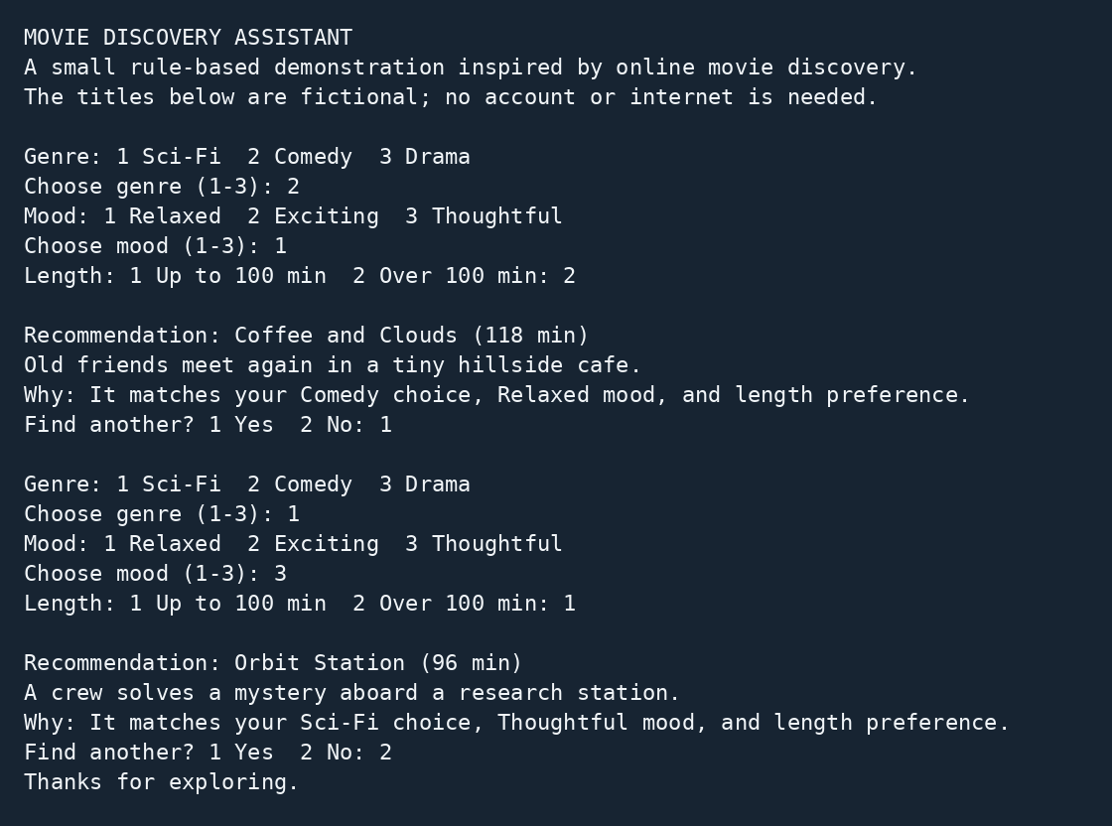
Figure 3. Actual terminal output and entered values. The full transcript is assets/program_output.txt.
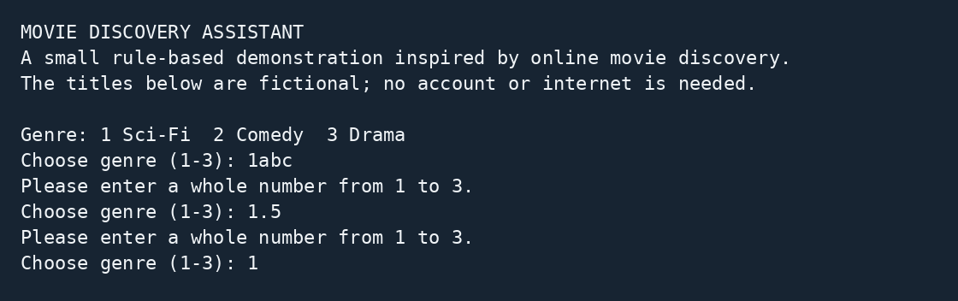
Figure 4. Actual rejection of 1abc and 1.5 before valid input. Full evidence is assets/invalid_output.txt.

Part 2 Testing and results
35 black-box checks passed: 18 preference combinations, 8 invalid inputs, 4 EOF cases, repeat, whitespace, menu bounds, fallback and mood priority.
The test driver executes the compiled programme as a separate process and checks explicit expected outputs. The complete 35-case record is assets/test_results.csv. These checks validate behaviour; they do not measure recommendation usefulness.
Case | Input | Expected | Actual | Status
C01 | 1, 1, 1; exit 2 | Orbit Station | Orbit Station | PASS
C08 | 2, 1, 2; exit 2 | Coffee and Clouds | Coffee and Clouds | PASS
C17 | 3, 3, 1; exit 2 | River Letters | River Letters | PASS
I01 | 'wrong'; then 1,3,1,2 | Reject and recover | Rejected and recovered | PASS
I05 | '1abc'; then 1,3,1,2 | Reject and recover | Rejected and recovered | PASS
I06 | '1.5'; then 1,3,1,2 | Reject and recover | Rejected and recovered | PASS
I07 | ''; then 1,3,1,2 | Reject and recover | Rejected and recovered | PASS
E01 | '' | Clean EOF exit | Clean EOF exit | PASS
R01 | 2,1,2,1; 1,2,1,2 | Two recommendations and normal exit | Two recommendations and normal exit | PASS
B01 | invalid length 3 and repeat 7 | Reject at both menus and recover | Rejected at both menus | PASS
F01 | Sci-Fi, Relaxed, short | Fallback does not claim a mood match | No false mood match | PASS
P01 | Drama, Exciting, short | Mood priority; no false length claim | Night Shift; no length claim | PASS
Test command: sh test.sh. The test runner requires Python 3; the C++ programme itself does not.

Part 2 Git development record
The log below is generated from the actual repository used to prepare this package. Original commits identify Codex draft; revision commits identify Codex assisted revision. They document AI-assisted preparation, not named students' contributions. The group must record genuine contributions through its own actual review and commits.
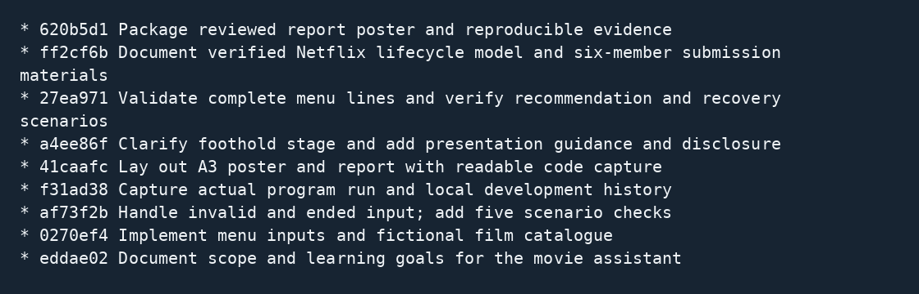
Figure 5. Real git log --oneline --graph --all, captured before the final artifact-packaging commit. Full author names and timestamps for this snapshot are in assets/git_history_authors.txt. The bundle also retains any later packaging commit.
The development_history.bundle restores the repository, source and history. The README explains git clone and the build/test commands. The brief's --online option is a typographical error; --oneline is the valid command.
Code and Git history access link: [INSERT WORKING SOURCE CODE AND GIT HISTORY URL]

Presentation links and assistance disclosure
Recorded group presentation on OneDrive: [INSERT WORKING ONEDRIVE VIDEO URL]
Source code and Git history: [INSERT WORKING SOURCE CODE AND GIT HISTORY URL]
Turnitin reports: [ATTACH REQUIRED REPORTS OR INSERT ACCESS LINK]
Speaker | Suggested section | Approximate time
Aziel Tan Zheng Chuan | Case and project introduction | 1:30
See Wing Kit | Model and customer mapping | 2:00
Soo Kian Rong | History and impact | 2:00
Vincent Lock Chun Kit | Programme design and logic | 2:30
Wong Kee Yuan | Live demo and validation | 3:00
Ho Ming Hao | Testing Git and conclusion | 2:30
The complete six-person script is provided separately. The suggested total is about 13:30, allowing rehearsal and transitions within a target of 14-16 minutes. The actual recording must not exceed 18 minutes and must use MPEG, MP4 or MOV format.

Generative AI assistance disclosure
OpenAI ChatGPT (Codex) assisted with initial preparation on 25 September 2026 and revisions on 30 September and 1 October 2026, including analysis, source verification, poster/report layout, code, tests, evidence and script. The 1 October revision aligns the graph with the supplied model sample and template. The Git record identifies that assistance. No student contributions, signatures, completed video or Turnitin result are asserted by these records. Full disclosure is included in AI_DISCLOSURE.txt.
Each member must enter their actual contribution, personally complete their declaration and follow the course's originality and AI-content requirements before submission.

