

ASSESSMENT COVERSHEET
Trimester 2620

Attach this coversheet as the cover of your submission. All sections must be completed.

Section A: Submission Details
Programme | : | Bachelor of Computer Science
Course Code & Name | : | LDCW6123 - FUNDAMENTALS OF DIGITAL COMPETENCE FOR PROGRAMMER
Course Lecturer(s) | : | Mr. V Segaran A/L Veeraya
Submission Title | : | Group 13 Spotify and Physical Music Clayton Model and Interactive Program
Deadline | : | Day | 02 | Month | 10 | Year | 2026 | Time | 23:59
Penalties | : | - Plagiarised work is an Academic Offence in University Rules & Regulations and will be penalised accordingly.  - Failure to fulfil the limits set for plagiarism similarity index and AI-generated content will result in the essay being awarded a score not exceeding 50% of the total score.  - Without Turnitin reports submission is deemed incomplete.
Section B: Academic Integrity

Tick (√) each box below if you agree:
I have read and understood the policy on Plagiarism in University Rules & Regulations.
This submission is my own, unless indicated with proper referencing.
This submission has not been previously submitted or published.
This submission follows the requirements stated in the course.

Section C: Submission Details (Group 13)

Student ID(s) | Student Name(s) | Designation
261UC240LY | Aziel Tan Zheng Chuan | Group leader
261UC240PJ | See Wing Kit | Member
261UC26145 | Soo Kian Rong | Member
261UC2406W | Vincent Lock Chun Kit | Member
253UC255P1 | Wong Kee Yuan | Member
262UC250T8 | Ho Ming Hao | Member

Declaration by group leader
I hereby declare that all group members’ names are correctly included in the above section. I hold a copy of this assignment which I can produce if the original is lost or damaged. I certify that no part of this assignment has been copied from any other student’s work or from any other source except where due acknowledgement is made in the assignment.

Group leader’s signature : _____________________________
Group leader’s name: Aziel Tan Zheng Chuan
Group leader’s student ID: 261UC240LY
Date : _____________________________
Group member declaration
(Each group member, including the group leader, must individually fill up and submit this form)

For the purpose of completing this assignment, I have performed the following tasks (please list):

I hereby declare that I have assessed this submission and I take full responsibility should there be any inaccuracies, incompleteness, omissions, delays or non-submission.

Group member’s signature : ________________________________

Group member’s name: Aziel Tan Zheng Chuan

Group member’s ID: 261UC240LY

Date : ________________________________

Group member declaration
(Each group member, including the group leader, must individually fill up and submit this form)

For the purpose of completing this assignment, I have performed the following tasks (please list):

I hereby declare that I have assessed this submission and I take full responsibility should there be any inaccuracies, incompleteness, omissions, delays or non-submission.

Group member’s signature : ________________________________

Group member’s name: See Wing Kit

Group member’s ID: 261UC240PJ

Date : ________________________________

Group member declaration
(Each group member, including the group leader, must individually fill up and submit this form)

For the purpose of completing this assignment, I have performed the following tasks (please list):

I hereby declare that I have assessed this submission and I take full responsibility should there be any inaccuracies, incompleteness, omissions, delays or non-submission.

Group member’s signature : ________________________________

Group member’s name: Soo Kian Rong

Group member’s ID: 261UC26145

Date : ________________________________

Group member declaration
(Each group member, including the group leader, must individually fill up and submit this form)

For the purpose of completing this assignment, I have performed the following tasks (please list):

I hereby declare that I have assessed this submission and I take full responsibility should there be any inaccuracies, incompleteness, omissions, delays or non-submission.

Group member’s signature : ________________________________

Group member’s name: Vincent Lock Chun Kit

Group member’s ID: 261UC2406W

Date : ________________________________

Group member declaration
(Each group member, including the group leader, must individually fill up and submit this form)

For the purpose of completing this assignment, I have performed the following tasks (please list):

I hereby declare that I have assessed this submission and I take full responsibility should there be any inaccuracies, incompleteness, omissions, delays or non-submission.

Group member’s signature : ________________________________

Group member’s name: Wong Kee Yuan

Group member’s ID: 253UC255P1

Date : ________________________________

Group member declaration
(Each group member, including the group leader, must individually fill up and submit this form)

For the purpose of completing this assignment, I have performed the following tasks (please list):

I hereby declare that I have assessed this submission and I take full responsibility should there be any inaccuracies, incompleteness, omissions, delays or non-submission.

Group member’s signature : ________________________________

Group member’s name: Ho Ming Hao

Group member’s ID: 262UC250T8

Date : ________________________________

Contents
Spotify and Physical Music Clayton Model and Music Discovery Assistant
LDCW6123 | Trimester 2620 | Group 13 | Class section: [CONFIRM CLASS SECTION]
Section | Page
Assessment coversheet and six declarations | 1–7
Contents | 8
Part 1 Clayton model poster (A3 landscape) | 9
Part 1 Model application | 10
Part 1 History and impact | 11
Part 1 Tradeoffs and critical interpretation | 12
Part 1 References | 13–14
Part 2 Programme design | 15
Part 2 Source-code captures | 16–17
Part 2 Programme output and validation | 18
Part 2 Tests | 19
Part 2 Git record | 20
Presentation links and declaration notes | 21
Part 1 applies the lecturer’s Clayton graph to CD listening and Spotify streaming with one stated audio-fidelity metric. Part 2 shows an offline, rule-based music-discovery demonstration. Historical events and a conceptual model interpretation are kept distinct.

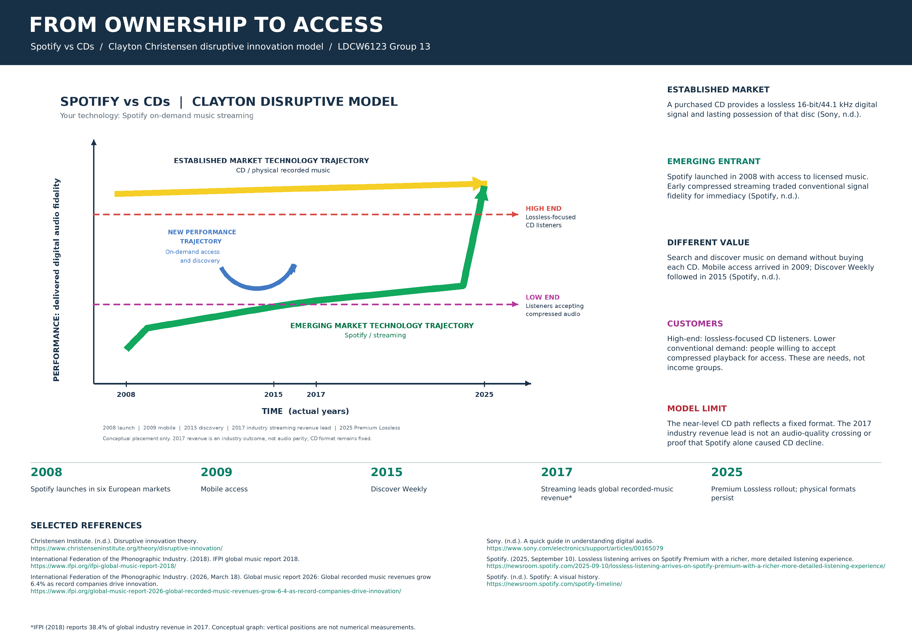

Part 1 Model application

Scope and model
The incumbent is purchased compact discs (CDs) within the physical recorded-music market. The entrant is Spotify’s licensed on-demand streaming service, launched in six European countries in October 2008 (Spotify, n.d.). Christensen’s model asks whether an entrant first satisfies less demanding or overlooked users on a conventional performance dimension while offering another form of value, then becomes more capable over time (Christensen Institute, n.d.). This poster applies that test to streaming; it does not equate any new digital service with a proven low-end disruption.

Foothold and customers
A CD listener seeking an owned, lossless digital recording has a higher fidelity requirement. A less demanding listener may accept compressed streaming when convenient search and access to many licensed tracks matter more than ownership or maximum fidelity. “Low-end” here refers to the tolerance for a lower level on this particular metric, not to a person’s income. Spotify’s free and subscription options illustrate a different way to access music, although the early market also included other digital alternatives.

Performance and customer mapping
The graph’s single vertical metric is the fidelity of the delivered digital music signal relative to a lossless source under suitable playback conditions. Sony identifies standard CD audio as 16-bit/44.1 kHz. Earlier Spotify streaming used compressed audio; Spotify announced a Premium lossless option with up to 24-bit/44.1 kHz FLAC in September 2025 (Sony, n.d.; Spotify, 2025). The yellow CD path is almost level because the CD format did not continuously gain bit depth. The green path begins lower, crosses a conceptual good-enough threshold for compression-tolerant listeners and ends at a supported lossless option. Arrow slopes and threshold crossings are schematic, not measured scores or dated parity observations.

A second, distinct value
The template’s blue curved callout is not another vertical scale. It denotes Spotify’s alternative attraction: on-demand catalogue access, instant search and later discovery tools such as Discover Weekly, which Spotify dates to 2015 (Spotify, n.d.). Listening without owning each disc reduced a purchase and storage barrier. This benefit explains why a user might choose an entrant whose conventional audio fidelity was initially lower.

Technology and business model
Licensing and digital distribution allowed one service to supply on-demand tracks across devices; mobile access followed in 2009, according to Spotify’s chronology. The free tier and paid Premium offered different access and quality options. The commercial arrangement differs from selling a permanently owned CD. These differences connect the technology, the business model and the audience’s trade-off (Spotify, n.d.; Christensen Institute, n.d.).

Part 1 Historical development and impact

Verified timeline
Spotify launched in October 2008, went mobile in September 2009, introduced a free mobile experience in 2013 and launched Discover Weekly in 2015 (Spotify, n.d.). IFPI reported that streaming became the largest single source of global recorded-music revenue in 2017, accounting for 38.4% of the total. That figure combines streaming services and is not a Spotify market-share statistic (IFPI, 2018). Spotify began rolling out Premium Lossless in September 2025 in selected markets (Spotify, 2025).

Interpreting the performance path
Early compressed playback was below a CD’s lossless digital format on this narrowly defined metric. The conceptual lower demand line denotes listeners for whom streaming quality was adequate even before lossless parity. By 2017, streaming as a format led global recorded-music revenue despite the absence of a Spotify lossless tier; therefore its market success cannot be explained by audio parity alone. The green endpoint marks a later improvement available to eligible Premium listeners, not a claim that every stream, device or track is lossless (IFPI, 2018; Spotify, 2025).

Access, revenue and social impact
Digital access shifted listening from purchasing specific physical albums towards searching a licensed catalogue and paying through subscriptions or advertising. Portability, recommendations and immediate discovery could benefit listeners with little storage or an inconvenient retail option. IFPI reported total streaming at 69.6% of global recorded-music revenue in 2025, while physical formats also grew by 8.0%. These are industry-wide format outcomes, not evidence that Spotify alone caused CD decline or that physical media vanished (IFPI, 2026).

Part 1 Tradeoffs and critical interpretation

Costs and limits
A purchased CD can be kept and played with compatible equipment without renewing a streaming subscription; licensed streaming is tied to available tracks, devices and service terms. Spotify Premium offers downloads for offline listening, but this still differs from owning a disc (Spotify, 2019). The quality comparison depends on encoding, plan, device and output path; Spotify specifically cautions that Bluetooth transmission may compress a lossless source (Spotify, 2025). Vinyl collectors and other physical-music buyers remain part of the market (IFPI, 2026).

Critical interpretation
Spotify is a useful illustration of a lower conventional performance trade-off and a new access value, but a strict Christensen classification is contestable. The incumbent record companies also licensed streaming, earlier digital downloads and other services played roles, and 2017 streaming revenue does not prove the model’s mechanism. The graph is a reasoned schematic, not causal identification, fidelity test results or a market-share plot. The CD line is nearly level to preserve the real format ceiling while retaining the lecturer’s upper incumbent trajectory.

Connection to Part 2
The offline C++ Music Discovery Assistant illustrates just one part of the new value proposition: searching a small catalogue by stated preferences. It uses fictional artists and transparent rules. It neither uses Spotify accounts or data nor reproduces Spotify’s recommendation algorithms.

Part 1 References
Christensen Institute. (n.d.). Disruptive innovation theory.
https://www.christenseninstitute.org/theory/disruptive-innovation/
International Federation of the Phonographic Industry. (2018). IFPI global music report 2018.
https://www.ifpi.org/ifpi-global-music-report-2018/
International Federation of the Phonographic Industry. (2026, March 18). Global music report 2026: Global recorded music revenues grow 6.4% as record companies drive innovation.
https://www.ifpi.org/global-music-report-2026-global-recorded-music-revenues-grow-6-4-as-record-companies-drive-innovation/
Multimedia University. (n.d.). Digital convergence and emerging innovative problem solving through: Topic 6A [Lecture slides]. LDCW6123.

Part 1 References continued
Sony. (n.d.). A quick guide in understanding digital audio.
https://www.sony.com/electronics/support/articles/00165079
Spotify. (2019, May 24). How to download and listen to music and podcasts - offline and on the go.
https://newsroom.spotify.com/2019-05-24/how-to-download-and-listen-to-music-and-podcasts-offline-and-on-the-go/
Spotify. (2025, September 10). Lossless listening arrives on Spotify Premium with a richer, more detailed listening experience.
https://newsroom.spotify.com/2025-09-10/lossless-listening-arrives-on-spotify-premium-with-a-richer-more-detailed-listening-experience/
Spotify. (n.d.). Spotify: A visual history.
https://newsroom.spotify.com/spotify-timeline/

Part 2 Programme design

Purpose and integration
The Music Discovery Assistant lets a user browse 12 fictional tracks by genre, mood and preferred duration. It demonstrates the catalogue-discovery aspect of access-based music services without connecting to Spotify or an external API.

Inputs and outputs
Genres are Pop, Electronic and Acoustic. Moods are Calm, Energetic and Reflective. A length option asks for up to four minutes or over four minutes. Output shows the fictional track title, artist, duration, description and the matched preferences. A repeat prompt allows another search.

Transparent selection rule
Genre is a required filter. A matching mood contributes two points, and a matching length contributes one. The first track in catalogue order wins an equal score. Mood therefore outranks length. The explanation prints only matches actually achieved; an absent genre in a future edited catalogue has a safe fallback.

Implementation and validation
C++17 uses a Track struct, a vector catalogue, loops and conditional scoring. readChoice consumes the entire line and uses istringstream to accept only one bounded integer with optional surrounding whitespace. It rejects text, decimals, trailing characters, blank input, overflow and out-of-range choices. End-of-input exits cleanly. Thirty-five black-box checks exercise 18 preference combinations and the key invalid-input, EOF, repeat and fallback cases.

Limits
Tracks and artists are invented, the catalogue is small, and weights were chosen for a classroom demonstration. No machine learning, personalised history, account, persistence, streaming, or usability study is implemented. Tests establish deterministic behaviour, not satisfaction with the selected music.
Build: g++ -std=c++17 -Wall -Wextra -pedantic src/main.cpp -o music_assistant

Part 2 Input validation source
The image is generated from the actual C++ file. readChoice validates each whole line before accepting a bounded integer. Full source is included in src/main.cpp.
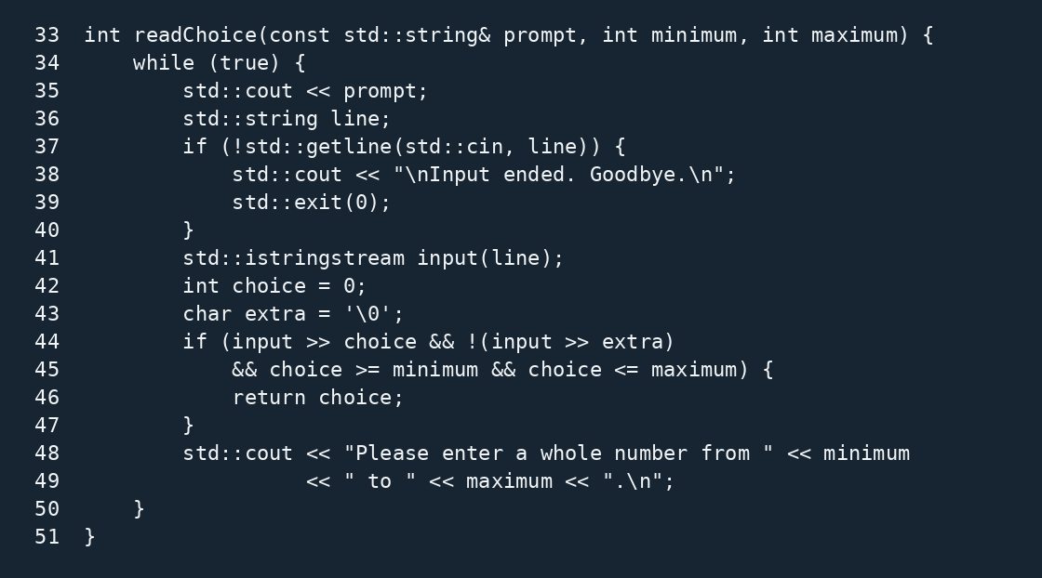
Figure 1. Actual readChoice source with line numbers.

Part 2 Recommendation source
A required genre filter, mood weight of two and length weight of one determine each result. Equal scores retain the first track; a missing-genre guard prevents a null dereference.
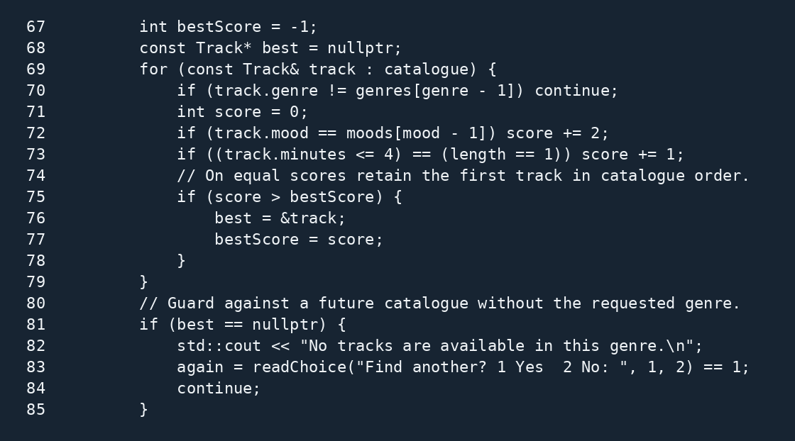
Figure 2. Actual selection code and fallback.

Part 2 Programme output and validation
A genuine terminal session recommends Slow Orbit, then City Lanterns after a second search. The explanation does not claim a Reflective mood match for City Lanterns.
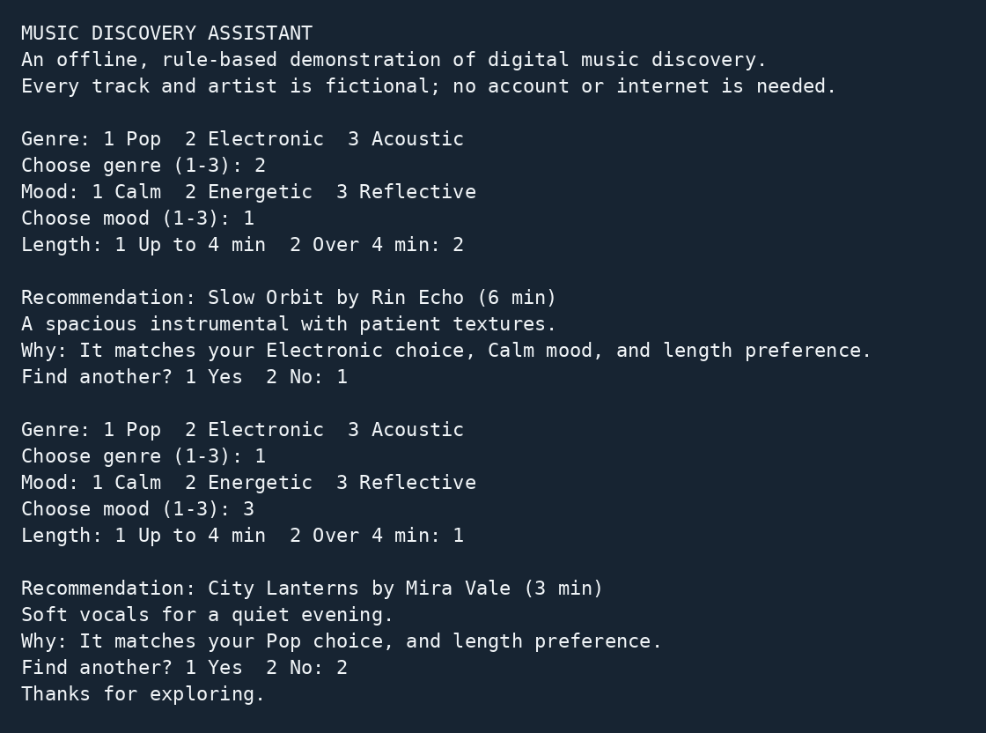
Figure 3. Interactive output and typed choices; complete transcript in assets/program_output.txt.
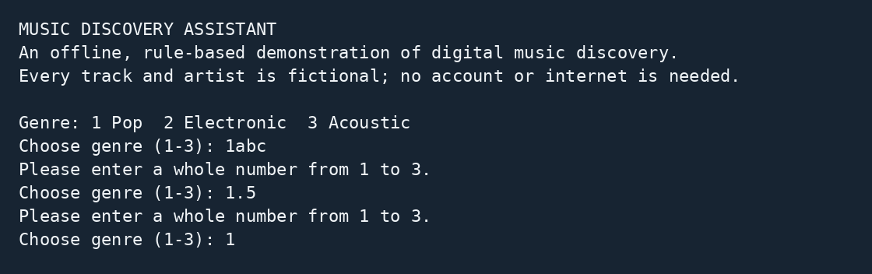
Figure 4. Real rejection of 1abc and 1.5; complete transcript in assets/invalid_output.txt.

Part 2 Testing and results
35 black-box checks passed: 18 preference combinations, 8 invalid inputs, 4 EOF cases, repeat, whitespace, menu bounds, fallback and mood priority.
The Python driver executes the compiled programme as a separate process and writes all 35 individual outcomes to assets/test_results.csv. These checks validate deterministic behaviour rather than listener satisfaction.
Case | Input | Expected | Actual | Status
C01 | 1, 1, 1; exit 2 | City Lanterns | City Lanterns | PASS
C08 | 2, 1, 2; exit 2 | Slow Orbit | Slow Orbit | PASS
C17 | 3, 3, 1; exit 2 | Paper Harbour | Paper Harbour | PASS
I01 | 'wrong'; then 1,3,1,2 | Reject and recover | Rejected and recovered | PASS
I05 | '1abc'; then 1,3,1,2 | Reject and recover | Rejected and recovered | PASS
I06 | '1.5'; then 1,3,1,2 | Reject and recover | Rejected and recovered | PASS
I07 | ''; then 1,3,1,2 | Reject and recover | Rejected and recovered | PASS
E01 | '' | Clean EOF exit | Clean EOF exit | PASS
R01 | 2,1,2,1; 1,2,1,2 | Two recommendations and normal exit | Two recommendations and normal exit | PASS
B01 | invalid length 3 and repeat 7 | Reject at both menus and recover | Rejected at both menus | PASS
F01 | Pop, Reflective, short | Fallback does not claim a mood match | No false mood match | PASS
P01 | Acoustic, Energetic, short | Mood priority; no false length claim | Storm Window; no false length claim | PASS
Run sh test.sh. Python is needed to reproduce tests, not to run the C++ programme.

Part 2 Git development record
This screenshot is generated from the actual Git repository. Earlier Netflix commits remain in its history; subsequent Spotify work records the progressive team development stages.
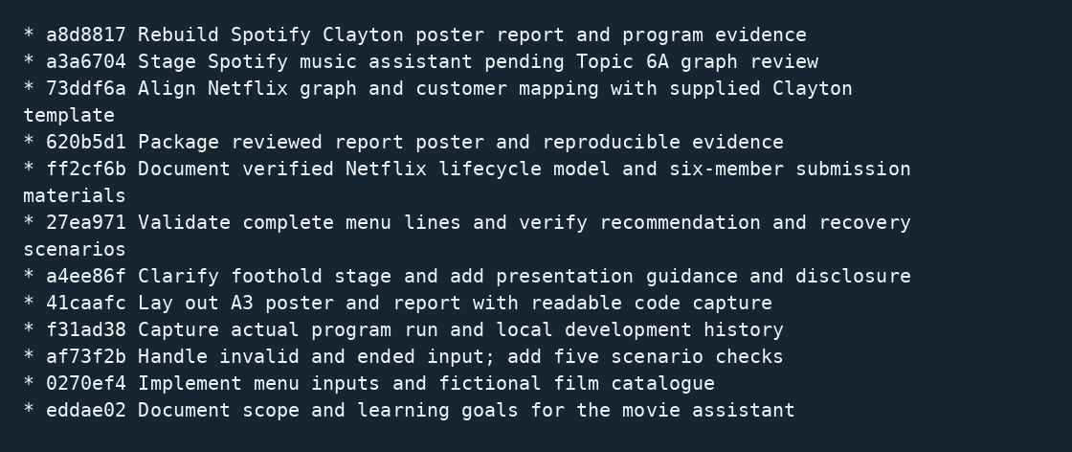
Figure 5. Real git log --oneline --graph --all showing the complete project development timeline.
Each member should review the work and add their real contribution record. The assignment’s --online example is a typo; the Git option used here is --oneline.
Source code and Git history access link: [INSERT WORKING SOURCE CODE AND GIT HISTORY URL]

Presentation links and declaration notes
OneDrive video recording: [INSERT WORKING ONEDRIVE VIDEO URL]
Source code and Git history: [INSERT WORKING SOURCE CODE AND GIT HISTORY URL]
Turnitin reports: [ATTACH REQUIRED REPORTS OR INSERT ACCESS LINK]
Speaker | Suggested subject | Approximate time
Aziel Tan Zheng Chuan | Case and thesis | 1:40
See Wing Kit | Graph and customer levels | 2:20
Soo Kian Rong | Timeline and market impact | 2:15
Vincent Lock Chun Kit | Programme design | 2:25
Wong Kee Yuan | Demo and validation | 3:00
Ho Ming Hao | Testing, critique and close | 2:30
The six-person script is supplied separately. The suggested total is 14:10, allowing transitions within the 18-minute maximum. The group must make its own MPEG, MP4 or MOV recording.

Submission declarations and verification
Each team member has contributed to the research, analysis, C++ program design, testing and documentation as specified in the individual contribution declarations. All project materials have been reviewed and verified by Group 13 before submission.
Each member must state their actual work and complete their own declaration. Confirm the class section, links, video, Turnitin reports and course originality requirements before submission.

