Laporan Praktikum
Laporan Praktikum Basis Data
Modul 5

Kelas : 2 – A
Syafia Jessie Chikita Claudy 253107030089
Program Studi D3 Manajemen Informatika
Politeknik Negeri Malang
2026

Daftar Isi
03 Modul 01 3
03 Modul 02 3
03 Modul 03 3
03 Modul 04 3
03 Modul 05 3
03 Modul 06 3
03 Modul 07 3
03 Modul 08 3
03 Modul 09 3

03 Modul 01
CREATE VIEW v_kasir AS
SELECT kasid "Kasir ID",
kasnama "Nama Kasir",
kotanama "Kota Asal"
FROM kasir, kota
WHERE kasir.kotaid = kota.kotaid;
SELECT * FROM v_kasir;

CREATE VIEW v_kasir_jumlah AS
SELECT kotanama "Kota Asal Kasir",
COUNT(Kasid) "Jumlah Kasir Asal Kota tersebut"
FROM kota LEFT JOIN `v_kasir_jumlah`kasir ON kota.kotaid = kasir.kotaid
WHERE kotanama IN ('kediri', 'malang', 'nganjuk')
GROUP BY kotanama;
SELECT * FROM v_kasir_jumlah;
Script Modul: 05 Modul 1
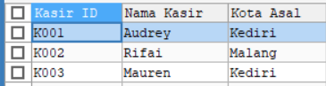
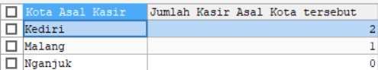
Screenshot Modul: 05 Modul 1

03 Modul 02
CREATE VIEW v_customer AS
SELECT custnama "Nama Customer",
kotanama "Kota Asal"
FROM customer, kota
WHERE customer.kotaid = kota.kotaid;
SELECT * FROM v_customer;

CREATE VIEW v_customer_jumlah AS
SELECT kotanama "Kota Asal Customer",
COUNT(custid) "Jumlah Customer Asal Kota Tersebut"
FROM kota LEFT JOIN customer ON kota.kotaid = customer.kotaid
GROUP BY kotanama;
SELECT * FROM v_customer_jumlah;
Script Modul: 05 Modul 2
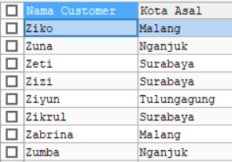
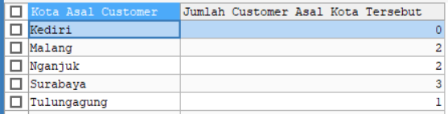
Screenshot Modul: 05 Modul 2

03 Modul 03
CREATE VIEW v_barang AS
SELECT brgnama "Nama Barang",
satnama "Satuan"
FROM barang, satuan
WHERE barang.satkode = satuan.satkode;
SELECT * FROM v_barang;

CREATE VIEW v_barang_jumlah AS
SELECT satnama "Satuan",
COUNT(brgid) "Jumlah Barang dengan Satuan Tersebut"
FROM satuan LEFT JOIN barang ON satuan.satkode = barang.satkode
GROUP BY satnama;
SELECT * FROM v_barang_jumlah;
Script Modul: 05 Modul 3
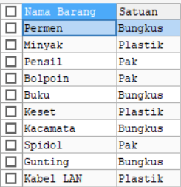
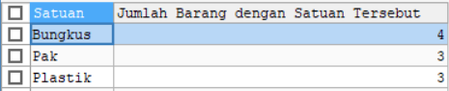
Screenshot Modul: 05 Modul 2

03 Modul 04
CREATE VIEW v_translengkap AS
SELECT transaksi.transid "ID Transaksi",
transtgl "Tanggal",
brgnama "Nama Barang",
jmltrans "Jumlah Barang"
FROM transaksi, barang, transdetail
WHERE transaksi.transid = transdetail.transid AND
transdetail.brgid = barang.brgid;
SELECT * FROM v_translengkap;
Script Modul: 05 Modul 4
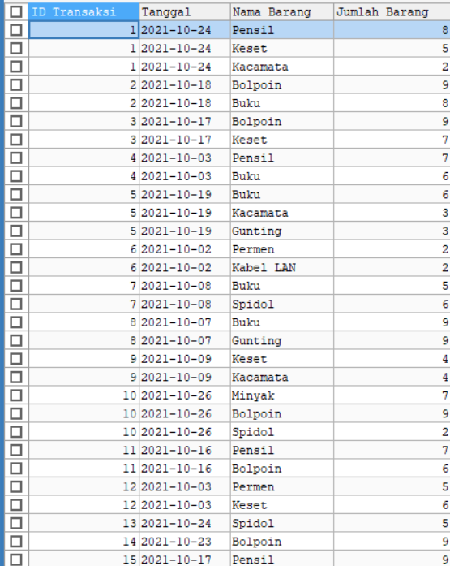
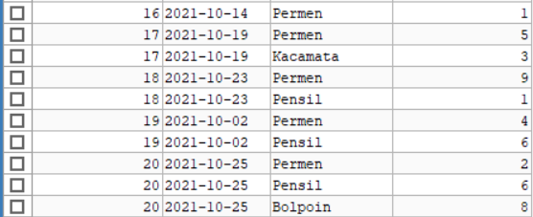
Screenshot Modul: 05 Modul 4

03 Modul 05
CREATE VIEW v_transrekap1 AS
SELECT transaksi.transid "ID Transaksi",
transtgl "Tanggal Transaksi",
COUNT(jmltrans) "Jumlah Tipe Barang yang Ditransaksikan"
FROM transaksi LEFT JOIN transdetail ON transaksi.transid = transdetail.transid
GROUP BY transaksi.transid;
SELECT * FROM v_transrekap1;
Script Modul: 05 Modul 5
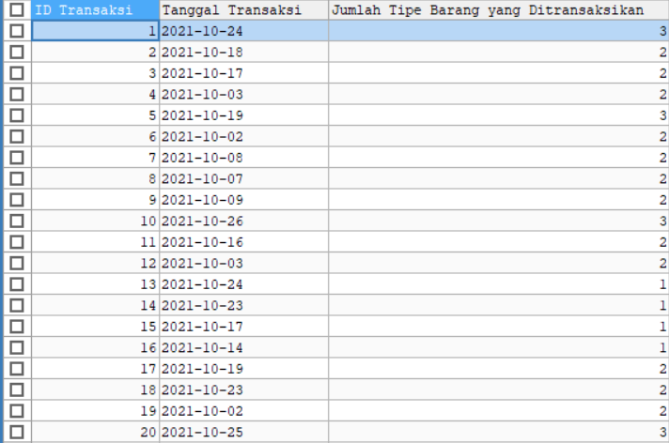
Screenshot Modul: 05 Modul 5

03 Modul 06
CREATE VIEW v_transrekap2 AS
SELECT transaksi.transid "ID Transaksi",
transtgl "Tanggal Transaksi",
GROUP_CONCAT(brgnama) "Nama Barang yang Ditransaksikan"
FROM transaksi
NATURAL JOIN transdetail
NATURAL JOIN barang
GROUP BY transaksi.transid, transtgl
ORDER BY transtgl, transaksi.transid;
SELECT * FROM v_transrekap2;
Script Modul: 05 Modul 6
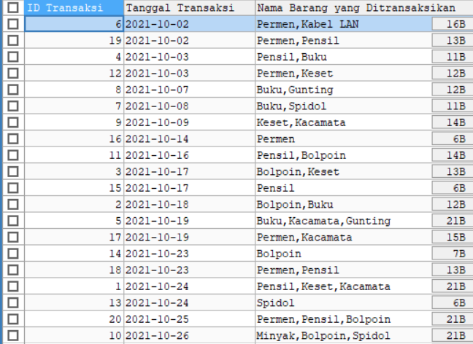
Screenshot Modul: 05 Modul 6

03 Modul 07
CREATE VIEW v_trans_rekapnominal AS
SELECT transaksi.transid "ID Transaksi",
transtgl "Tanggal Transaksi",
SUM(brghrg * jmltrans) "Nominal transaksi"
FROM transaksi
NATURAL JOIN transdetail
NATURAL JOIN barang
GROUP BY transaksi.transid;
SELECT * FROM v_trans_rekapnominal;
Script Modul: 05 Modul 7
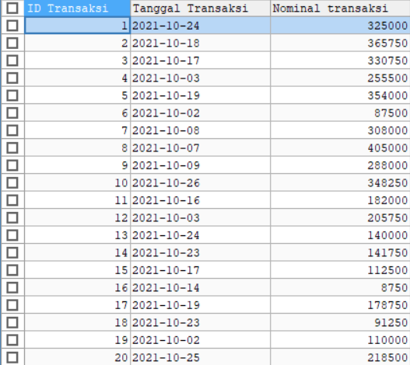
Screenshot Modul: 05 Modul 7

03 Modul 08
CREATE VIEW v_trans_rekapbarang AS
SELECT transaksi.transid "ID Transaksi",
transtgl "Tanggal Transaksi",
kasnama "Nama Kasir",
custnama "Nama Customer",
GROUP_CONCAT(brgnama) "Barang"
FROM transaksi
JOIN transdetail ON transaksi.transid = transdetail.transid
JOIN barang ON transdetail.brgid = barang.brgid
JOIN kasir ON transaksi.kasid = kasir.kasid
JOIN customer ON transaksi.custid = customer.custid
GROUP BY transaksi.transid, transtgl, kasnama, custnama
ORDER BY transtgl, transaksi.transid;
SELECT * FROM v_trans_rekapbarang;
Script Modul: 05 Modul 8
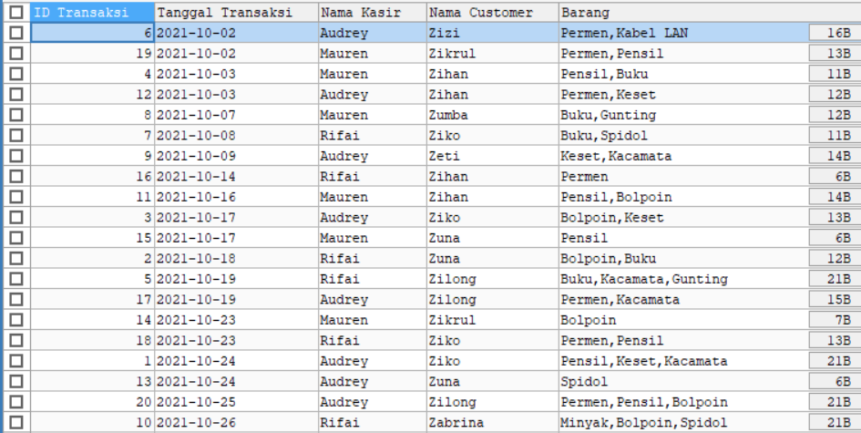
Screenshot Modul: 05 Modul 8

03 Modul 09
CREATE VIEW v_trans_rekapbarangdetail AS
SELECT transaksi.transid "ID Transaksi",
transtgl "Tanggal",
kasnama "Nama Kasir",
custnama "Nama Customer",
GROUP_CONCAT(CONCAT(brgnama, ' ( ', jmltrans, ' ', satnama, ' )')) "Barang"
FROM transaksi
JOIN transdetail ON transaksi.transid = transdetail.transid
JOIN barang ON transdetail.brgid = barang.brgid
JOIN kasir ON transaksi.kasid = kasir.kasid
JOIN customer ON transaksi.custid = customer.custid
JOIN satuan ON satuan.satkode = barang.satkode
GROUP BY transaksi.transid, transtgl, kasnama, custnama
ORDER BY transaksi.transid;
SELECT * FROM v_trans_rekapbarangdetail;
Script Modul: 05 Modul 9
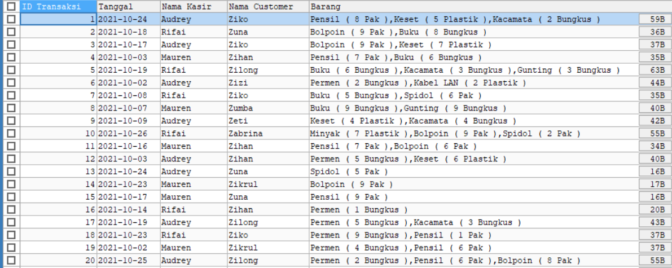
Screenshot Modul: 05 Modul 9

