

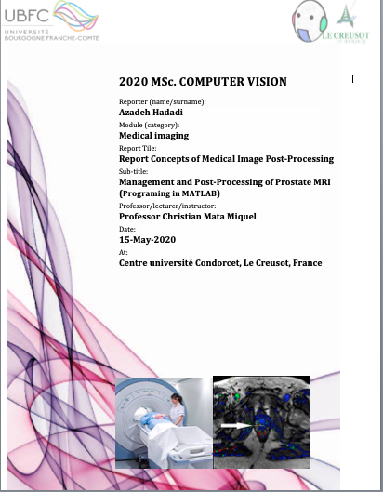

Table Of Contents

[TABLE OF FIGURES 4](#_Toc40431196)

[1. ABSTRACT 6](#_Toc40431197)

[2. INTRODUCTION 6](#_Toc40431198)

[2.1 Problem Definition 6](#_Toc40431199)

[2.2 Background 6](#_Toc40431200)

[2.3 Report Organization 6](#_Toc40431201)

[3. Prostate structure 7](#_Toc40431202)

[4. Prostate Cancer 7](#_Toc40431203)

[5. Prostate cancer detection using MRI 8](#_Toc40431204)

[5.2 ANATOMICAL imaging– 3D-T2 weighted imaging 9](#_Toc40431205)

[6. principle of Snake Contour 9](#_Toc40431206)

[6.1 SNAKE Behavior 9](#_Toc40431207)

[6.2 Image fources 10](#_Toc40431208)

[6.3 Line Functional 10](#_Toc40431209)

[6.4 Edge Functional 10](#_Toc40431210)

[6.5 Scale Space 10](#_Toc40431211)

[6.6 Termination Functional 10](#_Toc40431212)

[6.7 Constraint Energy 11](#_Toc40431213)

[6.8 Optimization through gradient descent 11](#_Toc40431214)

[6.9 Discrete approximation 11](#_Toc40431215)

[7. Procedure 12](#_Toc40431216)

[7.1 Actions 12](#_Toc40431217)

[7.2 Snake Contour 13](#_Toc40431218)

[7.3 3D Representation 15](#_Toc40431219)

[8. Flow charts and algorithms 15](#_Toc40431220)

[8.1 Function flow charts 15](#_Toc40431221)

[9. Results and functional display 19](#_Toc40431222)

[10. CONCLUSION 23](#_Toc40431223)

[11. REFERENCES 24](#_Toc40431224)

[12. Appendix 24](#_Toc40431225)

[12.1 loadDICOM 24](#_Toc40431226)

[12.2 Anonymize 24](#_Toc40431227)

[12.3 DICOMToJPG 24](#_Toc40431228)

[12.4 JPGToDICOM 25](#_Toc40431229)

[12.5 Smooth 25](#_Toc40431230)

[12.6 Snake 25](#_Toc40431231)

[12.7 CalculateSurface 25](#_Toc40431232)

[12.8 CalculateVolume 25](#_Toc40431233)

[12.9 3D Representation 25](#_Toc40431234)

## TABLE OF FIGURES

[Figure 1: different zones in a prostate 7](#_Toc40431267)

[Figure 2:50-year-old male with prostate cancer. (a) Axial T2WI showing low signal within the rightward aspect of the peripheral zone.Note the normal-appearing contralateral peripheral zone (PZ) comprised of glandular elements. (b) Axial T1WI showing an enlarged rightexternal iliac chain lymph node. 8](#_Toc40431268)

[Figure 3: actions panel: Load DICOM and JPG to DICOM buttons are active 12](#_Toc40431269)

[Figure 4: successful anonymized action message 12](#_Toc40431270)

[Figure 5: successful DICOM to JPG message 13](#_Toc40431271)

[Figure 6: error message in converting JPG to DICOM 13](#_Toc40431272)

[Figure 7: successful JPG to DICOM message 13](#_Toc40431273)

[Figure 8: sigma value for Gaussian filter 13](#_Toc40431274)

[Figure 9: snake panel 13](#_Toc40431275)

[Figure 10: snake contour 14](#_Toc40431276)

[Figure 11: 3D representation panel 15](#_Toc40431277)

[Figure 12: warning folder out of JPG file 15](#_Toc40431278)

[Figure 13: load DICOM function's flow 15](#_Toc40431279)

[Figure 14: Anonymize function's flow 16](#_Toc40431280)

[Figure 15: DICOM to JPG function's flow 16](#_Toc40431281)

[Figure 16: JPG to DICOM function's flow 17](#_Toc40431282)

[Figure 17: smooth function's flow 17](#_Toc40431283)

[Figure 18: Snake function's flow 18](#_Toc40431284)

[Figure 19: (a) calculate Surface's function flow (b) calculate volume's function flow 18](#_Toc40431285)

[Figure 20: 3D representation function 's flow 19](#_Toc40431286)

[Figure 21: DICOM files 19](#_Toc40431287)

[Figure 22: status panel 20](#_Toc40431288)

[Figure 23: anonymized DICOM file 20](#_Toc40431289)

[Figure 24: JPG and mat files 20](#_Toc40431290)

[Figure 25: smoothed image 20](#_Toc40431291)

[Figure 26: segmented DICOM file (a) peripheral zone (b) transitional zone (c) tumour (d) central zone 21](#_Toc40431292)

[Figure 27: snake parameters 21](#_Toc40431293)

[Figure 28: surface and volume of each zone 21](#_Toc40431294)

[Figure 29: created masks 22](#_Toc40431295)

[Figure 30: all zones in one image 22](#_Toc40431296)

[Figure 31: 3D representation of zones 22](#_Toc40431297)

[Figure 32: 3D representation of full prostate gland 23](#_Toc40431298)

# ABSTRACT

This report will present a management and post-processing tool for prostate MRI analysis. The objective of the tool and requested functionalities will be presented and usage procedure will be detailed. The application has a user interface (GUI) developed in MATLAB code and is easy to use. This GUI application is all about different operations related to DICOM format manipulation such as extraction patient’s information, anonymization, converting to JPG files and vice versa, prostate zone segmentation throughActive Contour Model (Snakes), calculating the surface and volume of each zone,and finally,show segmentation result in a 3D representation. A Database including DICOM image of 64 patients is the input data to the tooland the result will be displayed in the GUI interface. At the end of the report some images will be processed and the result will be presented. The report will end up to the conclusion and a summary of the findings of this work.

# INTRODUCTION

## 2.1 Problem Definition

The objective of the development is to design and implement a GUI interface in MATLAB capable of performing following functionalities on a set of prostate images with DICOM format:

“**A.** **1st stage**

• Display the information of DICOM (PatientName, PatientID, PatientBirthDate,StudyID, StudyDate, SliceLocation, and InstanceNumber)

• Anonymize DICOM images: Modify the following fields (PatientName,PatientID, and BirthDate) for all the setof images

• Save the anonymized images (Create a new folder containing the newanonymized images)

• Convert the DICOM image in JPG format (Be careful with the DICOMinformation!)

• Convert the JPG image into DICOM format

**B. 2nd stage**

• Snake segmentation for each region (only ZP, ZT, ZC, and the tumour region)

• Show a 3D representation of the prostate gland. (All the prostates)

• Show a 3D representation for PZ and CZ

• Show a 3D representation of the tumour region.

\* For the 3D representation should do using a transparent system.

**C.3rd stage**

• for each region calculate the surface (Surface = number of pixels x spatialresolution)

• Calculate the volume for each region.”

## 2.2 Background

The prostate is a small walnut shaped gland in the pelvis of men. Prostate cancer is the development of cancer in the prostate, a gland in the male reproductive system. In the last few decades, new imaging techniques based on Magnetic Resonance Imaging (MRI) have been developed to improve diagnosis. In practice, diagnosis can be affected by multiple factors such as observer variability and visibility and complexity of the lesions. In this regard, computer-aided detection and computer-aided diagnosis systems have been designed to help radiologists in their clinical practice.Researchon computer-aidedsystemsspecifically focusedforprostatecancerisayoungtechnologyandhasbeenpart ofadynamic field ofresearchduring thelast10years.

## 2.3 Report Organization

The remaining of the report is organized as follows. In section 3, the prostate structure and different zones will be detailed.Section 4 will discuss prostate cancer. In section 5, prostate MRI images and their detail will be explained. Thereafter, the theoretical aspects of the snake algorithm proposed by Kasset al. [1] will be explained and theoretical background and mathematical equations will be introduced in more detail in section 6. The application procedure will be detailed in section 7. This section will briefly explain how a new user shall install and use the GUI to process a given patient prostate MRI images. All of the steps and as per above functionality (see section 2.1 problem definition sub-section) will be described in this section. Section 8 explains all algorithms used in the development with the main functions’ flow charts. Section 9 contains the results obtained running the application with comparison with some other similar literatures. The report will end up with conclusion and references. Some parts of the main functions is attached in the Appendix I. the complete functions can be found in the attached MATLAB code (see ZIP file attached).

# Prostate structure

The prostate is a walnut-sized gland located between the bladder and the reproduction organs of the males. The prostate is situated right in front of the rectum. The urethra runs through the center of the prostate, from the bladder to the penis, letting urine flow out of the body. The prostate secretes fluid that nourishes and protects sperm. During ejaculation, the prostate squeezes this fluid into the urethra, and it’s expelled with sperm as semen. The vasa deferentia (singular: vas deferens) bring sperm from the testes to the seminal vesicles. The seminal vesicles contribute fluid to semen during ejaculation.

In general, doctors divide the prostate into three zones (see Figure 1below): the peripheral (1), central (2), and transition (3) zones. Most prostate cancers arise in the peripheral zone, the outer area of the prostate, which is next to the rectum. Doctors can sometimes feel a prostate tumor through the rectal wall during a digital rectal examination. Semen stored in the seminal vesicles passes through the central zone and into the urethra for ejaculation. The transition zone is the innermost section of the prostate. Prostate tissue in this area wraps around the urethra.

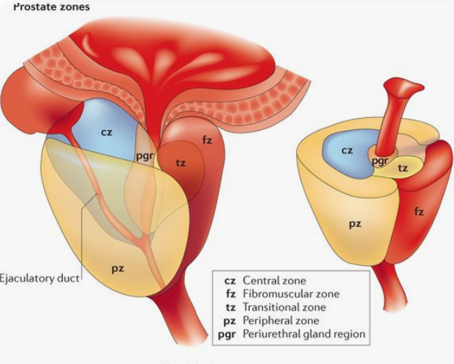

Figure : different zones in a prostate

# Prostate Cancer

Prostate cancer is the second most diagnosed cancer of men all over the world. In France, prostate cancer is the most common male cancer (71,200 new cases estimated in 2011) and the third leading cause of cancer death in men (8,700 deaths per year). The median age of diagnosis is 74 years, and 44 Percentage of prostate cancers are diagnosed after 75 years. The average age of death for prostate cancer is 78, almost the average life expectancy of men in France.

In the last few decades, new imaging techniques based on Magnetic Resonance Imaging (MRI) have been developed to improve diagnosis. In practice, diagnosis can be affected by multiple factors such as observer variability and visibility and complexity of the lesions. In this regard, computer-aided detection and computer-aided diagnosis systems have been designed to help radiologists in their clinical practice.Researchon computer-aidedsystemsspecifically focusedon prostatecancerisayoungtechnologyandhasbeenpart ofadynamic field ofresearchforthelast10years.

Prostate cancer typically presents as a round or ill-definedlow signal-intensity focus in the peripheral zone on T2WI.Since the majority of prostate carcinomas arise in theperipheral zone, many of them can be readily detectedwithin the high signal-intensity background of the looselypacked normal peripheral zone glandular tissueas is shown in Figure 2[].

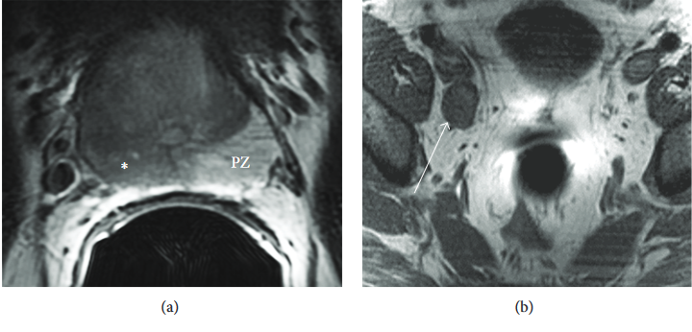

Figure :50-year-old male with prostate cancer. (a) Axial T2WI showing low signal within the rightward aspect of the peripheral zone.Note the normal-appearing contralateral peripheral zone (PZ) comprised of glandular elements. (b) Axial T1WI showing an enlarged rightexternal iliac chain lymph node.

# Prostate cancer detection using MRI

Magnetic resonance imaging (MRI) is a medical imaging technique used in radiology to form pictures of the anatomy and the physiological processes of the body which plays important role is in the anatomic evaluation, detection,and staging of prostate cancer is well established.

Multiparametric MRI (mpMRI) represents a growing modality for the non-invasive evaluation of prostate cancer, PCA and is increasingly being used for patients with persistently elevated PSA and prior negative biopsies, for monitoring patients in active surveillance protocols, for preoperative characterization of cancer for surgical planning, and in planning for MRI-targeted biopsy.

Prostate MRI is performed using either 1.5-T or 3-T magnetic field strengths, typically withthe combined use of endorectal and pelvic phased-array coils to maximize the signal-to-noiseratio. A bowel relaxant will also optimize the study by reducing artifact from bowel motion.The mpMRI is the current reference standard because no single MRI sequence isentirely sufficient to characterize prostate cancer. The optimal combination and interpretationapproach of anatomic and functional MR sequences still needs to be established. However, themore functional sequences that are combined, the better the accuracy appear to be. Recently,Turkbey et al. [] reported that a four-sequence multiparametric MRI (T2-weighted imaging, DWI,DCE-MRI, and MRS) had sensitivity of 86% and specificity of nearly 100% in a prospective trialof 45 patients. A number of studies that evaluated the use of a four-sequence multiparametricMRI approach in the diagnosis of localized prostate cancer reported sensitivity, specificity,accuracy, PPV, and NPV for the detection of prostate cancer of 69–95%, 63–96%, 68–92%,75–86%, and 80–95%, respectively.

The European Society of Urogenital Radiology (ESUR) and the European Association of Urology(EAU) have recently published clinical guidelines for multiparametric MRI of prostateoutlining both minimal and optimal requirements to allow a more consistent and standardizedapproach. Both articles recommend including T1-weighted, T2-weighted, DWI, and DCE-MRIsequences, but the addition of MRS is optional. The ESUR guidelines also outline the prostateimaging reporting and data system (PIRADS) structured reporting system, which includes a5-point scale for reporting the likelihood of clinically significant prostate cancer and probabilityof extraprostatic disease being present. The value of PI-RADS as a diagnostic tool and as apredictor of patient outcomes remains to be determined [].

## 5.2 ANATOMICAL imaging– 3D-T2 weighted imaging

T2-weighted imaging High-resolution axial, sagittal, and coronal T2-weighted imaging (T2WI)sequences offer excellent soft tissue contrast and depiction of the zonal anatomy of the prostate.As such T2WI is best placed to identify defects in zonal anatomy, as exhibited by PCA cells (orto depict seminal vesicle invasion and extra-capsular extension of disease). Normal PZ tissueis extremely water rich and composed of numerous ductal and acinar elements with sparselyinterwoven smooth muscle. This gives it a bright or high-intensity appearance on T2-weightedimages. On the other hand, PCA in the PZ appears as a rounded or ill-defined low-signalintensity focus that contrasts with the high-signal intensity of the loosely packed normal PZtissue.51 The presence of a low-signal intensity focus in the PZ of T2-weighted images does notdefinitively indicate the presence of cancer because conditions such as prostatitis, atrophy, andprior biopsy-related hemorrhages may mimic this appearance as well. The normal TZ tissuehas less water content, more compact smooth muscle, and sparser glandular components thanthe PZ and thus appears relatively darker on T2WI. PCA in the TZ appears as a homogeneousmass of low-signal intensity with indistinct margins. It is often hard to distinguish cancer fromstromal BPH in the TZ, which may also appear as low-signal intensity due to its high muscularand fibrous contents [].

# principle of Snake Contour

A snake is an energy-minimizing spline guided by external constraint forces and influenced by image forces that pull it toward features such as lines and edges. Snakes are active contour models: they lock onto nearby edges, localizing them accurately. Scale-space continuation can be used to enlarge the capture region surrounding a feature. Snakes provide a unified account of a number of visual problems, including detection of edges, lines, and subjective contours; motion tracking; and stereo matching[].

## 6.1 SNAKE Behavior

Basic snake model is a controlled continuityspline under the influence of image forcesand external constraint forces. The internalspline forces serve to impose a piecewise smoothnessconstraint. The image forces push the snaketoward salient image features like lines, edges,and subjective contours. The external constraintforces are responsible for putting the snake nearthe desired local minimum. These forces can, forexample, come from a user interface, automaticattention mechanisms, or high-level interpretations.

Representing the position of a snake parametricallyby , we can write its energy functional as:

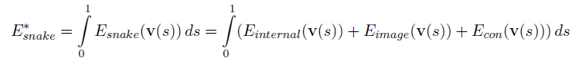

Whererepresent the internal energy of thespline due to bending, gives rise to theimage forces, and gives rise to the externalconstraint forces.The internal spline energy can be written

E:\MSCV2_Final_Docs\MIA\project\report\photos\fig4.png

The spline energy is composed of a first-orderterm controlled by and a second-order termcontrolled by . The first-order term makes thesnake act like a membrane and the second-orderterm makes it act like a thin plate. Adjusting theweights and controls the relative importanceof the membrane and thin-plate terms. Setting to zero at a point allows the snake tobecome second-order discontinuous and developa corner [].

## 6.2 Image fources

In order to make snakes useful for early vision weneed energy functional that attract them tosalient features in images.The total image energy can be expressed asa weighted combination of the three energyfunctions:

E:\MSCV2_Final_Docs\MIA\project\report\photos\fig6.png

By adjusting the weights, a wide range of snakebehaviour can be created[].

## 6.3 Line Functional

The simplest useful image functional is theimage intensity itself. If we set

E:\MSCV2_Final_Docs\MIA\project\report\photos\fig7.png

Then, depending on the sign Of, the snake willbe attracted either to light lines or dark lines.Subject to its other constraints, the snake will tryto align itself with the lightest or darkest nearbycontour[].

## 6.4 Edge Functional

Finding edges in an image can also be done witha very simple energy functional. If we set

E:\MSCV2_Final_Docs\MIA\project\report\photos\fig8.png

Then the snake is attracted to contourswith large image gradients.

## 6.5 Scale Space

A snake originating far from the desired object contour may erroneously converge to some local minimum. Scale space continuation can be used in order to avoid these local minima. Thiscan be achieved by a blurring filter on the image and reducing the amount of blurring as the calculation progresses to refine the fit of the snake. The energy functional using scale space continuation is:

E:\MSCV2_Final_Docs\MIA\project\report\photos\fig9.png

Where, is a Gaussian with standard deviation σ. Minima of this function fall on the zero-crossings of which define edges as per Marr–Hildreth theory[].

## 6.6 Termination Functional

Curvature of level lines in a slightly smoothed image can be used to detect corners and terminations in an image. Using this method, let be the image smoothed by:

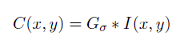

With gradient angle

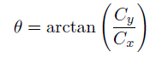

Unit vectors along the gradient direction

E:\MSCV2_Final_Docs\MIA\project\report\photos\fig12.png

And unit vectors perpendicular to the gradient direction

E:\MSCV2_Final_Docs\MIA\project\report\photos\fig13.png

The termination functional of energy can be represented as:

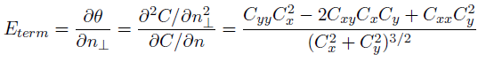

## 6.7 Constraint Energy

Some systems, including the original snakes implementation, allowed for user interaction to guide the snakes, not only in initial placement but also in their energy terms. Such constraint energy can be used to interactively guide the snakes towards or away from particular features.

## 6.8 Optimization through gradient descent

Given an initial guess for a snake, the energy function of the snake is iteratively minimized. Gradient descent minimization is one of the simplest optimizations, which can be used to minimize snake energy. The algorithm takes one step at each iteration in the negative gradient of the point with controlled step size to find local minima. This gradient-descent minimization can be implemented as

E:\MSCV2_Final_Docs\MIA\project\report\photos\fig15.png

Where, is the force on the snake, which is defined by the negative of the gradient of the energy field.



Assuming the weights and are constant with respect to *s*, this iterative method can be simplified to

E:\MSCV2_Final_Docs\MIA\project\report\photos\fig18.png

## 6.9 Discrete approximation

In practice, images have finite resolution and can only be integrated over finite time steps . As such, discrete approximations must be made for practical implementation of snakes.The energy function of the snake can be approximated using the discrete points on the snake.

E:\MSCV2_Final_Docs\MIA\project\report\photos\fig19.png

Consequentially, the forces of the snake can be approximated as

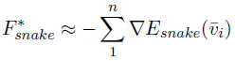

Gradient approximation can be done through any finite approximation method with respect to s, such as Finite difference.

# Procedure

The GUI of the processing application was developed in MATLAB R2017a revision on HP PC in Microsoft windows 10 pro OS, with Intel(R) Processor Core(TM) i7-8565U CPU @ 1.80GHz, 1992 MHz, 4 Core(s), and 8 Logical processor(s). StandardMATLAB’s GUIDE design tool was used to design the appearance of the GUI. To run the application, either you will run ***MIA\_App.fig*** in the MATLAB command line or use guide tool to load the GUI. Any way, MIA\_App.fig is the main GUI file. The guide commandshould be typed in MATLAB command line,then, ***MIA\_App.fig*** file must be selected from thepath where the file is located. Then the current folder root must be changed to the project root (right click on the GUI file and from the top-up menu select “change current folder as root”). The input data are composed of 64 DICOM image files in theDatabase, whichwas included in theapplication root. So if you are planning to run the GUI with different DICOM image, the image folder shall be copied into the root directory of the project.The application has three main panels including:

* ***Actions***
* ***Snake Contour***
* ***3D Representation***

Also, there is a ***Status*** panel to show the status and number of loaded images in every action. Below, the above panels and their functionality will be described.

## 7.1 Actions

* **Initial status**

The “action” panel includes Load DICOM, Anonymize, Converting from DICOM to JPG, and vice versa, and finally smoothing function as shown in. At the beginning, ***Anonymize***, **DICOM to JPG** and **Smooth** buttons are disabled, and ***Next*** and ***Previous*** buttons are invisible and Load DICOM and JPG to DICOM buttons are active. When Load DICOM function loaded the DICOM images then they will be active as well to be used during the further stages of the process.

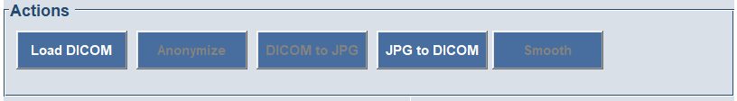

Figure : actions panel: Load DICOM and JPG to DICOM buttons are active

* **Load DICOM**

Multiple DICOM files are loaded by pushing “Load DICOM”button; then images will be loaded and displayed in the image windows allocated at the right side of the menu of the GUI and can be navigated through ***Next*** and ***Previous*** buttons. As soon as user loads DICOM files, the ***Next*** button will be visible and when navigates to the next image,***Previous*** button will be visible. Similarly, for the last image,***Next***button will be invisible and only ***Previous*** button will be visible.(As explained before, the target Database has already been located in the root directory of the project and is defined as default path for ***Load DICOM*** function)

The name of eachimageis shown at the top of the image when it is shown and the***Patient’s Information***is displayed at the bottom of the image. Also, the status of process and number of loaded images are displayed in the ***Status*** panel.

* **Anonymize**

After selecting DICOM files, the ***Anonymize*** button is enabled, and by clicking on this button, PatientName,PatientID, and BirthDatefieldsare anonymized; images can be saved in the selected path and the completion of the operation will be notified using a message as shown in Figure 4.

E:\MSCV2_Final_Docs\MIA\project\report\photos\fig23.png

Figure : successful anonymized action message

If the images have not been anonymized correctly it can be observed when loading these files.

* **DICOM to JPG**

User can convert DICOM imagesinto JPG formatjust by clicking on the **DICOM to JPG** button and save the JPG file and extracted ***mat*** file in the selected path. The result of this action is \*.JPG and \*.mat files which includes DICOM metadata. Finally, the bellow message will be displayed to inform the user that the conversion was done successfully and the resulted images have been successfully stored in the root directly and ready for further processes.

E:\MSCV2_Final_Docs\MIA\project\report\photos\fig28.png

Figure : successful DICOM to JPG message

* **JPG to DICOM**

“JPG to DICOM” function preforms the reverse conversion of the previous step. The JPG image and related metadata must be selected to allow the application to convert JPG to DICOM. Otherwise, an error message will be shown inFigure 6 to warn the user that one data or both data are missing.

E:\MSCV2_Final_Docs\MIA\project\report\photos\fig26.png

Figure : error message in converting JPG to DICOM

If conversion is done successfully, the completion message will be shown to inform the user as shown in Figure 7.E:\MSCV2_Final_Docs\MIA\project\report\photos\fig27.png

Figure : successful JPG to DICOM message

* **Smooth**

AGaussian filter will be applied to the image selectinga sigma parameter as input value. User should enter the sigma () value in the dialog boxthat the default value is 1as is shown inFigure 8. Smoothing the image is done before applying Snake.

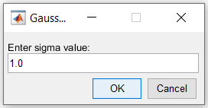

Figure : sigma value for Gaussian filter

## 7.2 Snake Contour

Snake Segmentation isdeveloped for contour detection as detailed in section 6. After loading DICOM flies, ***Region*** popupmenu will be enabled which contains Central Zone (CZ), Transitional Zone (TZ),Peripheral Zone (PZ), Tumour and can be selected by clicking on“--Select Zone—“ as is visualized in Figure 10.(After performing segmentation or clicking on the ***Next***&***Previous*** button, this component will be reset to the default value.)

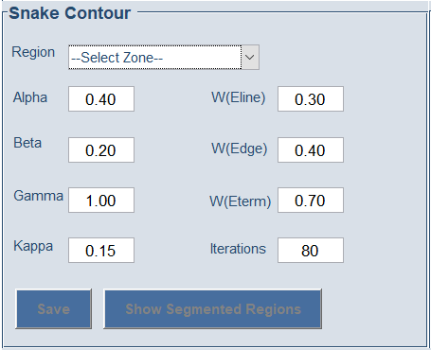

Figure : snake panel

Although default values for snake parameters were defined and hard coded, they are editable. So, just replace the old value with a desire value and click on enter to be replaced by the old value. The definition of each value is as follows (for better understanding of the each value refer section 6)

* : Elasticity of the snake is defined by this parameter. It controls the tension of the contour by combining with the first derivative
* Rigidity in contour is defined with this,through combination with the second derivative : This parameter defines the step size
* : A scaling factor for energy
* A weighing factor for intensity based potential
* Weighing factor for edge based potential
* Weighing factor for termination potential

The user can define the number of iteration as well by changing the default value of “iteration” parameter.

To perform the snake segmentation, first, one of the regionsis selected just by clicking on the **Region**and selecting one option from popupmenu.Selecting the initial position of the snake contouris done through clicking on the image and selecting control points, which later,are interpolated (Spline based) into a contour. Also the selected images can be navigated through ***Next*** and ***Previous*** buttons to find an image, which has all of the zones.

Before segmentation, **Save** and **Show Segmented Regions** are disabled. After segmentation of each zone, 3 operations are doneas shown in Figure 10:

1. Surface and Volume calculation will be done automatically and the results will be displayed in the ***Measures*** panel.
2. ***Save*** button will be enabled and the result can be saved as mask in the user-selected path. These masks are used in the ***3D Representation*** part. (There is a predefined ***Segmentation*** folder in the project root, which is the default path for saving masks. Depend on the selected zone, suggested name to save is concatenation of the abbreviation zone and selected image name)
3. ***Show Segmented Regions*** button will be enabled too and will show all of the segmented results together.

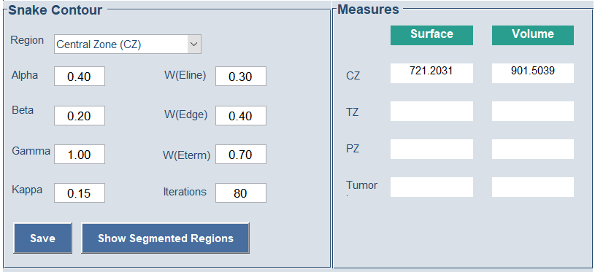

Figure : snake contour

## 7.3 3D Representation

The panel shown inFigure 11 is responsible for 3D reconstruction, which contains two buttons:***Load Segmented Images*** and ***Show 3D Representation***. Clicking on the ***“load segmented images”*** enables the ***”show 3D reconstruction***” button. The segmented masks for each zone, which were created during the ***Snake Contour***processing can be selected by the user using the “***load segmented images”*** and reconstruct 3D.

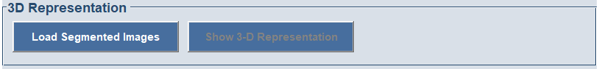

Figure : 3D representation panel

If the selected directory is out of JPG file, the bellow message will be shown.

E:\MSCV2_Final_Docs\MIA\project\report\photos\fig35.png

Figure : warning folder out of JPG file

Just clicking on the “***Show 3D Representation***” button will show the 3D representation of the masks.

# Flow charts and algorithms

The actions were described in section 7 shows only the functionalities that were request in sub-section 2.1. Now, the question is “to what base these functions were designed?” this section will describehow the function were designed and have been implemented. In the next section, one DICOM file from the attached Database (see the attached zip file) isselected and feed in each function as an input data the actions results are generated.

## 8.1 Function flow charts

In Loading DICOM action, the files are loaded and presented in the rightfigure and patient’s information will be shown in the bottom panel as detailed in section 7. The**dicomread**and**dicominfo**MATLAB methodsare used to implement this functionality. Figure 13 shows the flowchart of this action.

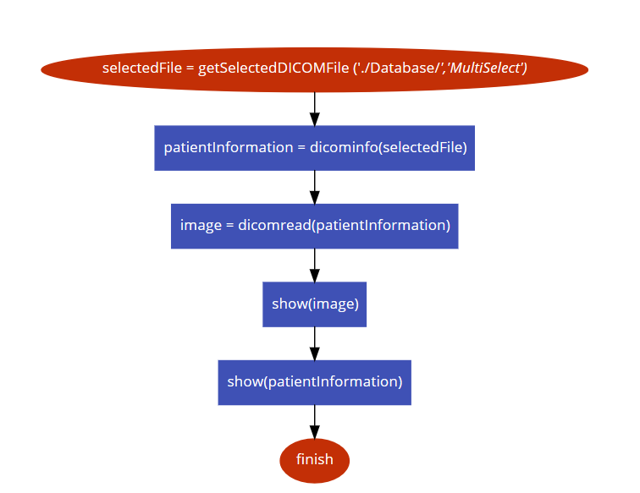

Figure : load DICOM function's flow

The **dicomanon** MATLAB function is used to anonymize the selected DICOM files.The related flow is illustrated in Figure 16.

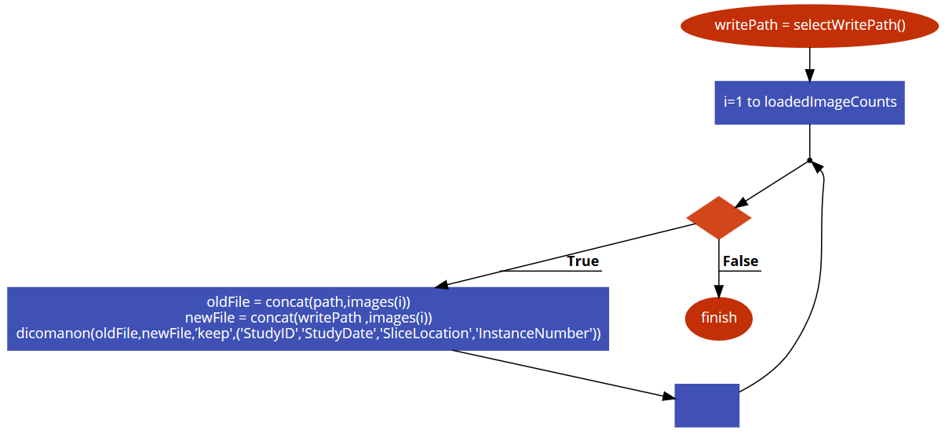

Figure : Anonymize function's flow

The DICOM metadata will be saved separately as ***.mat*** file in the converting DICOM to JPG action. In Figure 18 the related flow is shown.

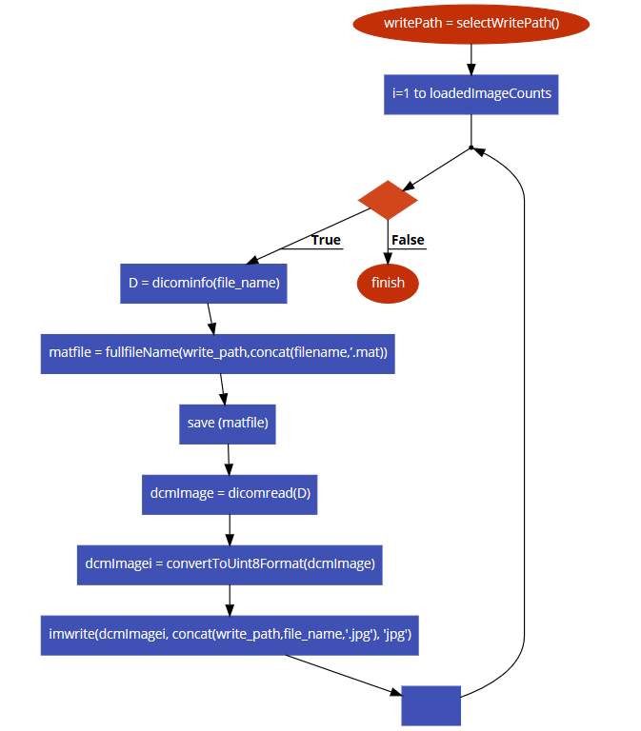

Figure : DICOM to JPG function's flow

In the opposite action, i.e. JPG to DICOM, JPG file and related .mat file will be merged together.

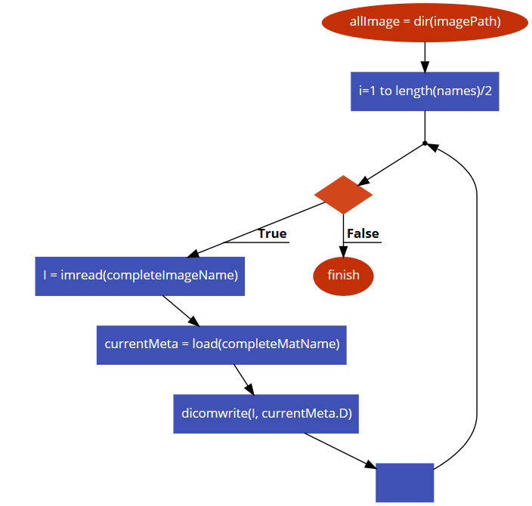

Figure : JPG to DICOM function's flow

Applying Gaussian filter was developed using **filter2** and **fspecial** function using as paramet Figure 21.

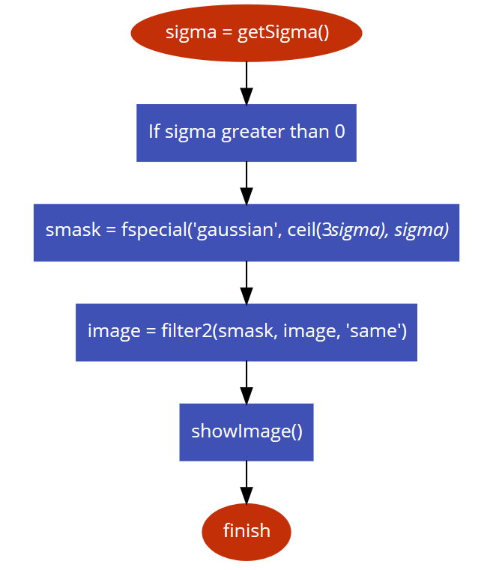

Figure : smooth function's flow

Segmentation on the objective zones including Central Zone, Transitional, Peripheral and Tumour have been done one by one according to flow in Figure 23 and using theory described in section 6 and parameter setting as detail in section 7.

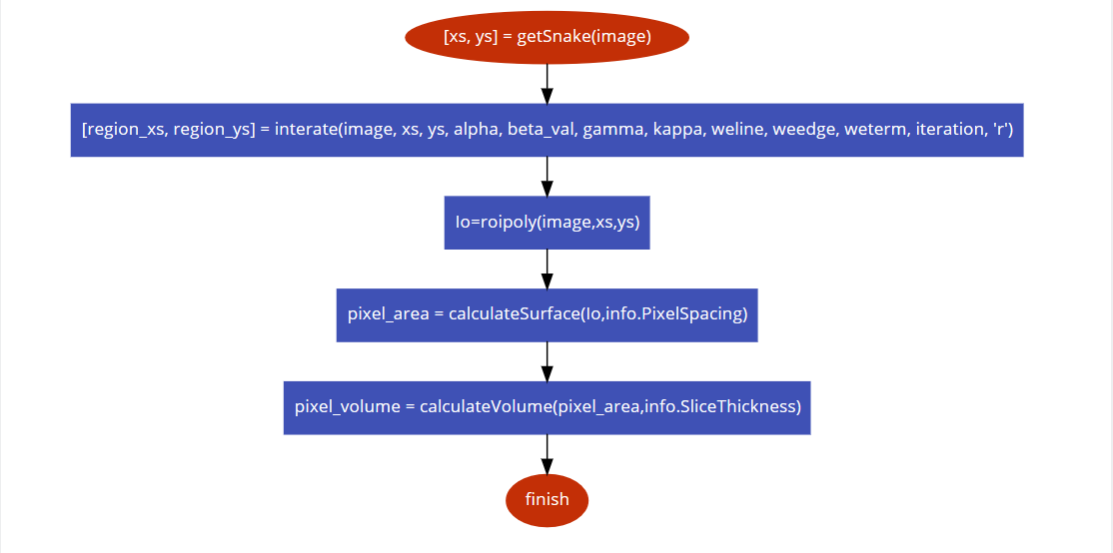

Figure : Snake function's flow

After selecting the ROI points, system will automatically start makingour snake move based on the ROI selected and parameters given. This has beenachieved using below function:

interate(image,xs,ys,alpha,beta,gamma,kappa,wl,we,wt,iterations,color)

Two functions calculateSurface and calculateVolumeare developed in this part. To calculate the surface, using regionprops MATLAB function, we can get the pixel area and sum of them multiply PixelSpacing gets final surface. Also volume equals to surface multiply by sliceThickness. shows both of their flows.

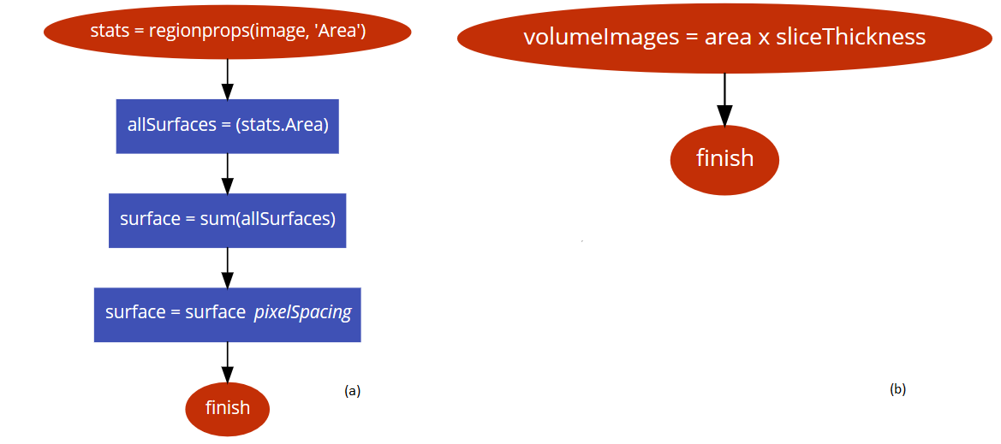

Figure : (a) calculate Surface's function flow (b) calculate volume's function flow

The 3D reconstruction uses the segmented images and puts them into an arranged order as of original order. Then uses surface function to plot them. Then the display parameters are set in another function as shown in Figure 20.

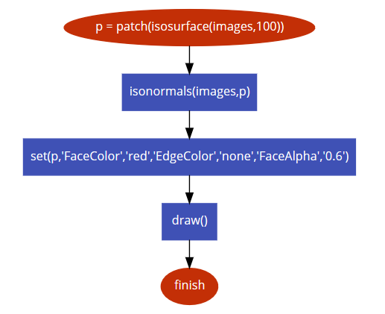

Figure : 3D representation function 's flow

# Results and functional display

In this section, result of the above functions will be presented and detail. All of the images of a given patient are selected to load as is shown in Figure 21. As seen, the image is loaded in the image windows, the image file name in the directly is displayed at the top and the patient’s information is displayed at the bottom of the image. There are already some images before this image because next and previous buttons are active to allow the user to go backward and forward to see more photos. The results of the anonymized DICOM files will be shown that the objective fields, i.e. PatientName,PatientID, and BirthDate are modified.

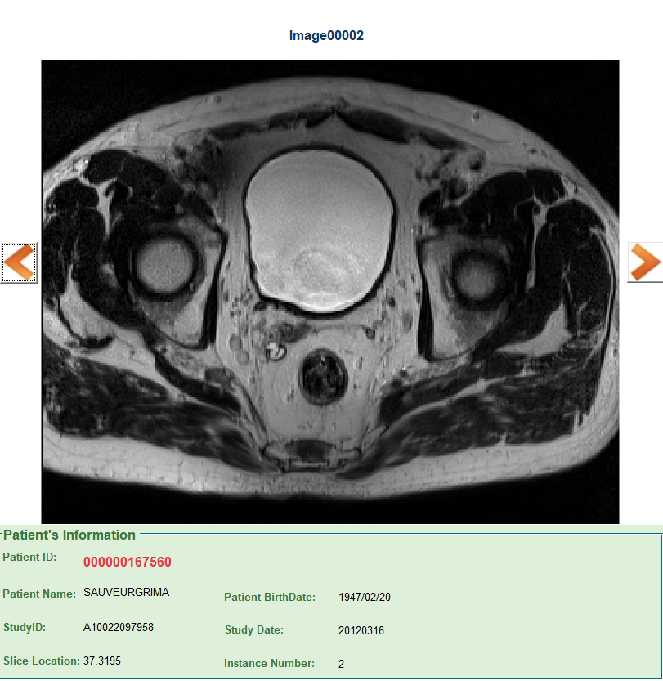

Figure : DICOM files

The status and number of loaded images are displayed in Status panel (Figure 22).



Figure : status panel

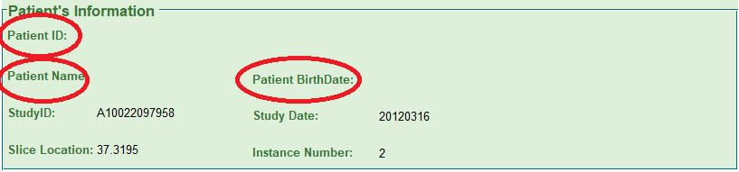

Figure : anonymized DICOM file

The image is converted from DICOM to JPG and MAT format and stored in the root directory of the project. So, as seen in Figure 24, for instance for given patient, image00002.jpg and image00002.mat have been generated after clicking on DICOM to JPG button.

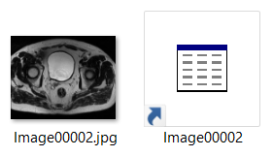

Figure : JPG and mat files

Gaussian filtering with a given image has produced the result as shown in Figure 25.

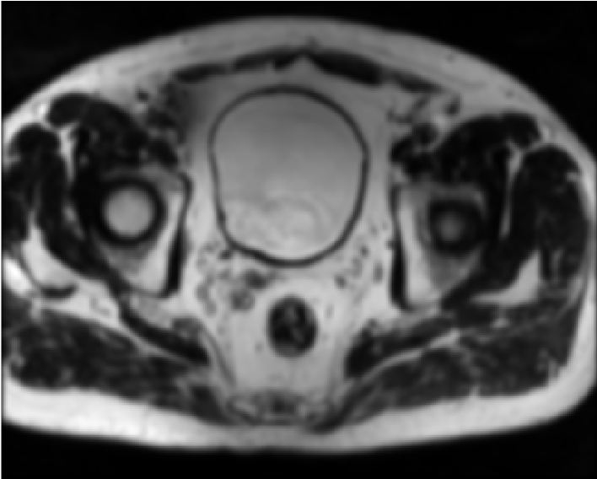

Figure : smoothed image

The results are illustrated in Figure 26 and related snake parameters are shown in Figure 27. Surface area and volume of each zone will be shown in Figure 28.

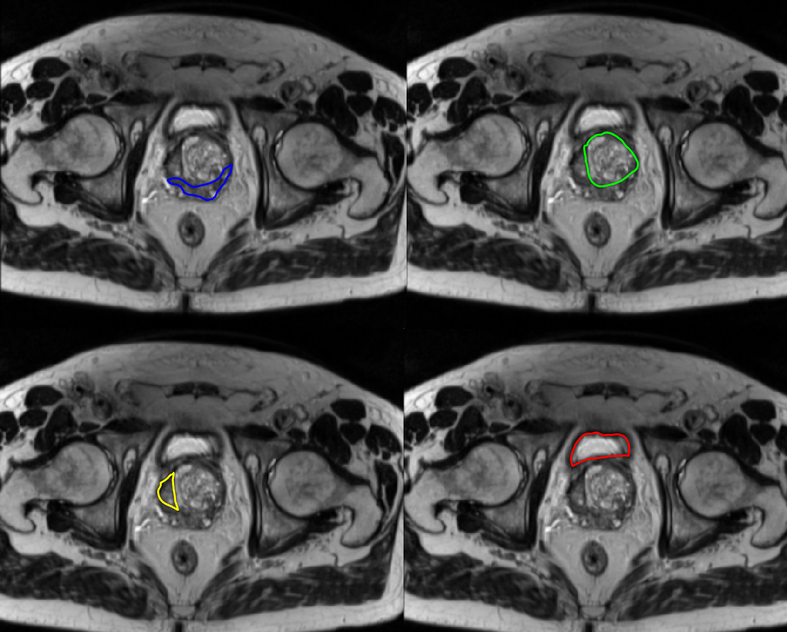

(a)

(c))

(d)

(b)

Figure : segmented DICOM file (a) peripheral zone (b) transitional zone (c) tumour (d) central zone

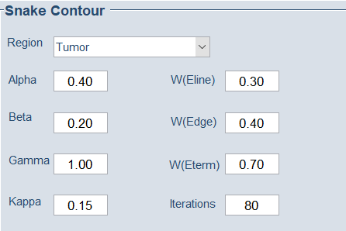

Figure : snake parameters

By pushing the save button, ***mask*** and ***snake*** result, as the same name of selected image, is saved. The default path has been set to ***Segmentation/masks and Segmentation/snake*** folders in the root. The selected zones the masks are created by segmentation are visualized in Figure 29.

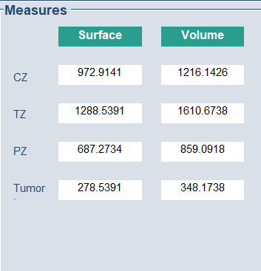

Figure : surface and volume of each zone



Figure : created masks

Figure 30 shows all segmented zones in one image.

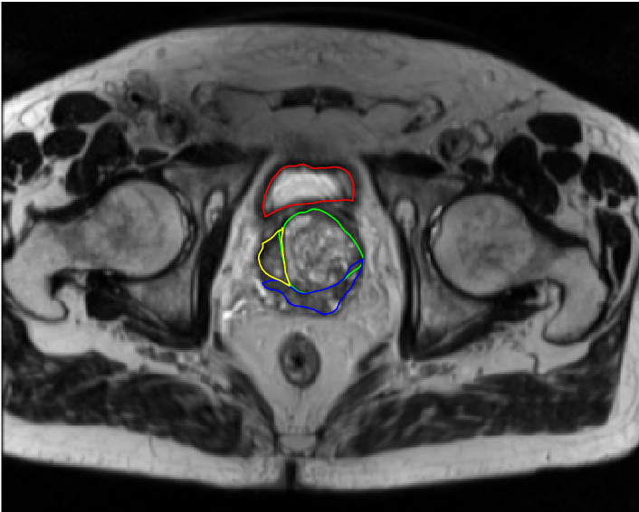

Figure : all zones in one image

As mentioned in Section 8.1, these masks are used as input data for 3D representation. 3D representation of zones and full gland respectively are shown in Figure 31 and Figure 32.

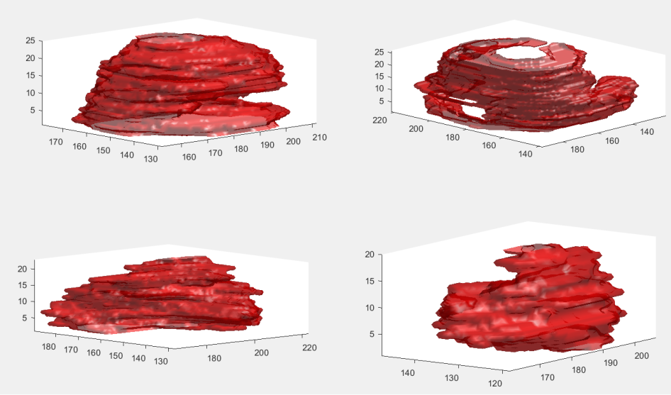

Figure : 3D representation of zones

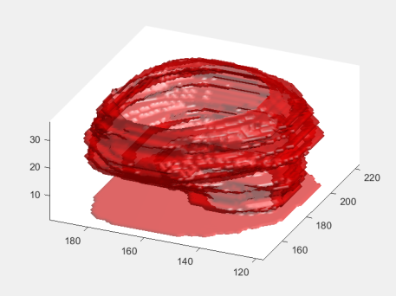

Figure : 3D representation of full prostate gland

# CONCLUSION

A tool for prostate DICOM image analysis were presented and different functionalities were detailed. Among these functionalities, loading DICOM images and converting them into JPG and vice versa as well as some preprocessing, notably smoothing, were presented. The snake segmentation was detail and the volume and surface extraction as well. The flow chart behind each function was presented and the implementation was explained. At the end some result were presented to show how the tool could be employed for prostate image analysis. This tool is a useful tool for doctor to load and manipulate DICOM image and study each patient for cancerous cell diagnosis.

# REFERENCES

[1] Anil Bhavsar and SadhnaVerma. Anatomic imaging of the prostate.*BioMed research international*, 2014, 2014.

[2] Witkin A. Terzopoulos D. Kass, M. Snakes: active contourmodels. *Int. J. Comput. Vis.1(14), 321â€“331*, 1998.

[3] David Marr and Ellen Hildreth. Theory of edge detection.*Proceedings of the Royal Society of London. Series B. Biological Sciences*, 207(1167):187–217, 1980.

[4] Gillian Murphy, MasoomHaider, SangeetGhai, and BoraiahSreeharsha. The expanding role of mri in prostate cancer. *American Journal of Roentgenology*, 201(6):1229–1238, 2013.

[5] Turkbey, Baris, and Peter L. Choyke. "Multiparametric MRI and prostate cancer diagnosis and risk stratification." *Current opinion in urology* 22.4 (2012): 310.

[6] Hegde, John V., et al. "Multi-parametric MRI of prostate cancer: An update on state‐of‐the‐art techniques and their performance in detecting and localizing prostate cancer." Journal of Magnetic Resonance Imaging 37.5 (2013): 1035-1054.

# Appendix

## 12.1 loadDICOM

selectedFile = getSelectedDICOMFile ('./Database/\*','MultiSelect')

patientInformation = **dicominfo**(selectedFile)

image = **dicomread**(patientInformation)

show(image)

show(patientInformation )

## 12.2 Anonymize

writePath = selectWritePath();

fori=1 to loadedImageCounts:

oldFile = concat(path,images(i))

newFile = concat(writePath ,images(i))

dicomanon(oldFile,newFile,’keep',

('StudyID','StudyDate','SliceLocation','InstanceNumber'))

end

## 12.3 DICOMToJPG

writePath = selectWritePath();

fori=1 to loadedImageCounts:

D = dicominfo(file\_name);

%extract the metadata from dicom image

matfile = fullfileName(write\_path,concat(filename,’.mat));

%save each image's meta data as .mat file

save (matfile);

%extract the image from dicom

dcmImage = dicomread(D);

%save it to jpeg file

dcmImagei = convertToUint8Format(dcmImage);

imwrite(dcmImagei, concat(write\_path,file\_name,'.jpg'), 'jpg');

end

## 12.4 JPGToDICOM

names = getSelectedJPGMatfiles();

allMeta = dir(matPath);

allImage = dir(imagePath);

fori=1 to length(names)/2:

%let's get the JPEG image

I = imread(completeImageName);

currentMeta = load(completeMatName);

%write the DICOM image in desired directory with metadata

dicomwrite(I, currentMeta.D);

end

## 12.5 Smooth

sigma = getSigma();

If sigma >0

smask = fspecial('gaussian', ceil(3\*sigma), sigma);

image = filter2(smask, image, 'same');

showImage();

## 12.6 Snake

%implementation of “Snakes: Active Contour Models”

[xs, ys] = getSnake(image)

% Let's make the snake move

[region\_xs, region\_ys] = interate(image, xs, ys, alpha, beta\_val, gamma, kappa, weline, weedge, weterm, iteration, 'r');

%create mask

Io=roipoly(image,xs,ys);

%find the surface & volume

pixel\_area = calculateSurface(Io,info.PixelSpacing);

pixel\_volume = calculateVolume(pixel\_area,info.SliceThickness);

## 12.7 CalculateSurface

%this function is used to calculate area

surface = calculateSurface(image,pixelSpacing)

stats = regionprops(image, 'Area'); %to get region properties

allSurfaces = [stats.Area]; %to get all areas

surface = sum(allSurfaces); % sum up all pixels

surface = surface \* pixelSpacing; % pixels \* spacing

## 12.8 CalculateVolume

%this function is used to calculate volume using area and slicethickness

volumeImages = calculateVolume( area, sliceThickness );

volumeImages = area \* sliceThickness;

## 12.9 3D Representation

%smooth the slices using gaussian filter

J = smooth3(images,'gaussian',5);

% formisosurface and extract patch

p = patch(isosurface(images,100));

% to find isonormals

isonormals(images,p);

%set the properties of patch and draw it

set(p,'FaceColor','red','EdgeColor','none','FaceAlpha','0.6');

draw();