DataCenterOS AI
Recursive AI agents that optimize GPU data centers and recover from operational failures
Project Guide and Page-by-Page Walkthrough
Crusoe Recursive Agents Hackathon · San Francisco · October 17, 2026
Simulation only. Every value in this document comes from a synthetic digital twin. No real data-center infrastructure is controlled, and no figure is real Crusoe data.

Contents

If the table of contents is empty, right-click it in Word and choose "Update Field".

1. Executive summary
AI data centers must coordinate GPU workloads, rack power budgets, cooling capacity, temperatures and job deadlines at the same time. A decision that looks reasonable in one domain, such as "move the hottest job to the coolest rack", can overload a rack power distribution unit (PDU), place a job on GPUs without enough memory, or delay a critical job.
DataCenterOS AI is a team of specialized agents that operates a simulated GPU data center. A Coordinator agent delegates investigation to Thermal, Power and GPU-Scheduling agents, proposes a recovery plan, and submits it to an independent Safety agent that checks every hard constraint with deterministic code. When a plan is rejected, the system stores the failure, learns which constraint families were violated, and recursively plans again within a fixed budget. If no safe plan exists, it stops and escalates to a human.
Headline result (cooling-failure demo, simulated)
Metric | Incident, no action | After agent plan
Hard-constraint violations | 2 | 0
Maximum outlet temperature | 47.3 °C | 41.9 °C
Maximum inlet temperature | 27.5 °C | 23.2 °C
Energy over 6 h horizon | 341.2 kWh | 339.5 kWh
Jobs missing deadline | 0 | 0
Plan attempts / rejections | — | 2 attempts / 1 rejection

What makes it different
- Real recursion, not a script. Every message on screen is a real tool call, LLM call or state transition, persisted in SQLite and replayable.
- Independent safety. PASS/REJECT is computed by deterministic Python, never by a language model claiming a plan is safe.
- Learning from failure. Rejected plans become tabu, and violated constraint families are added to the planner (lazy constraint generation, a technique from mathematical optimization).
- Safe stopping. Bounded attempts and recursion depth; escalation to a human when nothing is verifiable.
- Honest metrics. Before/after numbers are computed from the simulator. When a result gets worse (for example energy in the deadline scenario), it is reported as worse.

2. Running the project

2.1 Start the application
Requirements: Python 3.12 (installed with uv) and Node.js 20 or later.
- Backend: cd backend && .venv/bin/uvicorn app.main:app --port 8000
- Frontend (new terminal): cd frontend && npm install && npm run dev
- Open http://localhost:5173 in a browser.

2.2 Run the demo
- Click the red Inject Cooling Failure button at the top right.
- The app switches to the Agent Run page and shows the agents working live.
- When the run shows VERIFIED, open Results for the before/after comparison.

2.3 Verification commands
Purpose | Command
Backend tests (39 tests, 94% coverage) | cd backend && .venv/bin/python -m pytest --cov=app
Benchmark suite → CSV + JSON | cd backend && .venv/bin/python scripts/benchmark.py
Browser end-to-end check + screenshots | cd frontend && node e2e/demo.mjs
Re-record the demo video | cd frontend && node e2e/record.mjs

The demo video is included at docs/video/datacenteros-ai-demo.mp4 (about 95 seconds, 1440×900). It was recorded from the running application with real clicks and a real agent run.

3. Page-by-page guide
The interface is a single-page operations console with a top bar and seven pages. This section explains every element on each page, how to use it, and what happens underneath.

3.1 Top bar (visible on every page)
Element | What it means
DataCenterOS AI logo and subtitle | Product identity.
SIMULATION badge (amber) | Reminder that all data is synthetic and no real controls are connected.
Mock LLM mode / Crusoe badge | Purple "Mock LLM mode" when no Crusoe API key is set; green "Crusoe · <model>" when real inference is connected.
agents running / incident badges | Pulsing indicators while the agents work, or while a hard constraint is violated.
Scenario selector + Load scenario | Loads one of five benchmark scenarios into the digital twin.
Run agents | Starts the agent team on the current state (enabled only when there is a violation).
Inject Cooling Failure (red) | The main demo: reduces rack-04 cooling capacity by 30% and starts the agents automatically.
Navigation tabs | Overview, Digital Twin, Agent Run (with live event count), Results, Memory, Benchmarks, Settings.

3.2 Overview page
The operations overview: the first screen an operator sees.
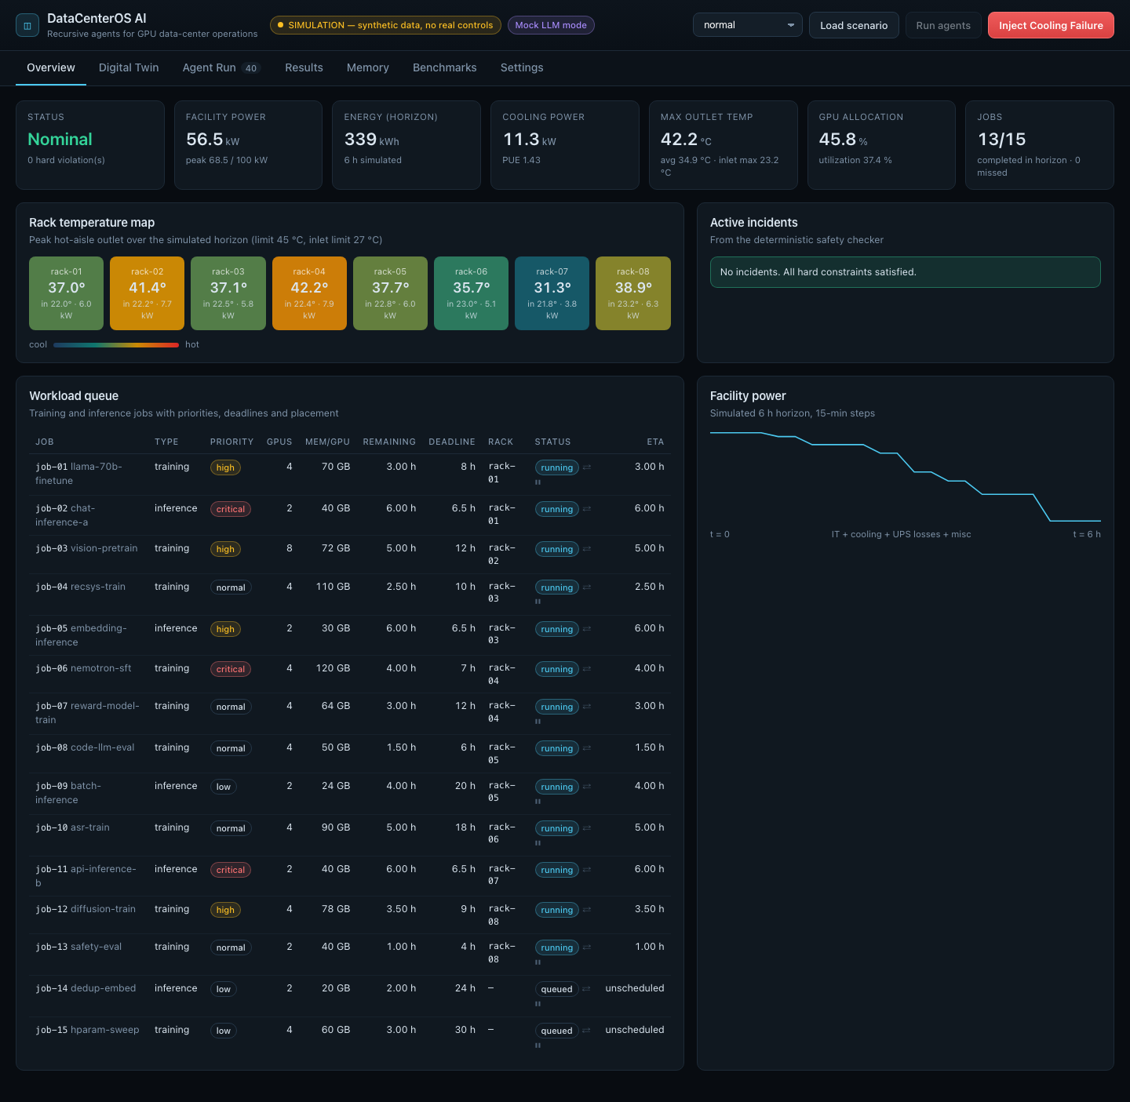
Figure 1. Overview in normal operation: all constraints satisfied.
What you see
- KPI row: status (Nominal / Incident / Mitigated), average and peak facility power against the 100 kW facility limit, energy over the 6-hour simulated horizon, cooling power and PUE (power usage effectiveness), maximum outlet and inlet temperature, GPU allocation and utilization, and jobs completed versus missed deadlines.
- Rack temperature map: eight tiles colored from cool blue to hot red by each rack's peak hot-aisle outlet temperature over the horizon. Each tile also shows peak inlet temperature and rack power. A light border marks a rack that breaks a temperature limit.
- Active incidents: the injected fault description plus every hard-constraint violation reported by the deterministic safety checker, with machine-readable codes such as OUTLET_TEMP_LIMIT.
- Workload queue: all 15 jobs (16 in the deadline scenario) with type, priority (critical / high / normal / low), GPUs, memory per GPU, remaining runtime, deadline, rack, status (running / queued / deferred) and simulated completion time. ⇄ marks a migratable job; ⏸ marks a deferrable one. A warning sign marks a missed deadline.
- Facility power chart: total facility power over the 6-hour horizon in 15-minute steps (IT + cooling + UPS losses + fixed overhead). It steps down as jobs finish.
After recovery
After the agents commit a plan, the status reads "Mitigated": no hard violations remain, but the cooling fault is still present, so the incident description stays visible.
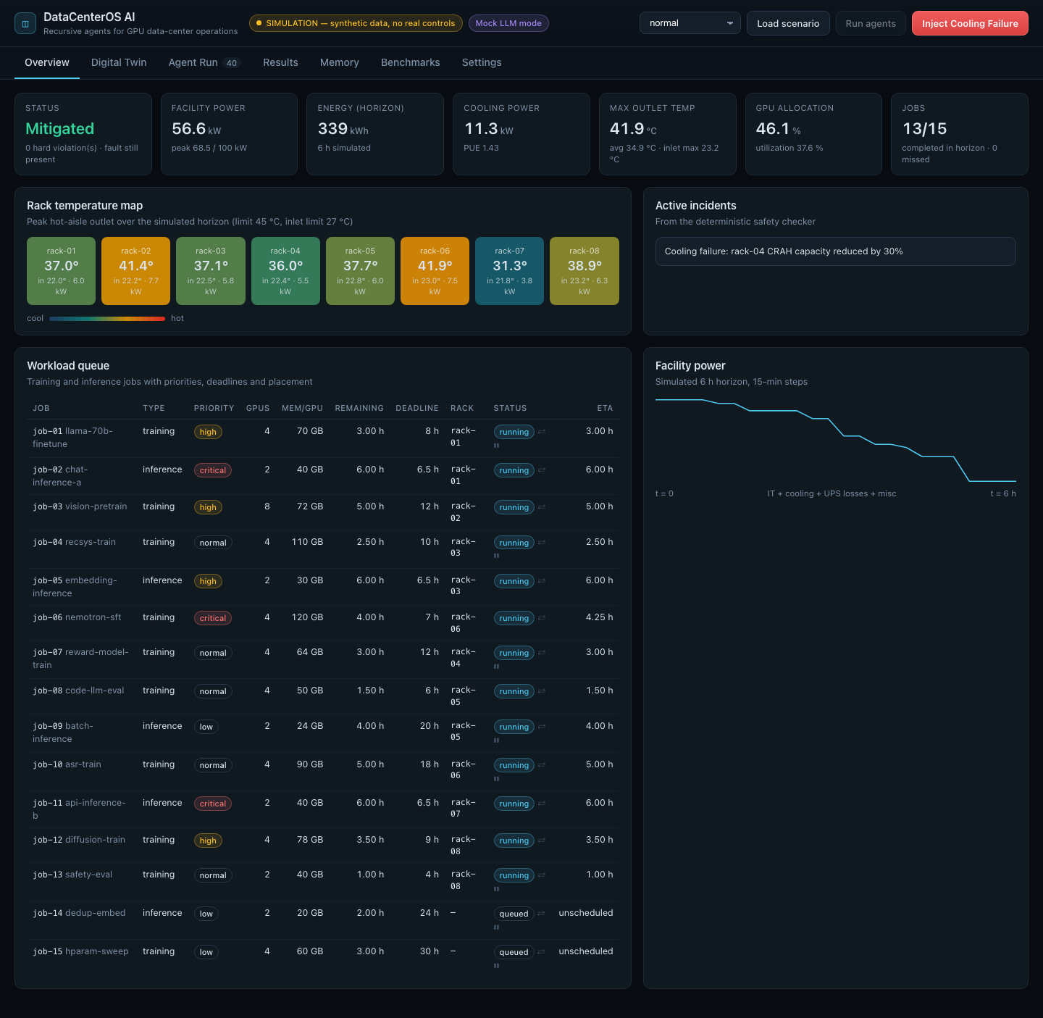
Figure 2. Overview after the agents recovered from the cooling failure.

3.3 Digital Twin page
A card for each of the 8 racks (8 GPUs each, 64 GPUs in total). Values are shown at t = 0 together with the peak over the simulated horizon.
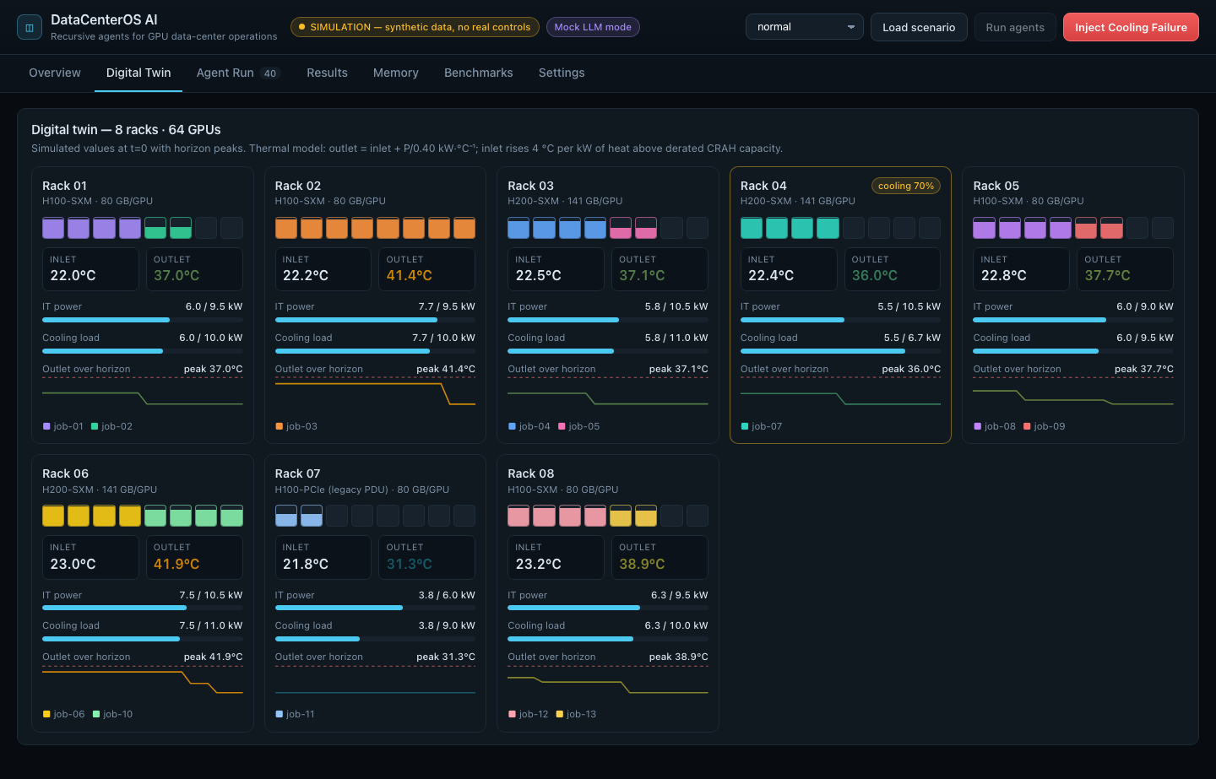
Figure 3. Digital twin after recovery: job-06 now runs on rack-06.
Reading a rack card
- Header: rack name, GPU model and memory per GPU (H100 80 GB, H200 141 GB, or the legacy H100-PCIe rack with a 6 kW PDU). Badges show degraded cooling (e.g. "cooling 70%"), a simulated power cap, or a thermal / power alarm.
- GPU tiles: eight tiles, one per GPU. A colored tile is allocated to a job (one color per job); the fill height shows that job's utilization. Hover a tile to see the job.
- Inlet / Outlet: current rack inlet (cold-aisle) and outlet (hot-aisle) temperatures.
- IT power meter: rack IT power against the rack power budget. Blue below 90%, amber above 90%, red when over budget.
- Cooling load meter: rack heat against the derated cooling capacity of its CRAH (computer-room air handler).
- Outlet over horizon: a small line chart of outlet temperature over 6 hours, with the 45 °C limit drawn as a red dashed line.
- Job legend: the jobs placed on that rack; deferred jobs show their start time.
Thermal model shown in the subtitle
Outlet = inlet + P / 0.40 kW per °C. Inlet rises 4 °C for every kW of heat above the derated cooling capacity (hot-air recirculation). These are documented simulation assumptions, listed in full in Section 6.

3.4 Agent Run page
The heart of the demo. It shows the recursive agent team working, live or in replay.
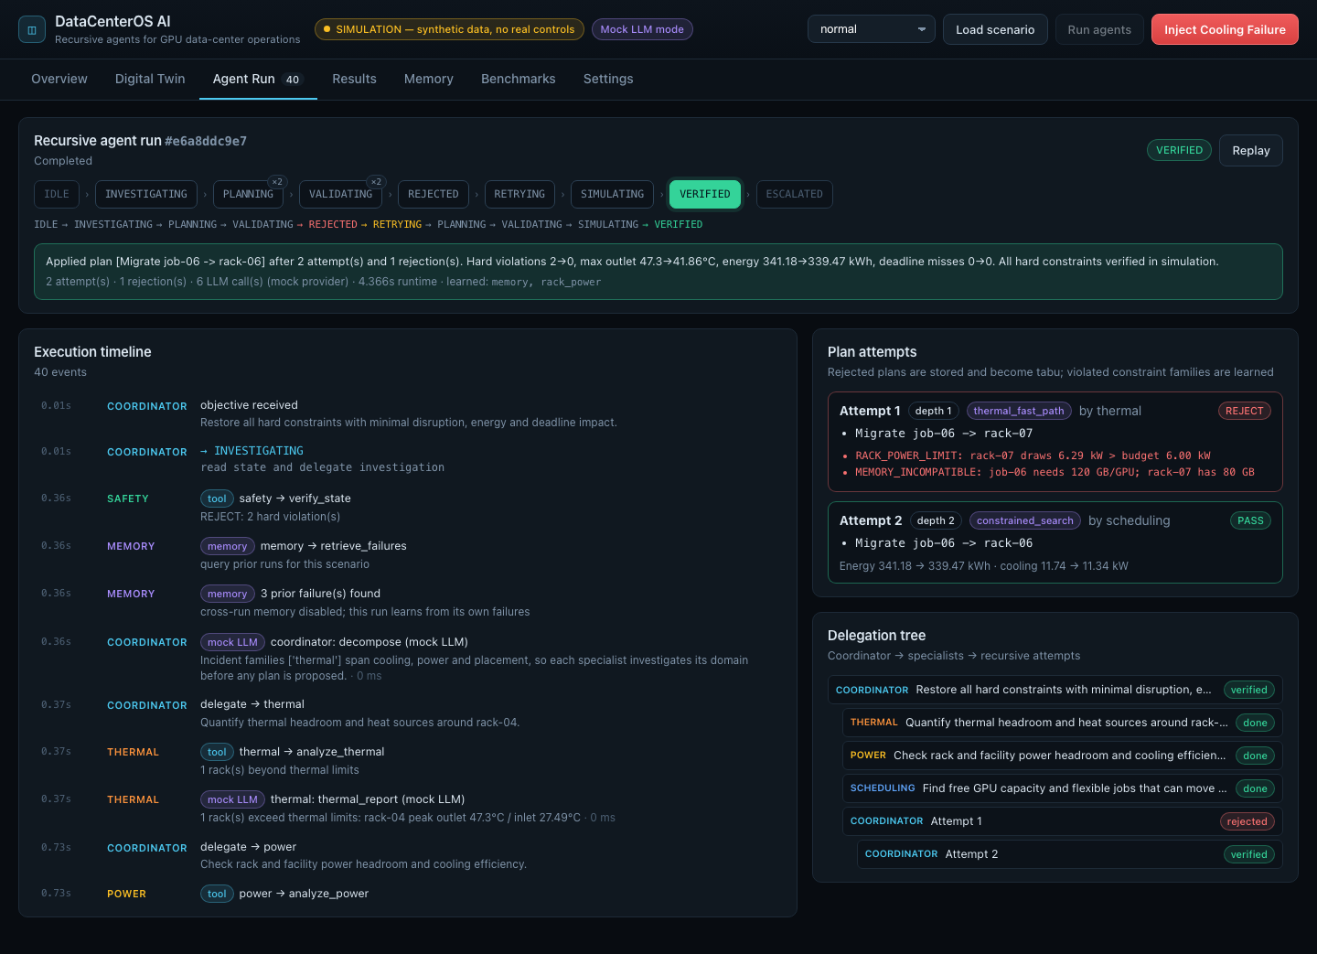
Figure 4. Completed cooling-failure run: plan 1 rejected, plan 2 verified.
State machine strip
Nine explicit states: IDLE, INVESTIGATING, PLANNING, VALIDATING, REJECTED, RETRYING, SIMULATING, VERIFIED and ESCALATED. The current state is highlighted (red for REJECTED / ESCALATED, green for VERIFIED). A small "×2" shows a state that was visited more than once, which is the visible sign of recursion. The line underneath is the exact transition path taken.
Run summary
A green (verified) or red (escalated) box with the coordinator's summary, the number of attempts, rejections and LLM calls, the provider (mock or Crusoe model), runtime, and the constraint families learned.
Execution timeline
Every event in order with its timestamp and agent. Event types:
- → STATE: a state-machine transition with its reason.
- tool: a deterministic tool call (e.g. thermal → analyze_thermal, safety → verify_plan).
- mock LLM / LLM: a language-model decision with its structured output, latency and token counts.
- memory: a read or write to the SQLite memory (retrieve_failures, record_attempt).
- Safety verdict: red background for REJECT (with reasons), green for PASS.
Plan attempts
One card per attempt with its recursion depth, strategy, authoring agent, the proposed actions, and the verdict. In the demo, Attempt 1 (thermal fast path: move job-06 to rack-07) is rejected for RACK_POWER_LIMIT (6.29 kW > 6.00 kW) and MEMORY_INCOMPATIBLE (needs 120 GB per GPU, rack-07 has 80 GB). Attempt 2 (constrained search: move job-06 to rack-06) passes, and its card shows the energy and cooling impact.
Delegation tree
Who delegated to whom: the Coordinator's objective at the root, the three specialist investigations beneath it, and each recursive attempt nested one level deeper than the attempt that spawned it.
Replay
The Replay button re-animates a finished run event by event from the stored history.
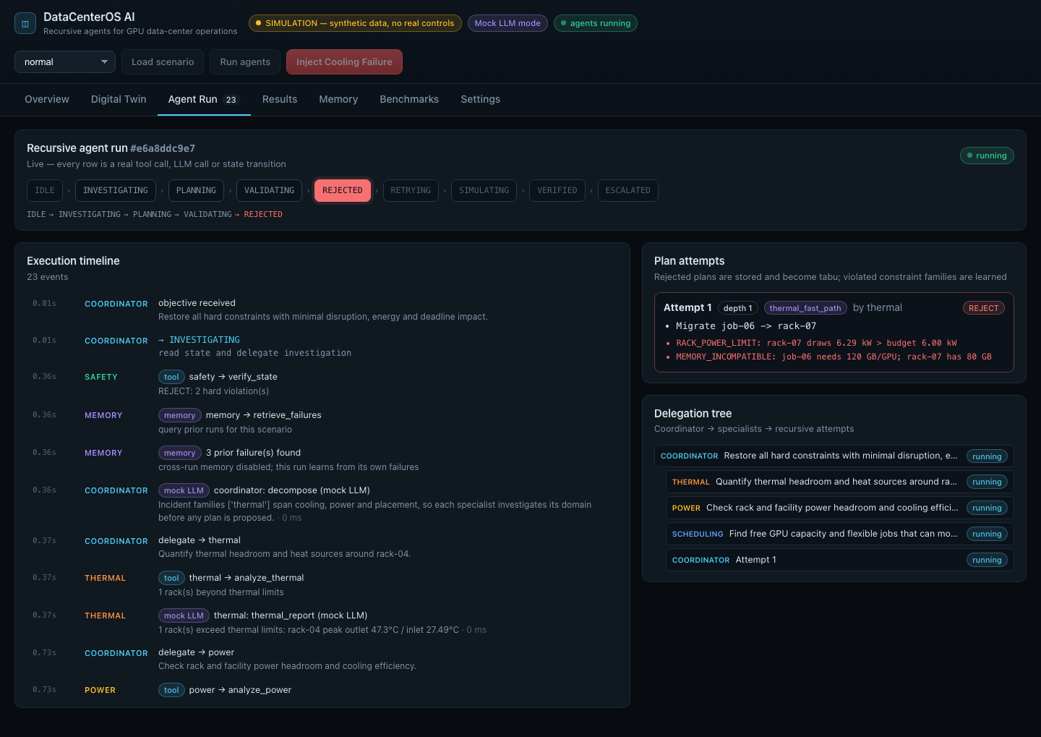
Figure 5. A run in progress: the coordinator is RETRYING after the first rejection.
When no safe plan exists
In the infeasible scenario the agents try four strategies, none of which can satisfy every hard constraint, and stop at ESCALATED. Nothing is applied to the twin.
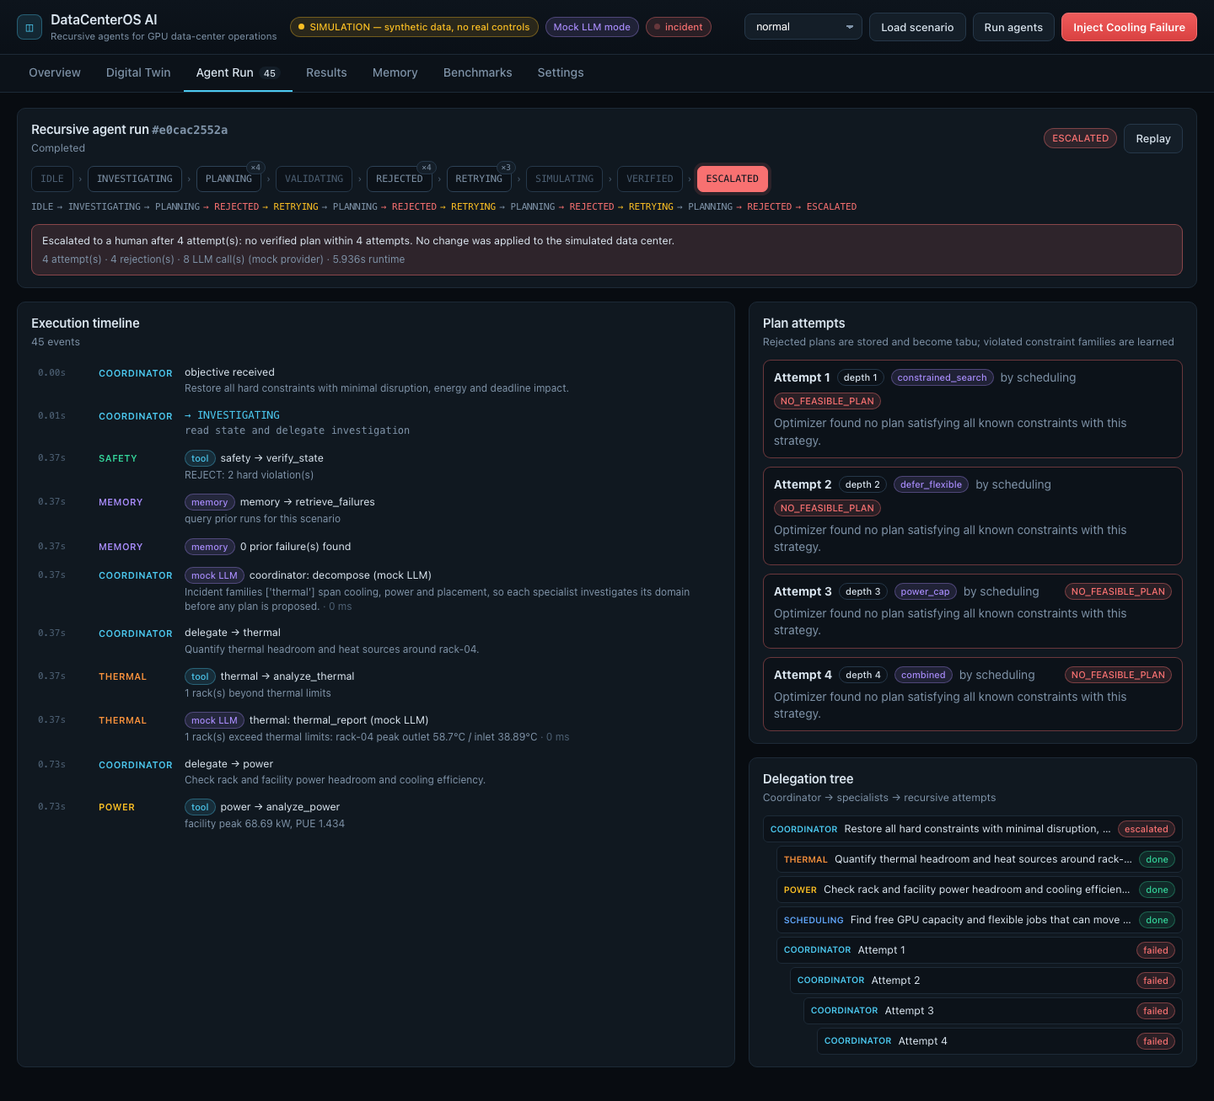
Figure 6. Infeasible scenario: four bounded attempts, then escalation to a human.

3.5 Results page
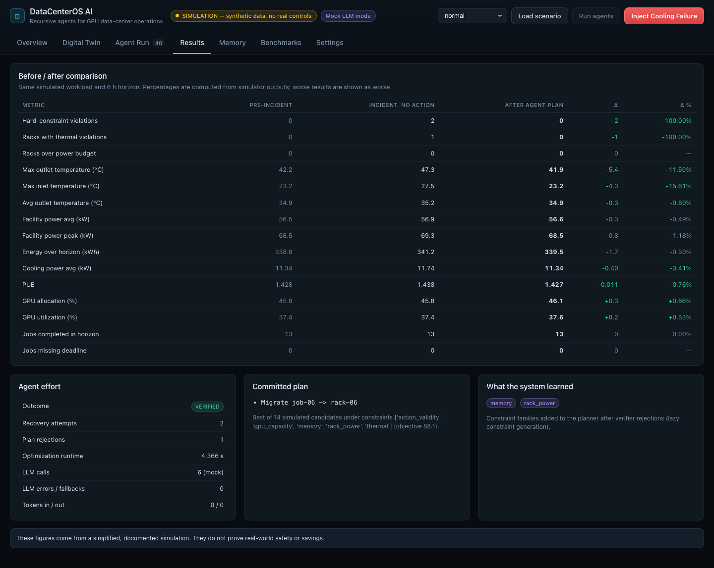
Figure 7. Before / after comparison for the cooling-failure run.
Before / after table
Three columns: Pre-incident (normal operation), Incident with no action, and After agent plan, all on the same simulated workload and 6-hour horizon. Δ and Δ% are computed from simulator outputs. Green means better, red means worse; metrics with no "better" direction (such as facility power) are grey.
Agent effort
Outcome, recovery attempts, plan rejections, optimization runtime, LLM calls (marked mock when applicable), LLM errors or fallbacks, and tokens in / out.
Committed plan and learned constraints
The plan applied to the twin with the optimizer's rationale (how many candidates were simulated and under which constraints), and the constraint families the planner learned from rejections.
Disclaimer shown on the page: these figures come from a simplified, documented simulation and do not prove real-world safety or savings.

3.6 Memory page
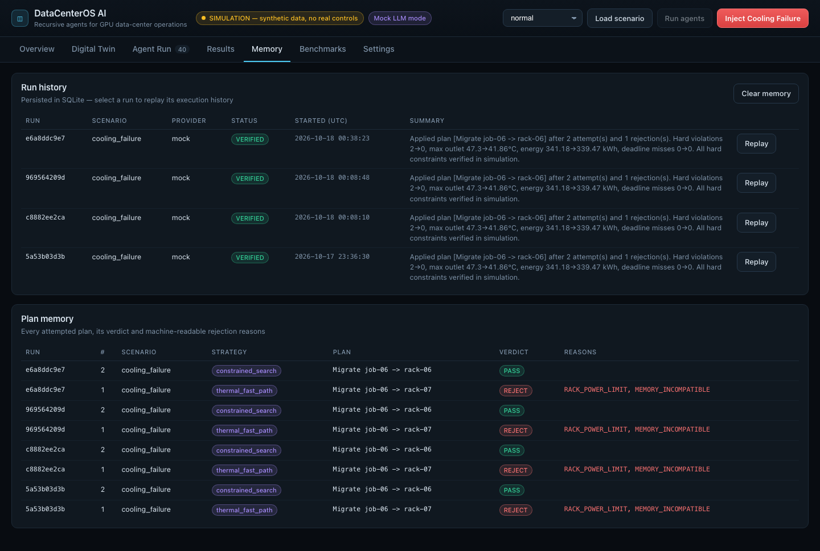
Figure 8. Run history and plan memory, persisted in SQLite.
- Run history: every run with scenario, provider, outcome, start time and summary. The Replay button loads the stored events into the Agent Run page and animates them.
- Plan memory: every attempted plan across runs with its strategy, actions, verdict and rejection codes. This is the data the coordinator retrieves before retrying.
- Clear memory: deletes stored runs and attempts (only while no run is active).
With "cross-run memory" enabled in Settings, a new run preloads known-invalid plans and learned constraints from earlier runs of the same scenario, so it can skip a mistake it has already made.

3.7 Benchmarks page
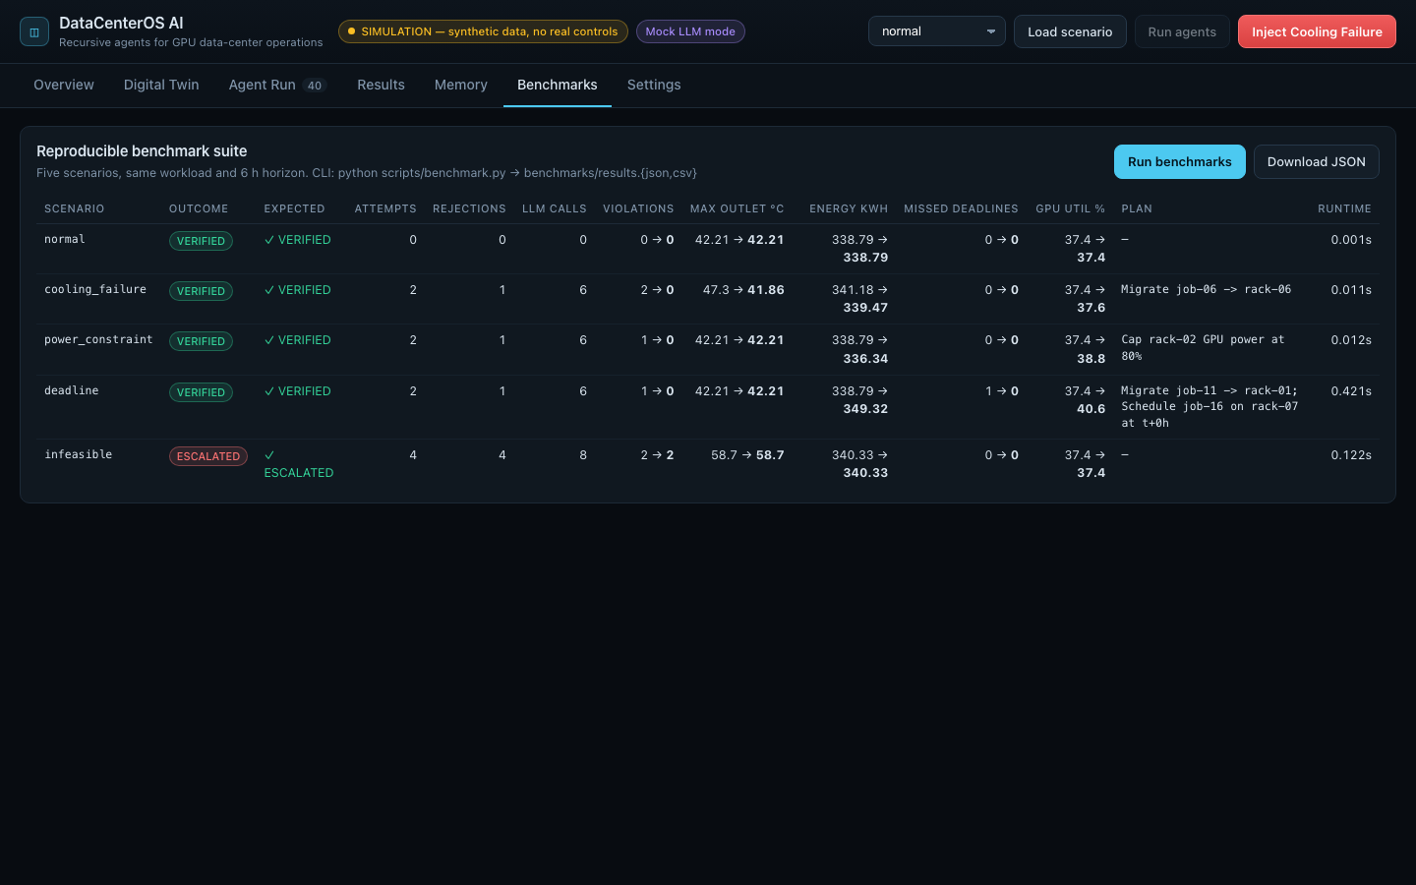
Figure 9. All five benchmark scenarios computed live.
Run benchmarks executes the full agent loop on five scenarios with the same workload and horizon and shows: outcome versus expected outcome, attempts, rejections, LLM calls, before → after for violations, maximum outlet temperature, energy, missed deadlines and GPU utilization, the committed plan and the runtime. Download JSON exports the rows. The command-line script writes the same data to CSV and JSON.

3.8 Settings page
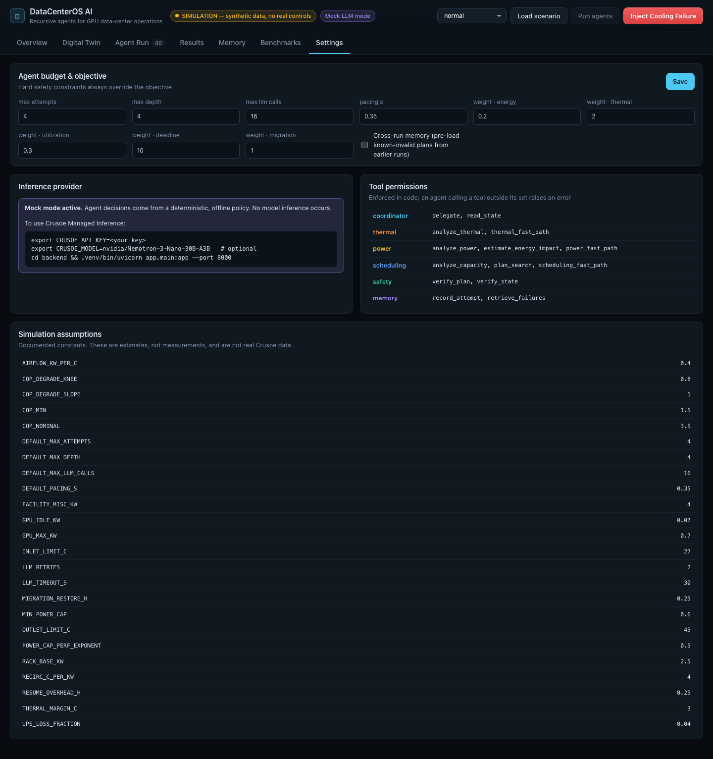
Figure 10. Agent budgets, objective weights, provider status, tool permissions and assumptions.
- Agent budget and objective: maximum attempts (default 4), maximum recursion depth, maximum LLM calls per run, UI pacing, and the optimizer objective weights (energy, thermal risk, utilization, deadline, migration). Hard constraints always override the objective.
- Cross-run memory: toggle described in Section 3.6.
- Inference provider: shows mock mode with exact instructions to connect Crusoe, or the connected model.
- Tool permissions: the tools each agent may call. Enforced in code: an agent calling a tool outside its set raises an error.
- Simulation assumptions: every physical constant used by the simulator.

4. Agent architecture
Agent | Responsibility | Tools (enforced) | LLM task
Coordinator | Receives the objective, decomposes it, delegates, decides retry / stop / escalate, enforces budgets | read_state, delegate | decompose, replan, final_summary
Thermal & Cooling | Thermal headroom, racks at risk, heat contributors; proposes the thermal fast path | analyze_thermal, thermal_fast_path | thermal_report
Power Optimization | Rack and facility power headroom, cooling power, PUE, energy impact of plans | analyze_power, power_fast_path, estimate_energy_impact | power_report
GPU Scheduling | Free GPUs, memory compatibility, job slack; runs the constrained plan search | analyze_capacity, scheduling_fast_path, plan_search | scheduling_report
Safety & Verification | Independent PASS / REJECT with machine-readable reasons | verify_state, verify_plan | none (deterministic)
Memory & Recovery | Stores plans, rejections, results; retrieves prior failures before retries | retrieve_failures, record_attempt | none

Language-model outputs are structured JSON, validated against a schema. If a call fails, times out, returns invalid JSON or exceeds the per-run call budget, a deterministic fallback policy is used and the event is labelled as a fallback. All arithmetic, physics, constraint checks and state transitions are deterministic Python.

4.1 The bounded recursive loop
- Read the objective and the current simulator state; verify it to find the incident.
- Retrieve prior failures from memory; ask the coordinator to decompose the task.
- Delegate investigation to the three specialists (sequential, bounded).
- Attempt 1: the specialist that owns the incident proposes its fast-path plan.
- The Safety agent verifies the plan on a copy of the twin over the full horizon.
- On REJECT: store the failure, mark the plan tabu, add violated constraint families, and recurse.
- On retry: the coordinator chooses a strategy; the optimizer searches under all learned constraints.
- On PASS: apply to a copy, measure energy impact, re-verify, then commit to the live twin.
- If attempts (default 4) or depth are exhausted, or the coordinator chooses to, escalate to a human.

4.2 States
State | Meaning
IDLE | No run in progress.
INVESTIGATING | Reading state, verifying the incident, delegating to specialists.
PLANNING | Generating a candidate plan (fast path or constrained search).
VALIDATING | Independent safety verification of the candidate plan.
REJECTED | The plan violated a hard constraint, or no feasible plan was found for the chosen strategy.
RETRYING | Recursing with the failure context at the next depth.
SIMULATING | Applying the verified plan to a copy and measuring its effects.
VERIFIED | The plan passed every check and was committed.
ESCALATED | No verifiable plan within budget; human intervention required; nothing applied.

5. Optimization engine and safety checks
The optimizer is a bounded beam search (width 30, at most 3 actions per plan). Each candidate is simulated over the full 6-hour horizon in 15-minute steps. Actions: migrate a job, defer a flexible job, schedule a queued job, and apply a simulated GPU power cap. Strategies chosen by the coordinator restrict the action types: constrained_search (migrate / schedule), defer_flexible, power_cap and combined.
Objective (lower is better, weights configurable): energy in kWh + thermal risk (squared °C above a soft margin) + idle GPU capacity + priority-weighted deadline misses + migration and disruption cost. Hard constraints always take priority over the objective.

5.1 Hard constraints checked by the Safety agent
Code | Family | Rule
INVALID_ACTION | action_validity | Job / rack exists; job is migratable or deferrable as required; cap within 60–100%
GPU_OVERALLOCATION | gpu_capacity | GPUs in use on a rack never exceed its usable GPUs at any time step
MEMORY_INCOMPATIBLE | memory | A job's memory per GPU must fit the rack's GPU memory
RACK_POWER_LIMIT | rack_power | Rack IT power never exceeds its PDU budget
FACILITY_POWER_LIMIT | facility_power | Facility power never exceeds 100 kW
INLET_TEMP_LIMIT | thermal | Rack inlet ≤ 27 °C (ASHRAE A1 recommended upper bound)
OUTLET_TEMP_LIMIT | thermal | Rack outlet ≤ 45 °C
CRITICAL_DEADLINE_MISS | critical_deadline | Priority-1 (critical) jobs must meet their deadlines

Lazy constraint generation: the planner starts with a relaxed model (thermal, GPU capacity, action validity and the incident's own constraint families). Each rejection adds the violated families to the planner's active set, and the rejected plan signature becomes tabu, so the same invalid plan is never proposed twice.

6. Simulation model and assumptions
Quantity | Model / value
GPU power | 0.07 kW idle + 0.63 kW × utilization × power cap (H100-SXM class, 0.70 kW max)
Rack IT power | 2.5 kW base (CPUs, NICs, fans, switch) + GPU power
Outlet temperature | inlet + P_IT / 0.40 kW per °C
Inlet temperature | supply air (21.8–23.2 °C) + 4 °C per kW of heat above derated cooling capacity
Cooling power | heat removed / COP; COP 3.5, degrading above 80% cooling load, minimum 1.5
Facility power | IT × 1.04 (UPS losses) + cooling + 4 kW fixed overhead
Power-cap throughput | cap^0.5 (sub-linear: an 80% cap gives about 89% throughput)
Migration / resume overhead | 0.25 h of checkpoint-restore time with GPUs reserved
Horizon | 6 hours in 15-minute steps
Racks | 8 racks × 8 GPUs; H100 80 GB, H200 141 GB, one legacy rack with a 6 kW PDU

These are plausible simplifications chosen for a hackathon simulation. They are estimates, not measurements, and the simulation does not prove real-world safety.

7. Benchmark results
Scenario | Outcome | Attempts | Rejections | Violations | Energy kWh (6 h) | Plan
Normal operation | VERIFIED | 0 | 0 | 0 → 0 | 338.8 → 338.8 | No action needed
Cooling failure | VERIFIED | 2 | 1 | 2 → 0 | 341.2 → 339.5 | Migrate job-06 → rack-06
Rack power constraint | VERIFIED | 2 | 1 | 1 → 0 | 338.8 → 336.3 | Cap rack-02 GPUs at 80%
High-priority deadline | VERIFIED | 2 | 1 | 1 → 0 | 338.8 → 349.3 | Migrate job-11 → rack-01; schedule job-16 on rack-07
Infeasible | ESCALATED | 4 | 4 | 2 → 2 | unchanged | None — human required

In the deadline scenario, energy increases by about 3% because the urgent job actually runs. This is reported as a cost, not hidden.

8. Crusoe Managed Inference
The hackathon requires projects to build on Crusoe Managed Inference. The application includes a client for Crusoe's OpenAI-compatible endpoint and a provider abstraction that switches between Crusoe and a deterministic mock provider.
Item | Value
Endpoint | https://api.inference.crusoecloud.com/v1/chat/completions
Authentication | Bearer API key from the Crusoe console (Security → Inference API keys)
Default model | nvidia/Nemotron-3-Nano-30B-A3B (configurable; verify in your console's model list)
Behaviour | JSON responses, 30 s timeout, 2 retries with backoff, latency and token logging; the key is never logged

Connect it
export CRUSOE_API_KEY=<your key>
export CRUSOE_MODEL=nvidia/Nemotron-3-Nano-30B-A3B # optional
cd backend && .venv/bin/uvicorn app.main:app --port 8000
Without a key the app runs the mock provider and the interface says "Mock LLM mode". No model inference is claimed in that mode. The first plan always comes from the thermal agent's fast-path heuristic, so the rejection-and-recovery demo is reproducible with either provider.

9. Limitations
- Simulation only: synthetic data, simplified steady-state thermal model per time step, no real controls.
- The Crusoe client is tested against a simulated HTTP server; a live call needs an API key.
- Rack = one 8-GPU node in this model; real racks hold several nodes.
- Cooling failure is assumed to persist for the whole horizon (no repair time).
- The optimizer is a bounded heuristic search, not a proof of global optimality.

10. Suggested 3-minute demo script
- Overview: "This is a simulated 64-GPU data center. Everything is computed by a deterministic digital twin."
- Digital Twin: "Each rack has its own power budget, cooling capacity and GPU memory. Rack 07 is a legacy rack with a 6 kW PDU."
- Click Inject Cooling Failure: "Rack 04 loses 30% of its cooling. The coordinator takes over."
- Agent Run: "The thermal agent does the obvious thing: move the hottest job to the coolest rack. The independent safety agent rejects it: the rack would overload its PDU and its GPUs do not have enough memory."
- Point at the state strip: "The coordinator stored the failure, learned two constraints, and recursed. The second plan passed every hard check and was committed."
- Results: "Violations went from 2 to 0, peak outlet from 47.3 to 41.9 °C, and energy slightly down. All computed, not hard-coded."
- Infeasible scenario: "And when no safe plan exists, it stops after four attempts and escalates. It never applies an unsafe change."

