GridMind AI
Website guide: what happens on every page
Autonomous multi-agent electrical circuit analysis, fault correction and data-center energy optimization.
SFTW: Harness Engineering & Model Wrangling Hackathon - October 2026
Reference run used for every screenshot
Item | Value
Scenario | Evening peak with data center (CIGRE MV benchmark + 4 MW AI data center)
Run ID | run-26b2db69e98c
Violations found | 17 (14 undervoltage, 3 transformer overloads)
Plans evaluated | 19 sized candidates, 179 plans, 185 AC power flows
Selected plan cost | $62,000 capital cost
Verification | Passed: 17 resolved, 0 remaining, 0 new (peak and light load)

1. What GridMind AI is
GridMind AI is a web application for distribution-network engineers. It draws a complete electrical network, calculates the voltage and loading of every component with an AC power flow, finds every limit violation, explains why each one happens, proposes and sizes corrective actions, re-simulates them, and proves with an independent verification that the corrected network is within limits. An AI data center is connected to the same network and its flexible load is optimised together with the electrical equipment.
Important principle: the language model never calculates electrical values. All voltages, currents, loadings and losses come from the pandapower Newton-Raphson power-flow solver, and every number shown on the website is read from a simulation result stored in MongoDB Atlas.

1.1 How a request flows through the system
Layer | Technology | Role
Web interface | React, TypeScript, React Flow, Recharts | 12 pages; interactive single-line diagram; charts
REST API | Python FastAPI, Pydantic | Validates every input; thin routes
Electrical engine | pandapower (AC Newton-Raphson), SciPy HiGHS LP | Power flow, violations, sizing, optimisation, 24 h time series
Agents | 10 specialised agents + orchestrator | Dependency graph, bounded fix-and-verify loop, resume after restart
Reasoning | Claude (claude-opus-5-5), optional | Explains computed evidence through read-only solver tools
Database | MongoDB Atlas (12 collections) | Circuits, equipment, results, faults, recommendations, agent tasks, memory, audit

1.2 The ten agents
# | Agent | What it does
1 | Circuit Modeling | Loads the 75 components from MongoDB, checks every required parameter, builds the solver model
2 | Power Flow | Solves the AC power flow and stores bus, branch and load results
3 | Violation Detection | Checks every component at peak and light load against configurable limits
4 | Root Cause | Decomposes voltage drops along the supply path and runs counterfactuals
5 | Corrective Action | Generates cause-specific remedies and sizes them by simulation
6 | Data Center | Models IT, AI, cooling and UPS demand; runs a 24-hour network time series
7 | Optimization | Ranks combinations with an explicit cost objective; schedules AI training
8 | Independent Verification | Reloads the model, re-solves the plan at peak and light load, compares
9 | Recursive Learning | Retrieves verified lessons before correcting and stores new ones afterwards
10 | Engineering Report | Writes the technical report from persisted results

1.3 Data used
- Network: CIGRE TF C6.04.02 European medium-voltage benchmark (20 kV feeders supplied by two 25 MVA 110/20 kV transformers). A unit test confirms the model reproduces the reference power-flow voltages.
- Load shapes: SimBench standard profiles (residential lv_urban6, commercial G0-A), CC BY 4.0.
- Weather: Open-Meteo hourly temperature and solar irradiance for San Jose, CA, CC BY 4.0.
- Data-center sizes, transformer tap-changer data, costs and the time-of-use tariff are documented assumptions, flagged in the data and on screen.

2. Page 01: Overview
A one-screen summary of the selected scenario: how healthy the network is, what the agents concluded, and where every number comes from.
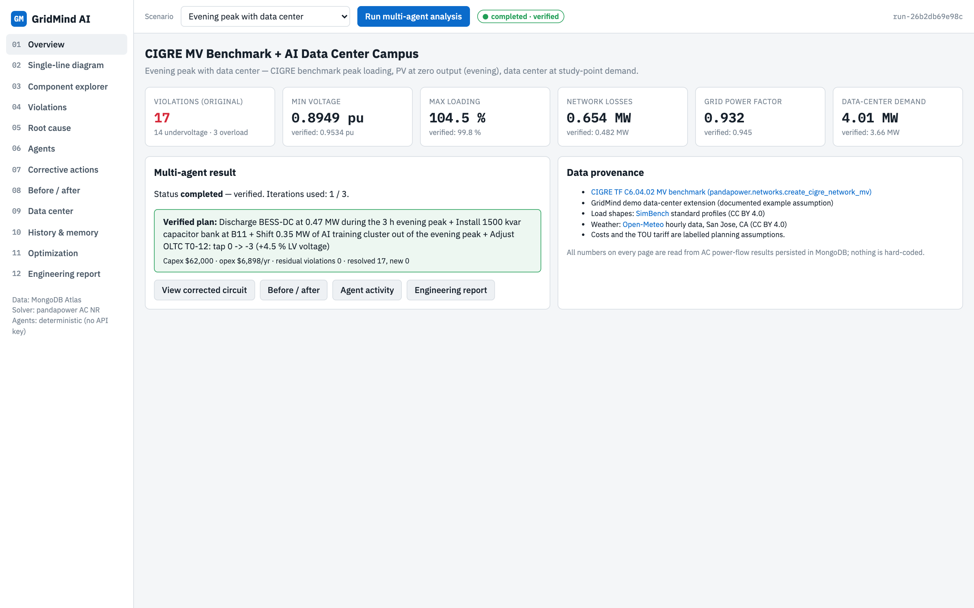
Figure 01: Overview page

What you see on the page
- Six KPI tiles: number of violations in the original circuit (17: 14 undervoltage, 3 overloads), minimum bus voltage, maximum branch loading, network losses, grid power factor and data-center demand. When a verified plan exists, each tile also shows the verified value underneath.
- The Multi-agent result card: run status, iterations used, and the recommended plan with its capital cost, operating cost and verification outcome (green banner = verified).
- Shortcut buttons to the corrected circuit, the before/after comparison, the agent activity page and the engineering report.
- The Data provenance card listing every source: the CIGRE MV benchmark network, SimBench load profiles, Open-Meteo weather data and the labelled cost assumptions.

What happens behind the scenes
- The page reads the latest agent run for the selected scenario from the MongoDB collection optimization_runs and the original-state power-flow result from simulation_results.
- If no run exists yet, the backend solves the scenario directly so the KPIs are still real solver output.
- Nothing on the page is hard-coded: every value is a field of a persisted AC power-flow result.

How to use it
- Pick a scenario in the top bar and press Run multi-agent analysis. The status pill at the top shows progress (queued, running, completed, verified).

3. Page 02: Single-line diagram (main page)
The heart of the application: the complete electrical network drawn as an interactive single-line diagram, generated from the circuit model stored in MongoDB and coloured from the stored simulation results.
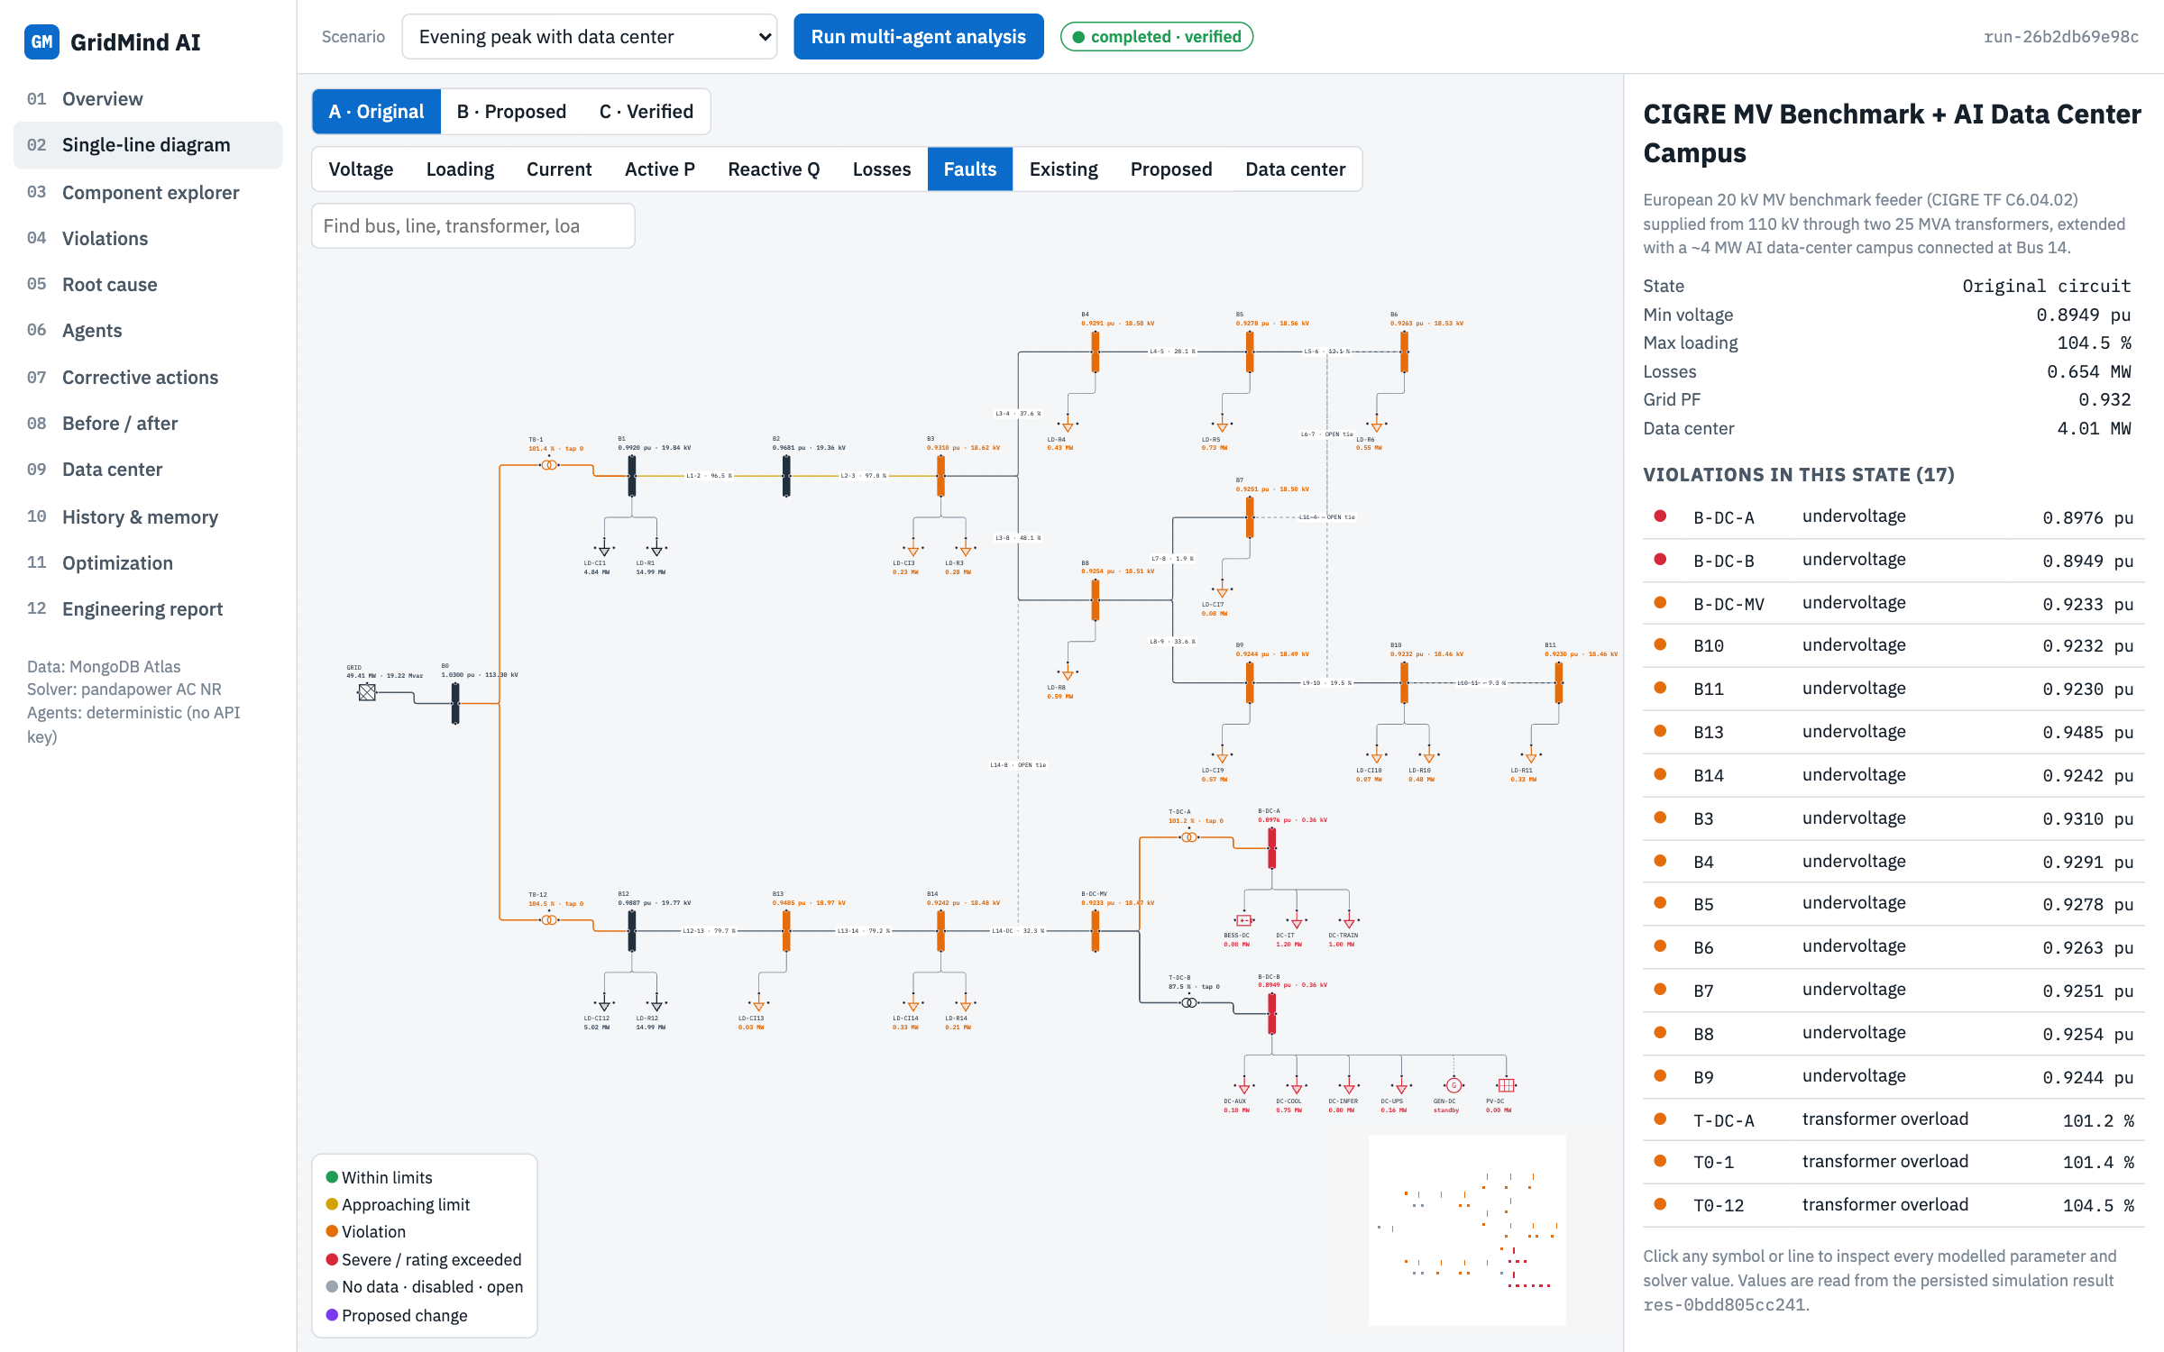
State A, Faults layer: the 17 violations highlighted where they occur (orange and red buses and transformers).
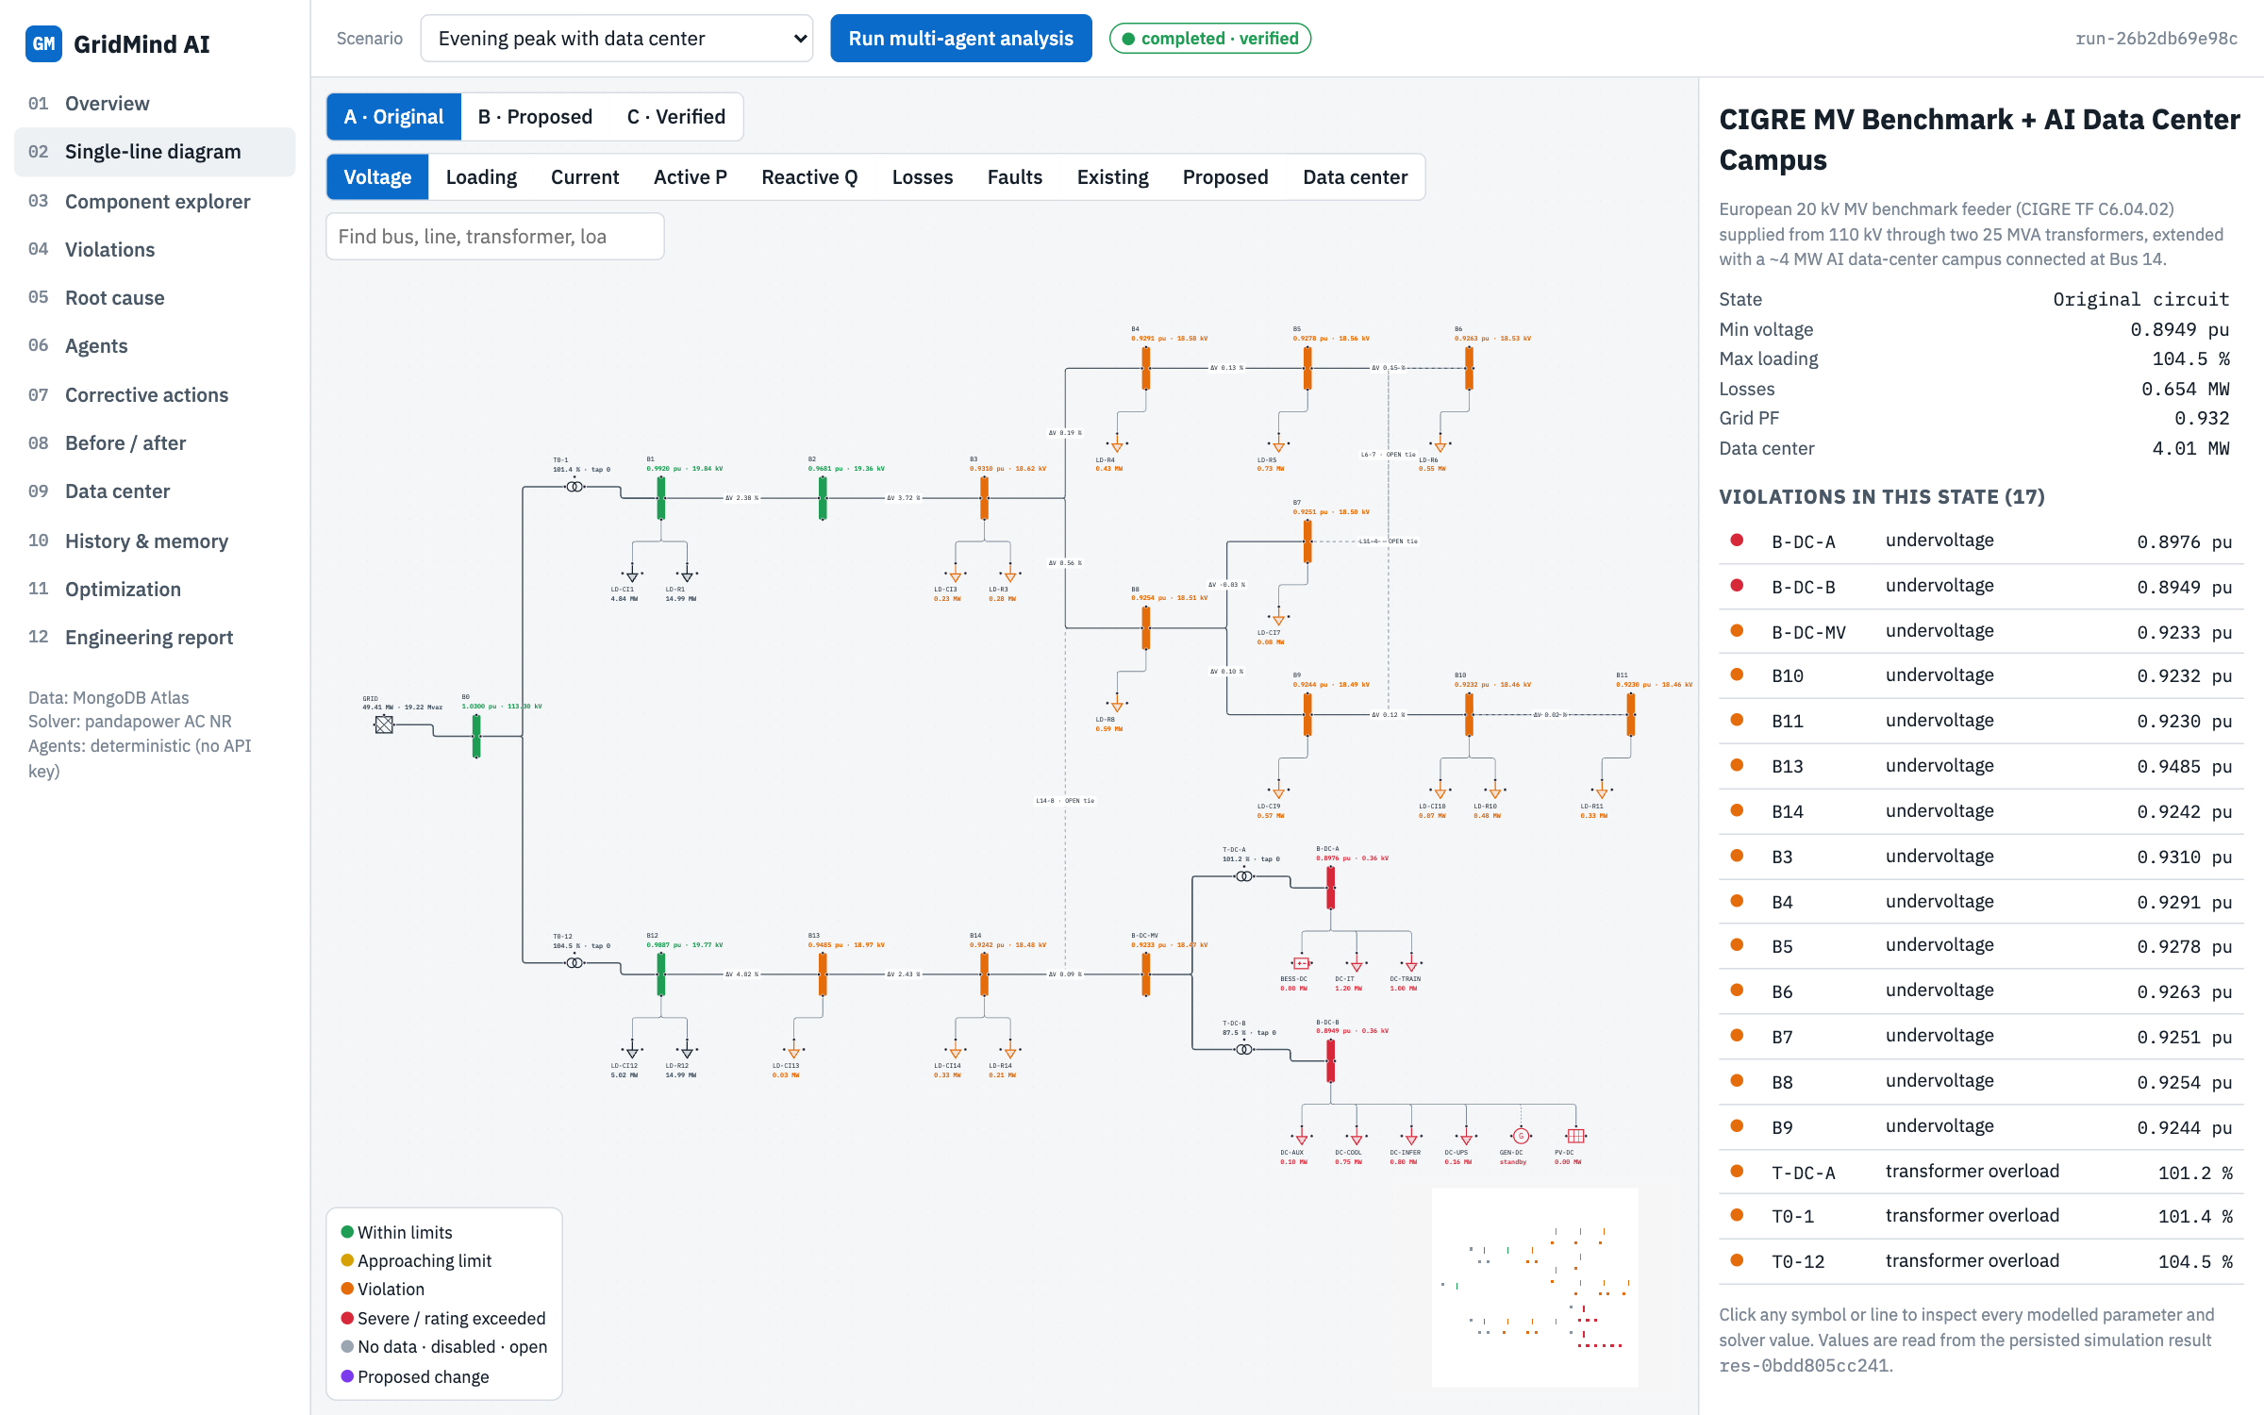
Voltage layer: every bus coloured by its voltage band, lines labelled with their voltage drop.
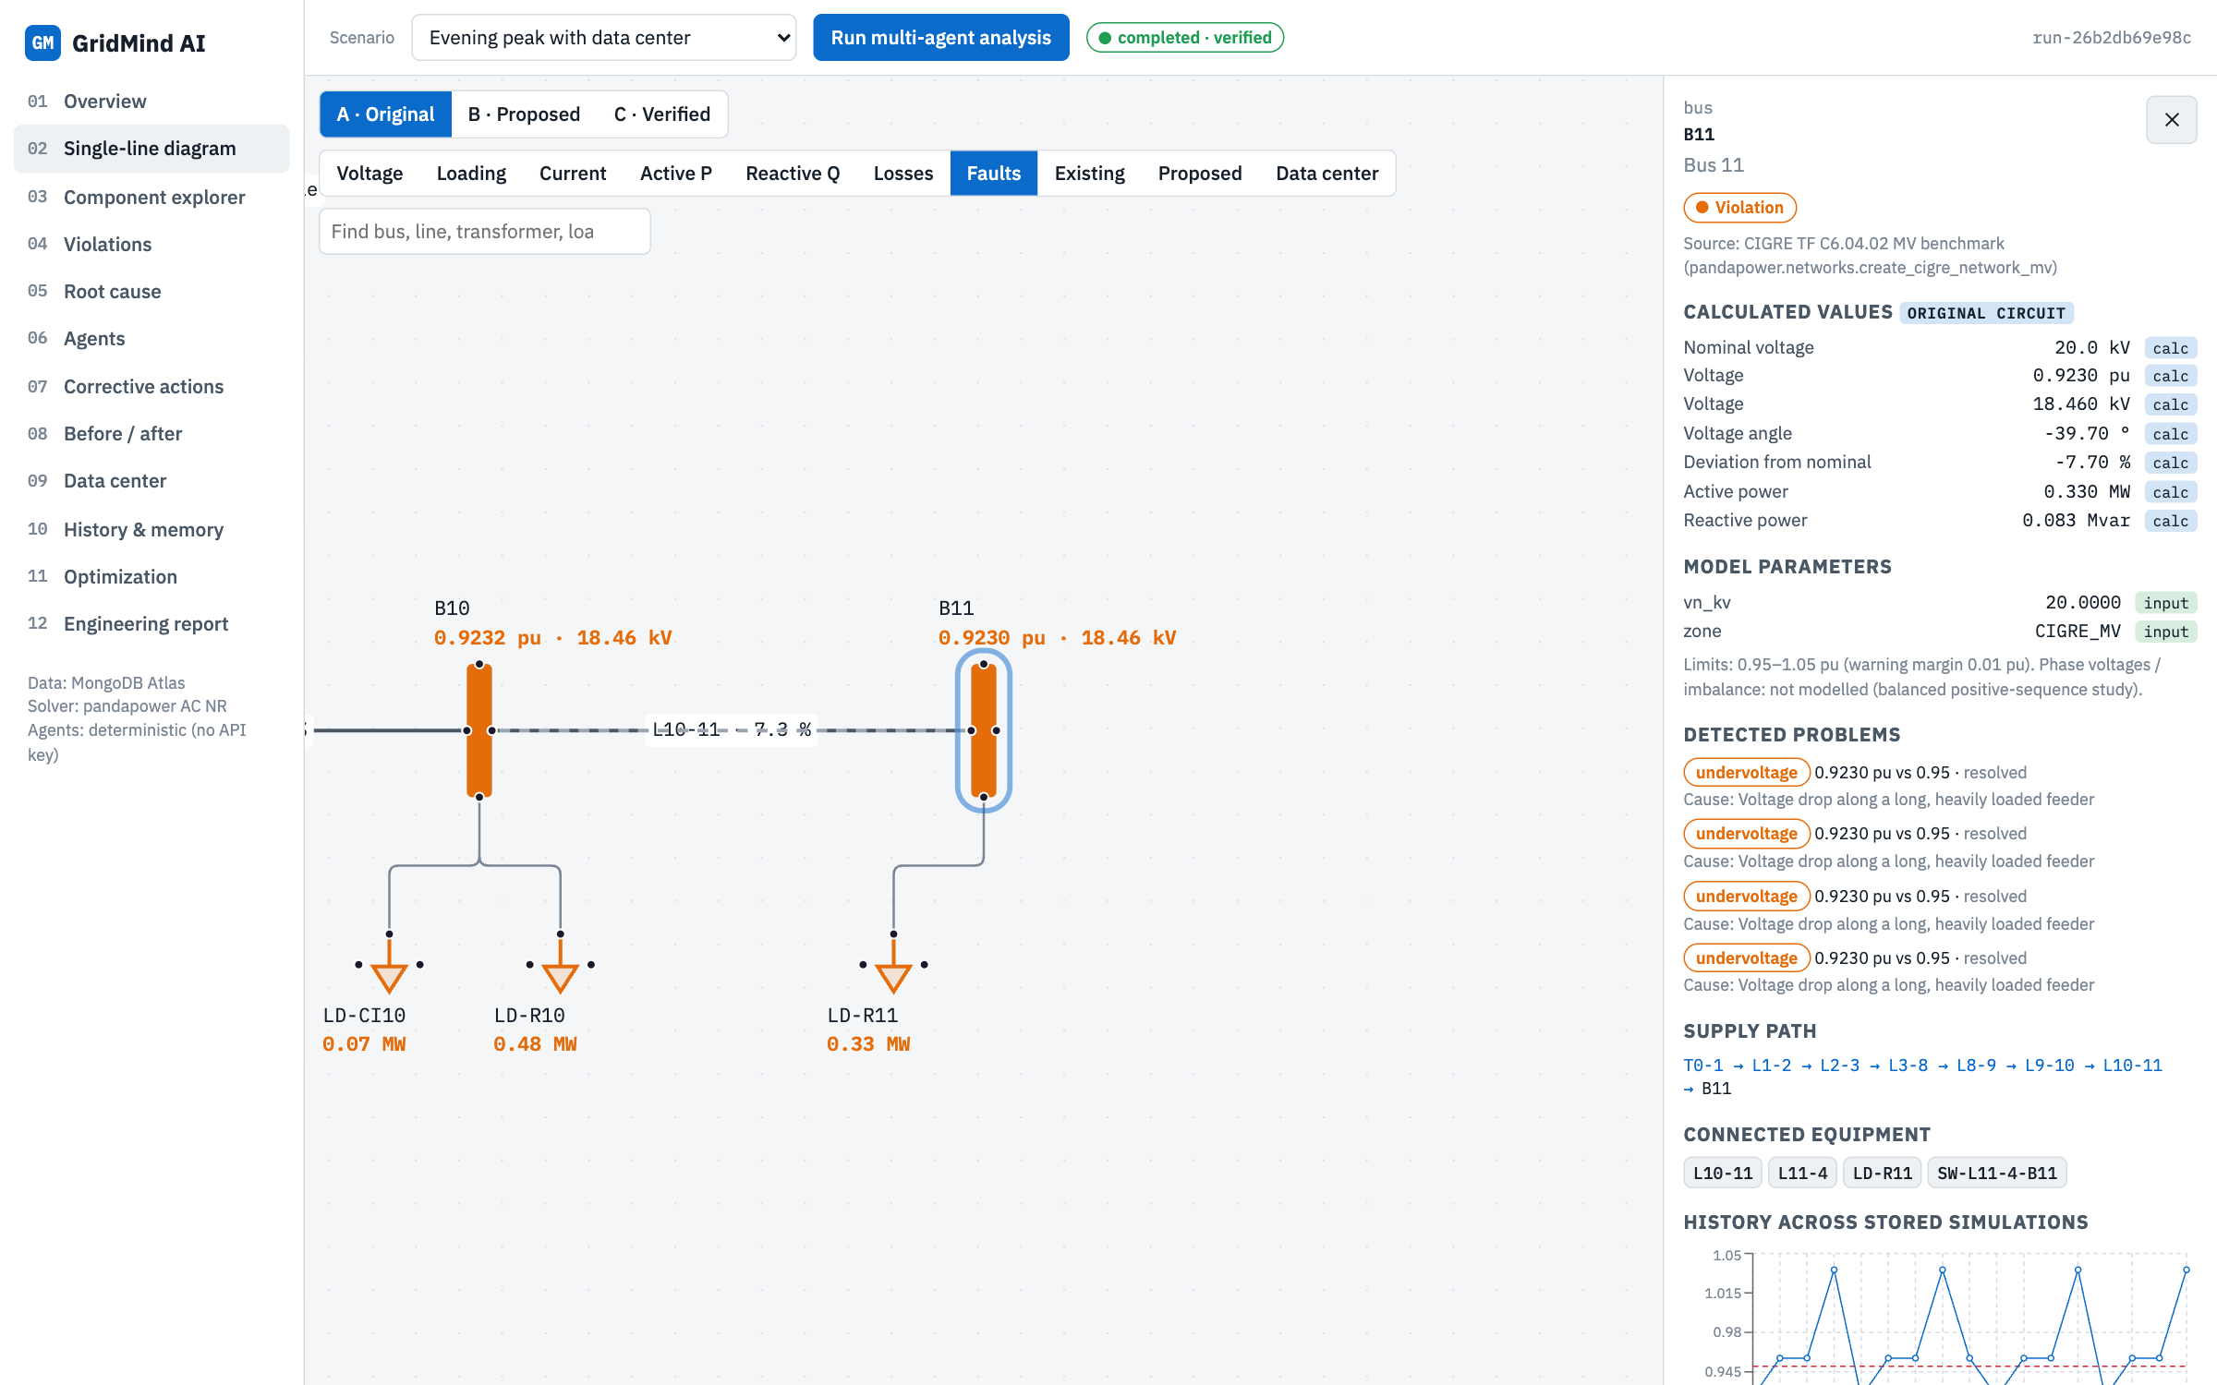
Detail panel for bus B11: calculated values, model parameters with data-quality tags, problems, supply path and history.
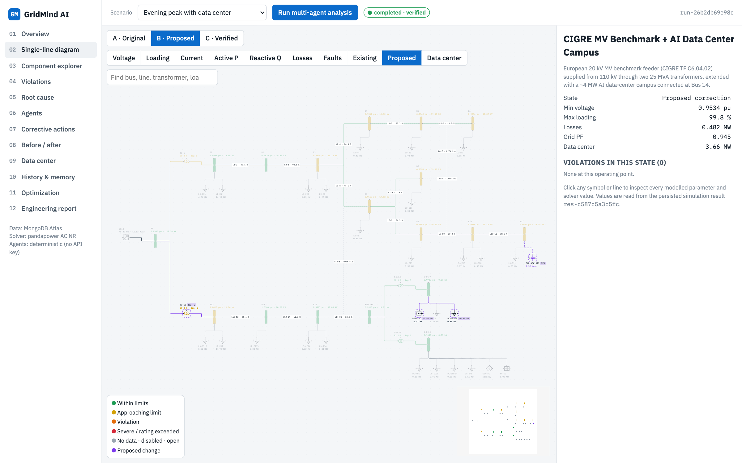
State B, Proposed layer: only the proposed changes stay highlighted in purple (new capacitor at B11, T0-12 tap, data-center load shift and battery dispatch).
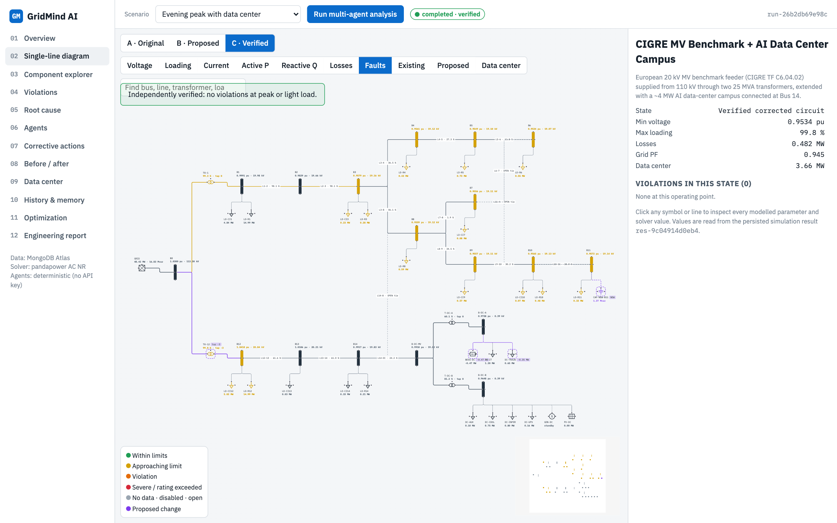
State C, Faults layer: the independently verified corrected circuit with no remaining violations.
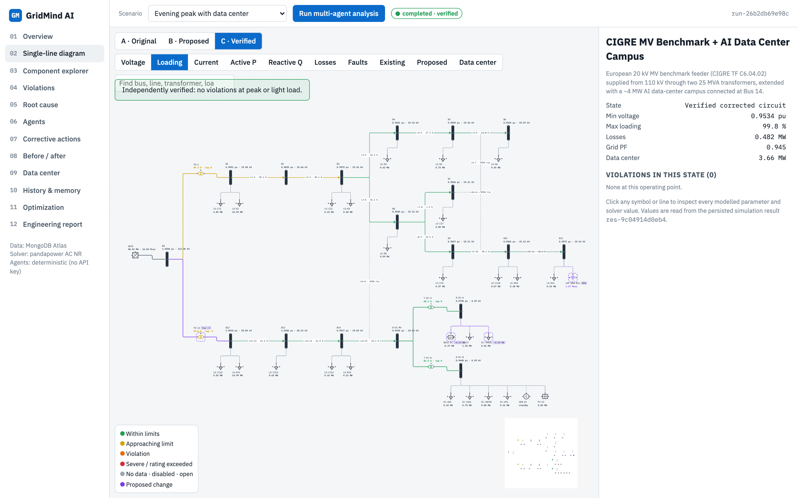
State C, Loading layer: branch and transformer loading after correction (T0-12 now below 100 %).

What you see on the page
- Every modelled component is drawn with an electrical symbol: the 110 kV utility grid, buses (vertical bars), transformers (two circles), loads (arrows), the data-center battery, rooftop PV, backup generator, and any proposed capacitor or regulator.
- Every line is a connection between buses. Normally-open tie lines are dashed and labelled OPEN tie.
- Labels show each bus voltage in per unit and kV, and each branch loading in percent (the label changes with the selected layer).
- Colours follow the legend: green within limits, amber approaching a limit, orange violation, red severe violation, grey no data or open, purple proposed change.
- Three state buttons: A Original (the circuit as it is), B Proposed (the corrective plan drawn on the diagram), C Verified (the corrected circuit re-solved independently).
- Ten layer buttons: Voltage, Loading, Current, Active P, Reactive Q, Losses, Faults, Existing, Proposed and Data center. Each one recolours and relabels the same diagram for that quantity; P and Q layers add flow-direction arrows.
- A search box to find any bus, line, transformer or load by ID or name, and a side panel listing the violations of the current state.

What happens behind the scenes
- The layout is computed automatically from the network topology: a spanning tree from the supply, left to right, with devices hanging below their bus.
- In state A the diagram uses the original power-flow result; in B the optimizer's proposed result; in C the result written by the Independent Verification Agent after it reloaded the model from MongoDB and solved it again.
- The verified banner only says fixed when verification really found no violation at peak and light load; otherwise it says Not verified and lists what remains.
- Clicking a component opens the detail panel, which calls /api/circuits/{id}/components/{eq_id} and shows every model parameter tagged input, assumed or missing, every calculated value, detected problems with their root cause, the supply path from the grid, connected equipment, a history chart across stored simulations, and recommendations that involve it.

How to use it
- Click any symbol or line to inspect it. Click a violation in the side list to zoom to it.
- Switch A, B, C to see the original, proposed and verified circuit in the same layout.
- Use the Proposed layer to dim everything except the changed equipment.

4. Page 03: Component explorer
A searchable table of all 75 modelled components, for engineers who prefer a list to a diagram.
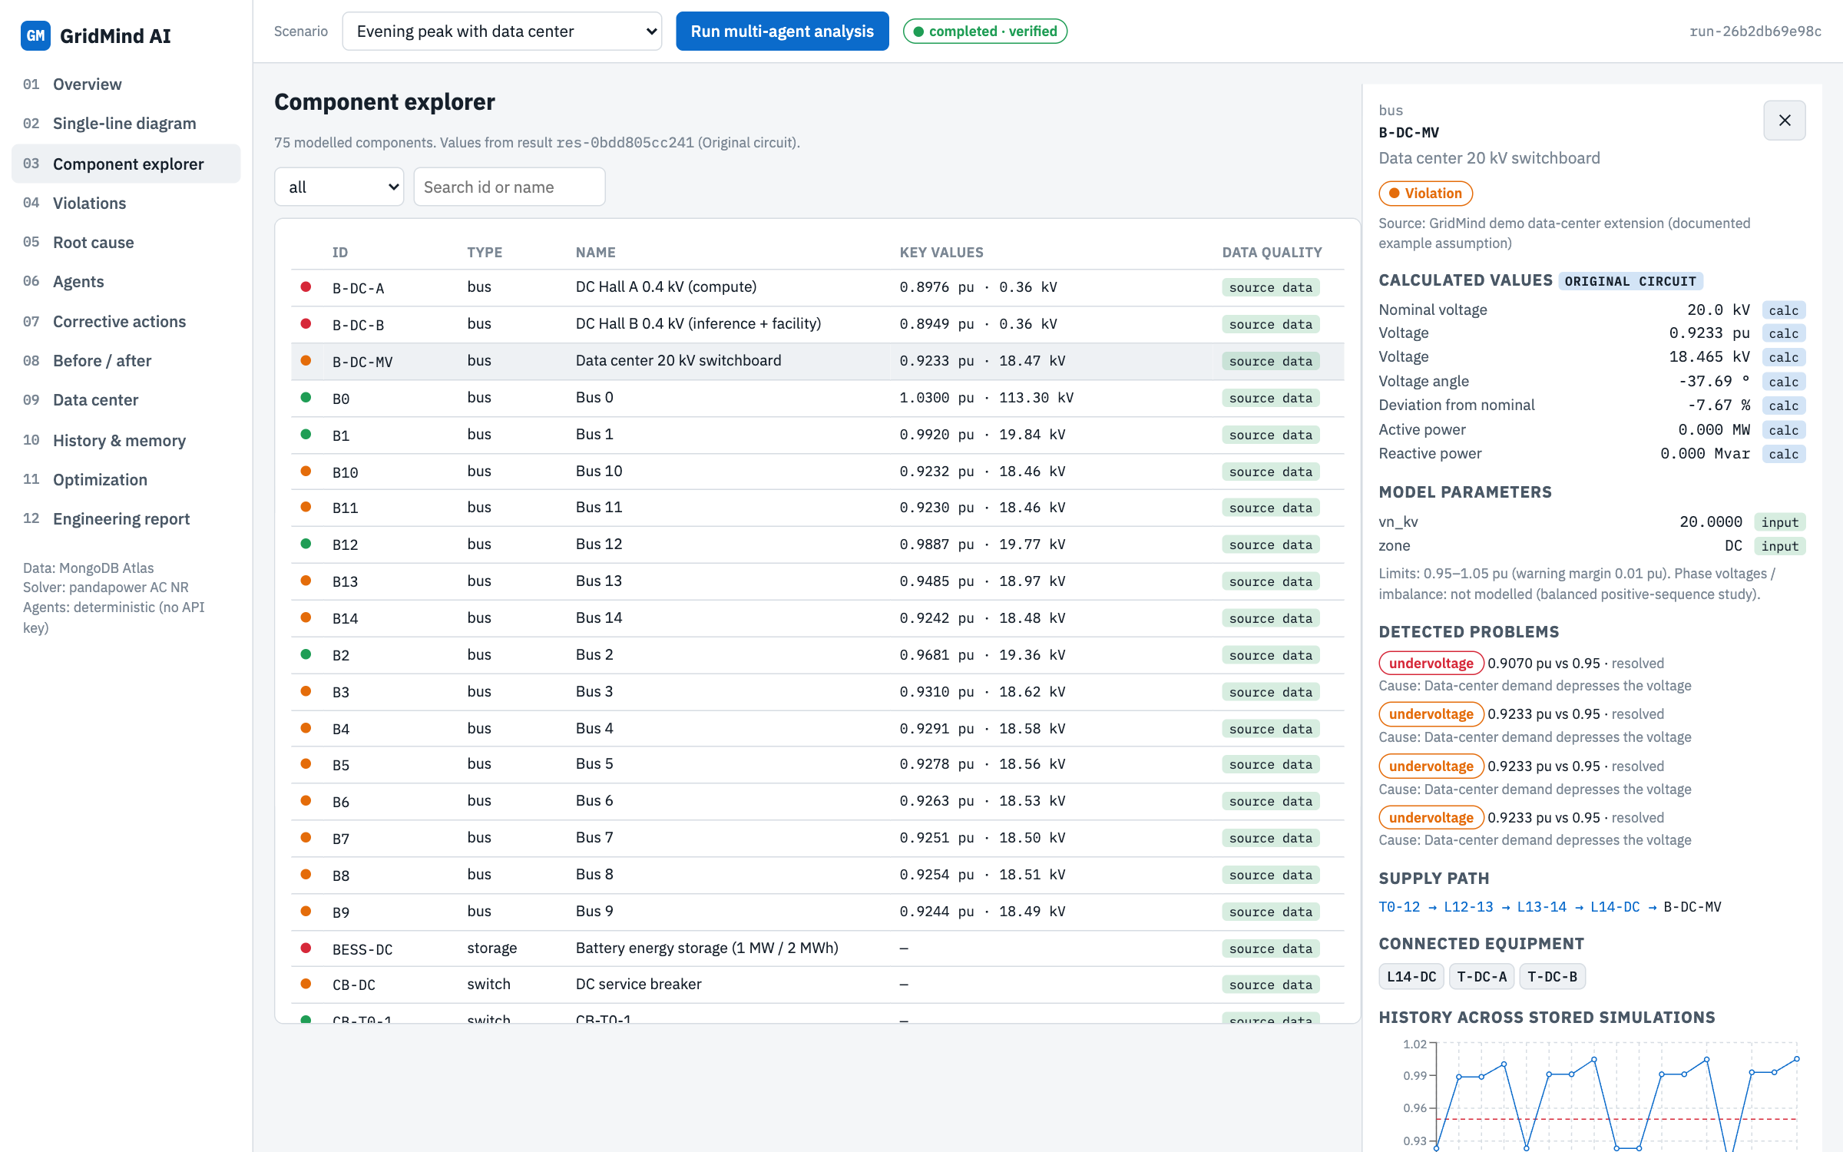
Figure 03: Component explorer page

What you see on the page
- One row per component with its status dot, ID, type, name and key solver values (voltage for buses, loading and current for branches, P, Q and power factor for loads).
- A Data quality column showing whether the component uses only source data or carries documented assumed parameters.
- Type filter and search box; clicking a row opens the same detail panel as the diagram.

What happens behind the scenes
- Values come from the original-state result of the selected scenario. The data-quality tags come from the data_quality field stored on each equipment document.

How to use it
- Filter by type (for example transformer) to review all ratings and loadings at once.

5. Page 04: Violations
The complete list of detected electrical violations and what happened to each one.
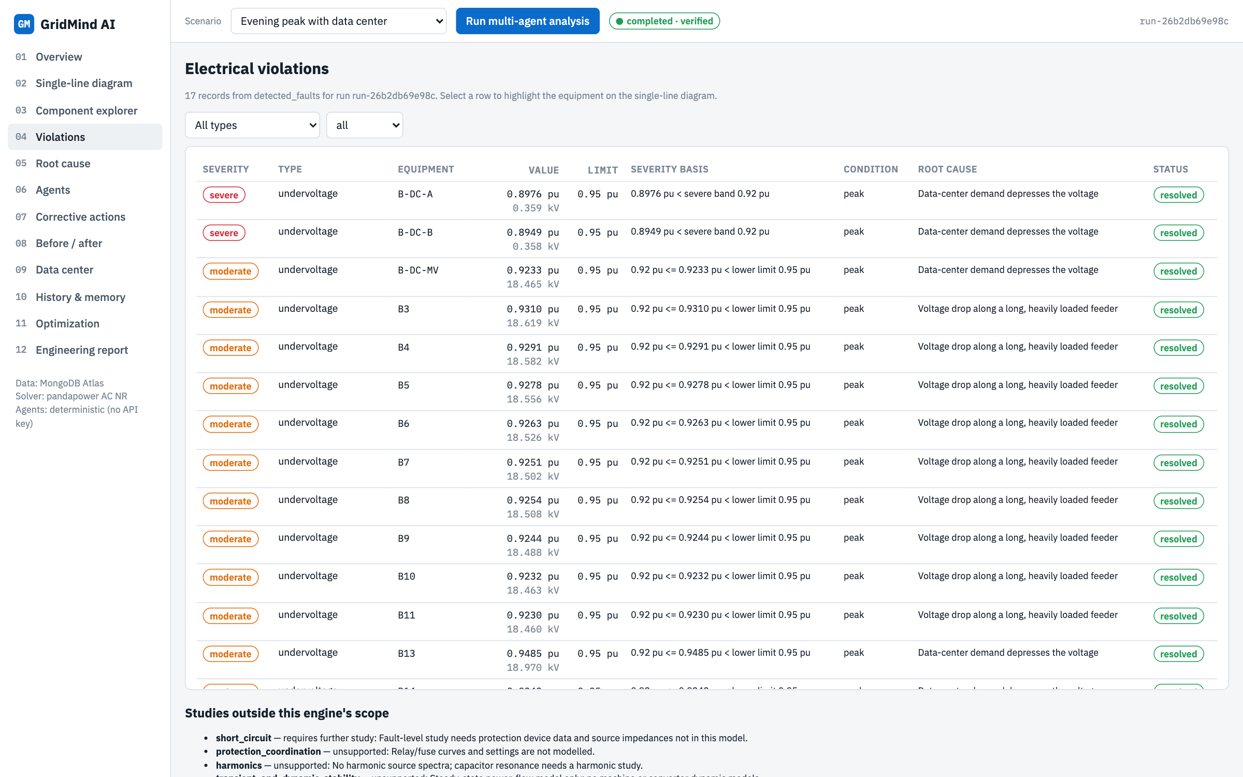
Figure 04: Violations page

What you see on the page
- Severity, violation type, equipment, value and limit (with kV for voltages and amperes for overloads).
- Severity basis: the exact numeric rule that produced the severity, for example 0.92 pu <= 0.9230 pu < lower limit 0.95 pu. There is no opaque AI score.
- Operating condition (peak or light load), the diagnosed root cause, and the status: open, resolved, remaining, or new (introduced by a correction).
- A list of studies outside the engine's scope (short circuit, protection coordination, harmonics, dynamic stability), clearly labelled as unsupported.

What happens behind the scenes
- Rows are read from the MongoDB collection detected_faults, written by the Violation Detection Agent and updated by the Root Cause and Verification agents.
- Limits are configurable per circuit: ANSI C84.1 Range A (0.95 to 1.05 pu) by default, 100 % thermal rating for lines and transformers.

How to use it
- Click any row to jump to the single-line diagram with that bus or branch focused and highlighted.

6. Page 05: Root cause
Explains why each violation happens, using numbers calculated from the solved network.
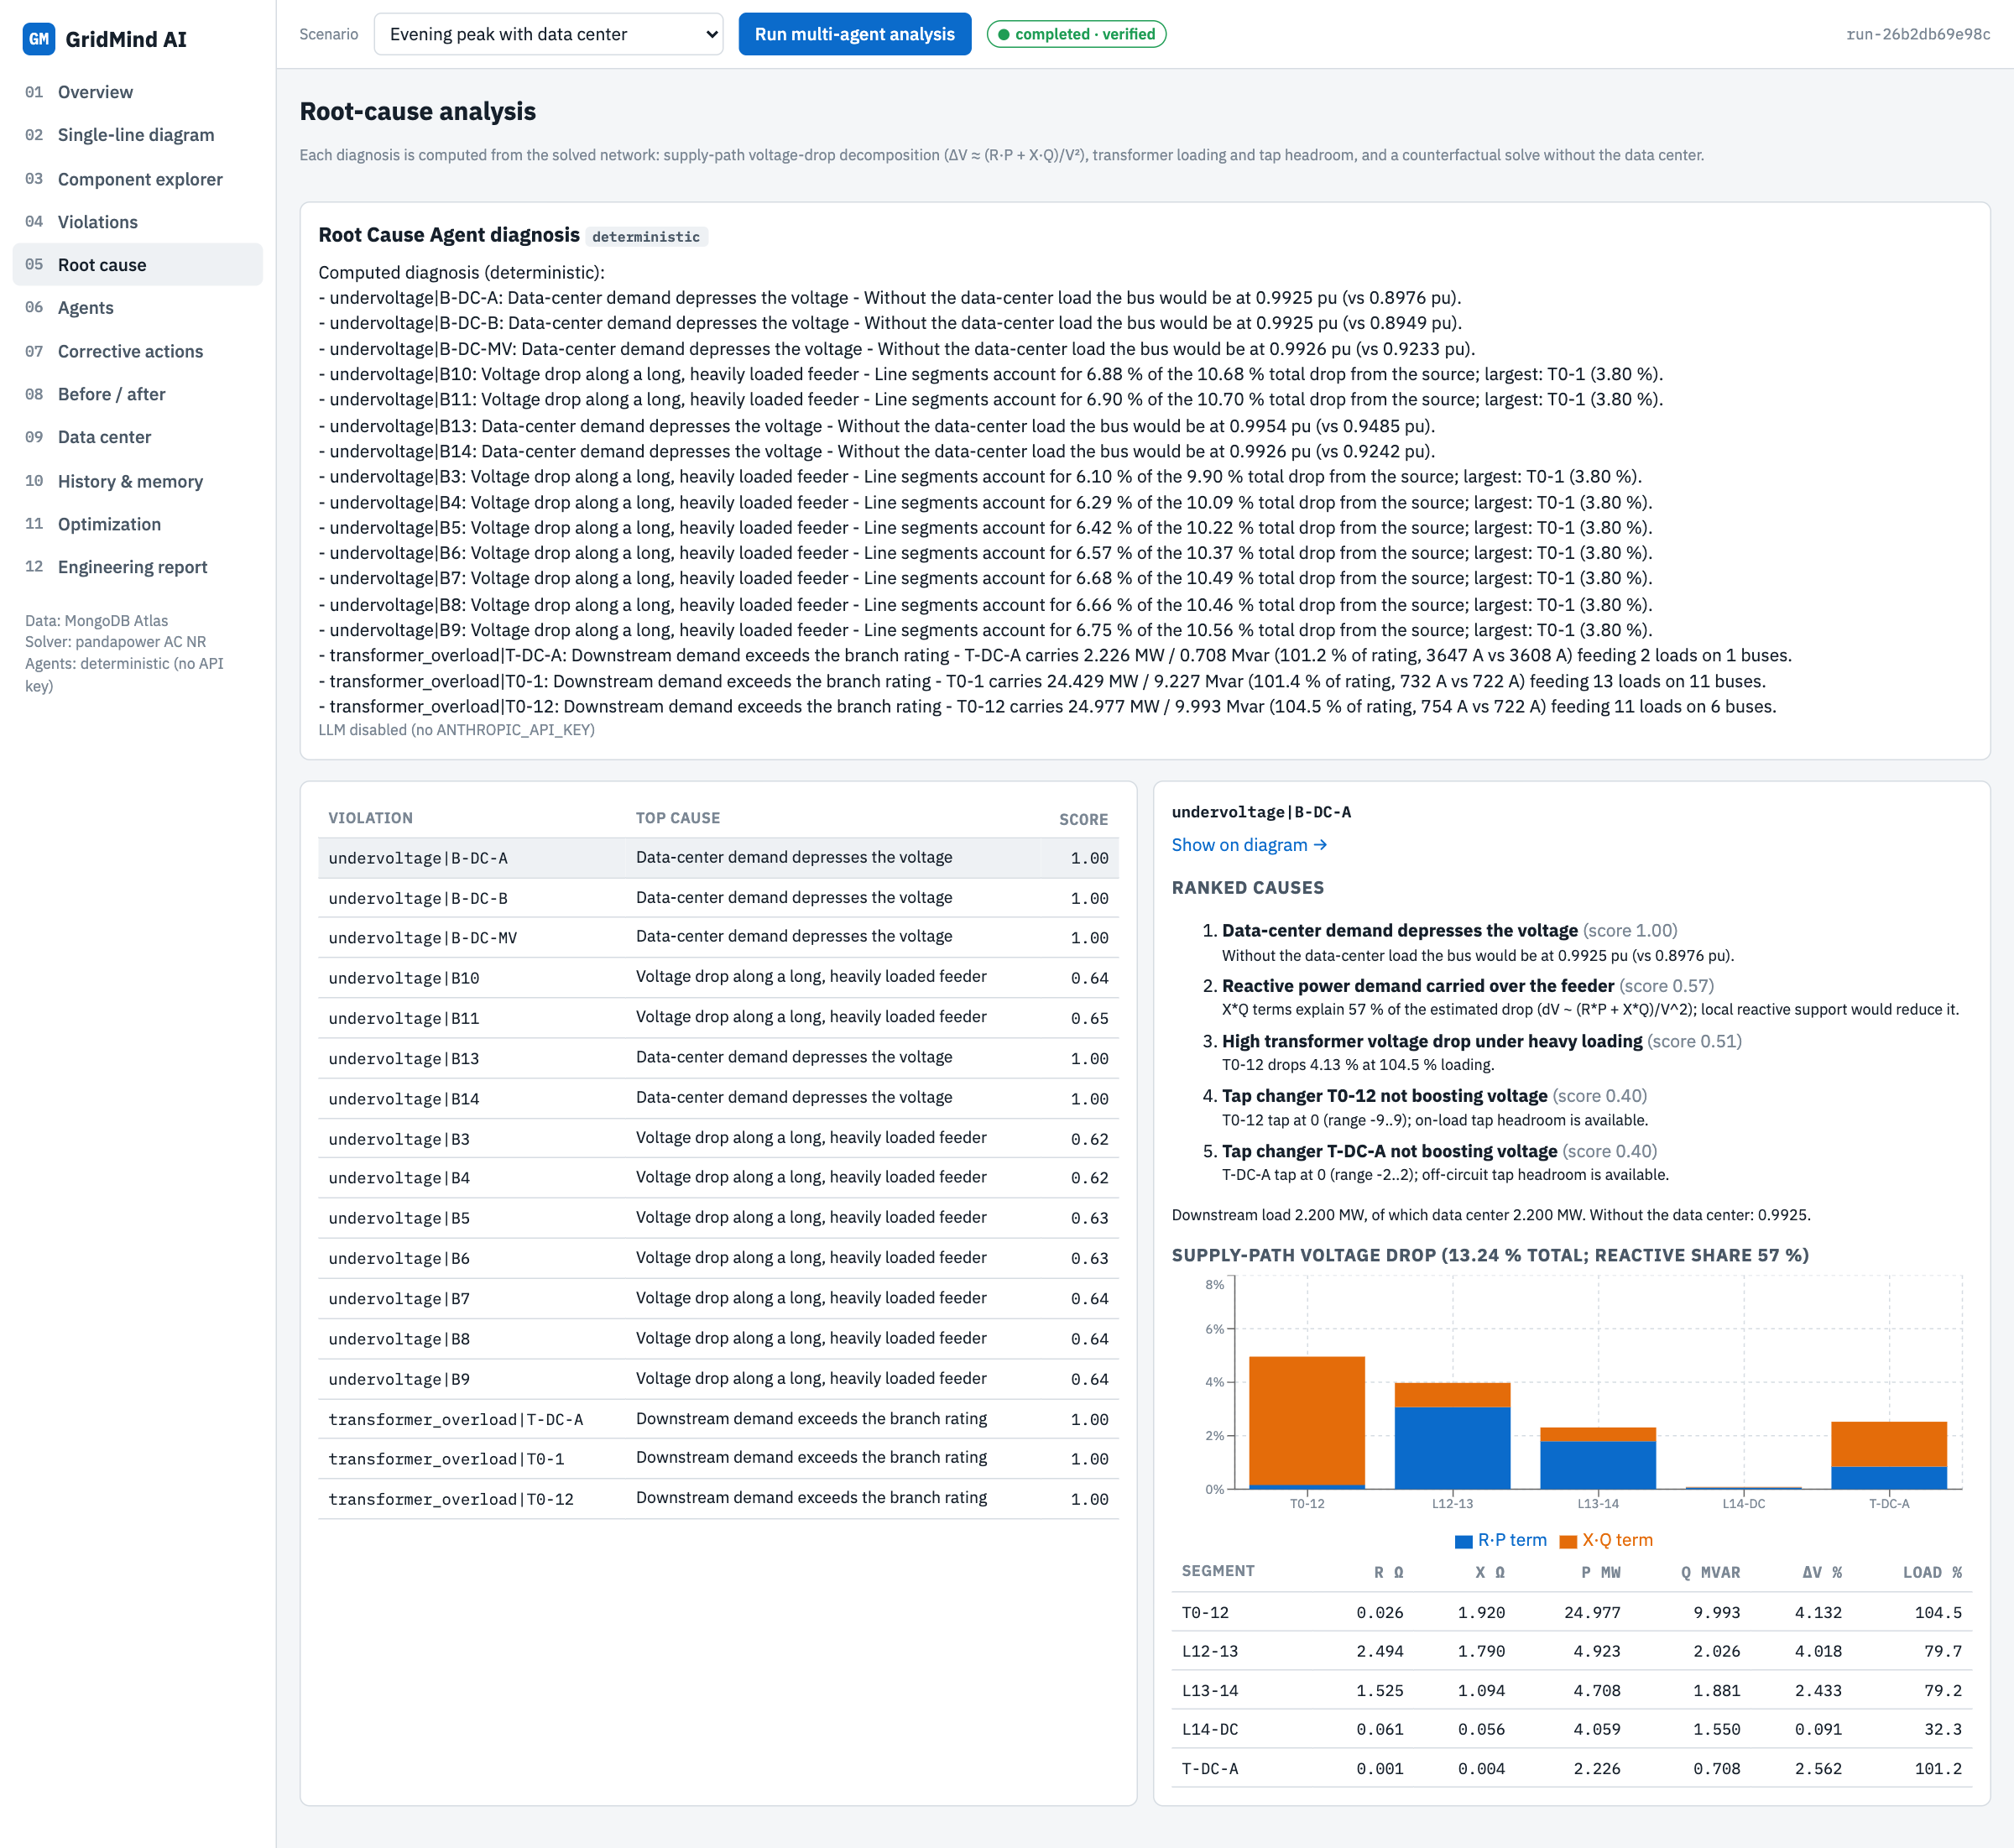
Figure 05: Root cause page

What you see on the page
- The Root Cause Agent's written diagnosis (by Claude when an API key is configured, otherwise a deterministic summary).
- A ranked list of causes for every violation with a score and evidence sentence, for example line segments account for 6.9 % of the 10.7 % total drop from the source.
- A stacked bar chart splitting the voltage drop of every segment on the supply path into the R x P part (active power) and the X x Q part (reactive power).
- A segment table with resistance, reactance, P, Q, voltage drop and loading, plus the counterfactual voltage without the data center.

What happens behind the scenes
- For each violated bus the agent finds the lowest-impedance supply path, decomposes the drop with dV approx (R x P + X x Q) / V squared, checks transformer tap headroom, and re-solves the network with the data-center load removed.
- In this run the dominant causes were feeder impedance drop on feeder 1 (9 buses), data-center demand around Bus 14 (5 buses) and downstream demand on the overloaded transformers (3).

How to use it
- Select a violation on the left; use Show on diagram to see it in context.

7. Page 06: Agents
Live view of the ten specialised agents, what each one is doing and what it produced.
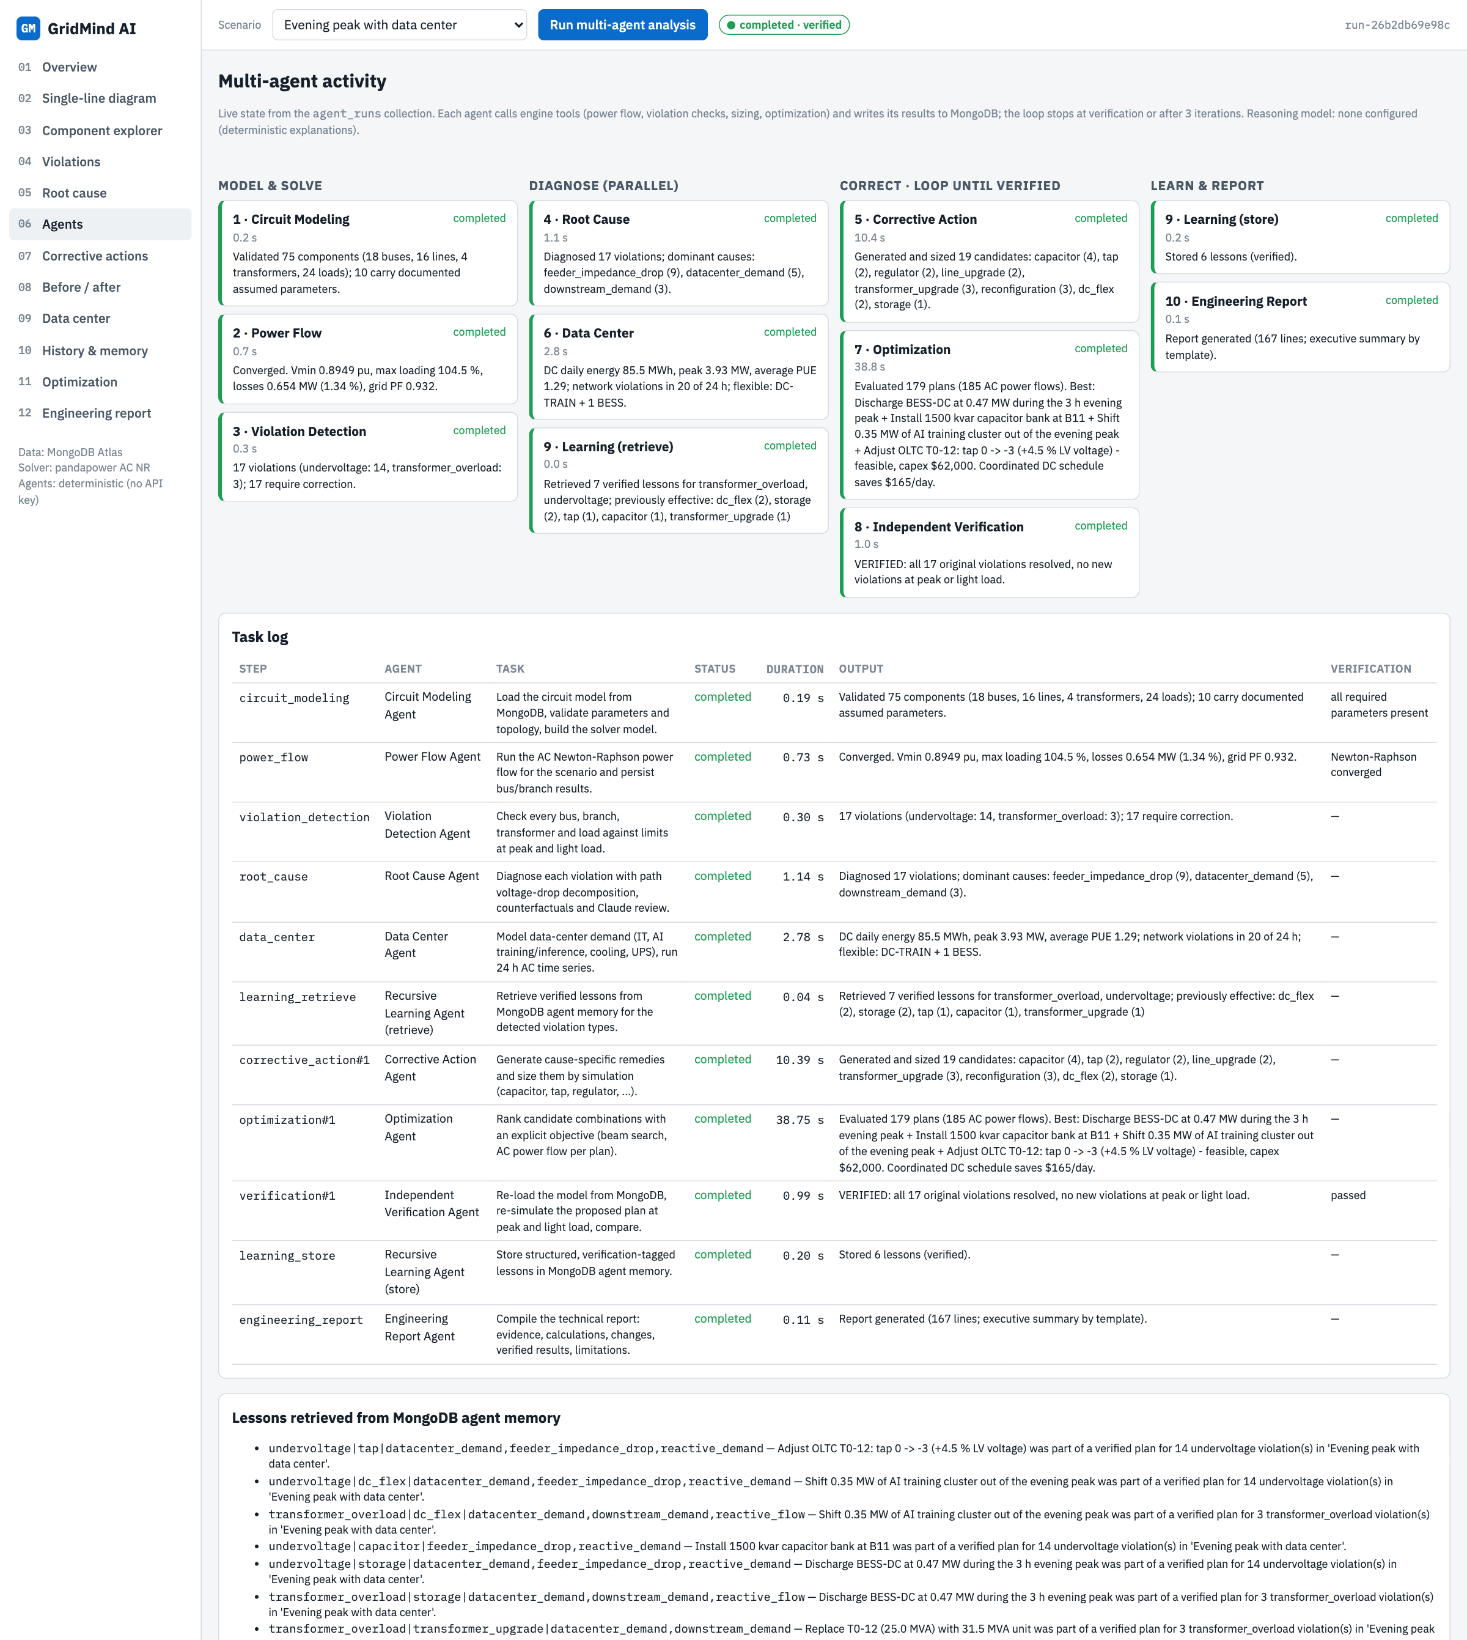
Figure 06: Agents page

What you see on the page
- Agent cards grouped by stage: Model and solve (Circuit Modeling, Power Flow, Violation Detection), Diagnose in parallel (Root Cause, Data Center, Learning-retrieve), Correct in a loop (Corrective Action, Optimization, Independent Verification), Learn and report (Learning-store, Engineering Report).
- Each card shows status, duration, iteration and the agent's real output summary.
- A task log table with the task text, status, duration, output and verification result of every step, and the lessons retrieved from MongoDB memory.

What happens behind the scenes
- The orchestrator runs a dependency graph; the three diagnosis agents run in parallel threads.
- Corrective Action, Optimization and Verification repeat until verification passes, the iteration budget (3) is used, or no improving action exists.
- Every task is written to agent_runs and the run state to optimization_runs after each step, so an interrupted run can be resumed after a restart.

How to use it
- Keep this page open while a run is in progress; it refreshes every 2 seconds.

8. Page 07: Corrective actions
Compares every candidate remedy and every ranked plan with its engineering trade-offs.
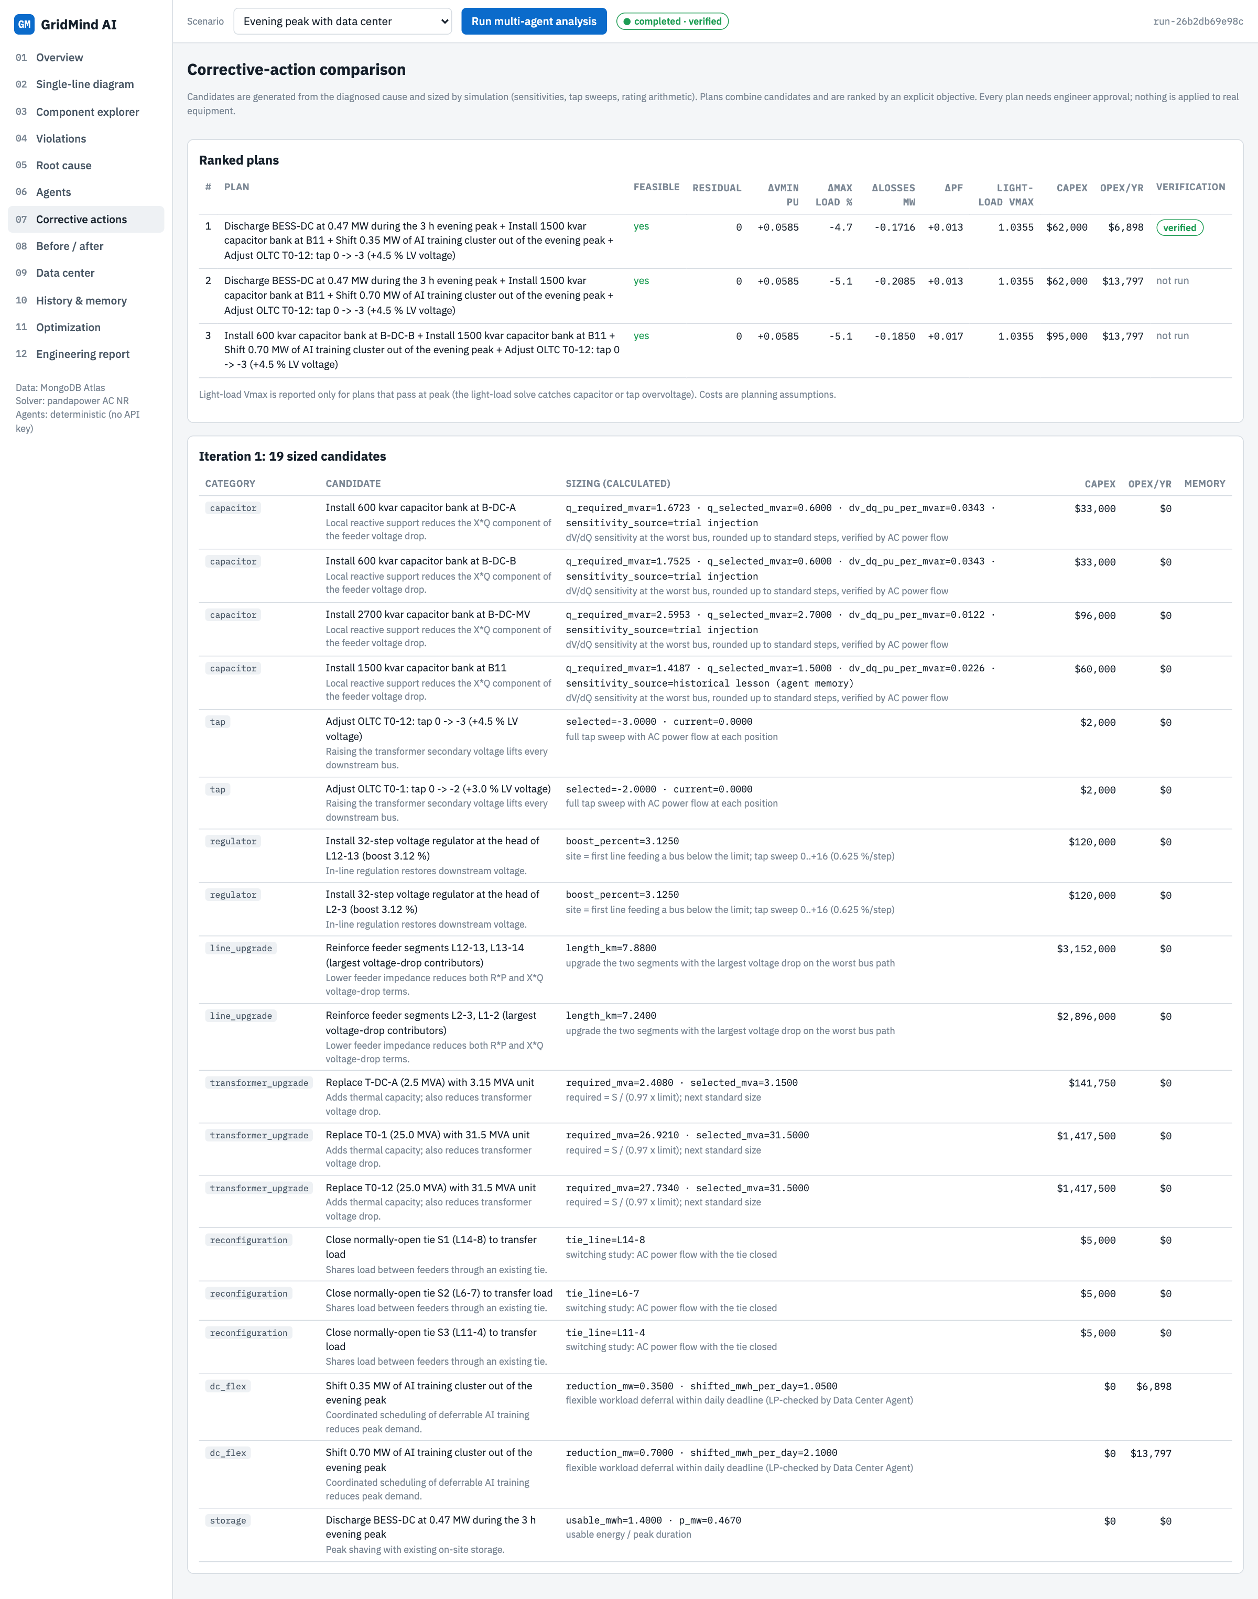
Figure 07: Corrective actions page

What you see on the page
- Ranked plans table: feasibility, residual violations, change in minimum voltage, maximum loading, losses and power factor, light-load maximum voltage, capital cost, yearly operating cost and verification status.
- Candidate table per iteration: category, title, the calculated sizing (for example required and selected kvar and the measured dV/dQ sensitivity), cost, and whether the remedy type was verified in a previous run. Clicking a row expands the full sizing record.

What happens behind the scenes
- Candidates depend on the diagnosed cause: capacitors only for undervoltage or reactive-flow problems (never for overvoltage), tap sweeps for transformers on the supply path, regulators for long feeders, conductor and transformer upgrades for overloads, tie-switch transfers, data-center training deferral and battery dispatch.
- Each candidate is sized by simulation: capacitors from a trial-injection sensitivity rounded to 300 kvar steps, taps by sweeping every position, transformers to the next standard size.

How to use it
- Compare a cheap operational plan with an equipment upgrade by reading the capex, opex and residual-violation columns side by side.

9. Page 08: Before / after
Side-by-side proof of what the correction changed.
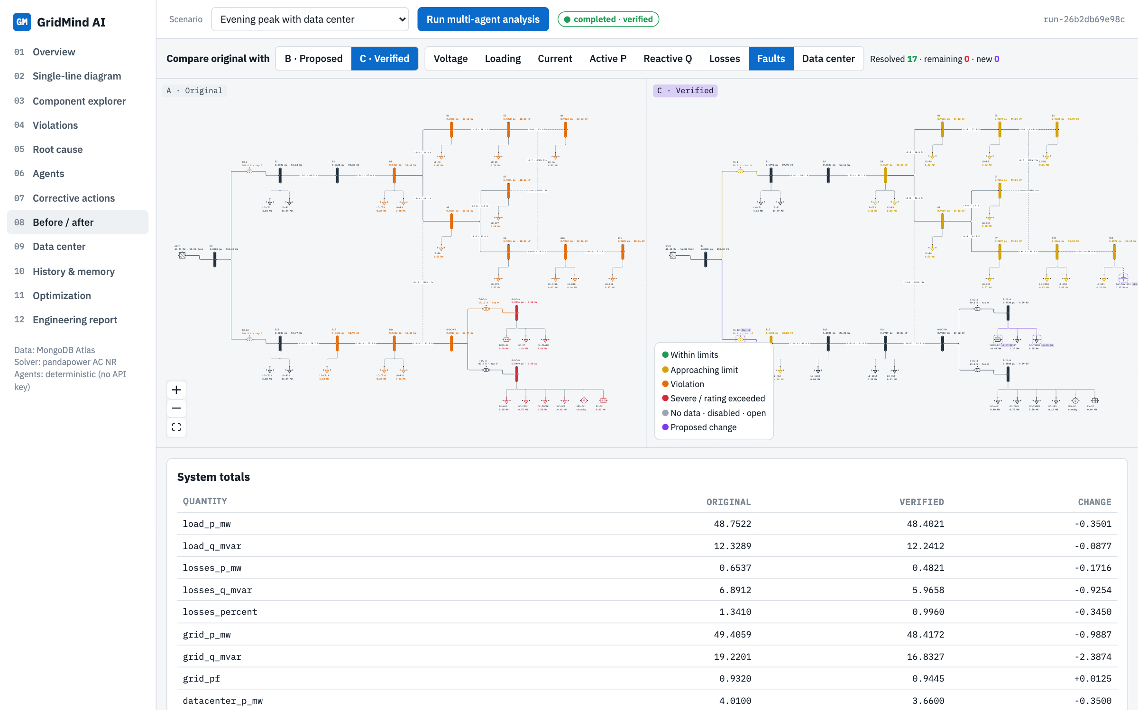
Figure 08: Before / after page

What you see on the page
- Two diagrams in the same layout: A Original on the left, B Proposed or C Verified on the right, with the same layer selector.
- A resolved, remaining, new counter (17, 0, 0 in this run).
- System totals table (load, losses, grid P and Q, power factor, data-center demand, minimum and maximum voltage, maximum loading) with original, new and change columns.
- One row per bus and per branch: original value, new value, change, limit and status change (for example moderate to ok), plus a violation-resolution table.

What happens behind the scenes
- The table comes from /api/compare, which compares two persisted simulation results; it never uses invented values.

How to use it
- Show this page to explain the outcome: minimum voltage rose from 0.8949 to 0.9534 pu and losses fell from 0.654 to 0.482 MW.

10. Page 09: Data center
Models the AI data center as part of the same network and optimises its flexible load.
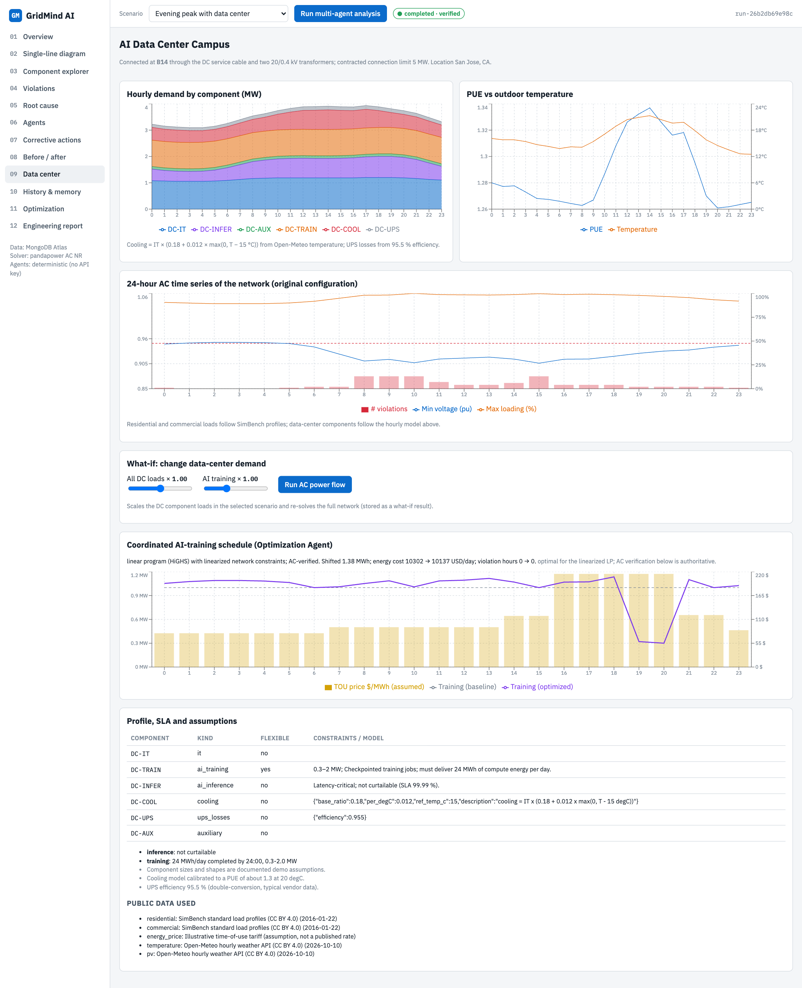
Figure 09: Data center page

What you see on the page
- Hourly demand by component: IT servers, AI training, AI inference, cooling, UPS losses and auxiliary load.
- PUE against outdoor temperature (from Open-Meteo data for San Jose).
- 24-hour AC time series of the network: minimum voltage, maximum loading and number of violations for every hour.
- A what-if panel: scale all data-center loads or only AI training and re-solve the whole network.
- The coordinated AI-training schedule found by the Optimization Agent against the time-of-use price, and the profile, service-level and assumption tables.

What happens behind the scenes
- Cooling = IT x (0.18 + 0.012 x max(0, T - 15 degC)); UPS losses use 95.5 % efficiency. Residential and commercial loads follow SimBench profiles.
- The scheduler is a linear program (HiGHS) that moves deferrable training energy to cheaper hours without breaking network limits; the result is then checked hour by hour with full AC power flow, with the on-load tap changers emulated as automatic voltage regulators.
- In this run it shifted 1.38 MWh out of the evening peak and cut the illustrative energy cost from 10,302 to 10,137 USD per day with zero violation hours.

How to use it
- Move the AI training slider to 1.8 and press Run AC power flow to see how a training surge affects voltages and transformer loading.

11. Page 10: History and memory
Everything the system remembers: past runs, learned lessons and the audit trail.
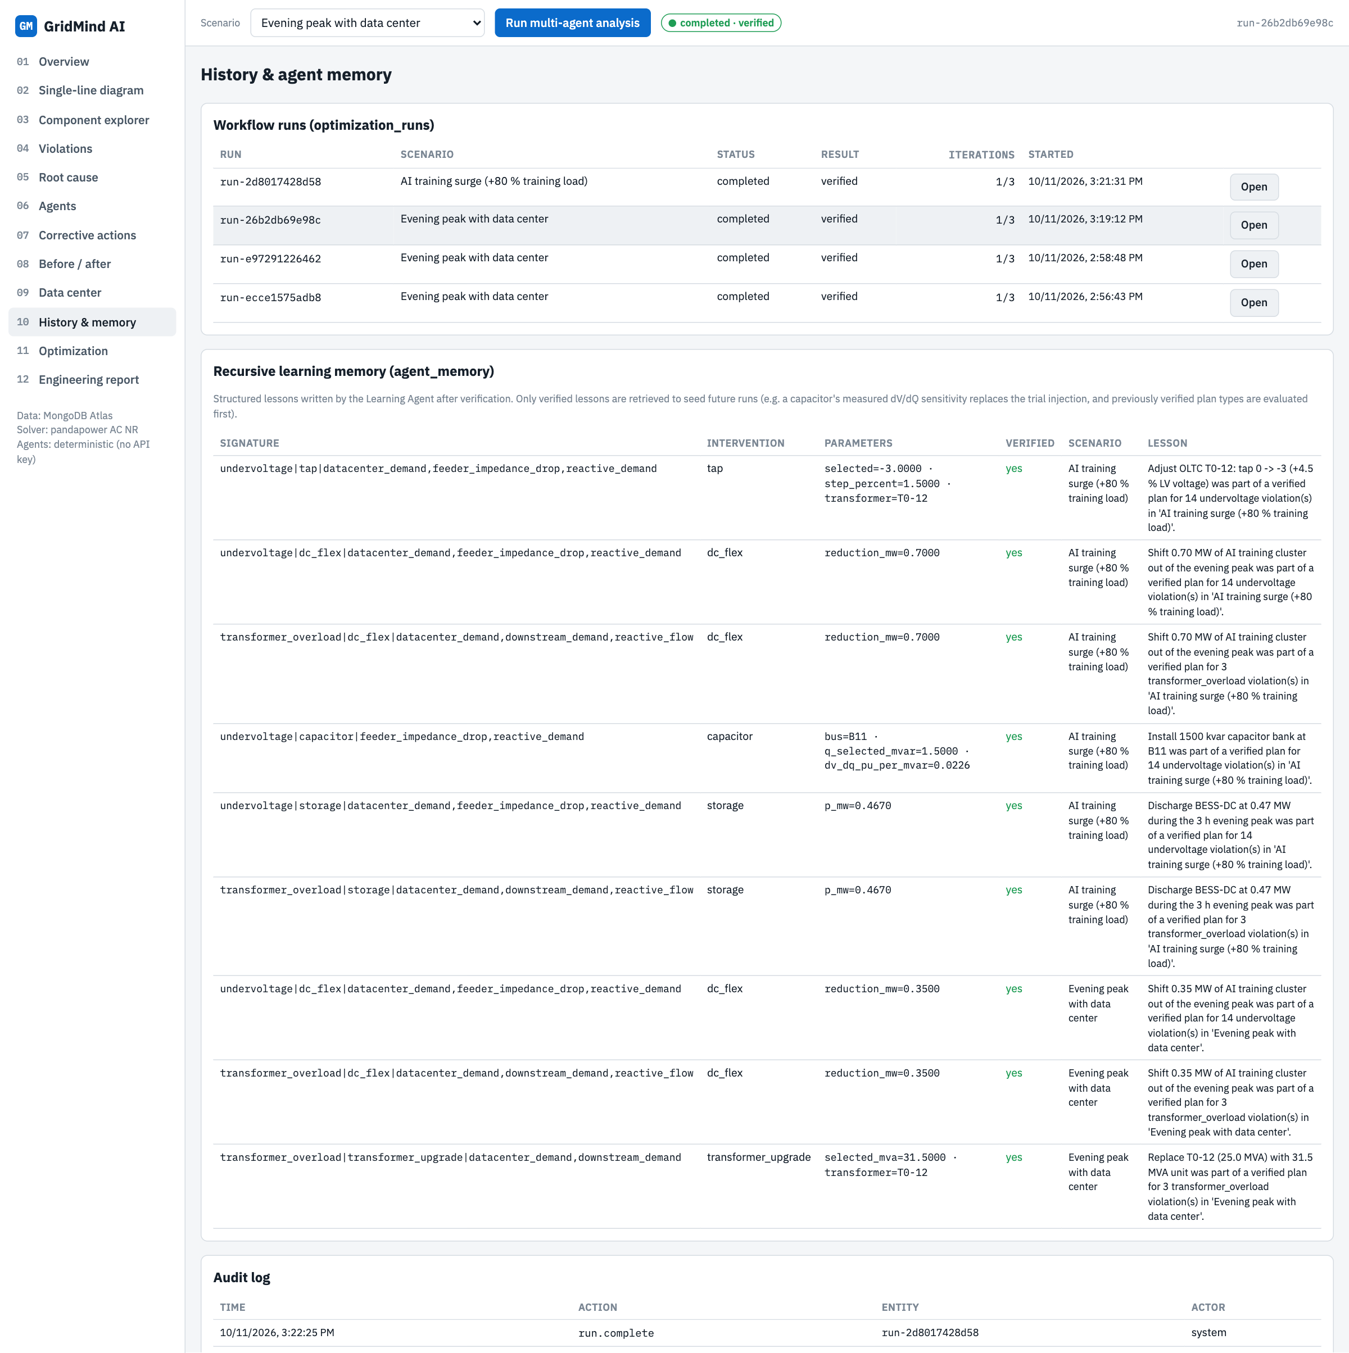
Figure 10: History and memory page

What you see on the page
- Workflow runs with scenario, status, verification result and iterations; Open loads any past run into every page.
- Recursive-learning memory: one lesson per remedy and violation type, with its parameters (for example the capacitor's measured sensitivity) and whether it was part of a verified plan.
- The audit log of seeds, runs, simulations and threshold changes.

What happens behind the scenes
- Lessons are written to agent_memory by the Learning Agent after verification. Later runs retrieve only verified lessons: they reuse measured sensitivities instead of a trial simulation and evaluate the previously verified plan types first.
- The AI-training-surge scenario retrieved the lessons from the evening-peak run and was also verified.

How to use it
- Run the second scenario and open this page to show learning across runs.

12. Page 11: Optimization
Shows how the plan was chosen and what claim can honestly be made about it.
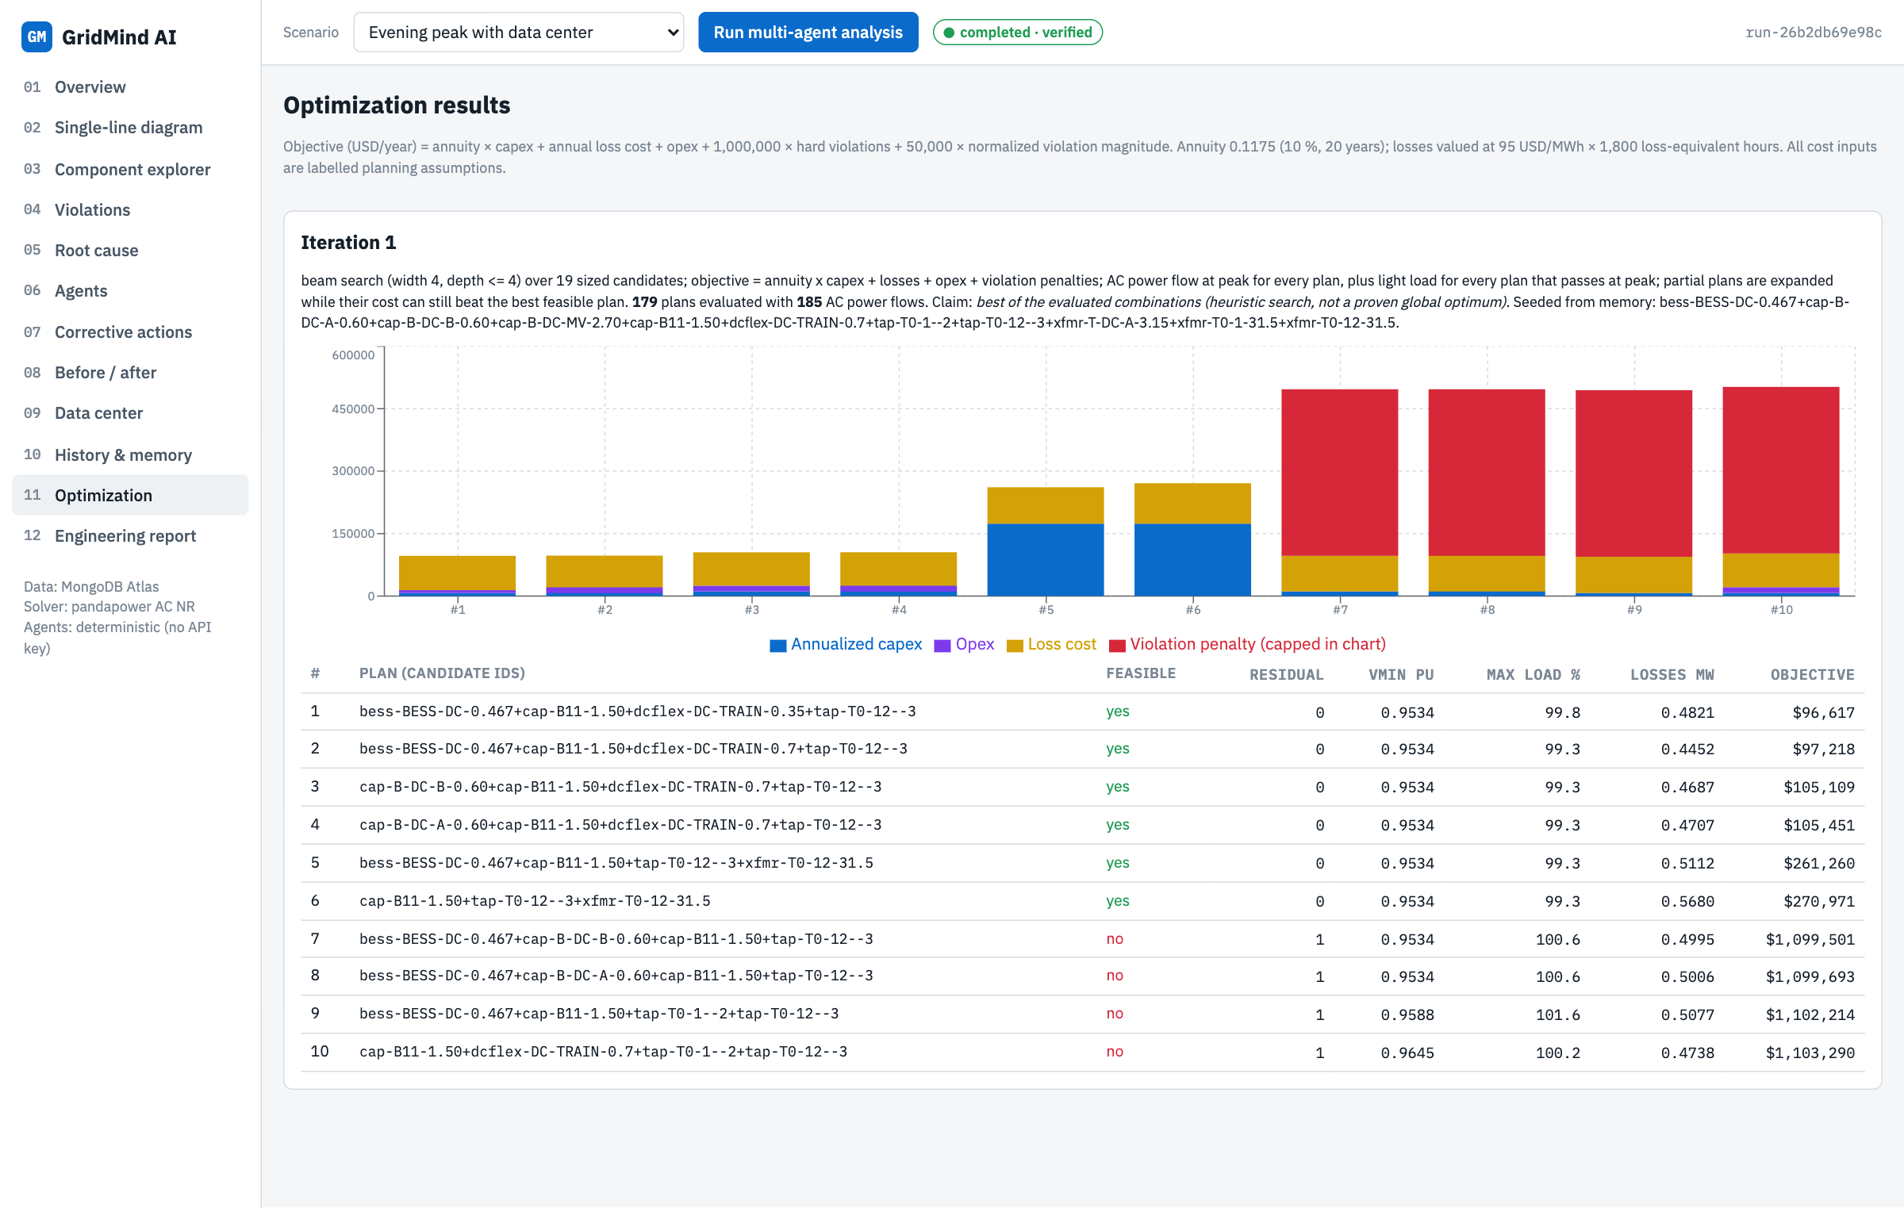
Figure 11: Optimization page

What you see on the page
- The search method and the number of plans and AC power flows evaluated (179 plans, 185 power flows in this run).
- A stacked cost chart of the top plans: annualised capex, opex, loss cost and violation penalty.
- The ranked plan table with feasibility, residual violations, minimum voltage, maximum loading, losses and total objective.

What happens behind the scenes
- Objective per year = annuity x capex + loss cost + opex + 1,000,000 x hard violations + 50,000 x violation magnitude, with a 10 % / 20-year annuity and losses valued at 95 USD/MWh.
- A beam search combines candidates and keeps expanding partial plans only while they can still beat the best feasible plan. The page states the claim plainly: best of the evaluated combinations, not a proven global optimum.

How to use it
- Use it to answer why this plan: it is the cheapest combination that removed every violation at peak and light load.

13. Page 12: Engineering report
A complete technical report generated by the Engineering Report Agent.
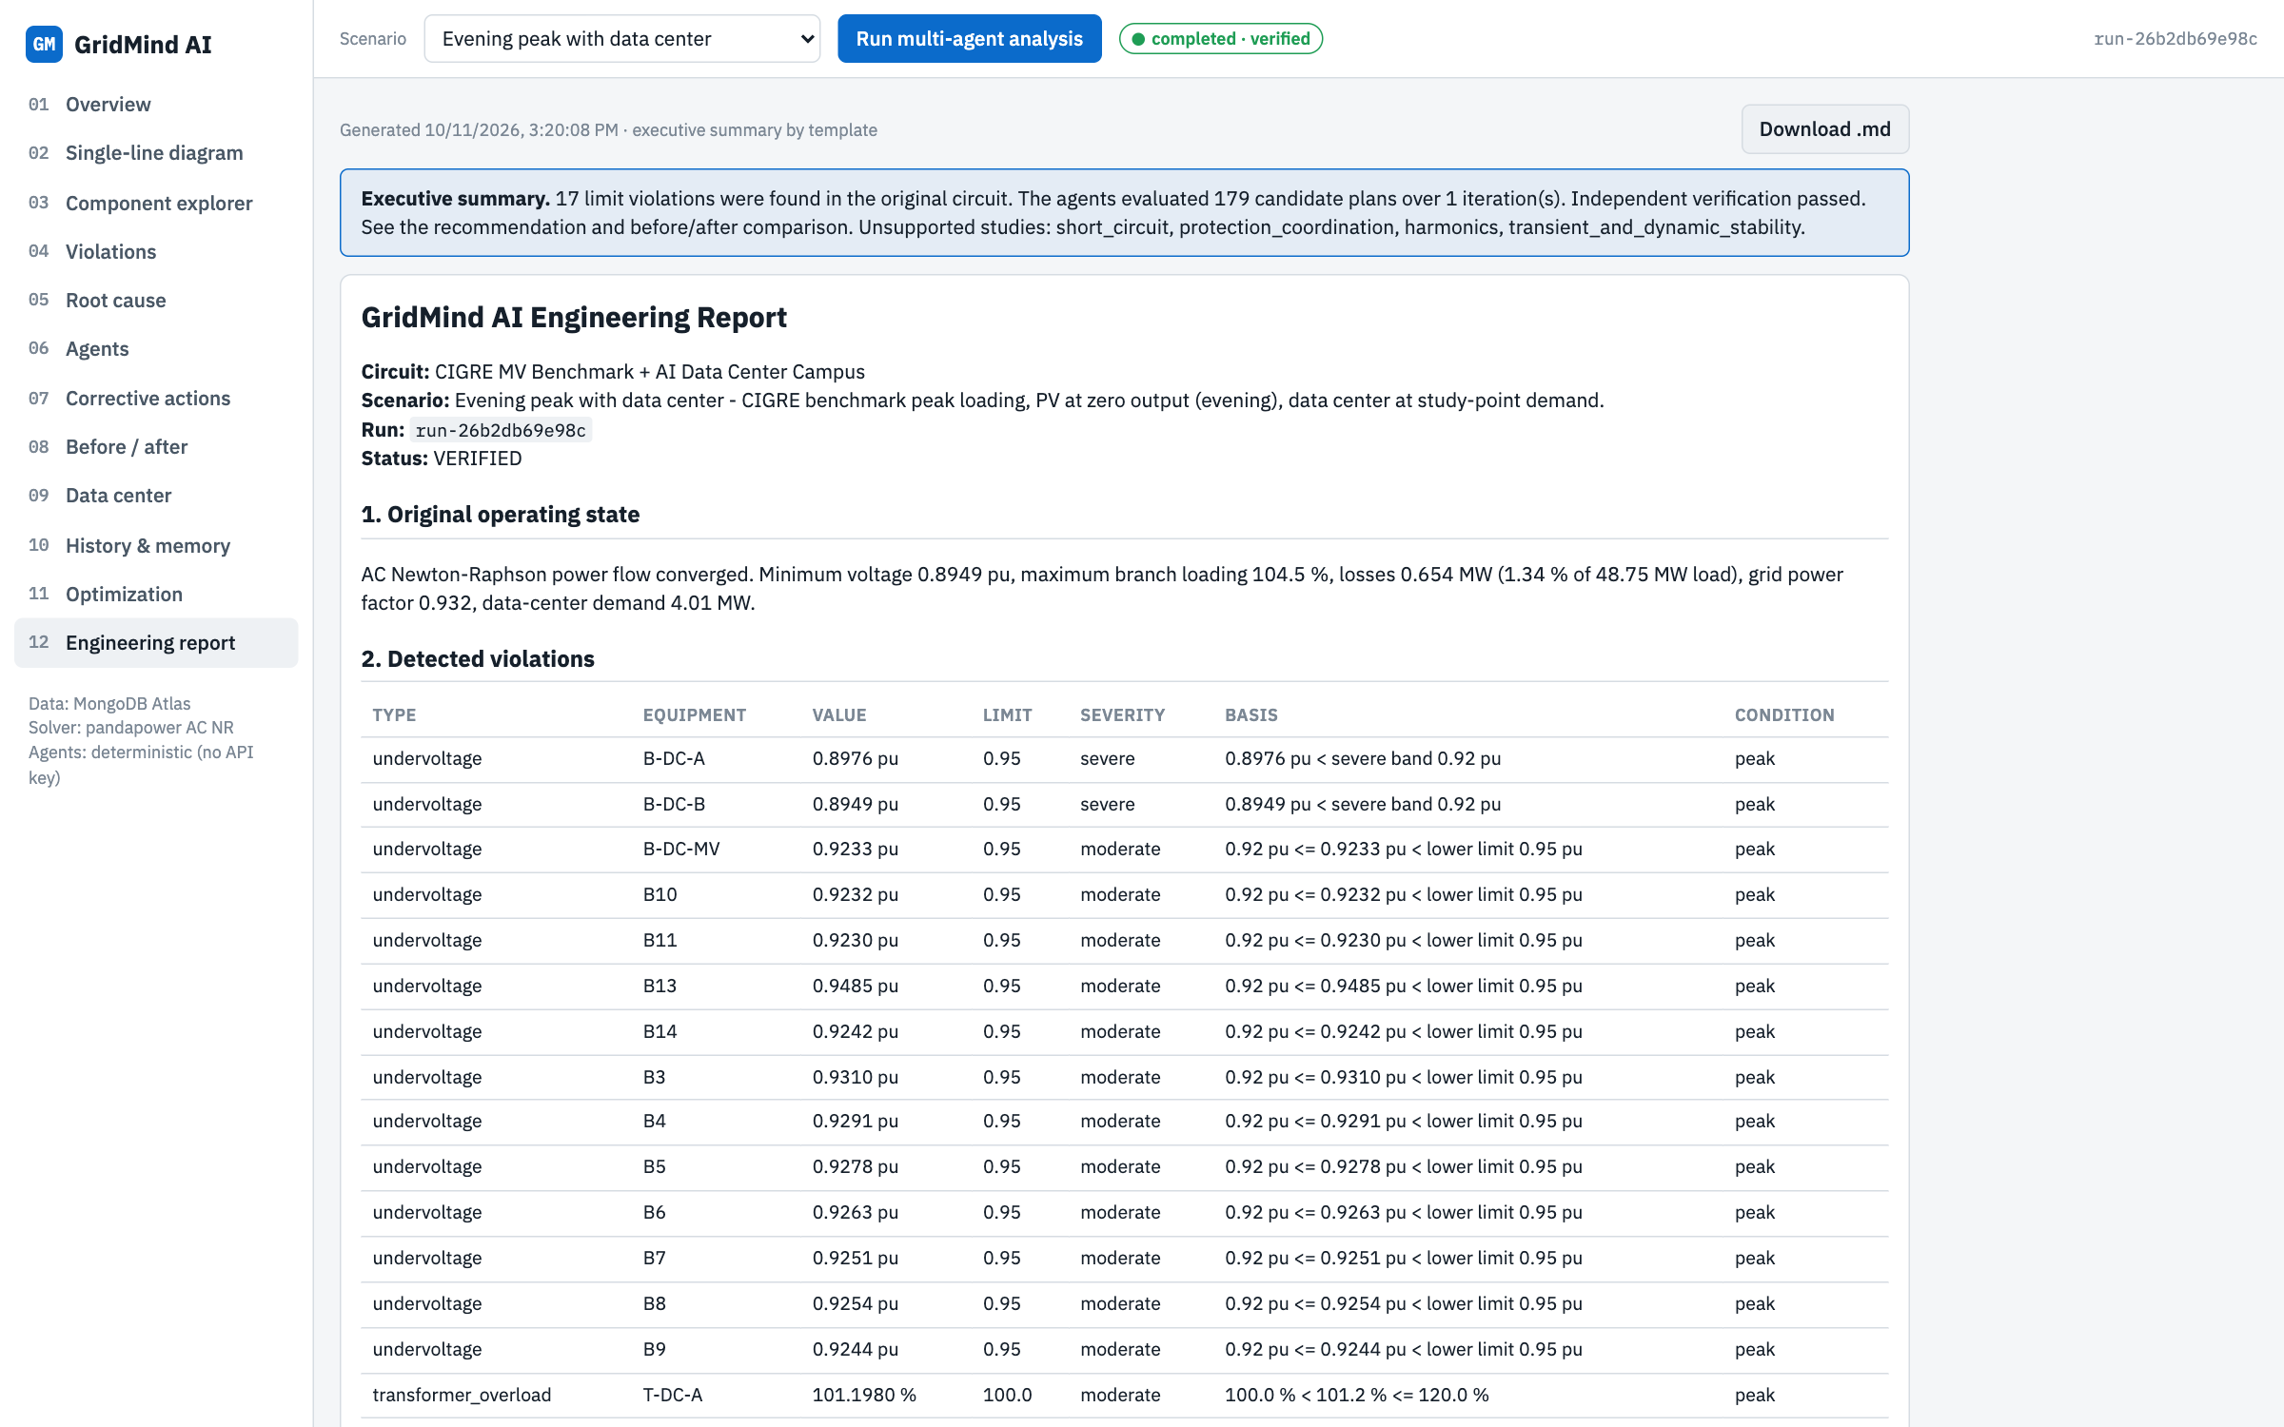
Figure 12: Engineering report page

What you see on the page
- An executive summary banner and a download button for the Markdown file.
- Sections: original operating state, detected violations with severity basis, root-cause analysis, candidates per iteration with sizing method and cost, ranked plans, the recommended plan with notes, independent verification tables for every bus and branch, data-center coordination, and limitations and assumptions.

What happens behind the scenes
- The report is built from the persisted results only. Claude writes the executive summary when an API key is configured; otherwise a template summary is used.
- The report HTML is sanitised before display so that no text can inject scripts.

How to use it
- Download the report and attach it to the hackathon submission.

14. Results of the reference run
Quantity | Original circuit | Verified corrected circuit
Violations (hard) | 17 | 0
Minimum bus voltage | 0.8949 pu | 0.9534 pu
Maximum branch loading | 104.5 % | 99.8 %
Network losses | 0.654 MW | 0.482 MW
Grid power factor | 0.932 | 0.945
Data-center demand at peak | 4.01 MW | 3.66 MW
Selected plan (capital cost $62,000, requires engineer approval):
- Install a 1,500 kvar capacitor bank at bus B11
- Raise the OLTC of transformer T0-12 by 3 steps (tap 0 to -3, about +4.5 % voltage)
- Shift 0.35 MW of the AI-training cluster out of the evening peak
- Discharge the on-site battery (BESS-DC) at 0.47 MW for the 3-hour peak

Suggested live demo (about 5 minutes)
- Open the Overview and point out 17 violations computed by the solver.
- Open the Single-line diagram, Faults layer; click bus B11 to show its full data.
- Press Run multi-agent analysis and switch to Agents to watch the ten agents work.
- Open Root cause, then Corrective actions to show sized candidates and trade-offs.
- Return to the diagram and switch A to B to C: the proposed changes appear in purple and the verified state has no violations.
- Open Before / after for the side-by-side proof, then Data center for the what-if slider and the training schedule.
- Switch to the AI training surge scenario and run again; History and memory shows the lessons it reused.
- Finish on the Engineering report.

Honest limitations
- Steady-state, balanced positive-sequence model: short circuit, protection coordination, harmonics and dynamic stability are listed as unsupported, not calculated.
- The plan search is a heuristic beam search: the plan is the best of the evaluated combinations, not a proven global optimum. The training schedule is optimal for its linearised constraints and is then checked with AC power flow.
- Costs and data-center parameters are illustrative assumptions; nothing is applied to real equipment.

