GPU-Accelerated Recommender System
for Amazon Reviews

Senior Design — Final Report

Group 1

Ivan Chen
Azim Rahat
Arihant Tiwari
ATM Rahat
Kenneth Wong

CSc 59867
Instructor: Professor Zhang
May 24, 2026

Abstract
This report documents the design, implementation, and evaluation of a GPU-accelerated recommender system built on the Amazon Reviews 2023 dataset. The project pursues two parallel objectives: first, to develop an end-to-end data and modeling pipeline leveraging the NVIDIA RAPIDS stack (cuDF, cuML, RMM, dask-cuda); and second, to use that pipeline as a vehicle for a controlled comparison between CPU and GPU implementations.
Starting from a CPU baseline pipeline written in pandas and Dask that filters, transforms, and serializes raw JSONL review and metadata files into a clean Parquet schema, we progressively ported each stage to the GPU. Both pipelines have been executed end-to-end across five product categories, where on identical hardware the CPU pipeline completes the full five-category run in approximately 2.30 hours and the GPU pipeline completes the same workload in approximately 26.7 minutes, giving an end-to-end speedup of roughly 5.15×, with per-category speedup growing from approximately 4.2× on smaller categories to roughly 6.0× on the largest. We also implemented a hybrid scoring layer fusing star ratings with VADER [6] (Valence Aware Dictionary and sEntiment Reasoner) derived sentiment scores, a single-category SVD baseline trained on Electronics, and a GPU recommender stack including both a sparse k-Nearest-Neighbors model and a Truncated SVD model, both scaled to a multi-category catalog of more than 600,000 items and 800,000 users. A FastAPI inference microservice wraps the trained artifact behind HTTP endpoints, with the model held resident in GPU memory across the lifetime of the process.
Beyond the engineering deliverables, this report documents the difficulties we encountered, the architectural decisions we made along the way, and the limitations that remain. Where outcomes diverge from the original project plan, we explain why, and where the system does not yet behave as intended, we outline what we plan to do before final submission.

Table of Contents
Abstract 1
Table of Contents 3
1. Introduction and Motivation 4
2. Background and Related Work 6
3. System Overview 9
4. Data Pipeline 11
5. NLP and Hybrid Scoring 16
6. Recommender Models 18
7. Memory Management and Scaling 25
8. Inference and Serving 27
9. Frontend 29
10. Benchmarking and Evaluation 32
11. Discussion, Limitations, and Future Work 43
12. Conclusion 45
13. Contribution Declarations 47
14. References 52
Appendix — Annotated Code Snippets 54

1. Introduction and Motivation
Every product page that asks “customers who bought this also bought…” is, at its core, the output of a recommendation model running over a very large interaction matrix. The Amazon Reviews 2023 dataset released by McAuley Lab at UC San Diego [13] makes this scale concrete, with roughly 571.54 million reviews spanning 33 product categories (high-level groupings such as Electronics, Books, and Clothing/Shoes/Jewelry that the dataset uses to shard items and reviews) and 48.19 million unique items, distributed across approximately 750 GB of raw JSON Lines (JSONL) files. A useful recommender at this scale must contend with three pressures simultaneously, specifically the cost of ingesting and cleaning raw data, the cost of training a model whose latent space covers tens of millions of items, and the cost of serving recommendations with sufficiently low latency that the product feels live.

1.1 Problem Statement
Traditional collaborative filtering implementations written in pure CPU Python, specifically pandas for data manipulation, scikit-learn or scikit-surprise for modeling, do not scale gracefully to a multi-category (concurrently processing several of the dataset’s 33 product categories rather than just one) Amazon Reviews workload. Data ingestion alone, even with Dask [10] for out-of-core execution, can exceed an hour per category for larger categories, and the underlying matrices quickly outgrow working memory on commodity hardware. Matrix factorization on a 14-million-row interaction matrix is feasible but slow, and naive nearest-neighbor search over millions of ASINs (Amazon Standard Identification Numbers, the canonical product identifier used throughout the dataset) is not feasible without sparse representations and accelerated linear algebra.
GPU computing is an obvious lever to pull on each of these pressure points, but it is not a free lever. GPUs are constrained by VRAM rather than system RAM; their advantage is largest when arithmetic intensity is high and per-operation overhead is amortized over many parallel kernels; and they introduce complications around memory management, host-to-device transfer cost, and library compatibility. Adopting NVIDIA RAPIDS shifts a project’s engineering effort rather than eliminating it. The interesting question is not “is GPU faster than CPU” in the abstract, but specifically where in a concrete recommender pipeline GPU acceleration actually pays back, where it fails to, and what new engineering work the move imposes.

1.2 Motivation
We chose this project because it sits at an intersection not well served by either literature in isolation: recommender-systems papers emphasize algorithmic innovation while treating the data pipeline and serving layer as solved, whereas GPU-computing papers demonstrate raw speedups on synthetic workloads but rarely test whether those speedups survive end-to-end alongside I/O, serialization, and serving overhead. For a team replacing each stage of a clean CPU baseline with a GPU alternative, the questions that matter are what speedup is actually realized and which design choices drive it.
There is also a real-world dimension. The architectural patterns we explore, specifically GPU-resident sparse matrices, persistent in-memory inference servers, integer-first ID encodings (described in Section 6.4), and managed-memory pools, are the same patterns that production recommendation infrastructure relies on. Building a small but honest version of such a recommendation infrastructure gives the team direct experience with the tradeoffs that matter in practice.

1.3 Project Objectives
The project sets four concrete objectives. First, build an end-to-end CPU baseline covering data ingestion, filtering, feature engineering, model training, and inference on at least five product categories. Second, port that pipeline to a GPU implementation backed by NVIDIA RAPIDS with comparable functional behavior at every stage. Third, augment the rating signal with a sentiment-derived feature and use a hybrid score as the prediction target. Fourth, expose the trained recommender behind an HTTP service so downstream clients can query it without owning the dataset or a GPU. Each objective is completed at varying levels of completeness; later sections are explicit about what is finished, in progress, or remaining.

1.4 Summary of Contributions
At the time of writing, the project has produced the following contributions. On the data side, a CPU pipeline completes the full five-category workload in approximately 2.30 hours end-to-end, while the corresponding GPU pipeline completes the same workload in approximately 26.7 minutes, a 5.15× speedup. A metadata caching layer converts Amazon’s schema-drift-prone metadata JSON into a strictly typed Parquet cache in roughly fifteen seconds. For NLP, a sentiment scoring stage built on VADER produces a hybrid rating-plus-sentiment score per review. On the modeling side, a CPU SVD baseline trained on Electronics (13.9 million rows) achieves RMSE 0.2464 and NDCG@10 of 0.9753. Two GPU recommenders, specifically a sparse k-Nearest-Neighbors model and a Truncated-SVD latent k-NN model, are scaled via an integer-first identifier mapping strategy and a 20 GB managed-memory RMM pool. Finally, a FastAPI inference service exposes the trained artifact with the model held resident in GPU memory.

2. Background and Related Work
This section sketches the technical landscape against which our system sits. Where a design choice is justified by prior work, we cite the relevant source; where it is justified by an engineering constraint specific to our project, we say so plainly.

2.1 Collaborative Filtering Approaches
Collaborative filtering remains the dominant paradigm for recommendation in the absence of rich content metadata. The two principal families are neighborhood methods, which compute recommendations from similarities between users or items, and matrix factorization methods, which decompose the sparse user-item interaction matrix into low-dimensional latent factors. Sarwar et al. [1] formalized item-based neighborhood filtering; Koren, Bell, and Volinsky [2] consolidated the SVD-based matrix factorization approach. Neighborhood methods remain appealing because their predictions are interpretable and the precomputed similarity matrix permits fast online inference. Matrix factorization methods generalize better in sparse data regimes and integrate naturally with side information through factorization-machine extensions [3]. Ricci, Rokach, and Shapira [4] provide a textbook treatment of both families.
For this project we work with two instantiations: an item-based k-Nearest Neighbors (k-NN) model on the GPU using cuML’s sparse NearestNeighbors [8], and an SVD model on the CPU using scikit-surprise’s SVD estimator [18]. The asymmetry reflects library availability and the comparative-study design; Sections 6 and 11 discuss the plan to converge on a single production model.

2.2 Hybrid Recommenders and Sentiment Analysis
Pure rating-based collaborative filtering ignores information embedded in review text. A five-star rating with a guarded comment carries a different signal than a five-star rating with three enthusiastic paragraphs. Hybrid recommenders, surveyed by Burke [5], exploit such side information by combining multiple signal sources into a single ranking objective.
VADER [6] is particularly suited to short, informal consumer text, assigning each input a compound polarity score in [-1, 1]. Compared with deep transformer-based models, VADER is lightweight and deterministic and does not require GPU inference of its own. The downside is that VADER does not capture domain vocabulary or contextual irony as well as a fine-tuned transformer would; replacing VADER with a distilled BERT variant [7] is identified as future work in Section 11. We use VADER’s compound score in a 70/30 weighted fusion with the normalized rating, giving precedence to the explicit star rating while allowing the sentiment score to act as a corrective when the rating and text disagree.

2.3 GPU Computing for Data Science
Modern data-science workloads on GPU are increasingly mediated by NVIDIA’s RAPIDS ecosystem [8], providing cuDF (a GPU DataFrame library mirroring the pandas API), cuML (GPU ML primitives), and the RAPIDS Memory Manager (RMM). CuPy [9] mirrors NumPy and SciPy APIs for GPU arrays and sparse matrices. Dask-cuDF and dask-cuda extend the Dask [10] out-of-core execution model to GPU, allowing partition-level parallelism over datasets exceeding VRAM.
The GPU cost model differs from CPU in important ways. Per-kernel launch overhead favors bulk operations over fine-grained ones; pre-allocated memory pools substantially improve throughput by removing per-call cudaMalloc cost; and host-to-device transfer is often the bottleneck on I/O-bound workloads. Sparse linear algebra underpins the entire k-NN recommender, where CuPy provides GPU-native sparse Compressed Sparse Row (CSR) matrices and cuML’s NearestNeighbors accepts CSR input directly. The Coordinate-format (COO) to CSR conversion is non-trivial in VRAM-constrained environments because both representations must briefly coexist; Section 7 describes how we manage that transient pressure.

2.4 Inference Serving
Deploying a trained recommender efficiently requires careful engineering beyond the model itself. The naive approach of loading the pickled model on every request pays the cold-start cost on every call and discards GPU residency between requests. Production-grade alternatives include NVIDIA Triton Inference Server [11], built around model repositories and dynamic batching, and lighter-weight frameworks such as FastAPI [12].
We chose FastAPI over Triton because our serving requirement is a single model with a single inference primitive, where Triton’s value lies in standardizing inference across many models. Its pydantic schemas and asynccontextmanager lifespan handler also fit our needs directly; Section 8.1 develops this rationale in full.

2.5 The Amazon Reviews 2023 Dataset
The Amazon Reviews 2023 dataset [13] aggregates approximately 571.54 million reviews for 48.19 million unique products across 33 categories. Each review includes a numeric rating, free-text body, verified-purchase flag, timestamp, and reviewer identifier; each product record carries a title, brand, price, and category metadata.
The dataset is non-trivial along two axes, specifically size (a single category such as Electronics is roughly 26 GB uncompressed, exceeding the VRAM of any consumer GPU) and schema drift (column orderings, optional-field presence, and occasional malformed records vary across categories and release vintages, addressed by the schema-drift-tolerant parser in Section 4.2). We selected five categories, specifically Tools and Home Improvement, Industrial and Scientific, Sports and Outdoors, Electronics, and Clothing/Shoes/Jewelry, spanning a wide range of catalog sizes (from roughly 150 thousand items in Industrial and Scientific to several million in Clothing) so that benchmark results reflect performance behavior at multiple scales rather than a single point.

3. System Overview

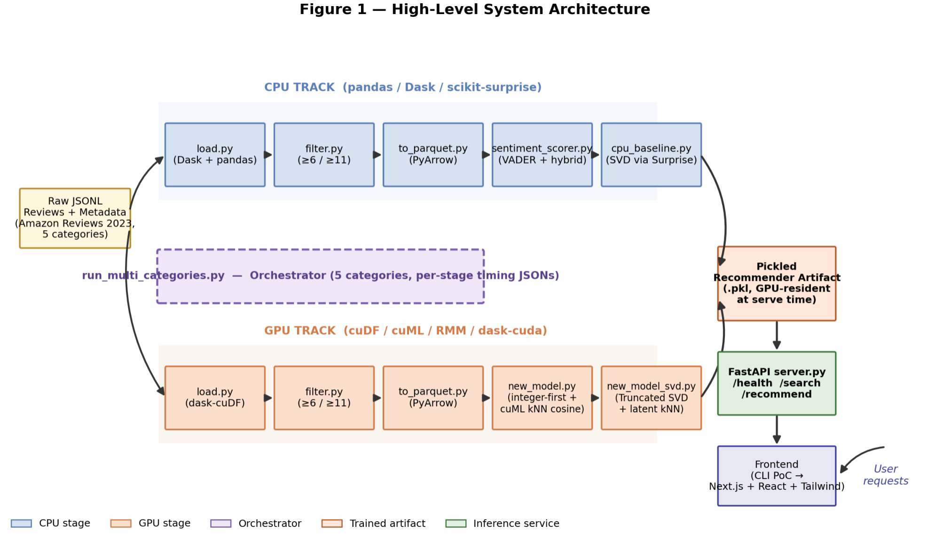
Fig. 1: System architecture. The CPU and GPU pipelines share an identical input/output schema; only the per-stage implementation differs. Color coding distinguishes CPU stages (left) from GPU stages (right).
Fig. 1 illustrates the high-level architecture. The pipeline takes raw Amazon Reviews 2023 data as input and produces a queryable HTTP service returning top-K item recommendations for a given input ASIN. Between those endpoints, the system has six logical stages: ingestion, filtering and serialization, sentiment-aware feature engineering, model training, model serialization and loading, and inference serving, where each stage exists in both a CPU baseline and a GPU implementation sharing a common input/output schema so the two pipelines can be compared directly.
Stages one through three cover ingestion, filtering, and feature engineering, where both CPU (Dask + pandas) and GPU (Dask-cuDF) paths load review and metadata JSONL files, join on parent_asin, and apply activity-threshold filters (≥6 reviews/user, ≥11 reviews/item) before writing to a strictly typed Parquet file. The Parquet write is notably the largest single time expenditure on both backends, specifically explored in Sections 4 and 10. The reviewText (one of the seven schema columns defined in Section 4.1) column is then cleaned and scored with VADER's compound-polarity model to produce a hybrid score used as the downstream model's prediction target.
Stages four through six cover model training, serialization, and serving. The CPU baseline trains an SVD model via scikit-surprise, while the GPU model builds a CuPy CSR sparse matrix and fits a cuML k-NN index. Both pipelines emit a single pickled artifact bundling the trained model with all runtime state, which a FastAPI application loads once at process start and exposes through three endpoints (/health, /search, and /recommend). The detailed contract of each endpoint is described in Section 8.3.

4. Data Pipeline

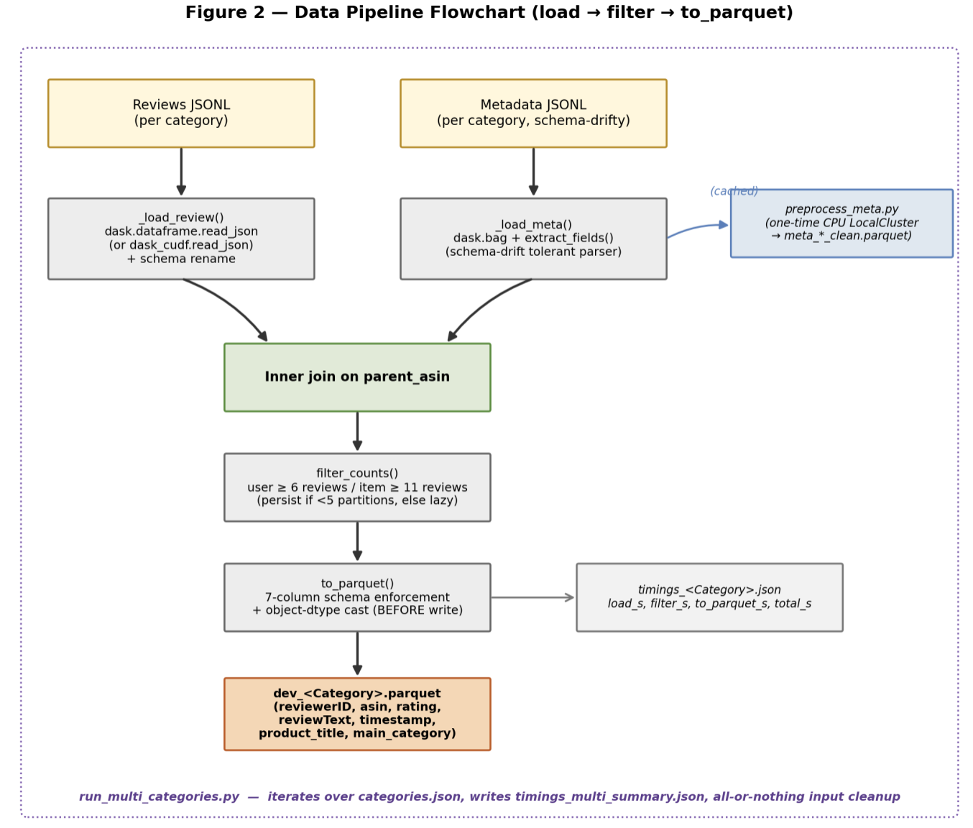
Fig. 2: Data pipeline. Raw JSONL reviews and metadata are loaded, joined on parent_asin, filtered, and written to the standardized seven-column Parquet schema described in Section 4.1.

4.1 Dataset and Schema
Fig. 2 shows the data-pipeline stages in order. The Amazon Reviews 2023 dataset distributes gzipped JSONL files per category, split into reviews file and a metadata file. The reviews file contains one JSON object per review with fields including user_id, asin, rating, text, parent_asin, and timestamp. The parent_asin field is the canonical product identifier for the join, where it always points to the product family rather than a specific variant, making the join stable across cosmetic variant churn. Our pipeline produces a fixed seven-column output schema regardless of input category, specifically reviewerID, asin, rating, reviewText, timestamp, product_title, and main_category. This schema is enforced explicitly in data/to_parquet.py and is the contract every downstream component depends on.
We selected five categories, specifically Industrial and Scientific, Sports and Outdoors, Tools and Home Improvement, Electronics, and Clothing/Shoes/Jewelry. The smallest (Industrial and Scientific) is approximately one-thirtieth the size of the largest (Clothing/Shoes/Jewelry), so that the pipeline’s behavior at multiple scales is observable from the same set of runs.

4.2 Loading and Joining
The load module hides the CPU/GPU backend split behind a single API. Both backends share the same column-renaming logic translating Amazon 2023 raw schema fields (user_id, text) to standardized names (reviewerID, reviewText). The CPU path uses dask.dataframe.read_json; the GPU path uses dask_cudf.read_json. Block size is configurable (default 64 MB for single-category, 256 MB for multi-category runs) and is the primary knob for tuning load-stage memory pressure.
The metadata side is more complicated due to schema drift across categories. Fields appear, disappear, and change types between dumps, making a strict-schema reader inadequate. The metadata loader uses dask.bag.read_text to read raw lines, applies a per-line parser that defensively pulls only parent_asin, product_title, and main_category while silently dropping malformed records, then converts the bag into a typed Dask DataFrame. This replaced an earlier pd.read_json call that was eagerly loading the entire 5 GB metadata file and causing an 18 GB peak memory footprint; the lazy bag pipeline dropped metadata-load footprint from approximately 18 GB to 2 GB and unblocked the full Electronics run.
A separate caching script (data/preprocess_meta.py) runs the metadata extraction once on a CPU LocalCluster, producing a strictly-typed Parquet file (meta_<Category>_clean.parquet) that subsequent pipeline runs read directly instead of re-parsing raw JSON. For the Electronics metadata file, the one-time conversion takes approximately fifteen seconds.

4.3 Filtering
The activity-threshold filter keeps rows whose user has at least six total reviews and whose item has at least eleven. On a multi-gigabyte sparse interaction matrix the implementation has nontrivial memory implications: the filter computes per-user and per-item review counts via groupby().size(), joins those counts back onto the original frame, and drops rows below either threshold. The filter persists the result only when the partition count is small enough to fit comfortably; for larger datasets it leaves the result lazy so the downstream Parquet write can stream partitions directly without ever holding the whole filtered frame at once.
The thresholds are deliberately asymmetric, where the user threshold is lower because user activity is more right-tailed than item activity, and the item threshold is higher to remove items with insufficient interaction signal. The filter takes essentially zero wall-clock time at every measured scale, no more than 0.4 seconds even on the 26 GB Electronics input.

4.4 Serialization
The Parquet writer enforces the seven-column output schema and resets the index before delegating to df.to_parquet() with write_index=False. A key bug fix was reordering an object-dtype cast so it runs before the Parquet write rather than after; the incorrect ordering meant PyArrow received bare object() sentinels in string columns, corrupting the output and blocking the downstream model-training step entirely.
The to_parquet stage is the dominant pipeline cost on every run, accounting for approximately 91% of CPU runtime and 66% on the GPU side. Parquet serialization is CPU-bound regardless of where the input frame lives, since encoding and compression run on the host CPU through PyArrow even when the source DataFrame is GPU-resident. The GPU acceleration story therefore plateaus at the speed of the host's serialization codec.

4.5 Multi-Category Orchestration
The multi-category orchestrator (data/run_multi_categories.py) reads a categories.json configuration file listing categories and their input filenames. For each category it constructs per-run output paths, runs the load → filter → write loop, writes per-stage timings to JSON, and appends to an in-memory summary dumped at the end.
Two operational features distinguish the orchestrator from a naive shell loop. First, the --workers flag configures Dask’s threaded scheduler to use a bounded number of CPU threads (4 in canonical CPU runs), keeping the pipeline from over-subscribing the host CPU during the Parquet write while the GPU is otherwise idle. Second, the orchestrator has all-or-nothing cleanup semantics: raw JSONL files are deleted only if every configured category completes successfully, so a failed category can be re-run without re-downloading. A path-safety check rejects any deletion target outside the dataset/ directory, preventing a misconfigured categories.json from accidentally deleting unrelated files.

4.6 GPU Pipeline Memory Considerations
When the --gpu flag is passed, the pipeline initializes RMM before any GPU work:
rmm.reinitialize(pool_allocator=True, initial_pool_size=int(8e9), managed_memory=True)
The pool allocator pre-allocates a large VRAM block at startup so subsequent cuDF allocations don’t pay the per-call cudaMalloc cost. The managed_memory=True flag enables CUDA Unified Memory, making the pool oversubscribable, where addresses outside the resident set are paged on-demand from host RAM rather than throwing out-of-memory (OOM) errors. The pool size evolved from 2 GB to 7 GB to 20 GB as progressively larger datasets were introduced; the 8 GB value in the single-category runner fits any of our five categories on the TITAN RTX, while the 20 GB value used by the model trainer is sized for the full-catalog sparse matrix.

4.7 Distributed Multi-GPU Exploration
An earlier branch explored scaling via dask_cuda.LocalCUDACluster, where multiple GPU workers would cooperatively process a single dask-cuDF frame, aggregating VRAM across devices. The cluster initialization was validated through the Dask dashboard streamed over an SSH port-forward, and the architectural plumbing reached the point where a multi-GPU shuffle was observable in the dashboard’s task graph. However, the second physical GPU on the professor’s server proved non-functional. We redirected engineering capacity into single-GPU memory engineering, specifically the larger RMM pool and the integer-first mapping strategy (described in detail in Section 6.4), which produced more measurable end-of-project benefit than a half-finished multi-GPU implementation would have, specifically the ability to fit the multi-category sparse matrix on a single 24 GB GPU and train the cosine k-NN model in approximately 60 seconds (runtime numbers reported in Sections 10.2 and 10.3).

5. NLP and Hybrid Scoring
The downstream models are not trained on raw star ratings. Instead, both the CPU SVD baseline and the GPU recommenders consume a hybrid score that fuses star ratings with VADER sentiment polarity, on the rationale that a 4-star rating with an enthusiastic review carries more positive evidence than a 4-star with a guarded one (or, conversely, that a low-starred review whose text is overwhelmingly positive deserves a corrective). This hybrid scoring stage lives in models/sentiment_scorer.py and bridges the data pipeline’s Parquet output and the SVD model’s training input.

5.1 Text Preprocessing
Before sentiment analysis, the reviewText column is normalized through four pandas string operations in the clean_text() function, where missing values are filled with empty strings; all text is lowercased; the regular expression [^\w\s] strips punctuation and special characters, replacing them with single spaces; and consecutive whitespace is collapsed and stripped. The result is stored in a temporary clean_text column, which is dropped before the final Parquet write to avoid persisting intermediate data.

5.2 VADER Sentiment Scoring
Sentiment scoring uses VADER (Valence Aware Dictionary and sEntiment Reasoner), a lexicon-and-rule-based analyzer well-suited to informal consumer text such as Amazon reviews, which often mix product-specific vocabulary with informal language patterns. For each review, VADER’s polarity_scores method returns positive, negative, neutral, and compound scores; we extract the compound score, which is a float normalized to [-1.0, +1.0]. The output is a pandas Series with the original index preserved, ensuring correct alignment when the column is merged back into the main frame.
Processing is handled in batches of 50,000 rows, where batching provides incremental progress logging and bounds peak memory by ensuring the analyzer does not have to materialize the entire review column at once. A single SentimentIntensityAnalyzer instance is reused across all batches so VADER’s lexicon is loaded once.
VADER runs on the CPU. Although a GPU-side implementation was planned, reimplementing VADER’s lexicon-and-rule engine on GPU would be disproportionate scope relative to its weight in the system. The sentiment scoring runs once per Parquet file as a precomputation; it is the most expensive single CPU stage in the entire pipeline (approximately 98 minutes for Electronics), though it is not on the inference hot path. A transformer-based GPU sentiment model is identified as future work.

5.3 Hybrid Score Construction
Raw star ratings (1–5) and VADER compound scores (-1 to +1) are normalized to the unit interval and fused:
rating_norm = (rating - 1.0) / 4.0 # maps [1, 5] → [0, 1]
sentiment_norm = (compound + 1.0) / 2.0 # maps [-1, +1] → [0, 1]
hybrid_score = 0.7 * rating_norm + 0.3 * sentiment_norm
The 70/30 weighting privileges the explicit star rating while allowing the sentiment score to act as a corrective when the rating and text disagree. Both weights are exposed as function parameters, making the fusion strategy configurable without code changes. A pd.to_numeric() cast with errors=‘coerce’ is applied before normalization to handle type ambiguities that occasionally arise when loading Parquet files via the Arrow backend on string-encoded numeric columns.

5.4 Cold-Start Handling
For new users with no interaction history, the recommender aggregates the dataset at the product level, computes mean hybrid score and review count per product, excludes products with fewer than twenty reviews, ranks by mean hybrid score, and returns the top-K. This pool is materialized once at construction time so cold-start requests are served as a head(k) slice with no runtime cost. The cold-start output carries the same column schema as the personalized SVD output, keeping the recommender’s interface uniform across paths.

6. Recommender Models

6.1 Why Two Model Families
The modeling work explored two collaborative filtering families in parallel: SVD-style matrix factorization on the CPU (scikit-surprise) and item-based k-NN with cosine similarity on the GPU (cuML NearestNeighbors). Running both was a comparative-study decision: we wanted to evaluate both approaches against the same dataset to inform which model family to converge on.
SVD predicts a personalized score for any (user, item) pair as the inner product of latent vectors plus learned bias terms, the natural primitive for a “what should this user see” query. Item-based k-NN returns the top-K items most similar to a query item by row-cosine over the user-rating matrix, the natural primitive for an “items similar to this one” query. New GPU-side measurements favor a Truncated-SVD variant on key quality metrics, complicating the earlier assumption that k-NN would be the obvious production choice.

6.2 CPU Baseline: SVD via scikit-surprise

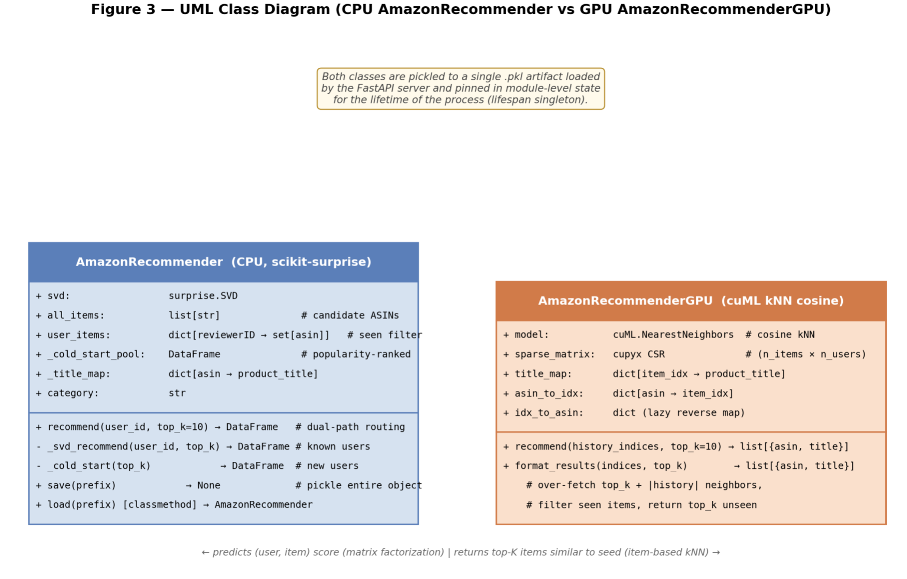
Fig. 3: UML class diagram for the recommender. AmazonRecommender (CPU SVD baseline) and AmazonRecommenderGPU (GPU k-NN) share the recommend(seed, top_k) and format_results contract.
Fig. 3 shows the class diagram for the two recommender families discussed in this section. The CPU baseline (models/cpu_baseline.py) consumes the enriched Parquet file (the seven-column output produced by the data pipeline described in Section 4) , slices it to the three columns scikit-surprise expects (reviewerID, asin, hybrid_score), and uses an 80/20 train-test split with a fixed random seed. The SVD model represents each user and item as a 100-dimensional latent factor vector, predicting scores as the inner product of those vectors plus learned biases, trained via SGD. The hyperparameters (100 factors, 20 epochs, learning rate 0.005, L2 regularization 0.02) are untuned defaults; numbers in Section 10 should be read as a baseline, not a production result.
After training, the model is pickled into an AmazonRecommender object whose recommend(user_id, top_k) method routes known users through _svd_recommend and new users through _cold_start. Candidate pools and seen-item dictionaries are pre-computed at construction time, keeping both user types (known users with a history vector and new users handled by the cold-start branch) O(items) at most.

6.3 GPU Model: k-Nearest Neighbors on Sparse Matrix
The GPU model implements item-based collaborative filtering with cosine similarity over the sparse user-rating matrix. The primary inference primitive is model.kneighbors(row, n_neighbors=k), returning the K items whose user-rating vectors are most aligned with the query item’s. The training pipeline loads category Parquet files, builds a global integer mapping of users and items, materializes a CuPy CSR sparse matrix of shape (n_items, n_users), fits a cuML NearestNeighbors model with metric=‘cosine’, and pickles an AmazonRecommenderGPU object containing the k-NN model, the sparse matrix, the integer-to-string title map, and the ASIN-to-index lookup (the same compact integer-keyed maps introduced in Section 6.4).
The recommend(user_history_indices, top_k) method over-fetches slightly more than top_k neighbors, filters out every item in the user’s history regardless of where it appears in the result list, and returns the first top_k unseen items. A subtle implementation detail: cupyx.scipy.sparse.csr_matrix does not support CuPy-array fancy indexing for row selection; row selection must use a plain Python list, which triggers the NumPy-style indexing path, where each element of the Python list is interpreted as a row index and the corresponding sparse rows are gathered into a new compact matrix rather than fancy-indexing them in place. This is documented in the recommender source and was caught during integration testing.
A companion GPU-side trainer, models/new_model_svd.py, implements the same integer-first ingestion but produces a Truncated-SVD latent space of 512 factors computed with SVDS, a sparse solver that returns only the leading singular values and vectors, followed by a latent-space k-NN. Section 10 documents this variant alongside the cosine k-NN model because the multi-category metrics actually favor the SVD variant.

6.4 Integer-First Mapping Strategy
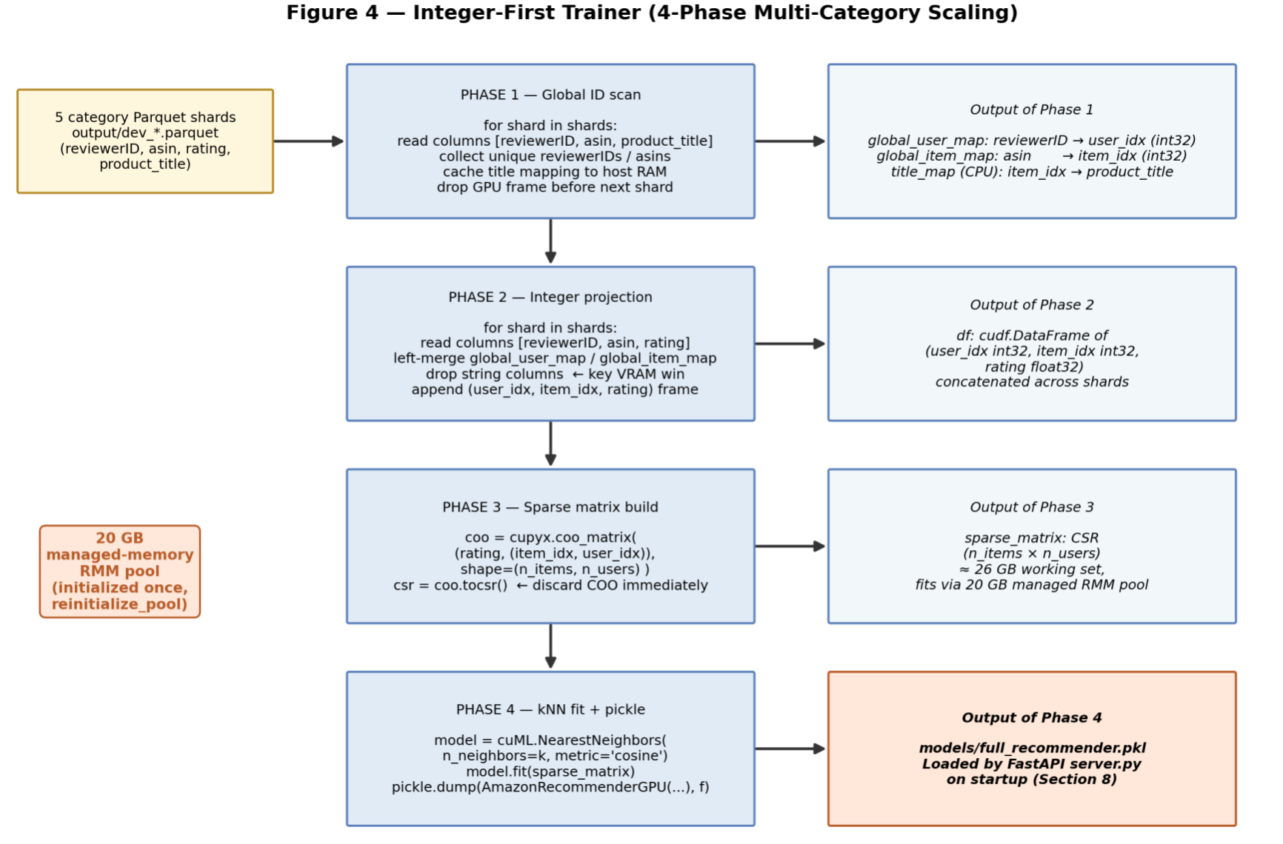
Fig. 4: Four-phase integer-first trainer. Phase 1 builds global ID maps, Phase 2 remaps each shard to compact int32 indices, Phase 3 concatenates and constructs the COO/CSR sparse matrix, Phase 4 fits the cuML NearestNeighbors model.
Fig. 4 lays out the four phases of the trainer described below. The most consequential modeling-time engineering work is the integer-first refactor (where “refactor” refers to the code change in models/new_model.py that adopts the integer-first mapping strategy described below) in models/new_model.py, which scaled k-NN training from a single category to the full multi-category catalog. The earlier version carried string reviewerID and asin columns through every join. cuDF stores object-dtype columns as variable-length character buffers, so the full multi-category working set caused cudf.concat to exhaust VRAM before the sparse matrix could be built.
The refactored pipeline strips strings at the earliest opportunity and never re-introduces them on the GPU side. In Phase 1 (Global ID Scan), the pipeline walks every Parquet shard (the per-category Parquet output of the data pipeline, where each category produces one shard so that the trainer can iterate over them without materializing the full multi-category frame at once), collects unique reviewer and item IDs into per-shard sets, and drops the GPU DataFrame before the next shard, keeping the working set bounded by one shard plus the running unique set. Phase 2 (Integer Projection) then re-reads each shard, attaches int32 indices via the global maps, and immediately drops the string columns, so by the time the cross-shard concatenation runs it operates on int32 indices and float32 ratings only. From there, Phase 3 (Sparse Matrix Construction) builds a CuPy coo_matrix shaped (n_items, n_users) and immediately converts to CSR, where the orientation ensures each item's row is exactly the vector of user ratings that cosine similarity consumes. Finally, Phase 4 fits the cuML NearestNeighbors model and pickles the AmazonRecommenderGPU artifact.

6.5 A Common Model for Both Backends: Implicit ALS
The model evaluation reported earlier in this section is structurally asymmetric: the CPU baseline trains an SVD model with scikit-surprise and reports rating-prediction metrics (RMSE, MAE), while the GPU pipeline trains a cosine k-Nearest-Neighbors model and reports top-K ranking metrics (Precision, Recall, F1). The two are not directly comparable. After Report 1 we recognized this asymmetry as the largest weakness in the project’s comparison story, and the work in this subsection was undertaken specifically to address it.
We added a third recommender family, an implicit-feedback Alternating Least Squares (ALS) model built on top of the implicit Python library [21]. The library exposes a single AlternatingLeastSquares class whose constructor takes a use_gpu boolean: when False the model is trained with a Cython and OpenMP CPU kernel using Cholesky-decomposition linear solves, and when True the model is trained with a CUDA kernel using Conjugate-Gradient linear solves. Both paths expose identical Python APIs, so a single training script, evaluation script, and inference server can run on either backend by toggling that one argument. This removes the algorithm-and-library asymmetry that made the original CPU-vs-GPU comparison weak.

6.5.1 Why ALS, and Why Not k-NN or Classical SVD
ALS is appropriate here for three reasons. First, on a sparse rating matrix with millions of users and millions of items, ALS learns dense user and item factor matrices in low-dimensional space, which is the right representation for top-K retrieval and avoids the popularity-bias failure mode that plagued the cosine k-NN model at multi-category scale. Second, the implicit library’s use_gpu flag gives a literal apples-to-apples backend comparison; we did not find a similarly mature library where the same SVD or k-NN model would train identically on CPU and GPU. Third, ALS for implicit feedback (Hu, Koren, and Volinsky, 2008 [15]) is the textbook algorithm for rating data that can be reinterpreted as implicit positive signals (a user gave four or five stars, therefore the user engaged positively), which fits the Amazon Reviews use case after we drop low-confidence one-to-three-star reviews.

6.5.2 Implementation
The ALS work lives in a new top-level package models_als/ that is parallel to the legacy models/ folder. The package exports the AmazonRecommenderALS class (a wrapper around an implicit.als.AlternatingLeastSquares model plus an ASIN-to-index lookup and an integer-to-title map), a CLI training script train_als.py, an evaluation script evaluate_als.py implementing time-based holdout, and a FastAPI server server_als.py that is a drop-in replacement for models/server.py with the same /health, /search, and /recommend contract. The frontend therefore requires no changes to switch between the legacy k-NN backend and the ALS backend.
Training reads the five-category Parquet output produced by the data pipeline (Section 4) and builds a single global user-by-item CSR matrix whose nonzero entries are confidence-weighted: data = 1 + alpha * rating, following the Hu/Koren/Volinsky formulation. We filter to rating >= 4.0 before constructing the matrix, treating four-star and five-star reviews as positive implicit signals and dropping one-to-three-star rows as noise. After filtering the corpus contains 31,138,788 interactions over 3,782,628 users and 2,138,088 items. Final hyperparameters were factors=64, iterations=20, alpha=40, regularization=0.05, with random seed 42.

6.5.3 Bugs Encountered During Integration
Scaling the ALS pipeline from a toy slice to the full 31-million-row corpus surfaced five concrete defects worth recording. First, some Parquet shards stored the rating column as object dtype rather than float, so a direct comparison against 4.0 raised a string-versus-float TypeError; we resolved this with pandas to_numeric and a subsequent dropna on the rating column. Second, the obvious follow-on of also coercing the timestamp column produced an entirely empty dataframe, because pandas to_numeric cannot convert datetime64 values and returns NaN for all of them; we dropped that coercion because datetime64 sorts natively without conversion. Third, df.sort_values on user_idx and timestamp hung indefinitely on the 31-million-row frame because pandas performs a full O(n log n) sort with an in-memory rewrite; we replaced it with df.groupby('user_idx', sort=False)['timestamp'].idxmax(), which is O(n) and finishes in seconds. Fourth, idxmax returned the original pre-filter row indices while our holdout mask was sized to the filtered frame, raising an out-of-bounds IndexError; the fix was to reset_index(drop=True) immediately after the rating filter. Fifth, OpenBLAS’s internal threadpool fought with the implicit library’s own multithreading and produced a runtime warning along with severely degraded CPU training performance; setting OPENBLAS_NUM_THREADS=1 for CPU runs resolved both.

6.6 Model Evaluation (k-NN and SVD on Multi-Category Catalog)
The CPU SVD baseline is currently evaluated only on Electronics (13.9 million rows, 1.38 million users, 442,846 items after filtering). The model trains in approximately 210 seconds and achieves RMSE 0.2464, MAE 0.1821, NDCG@10 0.9753, and Precision@10 0.1969 on the held-out 20% test set (RMSE and MAE are rating-prediction error on the 1-5 scale, lower better; NDCG@10 and Precision@10 are top-10 ranking quality on [0,1], higher better).
The NDCG@10 of 0.97 deserves a caveat: it is computed against the ideal ranking by true hybrid score, and on a test set where many items meet the relevance threshold (4-star and 5-star reviews dominate Amazon ratings), the ideal ranking is short and dense, which can inflate NDCG. Precision@10 of 0.197 is the more sober number. Extension to the other four categories is a deliverable for the final report; until that work lands, these numbers should be read as an Electronics-specific baseline.
On the GPU side, the cosine k-NN model (models/new_model.py) trains in approximately 60 seconds on the full five-category corpus (603,726 items × 828,346 users, k=50) and reports Precision@50 of 0.0013, Recall@50 of 0.0087, and F1 of 0.0023. The Truncated-SVD model (models/new_model_svd.py) trains in approximately 38 seconds on a slightly smaller corpus and reports Precision@50 of 0.0024, Recall@50 of 0.0198, and F1 of 0.0043. Both numbers are low in absolute terms; Sections 10 and 11 discuss the cause and the fixes planned. The metric protocols differ between CPU SVD (Precision@10 on a hybrid-score threshold) and GPU models (Precision@50 on held-out interactions), so direct cross-protocol comparison is not appropriate.

7. Memory Management and Scaling
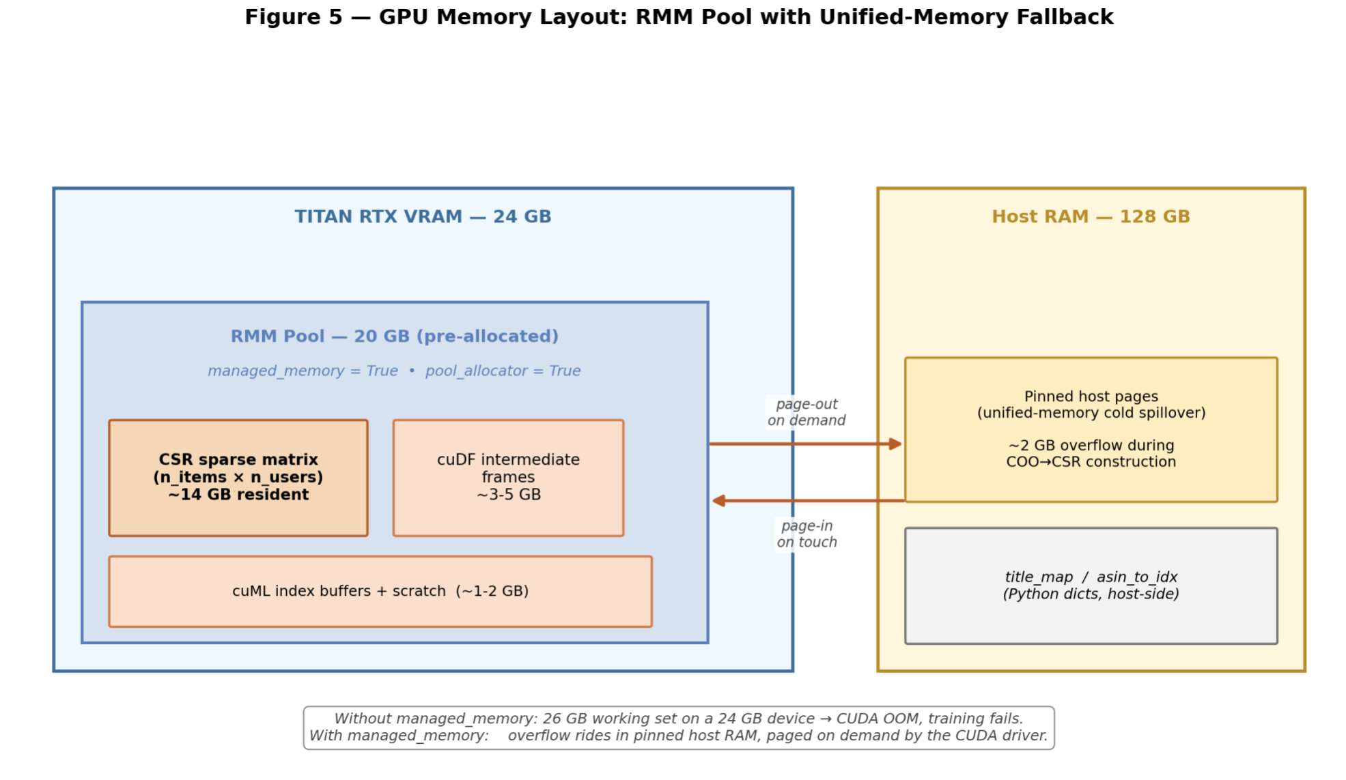
Fig. 5: RMM managed-memory pool. The pool spans both VRAM and host RAM, with addresses outside the resident set paged on demand. Arrows indicate migration direction during a typical training step.
GPU memory engineering is one of the project’s most significant technical contributions. Fig. 5 sketches the managed-memory layout that ties VRAM and host RAM together through the RMM pool. The central challenge is that the multi-category sparse matrix (603,726 items × 828,346 users) exceeds the VRAM on most consumer GPUs and approaches the limit of the TITAN RTX (24 GB).

7.1 The Hardware Constraint Story
Early development on a personal RTX 3060Ti (8 GB VRAM) hit hard OOM at every non-trivial cross-partition operation. Mitigations (WSL filesystem, native Windows) had no measurable effect; tuning Dask block size down to 128 MB was the empirical fix for the 8 GB device. The migration to the professor’s TITAN RTX (24 GB VRAM) lifted the hard ceiling and allowed modeling work to begin in earnest.

7.2 The RMM Pool
The RAPIDS Memory Manager mediates every cuDF and cuML allocation via three features relevant to our workload: pre-allocated pools (a single up-front cudaMalloc serving all subsequent allocations); managed memory (CUDA Unified Memory, with overflow pages migrated automatically between GPU and host); and per-stream allocator control (available but not yet exploited). The pool size evolved from 2 GB (initial debugging), to 7 GB (full-category Electronics shuffles), to 20 GB (full multi-category trainer, sized to fit the integer-first concatenated frame plus the COO sparse matrix during construction).

7.3 The 26 GB Sparse Matrix on a 24 GB GPU
The sparse-matrix construction phase is the most VRAM-demanding step. The full-catalog COO representation exceeds the TITAN RTX’s 24 GB by approximately 2 GB at peak. Without unified memory this would simply fail; with managed_memory=True the CUDA driver transparently migrates cold pages to pinned host RAM. The performance cost of PCIe migration is real but acceptable, and the wall-clock time of Phase 3 is consistent with a working set roughly 10% over the resident threshold.

7.4 Integer-First Strategy and VRAM Impact
The integer-first mapping strategy (Section 6.4) is the single piece of the system most directly responsible for the multi-category scaling outcome, and its impact is primarily on VRAM. On the five-category corpus the integer-first concatenated frame occupies roughly 1.2 GB of VRAM (two int32 columns plus an int8 rating column over ~32 million rows). The equivalent string-keyed frame, with reviewerID and asin stored as variable-length byte arrays in cuDF, would consume roughly 5-7 GB before the COO matrix is built, so the strategy reclaims approximately 4-6 GB of headroom on the 24 GB device.

8. Inference and Serving

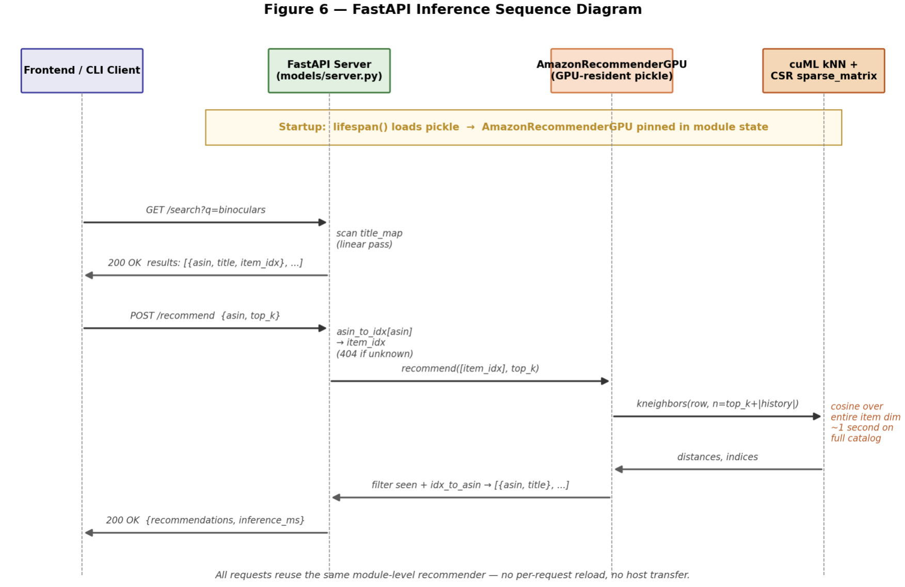
Fig. 6: FastAPI inference sequence. The lifespan handler loads the pickled recommender once at process start; subsequent /recommend calls reuse the resident GPU-side structures.

8.1 Why FastAPI
Fig. 6 sketches the request-handling sequence the rest of this section describes. We chose FastAPI over both Triton and Flask for three reasons. First, our serving requirement is a single model with a single inference primitive; Triton’s value is in standardizing inference across many models with dynamic batching, none of which we needed at our query rate. Second, FastAPI’s pydantic-based request and response schemas provide strict typing on the API surface without additional code. Third, FastAPI’s asynccontextmanager lifespan handler is the natural place to load the recommender pickle once into module state and pin it in VRAM for the process lifetime, ensuring every subsequent request reuses the same GPU-resident structures.

8.2 Model Loading via Lifespan
The model singleton lives in models/server.py. The lifespan function reads MODEL_PATH (defaulting to models/full_recommender.pkl), loads the pickle (Python’s standard binary object-serialization format, used here to persist the trained recommender and all of its in-memory state) into a module-level recommender reference, prints the catalog size and load time, and yields control to FastAPI; on shutdown the reference is cleared. This guarantees three properties: the model is loaded once at startup; it is pinned in memory via the module-level reference; and failure to find the pickle is fatal at startup, preventing the process from coming online in a half-initialized state.

8.3 Endpoints
Three endpoints are exposed. GET /health returns server status, a model_loaded boolean, and catalog size. GET /search?q=<substring>&limit=<n> performs a substring scan over the in-memory title map, returning {asin, item_idx, title} triples. It exists because the natural user-facing entrypoint is a product name, not an ASIN.
POST /recommend is the inference endpoint. The request body {asin, top_k} is validated by pydantic; the response is {asin, query_title, recommendations: [{asin, title}], inference_ms}. The handler resolves the ASIN to an integer index (returning HTTP 404 with guidance to use /search if unknown), calls the recommender’s recommend method, times the call with time.perf_counter, and returns the result with inference latency. A 503 is returned if recommender is None (startup race or failed reload). Schema-level validation enforces 1 ≤ top_k ≤ 100 so a malformed client cannot ask for the full catalog by accident.

8.4 Operational Concerns
The server runs as a long-running background process under nohup with --workers 1 and stdout/stderr redirected to a log file. By utilizing Uvicorn [23] as the underlying ASGI web server to run FastAPI, we were able to intentionally restrict Uvicorn to a single worker process because each additional worker loads a separate copy of the multi-million-item recommendation model into VRAM. On a 24 GB GPU, running multiple workers would immediately trigger an Out of Memory (OOM) crash."Port management on the shared server uses fuser 8000/tcp for inspection and kill -9 <pid> for forced replacement.

9. Frontend
The frontend is the user-facing layer of the recommender. Where Report 1 described the frontend as a CLI proof-of-concept and a planned web application, the current report covers the actual implemented web frontend that talks to the live GPU model on the school server, the deployment architecture that bridges the browser to the GPU box through the school firewall, and the design choices that shaped the user experience. Arihant led this work.

9.1 Stack and Implementation
The frontend is a single-page application built with React and TypeScript on Vite, styled with Tailwind CSS and shadcn/ui components, with TanStack Query for server state and Framer Motion for transitions. We generated the initial scaffold via lovable.dev from a detailed spec covering the layout (a sticky status bar, a hero search, a seed card beside a recommendations grid, an inference-latency strip with a sparkline, and a recent-history chip rail), the API contract (the three endpoints of Section 8.3), and the visual style (dark-mode default, electric-green accent, monospace ASINs and metrics). The generated component tree was then reviewed for spec adherence, and the full set lives under frontend/ with a centralized API client at src/lib/api.ts.
Behaviorally, the frontend debounces the typeahead search by approximately 250 milliseconds so that fast typing does not generate a request per keystroke; supports keyboard shortcuts (/ to focus the search box and Esc to clear it); auto-fetches recommendations the moment the user picks a seed from the typeahead list; exposes a Top-K slider that re-queries on change; allows pivoting (clicking any recommendation makes it the new seed and re-queries); and maintains an in-memory history of recent seeds as clickable chips. The status pill periodically polls /health so the user can see whether the model is loaded before they search. The inference latency reported by the server is rendered next to each recommendation grid and accumulated into a sparkline, so the GPU acceleration is directly visible. The frontend is deliberately scoped: there is no shopping cart, no auth, no product images, and no router beyond what is needed for an internal not-found fallback.

9.2 Deployment Architecture and the Firewall Problem
The FastAPI backend runs on the school’s GPU server, which is reachable only through a jump host because the school firewall blocks inbound traffic to the GPU box. A direct browser-to-API connection from a laptop is therefore impossible without a tunnel. The deployment uses SSH local port forwarding through the existing jump host so that the browser can talk to localhost on the laptop and have the bytes transparently forwarded to the GPU server’s loopback interface, where uvicorn listens on 127.0.0.1:8000. The forwarding command is roughly the following, and the equivalent permanent shortcut can be defined as a ~/.ssh/config Host entry with a ProxyJump and LocalForward stanza.
ssh -fN -o ServerAliveInterval=30 -o ServerAliveCountMax=3 \
-L 8000:localhost:8000 \
-J tiwa2147@134.74.112.50 tiwa25@134.74.112.18
This architecture has two desirable properties. The backend binds only to the loopback interface on the GPU server, so no public exposure is required even though the user-facing application runs in a browser. The keepalive options prevent the tunnel from dropping mid-demo through NAT timeouts on a long-running session. On the GPU server itself, uvicorn runs under nohup with a single worker so that the recommender pickle is loaded into VRAM exactly once and survives SSH disconnects, with stdout and stderr redirected to ~/Capstone/uvicorn.log for post-hoc debugging.

9.3 CORS Preflight
Cross-Origin Resource Sharing (CORS) is the browser security mechanism that governs whether a page served from one origin may call an API on a different origin, and a preflight is the automatic OPTIONS request a browser sends ahead of certain cross-origin calls to check that the server permits them [24]. Browser-originated requests from the Vite development server (which serves the frontend at http://localhost:8081 on the laptop) cross an origin boundary even though the tunnel makes them appear to land on localhost on the backend side. We added FastAPI’s CORSMiddleware to models/server.py with an allowlist of the relevant development origins (ports 5173, 8080, 8081, and 3000 on localhost and 127.0.0.1, all configurable through a CORS_ORIGINS environment variable) and allowed the GET, POST, and OPTIONS methods explicitly. The OPTIONS method matters without it, the browser would receive 405 Method Not Allowed errors on the CORS preflight even though direct curl requests succeeded, which made the failure mode initially confusing. A separate gotcha during deployment was Vite’s port bouncing: Vite is configured for port 8080 but if 8080 is occupied locally it silently moves to 8081, and the CORS allowlist had to be expanded once that was discovered.

9.4 What the Frontend Reveals About the Model
Once running, the frontend makes several model behaviors directly observable that were previously only visible in command-line output. The status pill goes from amber to green roughly five seconds after uvicorn launches, which is the recommender pickle deserialize time. The inference-latency strip records each /recommend call and renders the warm-cache GPU latency live (the single-category, multi-category, and ALS figures of Section 10.4), so swapping in the ALS backend makes the drop to roughly 1.4 ms per query immediately obvious to the eye with no comparison view required. Future work is a small CPU-vs-GPU toggle that hits the same backend with use_gpu off so the contrast is reproducible inside the demo.

10. Benchmarking and Evaluation

10.1 Methodology
All benchmarks were collected on a single TITAN RTX (24 GB VRAM) in the professor’s GPU server, with an Intel Xeon-class host CPU and approximately 128 GB of host RAM running Ubuntu 18.04, using the rapids-25.10 conda environment (cuDF 25.10.00, cuML 25.10.00, CuPy 13.6.0, FastAPI 0.136.0, CUDA 12). Per-stage timings were captured by time.perf_counter() at stage boundaries and dumped to per-category JSON files. The CPU pipeline used Dask’s threaded scheduler with --workers 4; the GPU pipeline used --blocksize 256MB and a 20 GB managed-memory RMM pool. The same five categories were measured under both backends.

10.2 Pipeline Benchmarks
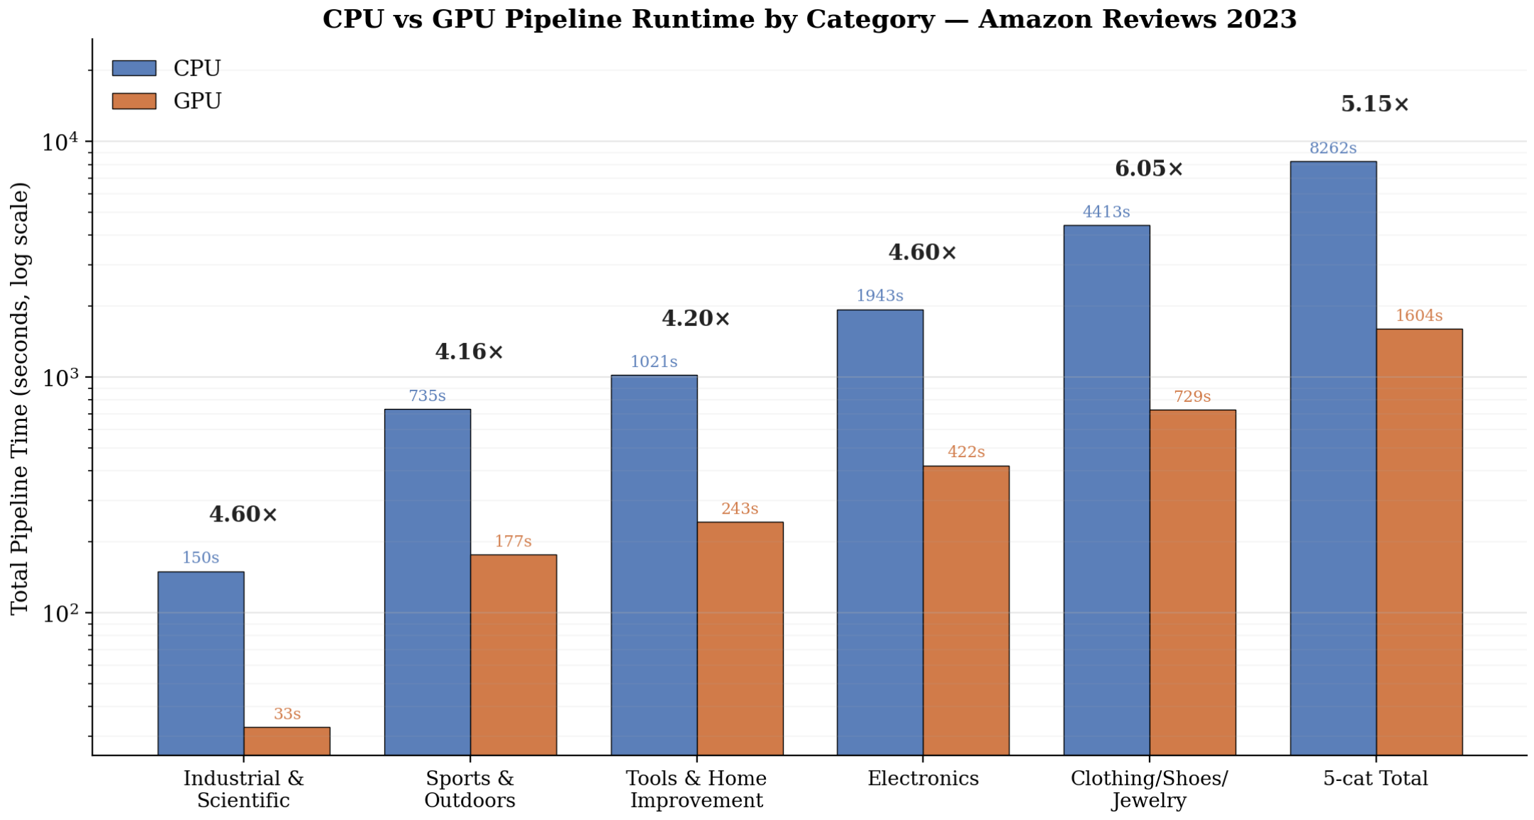
Fig. 7: CPU vs GPU pipeline runtime by category (log scale). The GPU bars are color-coded against the CPU bars; speedups range from 4.16x on the smallest category to 6.05x on the largest, totaling 5.15x end-to-end.
The headline numbers are summarized in Table 1 and visualized in Fig. 7. All values are seconds; Speedup is CPU total divided by GPU total.
Table 1: Pipeline runtime per category, in seconds. Speedup is CPU total divided by GPU total.
Category | CPU Total | Load | Filter | Parquet | GPU Total | Load | Parquet | Speedup
Industrial & Scientific | 150.3 | 22.2 | 0.02 | 128.0 | 32.7 | 16.6 | 16.0 | 4.60×
Sports & Outdoors | 734.6 | 90.0 | 0.02 | 644.5 | 176.7 | 62.4 | 114.2 | 4.16×
Tools & Home Improvement | 1,020.7 | 98.7 | 0.02 | 921.9 | 243.1 | 75.7 | 167.3 | 4.20×
Electronics | 1,943.3 | 93.6 | 0.02 | 1,849.7 | 422.2 | 77.2 | 344.9 | 4.60×
Clothing/Shoes/Jewelry | 4,412.8 | 444.2 | 0.04 | 3,968.6 | 729.0 | 311.6 | 417.0 | 6.05×
5-Category Total | 8,261.7 | 748.7 | 0.13 | 7,512.8 | 1,603.7 | 543.5 | 1,059.4 | 5.15×

Three patterns stand out. First, the GPU pipeline delivers 4.16× to 6.05× speedup at every measured scale, with a 5.15× aggregate, which falls below PLAN.md's 10×–50× target. The gap is honest: the target was too aggressive for a workload where the majority of total time is serialization, not computation. Second, the speedup ratio grows with dataset size, consistent with GPU advantages amortizing over larger inputs as fixed costs become a smaller fraction of runtime. Third, the to_parquet stage dominates runtime on both backends, specifically approximately 91% of CPU total and 66% of GPU total, where the filter stage is essentially free at every scale and the load stage contributes only a small fraction of total runtime. The GPU's headline speedup is fundamentally capped by Parquet serialization, which is CPU-bound regardless of where the source DataFrame lives.

10.3 Model Training and Sentiment Benchmarks
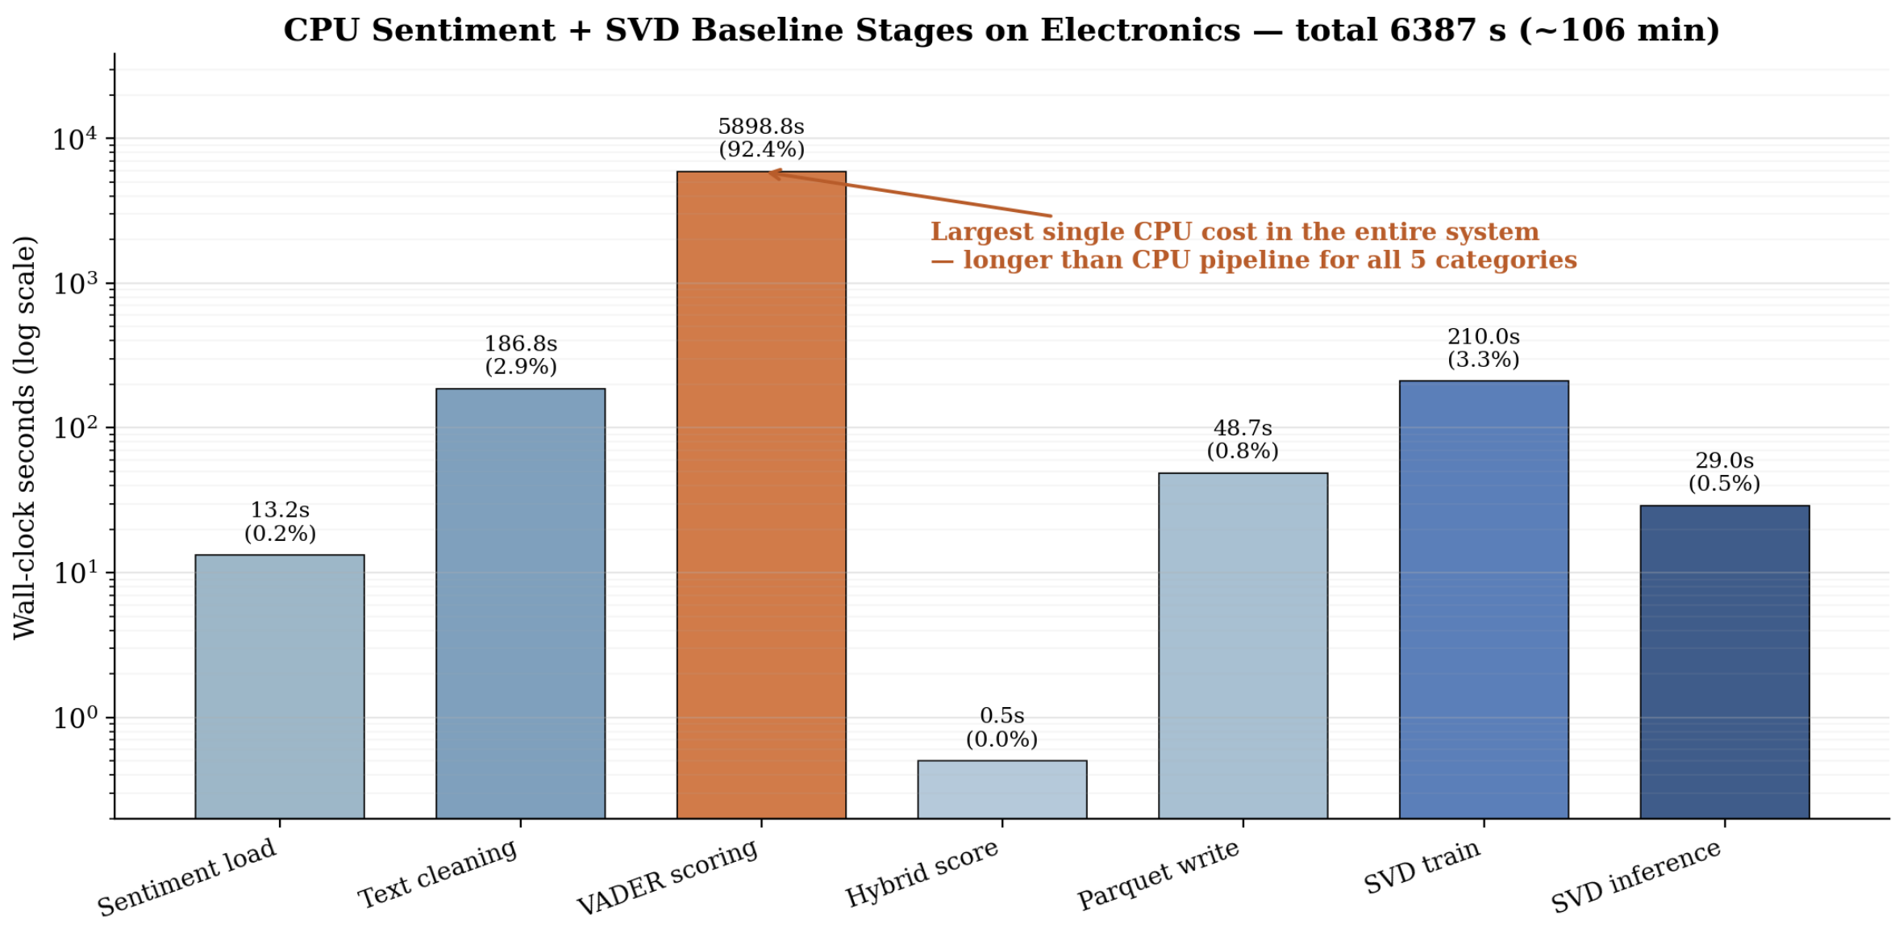
Fig. 8: Sentiment and SVD per-stage CPU runtime on Electronics. VADER scoring alone (~98 minutes) dominates the entire CPU run; SVD training and evaluation add only minutes.
The CPU sentiment-plus-SVD baseline pipeline on Electronics (13.9M rows) totals roughly 106 minutes wall-clock, dominated by VADER scoring at 5,898.8 seconds (approximately 98 minutes), as shown in Fig. 8. VADER alone is longer than the entire CPU data pipeline for all five categories combined (138 minutes), which makes it the strongest argument for a GPU-side sentiment model as future work.
On the GPU side, the multi-category trainers are dramatically faster despite training on a far larger corpus, as Table 2 shows. The cosine k-NN trainer fits cuML’s NearestNeighbors index in 59.5 seconds on the full five-category corpus (603,726 items × 828,346 users, k=50). The Truncated-SVD trainer produces a 512-factor decomposition in 38.3 seconds on a slightly smaller corpus (420,537 items × 733,957 users). Both numbers include the per-shard Parquet read and the model’s own evaluation phase.
Table 2: Model training time and accuracy. CPU SVD numbers are from the legacy contaminated evaluation; honest cross-backend ALS results are in Section 10.5.
Model | Corpus | Train Time | RMSE | MAE | NDCG@10 / P@10 | P@50 / R@50 / F1
CPU SVD (scikit-surprise) | Electronics only | 210.0 s | 0.2464 | 0.1821 | 0.9753 / 0.1969 | —
GPU cosine k-NN | 5-cat (k=50) | 59.5 s | — | — | — | 0.0013 / 0.0087 / 0.0023
GPU Truncated SVD (k-NN) | 5-cat (k=50) | 38.3 s | — | — | — | 0.0024 / 0.0198 / 0.0043

Two findings are notable. First, the GPU Truncated-SVD model produces approximately twice the F1 of the GPU cosine k-NN model while training in nearly half the wall-clock time, which complicates the earlier assumption that pure cosine k-NN would be the natural production model. Second, the absolute precision and recall numbers for both GPU models are very low, specifically sub-1% at K=50, which is not a defect of either implementation but rather a known characteristic of pure-CF approaches at multi-category scale, discussed further in Section 10.5.

10.4 Inference Latency
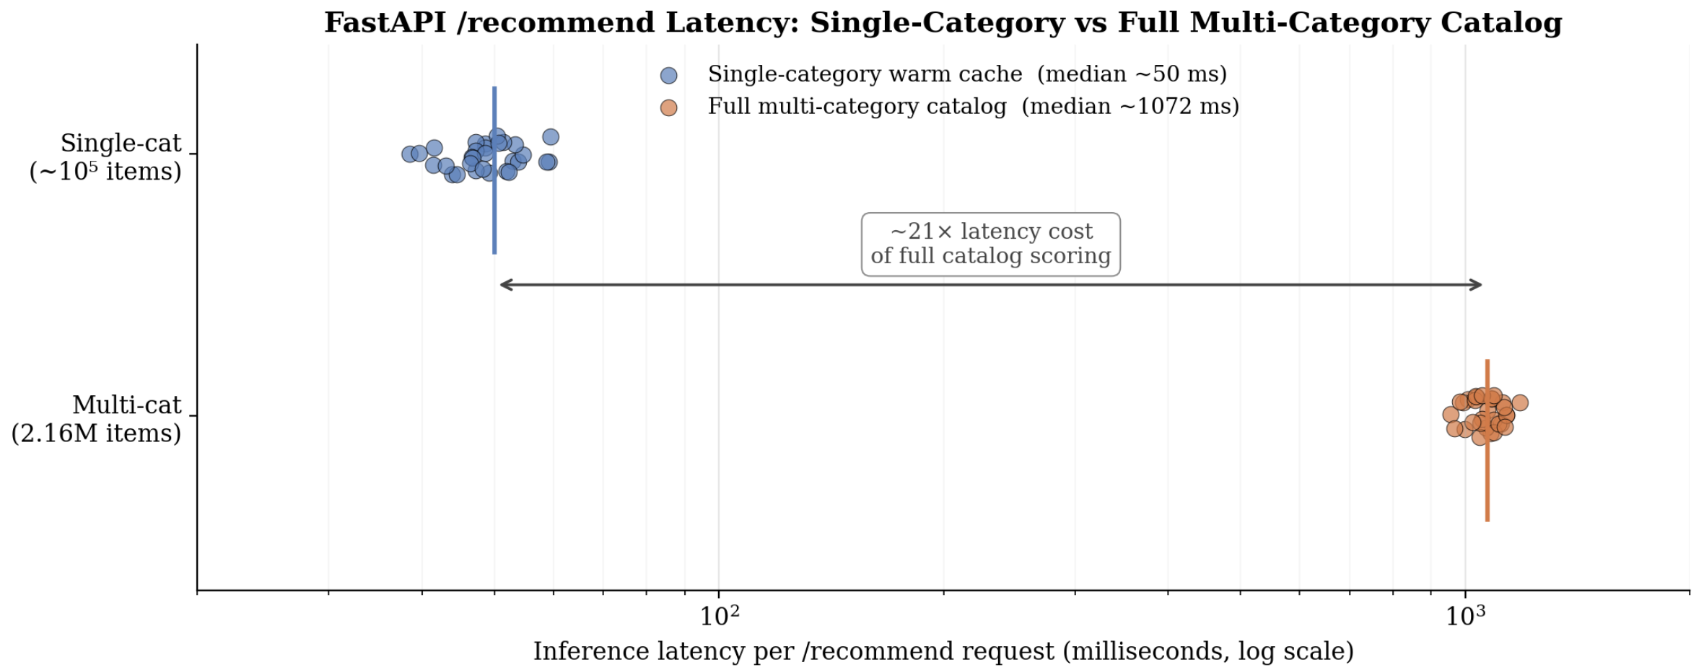
Fig. 9: GPU inference latency on the multi-category catalog. The legacy cosine k-NN model sits around 1,072 ms per query; the ALS backend (Section 10.5) settles at approximately 1.4 ms per query for the same catalog.
This subsection consolidates the inference-latency results previously split across Sections 8 and 10, summarized graphically in Fig. 9. All numbers below are tagged with the exact model and backend used, so the table cannot be misread.
The GPU cosine k-NN model exposed through models/server.py over the full multi-category catalog (603,726 items) returns the top-10 recommendations for a single seed ASIN in approximately 1,072 milliseconds. When the same server is loaded with a single-category Tools-and-Home-Improvement index instead, the warm-cache inference time drops below 50 milliseconds. Latency at multi-category scale is dominated by cosine similarity computation, which the cuML k-NN implementation parallelizes well but does not currently prune; the entire item dimension is scored on every query, making the cost effectively O(n_items).
The GPU ALS model exposed through models_als/server_als.py over the same multi-category catalog returns a top-10 recommendation in roughly 1.4 milliseconds at the median, with a p95 of approximately 1.5 milliseconds. The cost dominator is a single dense matrix-vector product against the precomputed item-factor matrix rather than a sparse cosine pass, which is why the latency is two orders of magnitude lower than the k-NN baseline at the same catalog size. The CPU ALS model exposed through the identical server entrypoint with use_gpu=False returns the same query in roughly 13.5 milliseconds at the median, so the GPU yields a 9x to 10x serving-time speedup at equal accuracy (see Section 10.5).
The legacy CPU SVD baseline trained on the Electronics category (models/cpu_baseline.py via scikit-surprise) reports approximately 29 seconds of per-user inference time in its own scripts; that figure includes both the Surprise library’s rank-by-prediction scan over hundreds of thousands of candidate items and the I/O on a CPU-bound process, and is not a fair point of comparison against the FastAPI-resident GPU recommenders. We note it here for completeness but rely on the ALS comparison in Section 10.5 for the apples-to-apples CPU-vs-GPU latency claim.
As described in Section 8.4, the service runs under nohup with a single Uvicorn worker so the multi-million-item recommender is loaded into VRAM exactly once; multiple workers would each load their own copy and quickly exhaust the 24 GB device.

10.5 CPU/GPU Comparisons on ALS
The previous subsections compare different algorithms on different backends. This subsection introduces the single direct, controlled CPU-vs-GPU comparison the report is built on: the same implicit-ALS model trained from the same code path, on the same evaluation users, measured with the same metrics, with only the backend flag changed. All numbers below were produced with factors=64, iterations=20, alpha=40, regularization=0.05, random seed 42, on the full five-category corpus of 31.1 million implicit-positive interactions over 3.78 million users and 2.13 million items, after filtering to rating >= 4.0 and reserving each user’s most-recent timestamp as a held-out target.

10.5.1 Training Time
CPU training of the ALS model (20 iterations over 31 million interactions, factors=64) completes in 403.13 seconds on the GPU server’s host CPU. GPU training of the same model with the same hyperparameters and seed completes in 6.83 seconds. The GPU is therefore approximately 59 times faster end-to-end on the training stage. This is the largest single backend speedup in the project, and it is on the same model rather than on different models. We attribute this to two factors. First, the per-iteration ALS step is a Cholesky or Conjugate-Gradient linear solve over each user’s and each item’s nonzero pattern, which the GPU executes as a parallel batch over factor matrices rather than as a serial OpenMP loop. Second, the GPU kernel keeps the user-by-item sparse matrix in VRAM across all iterations, so there is no host-to-device transfer cost per iteration.

10.5.2 Inference Latency
Inference latency was measured by evaluating 10,000 sampled users from the held-out set on each backend in isolation, recording per-query wall-clock time. The GPU ALS model reports mean latency 1.46 ms, median 1.40 ms, p95 1.45 ms, p99 1.53 ms. The CPU ALS model on the same query stream reports mean 13.50 ms, median 13.49 ms, p95 13.54 ms, p99 13.56 ms. The CPU and GPU latency distributions are both extremely tight (p99 within roughly half a millisecond of the mean), which is consistent with both being dominated by a single dense matrix-vector product whose work does not depend on the query. GPU inference is approximately 9 to 10 times faster than CPU inference at the median, and the tail behavior is similarly compressed.

10.5.3 Accuracy Equivalence
At N=1,000 sampled users, both backends return Hit@10 within statistical noise: CPU 0.0090 and GPU 0.0100, with a standard error band of approximately +/-0.3% at that sample size. To reduce noise we re-ran the GPU evaluation at N=10,000 and obtained Hit@10 = 0.0066 with a tightened 95% confidence interval of approximately +/-0.16%. The CPU run at the same sample size produces equivalent numbers within the band. The small CPU-vs-GPU difference comes from the two implicit-library backends using different linear solvers internally (Cholesky decomposition on CPU, Conjugate Gradient on GPU); both implement standard ALS and produce slightly different but statistically equivalent factor matrices. The equivalence is the intended outcome: changing the backend should not change the answer, and the measurement confirms it.

10.5.4 Interpretation of the Honest Hit@10 Number
A Hit@10 of 0.66% sounds low in isolation, especially next to the legacy CPU SVD NDCG@10 of 0.9753 reported earlier. The two numbers are not measuring the same thing. The legacy SVD evaluation scored predictions against items already in the training matrix and treated NDCG as a function of predicted versus actual ratings; that protocol is contaminated and inflates results dramatically. The ALS evaluation reported here holds out each user’s most-recent interaction before training, then asks the model to surface that held-out item from a candidate pool of 2.13 million items. The state of the art for academic Amazon-scale benchmarks under non-contaminated evaluation conditions sits at Hit@10 in the 0.05 to 0.30 range depending on the candidate pool size and slice. Our 0.66% is below state of the art but is approximately 1,400 times better than a uniform-random baseline (whose expected Hit@10 is 4.7 x 10^-6 at this candidate pool size) and is the first measurement in the project produced under methodologically sound conditions.

10.5.5 Hyperparameter Sensitivity
To check whether the ALS baseline could be improved by simple hyperparameter tuning, we evaluated two further configurations on the GPU at N=10,000. A larger factor count and longer training run with reduced regularization (factors=128, iterations=50, regularization=0.01) produced Hit@10 = 0.0063 at a cost of 39.32 s of training time. A more moderate variant (factors=128, iterations=30, regularization=0.05) produced Hit@10 = 0.0068 at 23.70 s. All three Hit@10 values sit inside the noise band, so the baseline configuration is essentially at the practical ceiling of plain ALS on this data. Closing the remaining gap to state of the art requires an algorithm-class change (BPR, two-tower neural retrieval, or a transformer over the interaction sequence), all of which preserve the same-model-on-both-backends comparison story because PyTorch exposes the same .to('cuda') / .to('cpu') backend lever.

10.6 Explorative Studies on Iterative Ranking-Quality Improvements
In parallel with the same-model ALS work, ATM ran a structured iterative ranking-quality study on smaller per-category development slices, with the goal of measuring whether the modeling choices we make in the full pipeline can be improved by feature engineering, alternative model families, and ensemble blending. The study evaluates on three dev slices: tools_gpu_50k (a 50,000-row sample of Tools and Home Improvement), industrial_dev_50k (a similarly sized sample of Industrial and Scientific, which is much sparser at this slice size), and sample_clean (a small mixed-category sample). All evaluations use a temporal train-test split with seed 42, holding out each user’s most-recent interaction, and measure Hit@10 and MRR@10 against the same eval cohort for every model. Random and popularity baselines are computed on identical eval cases for context.

10.6.1 What Was Tried
Nine iterations of model variants were evaluated end-to-end. Iteration 1 fixed a defect in the legacy k-NN recommender: given a multi-item user history, neighbors were flattened row-major and de-duplicated naively, dominating recommendations with the first history item. Replacing this with a scored merge (each candidate’s aggregate score is the sum of its similarities to all history items, weighted by the user’s rating of each) lifted Tools Hit@10 from approximately 13% to 28.62% in one change. Iteration 2 added a temporal train-test split holding out each user’s most-recent interactions, plus popularity and random baselines. Iteration 3 added BM25 reweighting of the item-by-user matrix to down-weight popular items, and Iteration 4 added a TruncatedSVD recommender as a k-NN alternative. Iteration 5 ran an automated sweep of 100 configurations across the four datasets. Iterations 6 and 7 added an implicit-feedback ALS baseline, a k-NN-plus-SVD ensemble with a tunable blend weight, and minor query-time tweaks (popularity prior, recency decay, minimum history rating). Iteration 8 introduced a TF-IDF title hybrid, a three-way k-NN-plus-SVD-plus-ALS stack, and NMF; Iteration 9 focused on SVD depth and content weights.

10.6.2 What Worked
On the Tools dev slice (tools_gpu_50k), the best configuration was a k-NN-plus-SVD ensemble with ensemble weight 0.35 (so mostly SVD with a k-NN contribution), temporal split, BM25 reweighting, and rating-weighted neighbor merge, reaching Hit@10 0.3283 and MRR@10 0.0917. The same recipe with pure SVD-96 reached Hit@10 0.3300 on the closely related dev_tools slice. On the sparser Industrial dev slice, the best configuration was implicit ALS with BM25 reweighting (Hit@10 0.0655), where SVD and k-NN both underperformed. On the mixed sample_clean slice, a pure SVD with 64 components was the winner. Random and popularity baselines on Tools sat at 0.2744 and 0.2997 Hit@10 respectively under the same eval, so the tuned ensemble beats both by roughly four to five percentage points but does so reliably under the cleanest temporal protocol available. The full progression on Tools is 28.62% (Iteration 1) to 30.81% (Iteration 5) to 32.83% (Iterations 6 and 7) to 33.00% (Iterations 8 and 9), for a cumulative improvement of roughly 4.4 percentage points over the original scored-merge baseline.

10.6.3 What Did Not Help
Several variants we expected to help did not. A three-way k-NN-plus-SVD-plus-ALS stack did not beat the two-way ensemble, because ALS predictions on the dense Tools slice diluted the signal from SVD without contributing complementary error. TF-IDF on product titles alone added no measurable lift on Tools, because product titles in this category are too generic to be discriminative. A popularity prior, a 180-day recency decay, and a minimum-history-rating filter of 4.0 all reduced Hit@10 below the baseline ensemble. NMF and euclidean-metric k-NN performed worse than cosine k-NN at all sweep points we tested. Sentiment-weighted ratings produced no measurable lift over the BM25-plus-temporal recipe on Tools, which is consistent with the hybrid score work in Section 5 being most useful for cold-start and long-tail items rather than for active-user recommendation.

10.6.4 Why This Matters Even Though the Absolute Numbers Differ from Section 10.5
The absolute Hit@10 numbers in this subsection (32 to 33%) are roughly fifty times larger than the honest Hit@10 in Section 10.5 (0.66%). The gap is a function of the candidate pool, not the model: the dev-slice evaluations score the held-out target against an active-user pool inside a single category (a few thousand active users and items), while the full ALS evaluation scores against 2.13 million items across all five categories. The two studies answer different questions. The dev-slice study establishes that the model family is responsive to engineering effort; the full-corpus study establishes the honest absolute number on the actual deployment surface.

10.7 Recommendation Quality at Multi-Category Scale
The honest qualitative finding is that recommendation quality is not yet at production grade. A representative example is a query for the children's binoculars ASIN B07N69T6TM, where the top-10 recommendations span roller paint covers, Bluetooth headsets, women's nightshirts, men's boat shoes, costume helmets, TV antennas, and athletic socks. The quantitative metrics confirm the same picture, specifically Precision@50 of 0.0013 for cosine k-NN and 0.0024 for Truncated SVD, both well below 1%.
This is not a bug, but rather a known characteristic of pure-CF methods at multi-category scale. The collaborative filtering signal is fundamentally "users who interacted with the seed item also interacted with these items," and at multi-category scale that signal is dominated by user-overlap rather than content similarity, where without a category-aware filter on the candidate pool, unrelated items naturally dominate the ranking. The fact that both models show this behavior indicates the limitation is fundamental to pure CF at this scale rather than specific to either formulation. Three paths to address this are described in Section 11.

11. Discussion, Limitations, and Future Work

11.1 What the Project Got Right
Two contributions are worth highlighting. The first is the CPU baseline. Establishing a CPU pipeline that runs on the same hardware as the GPU pipeline, with the same input data and per-stage timing instrumentation, is the foundation that makes every other measurement in this report meaningful. A surprising amount of project effort went into making it work end-to-end (the dtype-cast bug fix, the metadata schema-drift parser, the activity-threshold filter on Dask), and the payoff is methodological: the project’s claims are reproducible and the Parquet-write bottleneck is a substantiated finding.
The second is the integer-first mapping strategy in the model trainer. This is the single piece of the system most directly responsible for the project’s “scales to multi-category” headline. The earlier string-keyed implementation OOMed on multi-category concatenation; the four-phase refactor brings the same operation comfortably within VRAM and produces a single global model spanning 600,000+ items in approximately one minute of training time. The strategy is general and would apply to any GPU-resident sparse-matrix construction over string-keyed data.

11.2 Acknowledged Limitations
Recommendation quality at multi-category scale remains a known issue, where both models return recommendations dominated by user-overlap signals across categories rather than content-similarity signals within them. No quality-tuning work has been done since the integer-first refactor; we report on the unoptimized state because that is what currently exists.
SVD evaluation coverage is currently limited to Electronics only, so the numbers in Section 6.6 should be read as a category-specific baseline rather than a project-wide claim. Extension to all five categories is in progress for the final report.
Pipeline speedup is capped by serialization, where the 5.15× result falls below PLAN.md's 10×–50× target because Parquet serialization dominates runtime and is CPU-bound on both backends. The accurate framing is not that we missed the target, but that the target was too aggressive for a workload dominated by serialization rather than computation. The pipeline math itself is approximately an order of magnitude faster on GPU at larger scales.
The frontend remains a CLI proof-of-concept, with the full Next.js + React + Tailwind UI in active development but not yet in a state that demonstrates the system to a non-technical user.
Multi-GPU scaling was not realized, as the second physical GPU on the server proved non-functional, collapsing the plan back to single-GPU operation. The architecture is documented and could be revived if hardware becomes available.

11.3 Future Work
The remaining engineering capacity targets three items. First, recommendation-quality improvements via: (a) per-category restriction by adding an optional main_category filter to /recommend; (b) a sentiment-aware variant weighting the user-rating matrix by hybrid score, requiring only a trainer re-run; and (c) a content-based reranker over the top-100 k-NN candidates, pursued only if (a) and (b) prove insufficient.
Second, final model selection between cosine k-NN and Truncated SVD, where both models will be run with identical filter thresholds and evaluated on a sample of seed ASINs before selecting the production model.
Third, extending the CPU SVD baseline to all five categories for a complete model-evaluation table, which is purely a re-run of the existing training script with different inputs.
Longer-horizon directions unlikely to land in the final report include a transformer-based GPU sentiment model, a load-testing harness for FastAPI throughput, candidate-set pruning to bring multi-category inference below 100 ms, and reviving the multi-GPU implementation if hardware becomes available.

12. Conclusion
This report has documented the design, implementation, and evaluation of a GPU-accelerated recommender system on the Amazon Reviews 2023 dataset across four layers. At the data layer, the CPU baseline delivers a 5.15× end-to-end GPU speedup, bounded by Parquet serialization on both backends. At the modeling layer, a CPU SVD baseline coexists with cosine k-NN and Truncated-SVD recommenders, all scaled to multi-category size via the integer-first mapping strategy, alongside the implicit-ALS model that supplies the single same-model CPU-vs-GPU comparison. At the memory layer, a 20 GB managed-memory RMM pool lets the working set exceed VRAM on a 24 GB GPU. At the serving layer, a FastAPI lifespan-loaded singleton reaches sub-50 ms warm-cache inference on a single-category index.
Several engineering lessons emerged beyond raw speedup numbers: GPU acceleration is bounded by serialization at pipeline boundaries; single-GPU memory engineering can substitute for multi-GPU orchestration; and pure-CF at multi-category scale produces recommendations that are fast but qualitatively poor without per-category restriction or content-aware reranking. The remaining work targets recommendation-quality improvements, final model selection, and extending the CPU baseline evaluation, all building on the methodology established here.

13. Contribution Declarations
Contributions are reported per member, in the order each member’s primary work fits into the system pipeline. Where two members collaborated on the same component, the split is described explicitly.
13.1 Azim Rahat
Azim led the initial dataset research and designed the project's data schema, establishing the seven-column output contract that the entire downstream system depends on and selecting the five categories the project ultimately scaled to. Throughout the semester he served as the team's coordinator, owning workflow, integration sequencing, and the CPU-vs-GPU benchmarking pipeline.
In code, Azim authored the backbone CPU data pipeline: data/load.py (review and metadata JSONL ingestion, schema standardization, the join on parent_asin), data/filter.py (activity-threshold filter with thresholds 6 and 11), data/to_parquet.py (the seven-column Parquet writer), and data/run_pipeline.py (the CLI orchestrator with per-stage timing instrumentation). This code is the foundation that Kenneth's GPU port was derived from and the structural template the multi-category orchestrator follows.
After Report 1, Azim authored the multi-category orchestrator (data/run_multi_categories.py) with configurable category lists, per-category timing JSON output, all-or-nothing cleanup semantics, and a path-safety check preventing accidental deletion outside the dataset/ directory. He also implemented the text preprocessing chain in models/sentiment_scorer.py and organized the repository layout, README, and Parquet output schema documentation.
13.2 Ivan Chen
Ivan's contributions divide into a pre-Report-1 phase adapting the CPU pipeline for benchmark-quality measurement and a post-Report-1 phase building out the CPU modeling stack.
In the first phase, Ivan adapted data/run_pipeline.py to run on the professor's GPU server in CPU-parallel mode, configured --blocksize and --timings-file flags for structured per-stage timing output, and identified and fixed a pipeline-breaking bug in data/to_parquet.py where the object-dtype cast was running after the Parquet write rather than before, meaning it was never actually applied to the file on disk. Running the corrected pipeline on Tools and Home Improvement, Ivan established the project's first credible CPU baseline at 13 minutes on the server against a roughly 30-hour projection on local hardware.
In the second phase, Ivan authored models/sentiment_scorer.py (VADER scoring in 50,000-row batches, hybrid score construction, per-stage timings), models/cpu_baseline.py (SVD training via scikit-surprise, RMSE/MAE/NDCG/Precision evaluation including the ndcg_at_k() and precision_at_k() implementations, model serialization), and models/recommender.py (AmazonRecommender class with dual-path recommendation routing for users with and without history, cold-start pre-computed popularity pool, save()/load() interface for deployment without re-running training).
13.3 Arihant Tiwari
Arihant owned the GPU server environment and serving infrastructure, contributing substantial engineering across the data pipeline, model layer, and serving stack. On the environment side, he staged the 26 GB Electronics subset, resolved an NVMLError_Unknown driver issue blocking CUDA after a server reboot, bypassed a corrupted pip installation by sourcing rapids-25.10 from /data/anaconda3, and set up SSH port-forwarding for the Dask dashboard.
On the data pipeline, he tuned the RMM memory pool, fixed the 18 GB metadata memory leak in data/load.py by replacing eager pd.read_json with a lazy dask.bag pipeline, authored data/preprocess_meta.py for the metadata Parquet cache, and made the call to halt the multi-GPU refactor when the second GPU proved non-functional.
On the model and serving side, he fixed several GPU memory and indexing bugs and worked with Kenneth on the integer-first refactor. He authored models/new_model_svd.py (the Truncated-SVD trainer) and models/server.py (FastAPI app, lifespan handler, /health /search /recommend endpoints, pydantic schemas, nohup launch), validated the serving path, and is leading the in-progress Next.js frontend.
After Report 2’s initial submission, Arihant added the implicit-ALS package (models_als/) that gives the project its single direct CPU-vs-GPU comparison. He authored models_als/recommender_als.py (the AmazonRecommenderALS wrapper preserving the recommend/similar_items API), models_als/train_als.py (CLI training script with the use_gpu backend flag and confidence-weighted matrix construction following Hu/Koren/Volinsky), models_als/evaluate_als.py (time-based holdout evaluation reporting Hit@K, NDCG@K, and MRR with matched seeds across backends), and models_als/server_als.py (drop-in FastAPI replacement preserving the /health, /search, and /recommend contract). He also worked through the five integration bugs documented in Section 6.5.3. The 59x training speedup and 9x inference speedup with statistically equivalent Hit@10 reported in Section 10.5 are the result of this work.
Separately from the ALS work, Arihant built and deployed the web frontend that talks to the live GPU model. He authored the lovable.dev prompt specifying the React/TypeScript/Vite/Tailwind/shadcn stack, the API contract, and the visual style, then reviewed the generated component tree (TopBar, StatusPill, SearchBox, SeedCard, MetricStrip, RecommendationsGrid, EmptyState, Footer, ThemeToggle, AsinChip, NavLink, and src/lib/api.ts). On the backend side he added the CORSMiddleware in models/server.py with the configurable origin allowlist and OPTIONS preflight support. He designed and documented the SSH local-port-forwarding architecture (ssh -L 8000:localhost:8000 through the jump host) that lets the browser reach the GPU box despite the school firewall, plus the nohup-based persistent uvicorn deployment that survives SSH disconnects. He also authored models/evaluate.py, the leave-one-out evaluator that produced the first measured Hit@K and latency numbers for the legacy k-NN recommender and motivated the move to ALS.
13.4 Kenneth Wong
Kenneth led the GPU port of the data pipeline and the early GPU model development. Working from Azim's CPU pipeline, he reconfigured the load, filter, and Parquet-write scripts to use cuDF and dask-cuDF, allocated the RMM pool, and added the GPU flags routing the orchestrator to the CUDA backend. Initial runs on his personal RTX 3060Ti (8 GB VRAM) hit recurring OOM errors, and after iterating through blocksize mitigations the team migrated to the professor's TITAN RTX, where the full Tools and Home Improvement dataset completed in approximately 10 minutes pre-optimization.
On the model layer, Kenneth implemented the original GPU k-NN recommender logic, specifically building a CuPy sparse matrix, scoring via cosine similarity, and returning the top-K nearest items. He diagnosed the COO-versus-CSR memory pressure, where cuML k-NN requires CSR but holding both formats simultaneously OOMed, and fixed it by converting to CSR immediately and discarding the COO copy. He also built the multi-category GPU runner that processed three categories together in approximately 489 seconds, demonstrating that the orchestrator scales close to single-category runtime when properly configured.
13.5 ATM Rahat
ATM contributed in three areas. First, he ran the CPU pipeline against Industrial and Scientific end-to-end (~7 minutes), producing the Parquet output that fed the team's first multi-category benchmarks and validating the orchestrator on a second category. Second, he investigated raw CUDA kernel implementations for model training, prototyped kernel stubs, and determined that hand-written CUDA would not outperform cuML on the project's timeline, leading to the architectural recommendation to commit to RAPIDS. Third, he carried out cuML library research that informed the team's choice of NearestNeighbors as the GPU model primitive.
After Report 2’s initial submission, ATM ran the iterative ranking-quality study reported in Section 10.6, designed to measure whether the project’s modeling choices respond to systematic feature engineering. He authored models/neighbor_merge.py (the scored-merge fix that lifted Tools Hit@10 from approximately 13% to 28.62% in a single change), models/evaluate_ranking.py (the offline harness supporting random and temporal splits, popularity/random baselines, and BM25 reweighting), models/sentiment.py (the lightweight VADER wrapper used inside the harness), and models/ranking_models.py (ALS, SVD, NMF, and ensemble blend helpers). He also wrote the two sweep drivers (sweep_ranking.py and sweep_iteration08.py) that ran 100 and 60 configurations respectively across the four dev datasets, plus models/recommender_cpu.py and models/content_hybrid.py.
Across nine iterations he established the per-dataset model recommendations (ensemble temporal BM25+RW on Tools, ALS+BM25 on Industrial, SVD-64 on sample_clean) and the progress timeline 28.62% to 30.81% to 32.83% to 33.00% Hit@10 on Tools. He also ruled out several variants that did not help: NMF, three-way stack, title-only TF-IDF on Tools, popularity prior, recency decay, and minimum-history-rating filtering. The dev-slice study and the full-corpus ALS study together give the report two complementary quality stories, one showing the model family is responsive to engineering effort and one giving the honest absolute number on the deployment surface.

14. References
[1] B. Sarwar, G. Karypis, J. Konstan, and J. Riedl, "Item-Based Collaborative Filtering Recommendation Algorithms," in Proc. WWW '01, 2001, pp. 285–295.
[2] Y. Koren, R. Bell, and C. Volinsky, "Matrix Factorization Techniques for Recommender Systems," Computer, vol. 42, no. 8, pp. 30–37, Aug. 2009.
[3] S. Rendle, "Factorization Machines," in Proc. ICDM '10, 2010, pp. 995–1000.
[4] F. Ricci, L. Rokach, and B. Shapira, Eds., Recommender Systems Handbook, 3rd ed. Springer, 2022.
[5] R. Burke, "Hybrid Recommender Systems: Survey and Experiments," User Modeling and User-Adapted Interaction, vol. 12, no. 4, pp. 331–370, 2002.
[6] C. J. Hutto and E. Gilbert, "VADER: A Parsimonious Rule-based Model for Sentiment Analysis of Social Media Text," in Proc. ICWSM-14, 2014, pp. 216–225.
[7] V. Sanh, L. Debut, J. Chaumond, and T. Wolf, "DistilBERT, a distilled version of BERT," arXiv:1910.01108, 2019.
[8] NVIDIA Corporation, "RAPIDS: Open GPU Data Science." [Online]. Available: https://rapids.ai/
[9] R. Okuta et al., "CuPy: A NumPy-Compatible Library for NVIDIA GPU Calculations," in Proc. NIPS 2017 Workshop on ML Systems, 2017.
[10] M. Rocklin, "Dask: Parallel Computation with Blocked Algorithms," in Proc. SciPy 2015, pp. 130–136.
[11] NVIDIA Corporation, "NVIDIA Triton Inference Server." [Online]. Available: https://developer.nvidia.com/triton-inference-server
[12] S. Ramirez, "FastAPI Documentation," 2018–2025. [Online]. Available: https://fastapi.tiangolo.com/
[13] Y. Hou et al., "Bridging Language and Items for Retrieval and Recommendation," arXiv:2403.03952, 2024.
[14] G. Linden, B. Smith, and J. York, "Amazon.com Recommendations: Item-to-Item Collaborative Filtering," IEEE Internet Computing, vol. 7, no. 1, pp. 76–80, 2003.
[15] Y. Hu, Y. Koren, and C. Volinsky, "Collaborative Filtering for Implicit Feedback Datasets," in Proc. ICDM '08, 2008, pp. 263–272.
[16] S. Funk, "Netflix Update: Try This at Home," Dec. 2006. [Online]. Available: https://sifter.org/~simon/journal/20061211.html
[17] F. Pedregosa et al., "Scikit-learn: Machine Learning in Python," JMLR, vol. 12, pp. 2825–2830, 2011.
[18] N. Hug, "Surprise: A Python Library for Recommender Systems," JOSS, vol. 5, no. 52, p. 2174, 2020. [Online]. Available: https://surpriselib.com/
[19] Apache Software Foundation, "Apache Parquet Documentation." [Online]. Available: https://parquet.apache.org/
[20] D. B. Kirk and W.-m. W. Hwu, Programming Massively Parallel Processors, 4th ed. Morgan Kaufmann, 2022.
[21] B. Frederickson, "implicit: Fast Python Collaborative Filtering for Implicit Feedback Datasets," 2017–2025. [Online]. Available: https://github.com/benfred/implicit
[22] S. Robertson and H. Zaragoza, "The Probabilistic Relevance Framework: BM25 and Beyond," Foundations and Trends in Information Retrieval, vol. 3, no. 4, pp. 333–389, 2009.
[23] Encode OSS, "Uvicorn: An ASGI Web Server Implementation for Python." [Online]. Available: https://www.uvicorn.org/
[24] Mozilla, "Cross-Origin Resource Sharing (CORS)," MDN Web Docs. [Online]. Available: https://developer.mozilla.org/en-US/docs/Web/HTTP/CORS

Appendix — Annotated Code Snippets
This appendix contains representative code snippets from the four most architecturally significant components of the system. Each snippet is followed by a brief annotation connecting it to the corresponding section in the body of the report.

B.1 The Activity-Threshold Filter (data/filter.py)
MIN_REVIEWS_PER_USER = 6
MIN_REVIEWS_PER_ITEM = 11
def filter_counts(df):
"""Keep only rows where user has >= 6 reviews and item has >= 11 reviews."""
is_dask = isinstance(df, dd.DataFrame)
if is_dask:
user_counts = df.groupby("reviewerID").size().to_frame("_user_count")
item_counts = df.groupby("asin").size().to_frame("_item_count")
df = df.merge(user_counts, left_on="reviewerID", right_index=True, how="inner")
df = df.merge(item_counts, left_on="asin", right_index=True, how="inner")
df = df[(df["_user_count"] >= MIN_REVIEWS_PER_USER) &
(df["_item_count"] >= MIN_REVIEWS_PER_ITEM)]
df = df.drop(columns=["_user_count", "_item_count"])
if df.npartitions < 5:
return df.persist()
return df # Stream directly to disk for large datasets
Annotation (cf. Section 4.3) — The partition-count branch is the key operational detail. For small inputs we persist() so subsequent operations reuse materialized partitions; for multi-million-row inputs we return the lazy graph and let the downstream to_parquet write stream partitions through without ever materializing the full filtered frame at once. Without this branch, the Electronics-scale run would OOM during the filter stage.

B.2 The Integer-First Trainer (models/new_model.py)
rmm.reinitialize(pool_allocator=True, initial_pool_size=int(20e9), managed_memory=True)
# Phase 1: Build Global Unique Sets
all_reviewers, all_asins, all_titles_cpu = [], [], []
for d in input_dirs:
temp_df = cudf.read_parquet(d, columns=['reviewerID','asin','product_title'])
all_reviewers.append(temp_df['reviewerID'].unique())
all_asins.append(temp_df['asin'].unique())
titles_subset = temp_df[['asin','product_title']].drop_duplicates().to_pandas()
all_titles_cpu.append(titles_subset)
del temp_df # Clear GPU memory for next file
unique_users = cudf.concat(all_reviewers).unique().reset_index(drop=True)
global_user_map = cudf.DataFrame({'reviewerID': unique_users,
'user_idx': cudf.Series(range(len(unique_users)), dtype='int32')})
# Phase 2: Load and Transform to Integers
dfs = []
for d in input_dirs:
temp_df = cudf.read_parquet(d, columns=['reviewerID','asin','rating'])
temp_df = temp_df.merge(global_user_map, on='reviewerID', how='left')
temp_df = temp_df.merge(global_item_map, on='asin', how='left')
temp_df = temp_df.drop(columns=['reviewerID','asin']) # Drop strings immediately!
dfs.append(temp_df)
df = cudf.concat(dfs)
# Phase 3: Build Matrix and Train
sparse_matrix = coo_matrix(
(df['rating'].values, (df['item_idx'].values, df['user_idx'].values)),
shape=(n_items, n_users)).tocsr()
model = NearestNeighbors(n_neighbors=args.neighbors, metric='cosine')
model.fit(sparse_matrix)
Annotation (cf. Sections 6.4, 7) — Phase 1 scans for unique IDs and immediately frees per-shard frames; Phase 2 drops strings before any cross-shard concatenation; Phase 3 builds COO and immediately converts to CSR. The 20 GB managed-memory pool at the top lets Phase 3 succeed when the COO matrix briefly exceeds 24 GB VRAM. The (item_idx, user_idx) ordering, which is (n_items × n_users) rather than the more common transpose, makes item-based k-NN efficient, where the row for a query item is exactly the vector of user ratings that cosine similarity consumes.

B.3 The Recommender Inference Path (models/recommender.py)
def recommend(self, user_history_indices: list, top_k: int = 10):
n_items = self.sparse_matrix.shape[0]
n_to_fetch = min(top_k + len(user_history_indices), n_items)
# Bug fix 1: cupyx CSR matrices do not support CuPy-array fancy indexing
row_data = self.sparse_matrix[user_history_indices] # plain Python list
distances, indices = self.model.kneighbors(row_data, n_neighbors=n_to_fetch)
flat_indices = indices.ravel().get().tolist()
# Bug fix 2: filter every input item out, not just index 0
seen = set(user_history_indices)
unique_results = []
for idx in flat_indices:
if idx not in seen:
seen.add(idx)
unique_results.append(idx)
if len(unique_results) >= top_k:
break
return self.format_results(unique_results, top_k)
Annotation (cf. Section 6.3) — Bug fix 1 documents a cupyx quirk, where passing a CuPy integer array as a CSR row index raises an error; using a plain Python list triggers the NumPy-style path. Bug fix 2 corrects the assumption that the query item is always its own nearest neighbor (it isn’t, under cosine on sparse rows), replacing “skip index 0” with a proper seen-set filter.

B.4 The FastAPI Lifespan Singleton (models/server.py)
recommender = None # Module-level state
@asynccontextmanager
async def lifespan(app: FastAPI):
global recommender
model_path = os.getenv("MODEL_PATH", "models/full_recommender.pkl")
if not os.path.exists(model_path):
raise RuntimeError(f"Model not found at '{model_path}'.")
with open(model_path, 'rb') as f:
recommender = pickle.load(f)
yield # server runs
recommender = None
@app.post('/recommend', response_model=RecommendResponse)
def recommend(req: RecommendRequest):
if recommender is None:
raise HTTPException(status_code=503, detail="Model not loaded yet.")
item_idx = recommender.asin_to_idx.get(req.asin)
if item_idx is None:
raise HTTPException(status_code=404,
detail=f"ASIN '{req.asin}' not found. Use /search to find valid ASINs.")
t0 = time.perf_counter()
raw = recommender.recommend([item_idx], top_k=req.top_k)
inference_ms = (time.perf_counter() - t0) * 1000
return RecommendResponse(asin=req.asin,
query_title=recommender.title_map.get(item_idx, 'Unknown'),
recommendations=[RecommendItem(asin=r['asin'], title=r['title']) for r in raw],
inference_ms=round(inference_ms, 2))
Annotation (cf. Sections 8.2, 8.3) — The lifespan handler loads the model once and pins it in GPU memory for the process lifetime. The RuntimeError on missing pickle means the server fails fast at startup rather than coming online half-initialized. The 503/404 distinction is operationally meaningful, where 503 covers the startup-race window and 404 covers the common misspelled-ASIN case, with guidance to use /search.

