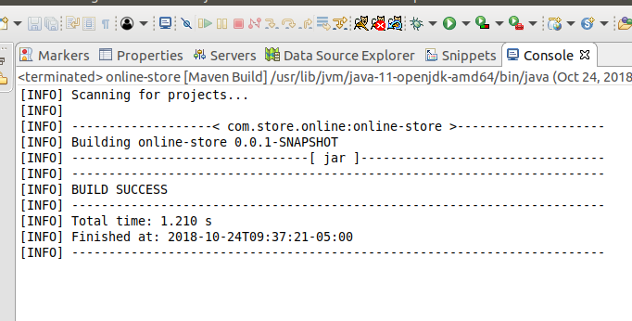Maven build successful.

I am using remote Oracle SQL database. I have populated database with about 200 users and 600 product items. I have created users objects with random library of python. Products are populated by scrapping bestbuy website.

I also added dependency to pom file for Java persistance, however, I am still having difficulty implementing it. It spent most of the time for this part. I also updated application.property file for JDBC configuration.