ID #:2301230
Name: Aziki Woolcock
Assignment 2
Day/Time of class: Monday 5pm-6pm
Module name/module code: Web Programming CIT2011
Storyboard
A Storyboard: usually contains:
- Draw two [2] separate layout designs, one for mobile [min 600px] and one for desktop [min 950px]. This can be hand-drawn or done using an app or tool, eg Figma, SketchUp, etc. Include the <div> groups in the layout ui/ux design. Webpages must match layout.
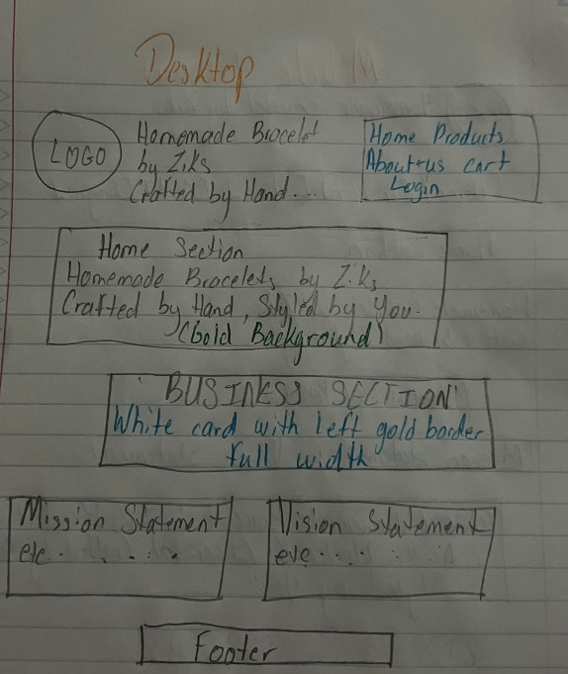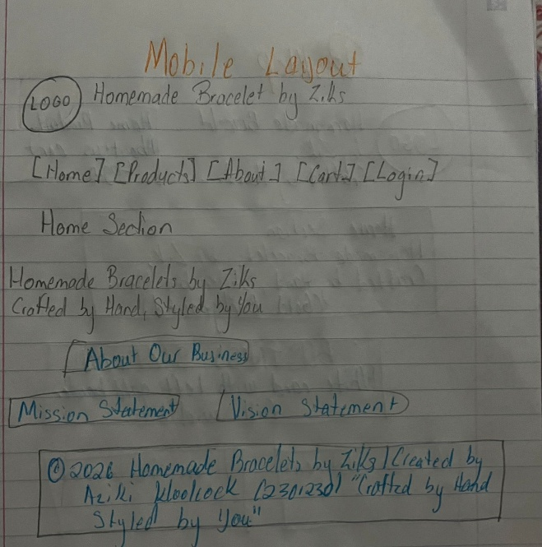
- Include an image of the intended colour palette [including the RGB], icons and their dimensions, font-family, root font-weight, etc.
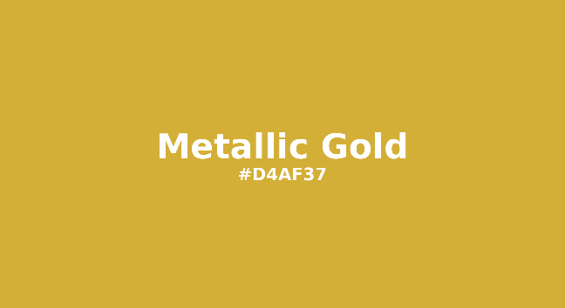

- List of each user-defined function, description of their purpose, and creator.
getCart() | Provides the current cart data as a JavaScript array after retrieving it from the browser's localStorage. It returns an empty array if there isn't a cart.
saveCart(cart) | Automatically calls updateCartCount() to update the cart item count shown on the site and saves the modified cart array back into localStorage.
updateCartCount() | Updates the cart count number displayed on the navigation bar after calculating the total number of goods in the cart by adding up all item amounts.
renderCart() | Creates and automatically displays the entire cart page using HTML, displaying an order summary with the total cost as well as a table of all cart items with their prices, quantities, and subtotals.
clearCart() | After asking the user to approve, it clears the localStorage entry and refreshes the cart display to remove every item from the cart.
updateQuantity(id,newQty) | Modifies the amount of a particular cart item. The item is completely removed if the new quantity is less than 1. If not, the cart display is refreshed and the updated quantity is saved.

A link to your GitHub repository with the IA#2 source code, resources, such as images, and files such as “storybard-id#.pdf”.
  - Free hosting link, eg www.netlify.com
AzikiW/IA2-Web-Programming-CIT2011

A description of your business, logo, slogan, mission statement, vision, statement, etc

- Description of my business
Homemade Bracelets by Ziks is a creative jewellery company that specializes in handmade, fashionable, and customized bracelets. Each piece is expertly crafted with vibrant beads, charms, and distinctive designs to showcase uniqueness, originality, and self-expression. The brand specializes in stylish, reasonably priced accessories that are ideal for gift-giving or daily use.

- Logo
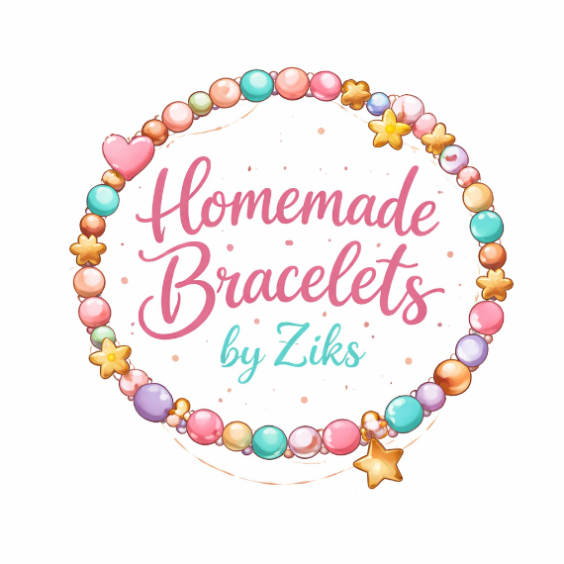

- Slogan: “Crafted by Hand, Styled by You.”

- Mission statement
To produce beautiful, handcrafted bracelets that encourage originality, self-expression, and confidence while offering unique designs that customers adore and relate to.

- Vision statement
To establish a reputable and well-known brand for handcrafted accessories that is renowned for its originality, excellence, and ability to enable individuals to use jewellery to express their individual style.

Description of the intended audience for your website.
Homemade bracelet by ziks caters to a wide range of people between the ages of 16 and 35, including young professionals who appreciate significant, fashionable accessories, present college students, and high school kids getting ready for college. This demographic is tech-savvy, prefers to purchase on mobile devices, and looks for reasonably priced luxury goods that represent different milestones.

- Use APA formatting to reference all content used including pictures taken from online sources, ie. provide links to the resource.
HTML Forms
CSS Media Queries
CSS Responsive Web Design
CSS Box Shadow Generator - W3Schools
What is a Loop?
What is an Array?
HTML DOM Element Object

- Include a brief justification of the colour palette you chose for your website, ie the psychology of colour in web design and marketing.
White is perfect to represent a clean, polished, and reliable style that goes well with any accent colour since it symbolizes purity, clarity, simplicity and new beginnings. Gold is useful for expressing premium value, celebration, and academic excellence since it represents success, prestige, luxury, achievement, and high quality. It reflects growth and aspiration. Gold's "achievement" symbolism combined with white's "new beginnings" energy depicts that the business is both creating something significant and already producing greatness.

