**Laboratory work #8**

**Discrete Fourier Transform**

**Task 1:**

Assume that you have a signal, which composed of three sinusoids, with frequencies 50Hz, 100Hz and 120Hz.

$$x\left(t\right)=\sin\left(2π∙50t\right)+0.7\sin\left(2π100t\right)+0.5sin⁡(2π120t)$$

Calculate the spectrums of given signal and the same signal, which was corrupted with noisy signal. The number of simulated samples is chosen to be a multiple of fs, which in this case means that the DFT‘s analysis frequencies exactly match to the frequencies present in the signal. Show signals in time and frequency domains. Show spectrums in terms of analog frequencies (Hz). Analyze obtain results.

For calculating of DFT use **fft** build-in function. **abs** function calculate Magnitude of complex signal, **angle** function calculate phase of signal.

**Task 2:**

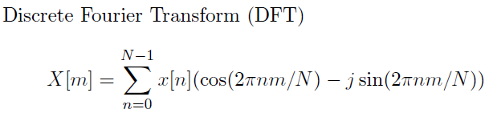Using the same $x(t)$ signal calculate amplitudes of cosine and sine waves (Discrete Fourier Transform of signal). Represent Magnitude and Phase of signal using **plot** function. Do not use build-in functions. Program formula that is shown below:

