O V E R V I E W
of the Datavue system — a platform for automatic generation of BI dashboards powered by artificial intelligence

Project Purpose
Data-driven management decisions require building analytical dashboards: summary charts, counters and tables that reflect the state of sales, inventory, customers and other company processes. This is usually handled by a dedicated specialist — an analyst or developer — who manually writes database queries, chooses a visualization and updates reports as the task changes. For small and medium-sized companies, keeping such a specialist on staff or waiting in line for the IT department is often not worthwhile.
The Datavue system solves this by removing the middleman between question and answer: the user connects a data source (a database or a file) and describes in a chat, in plain language, what dashboard they need — "show revenue by month and the top 10 customers." The system figures out the source’s structure itself, designs a set of widgets and generates code that calculates the required metrics — the result is ready in minutes, without a developer involved.
In Datavue, artificial intelligence is not responsible for a single step but for the entire path of building a dashboard: it groups the source’s tables by meaning, determines which of them are needed for a specific request, designs the set and type of widgets, writes Python code to calculate the metrics, and runs it. If the generated code fails or calculates the wrong thing, the system detects this itself and rewrites the code — without involving the user.
Further edits — "add a chart by country," "translate the labels into English," "remove the second widget" — are handled by the same AI agent in dialogue mode: the user doesn’t need to rebuild the dashboard from scratch, just continue the conversation.

Datavue System Functionality
The system consists of a public part (landing page, registration and login) and the company’s workspace, where data sources are connected, work with the AI agent happens, and dashboards are built. The functionality below is described in the order the user encounters it.
Landing page and sign-in. The first thing a new user sees is the platform’s public landing page describing its capabilities and offering a free trial. It also hosts the company registration and login forms.
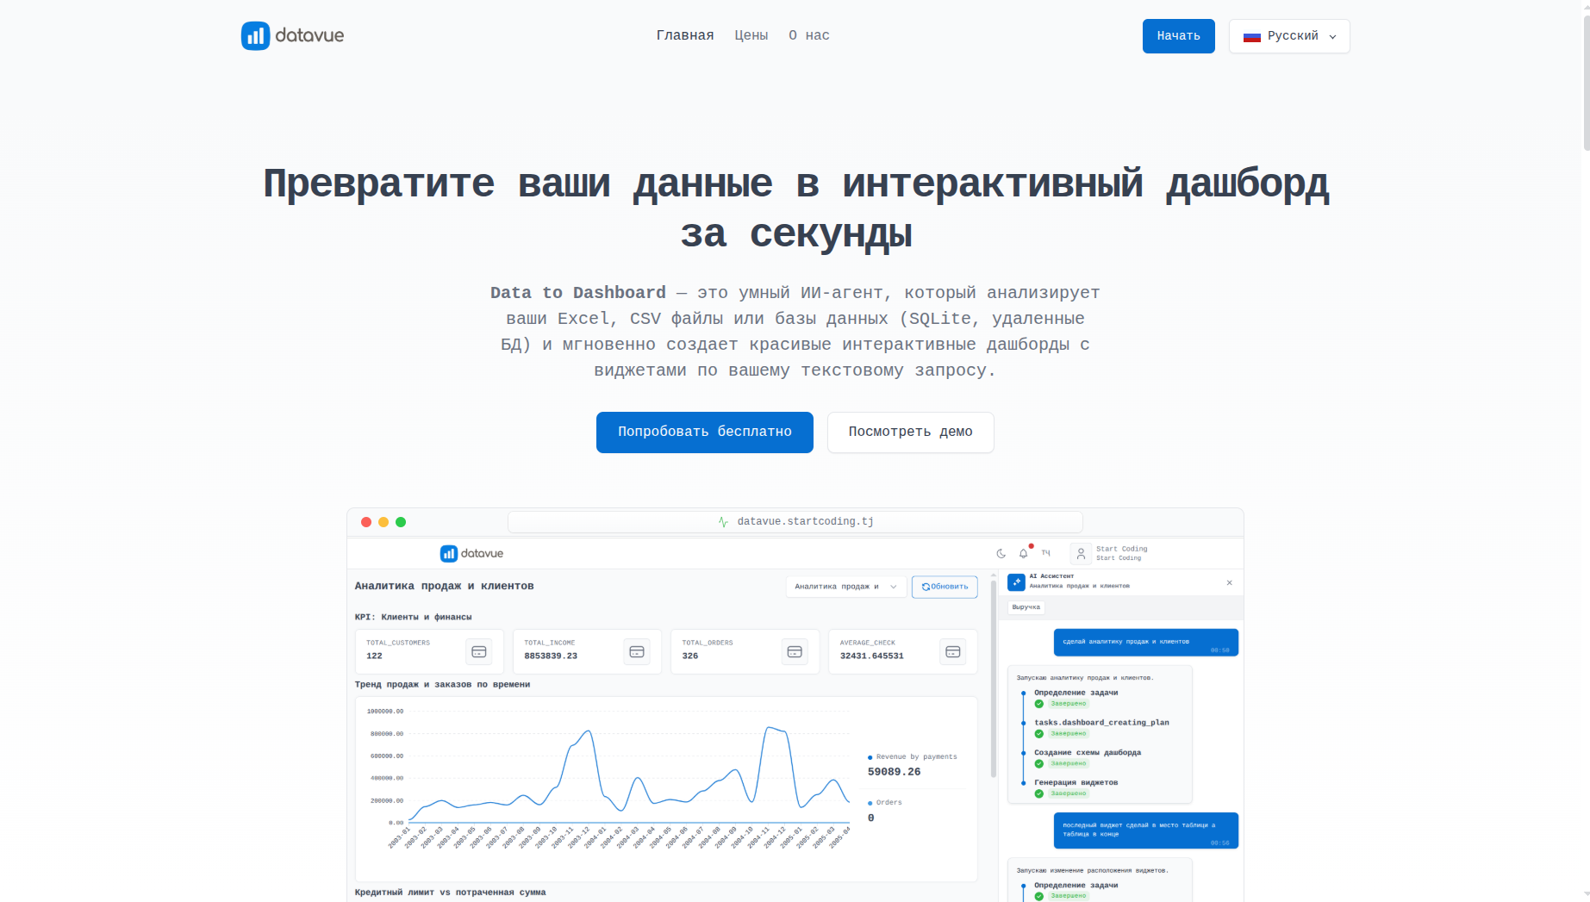
Figure 1. Datavue platform landing page
Connecting a data source. Work starts with connecting a data source — a three-step wizard available via the “Connect source” button. In the first step the user selects the source type: MySQL, PostgreSQL, SQLite, DuckDB, a CSV/Excel file, or a Google Sheet; the list of providers comes from the server, so a new source type appears in the wizard without any frontend changes.
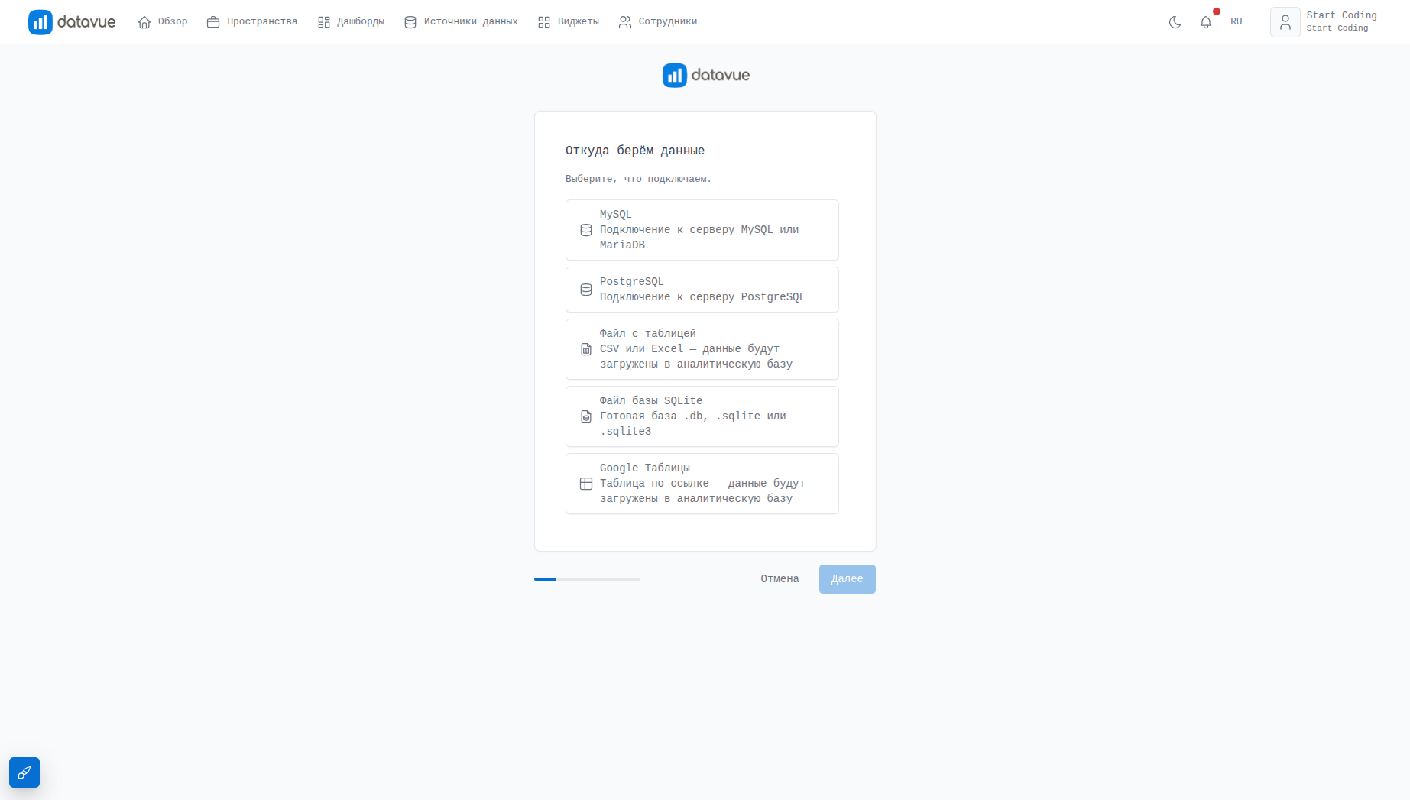
Figure 2. Data source connection wizard — provider selection
In the second step, depending on the source type, the user either enters the database connection parameters (host, port, database name, username, password) or uploads a file. The system immediately checks the connection and does not allow proceeding further if the data is unavailable.
After a successful connection, a background grouping task starts: the system analyzes all the source’s tables and combines them into meaningful groups (for example, "Sales," "Customers," "Inventory"), so that the AI agent later relies not on a scattered list of tables but on a clear data structure. The grouping progress is shown to the user in real time via web sockets.
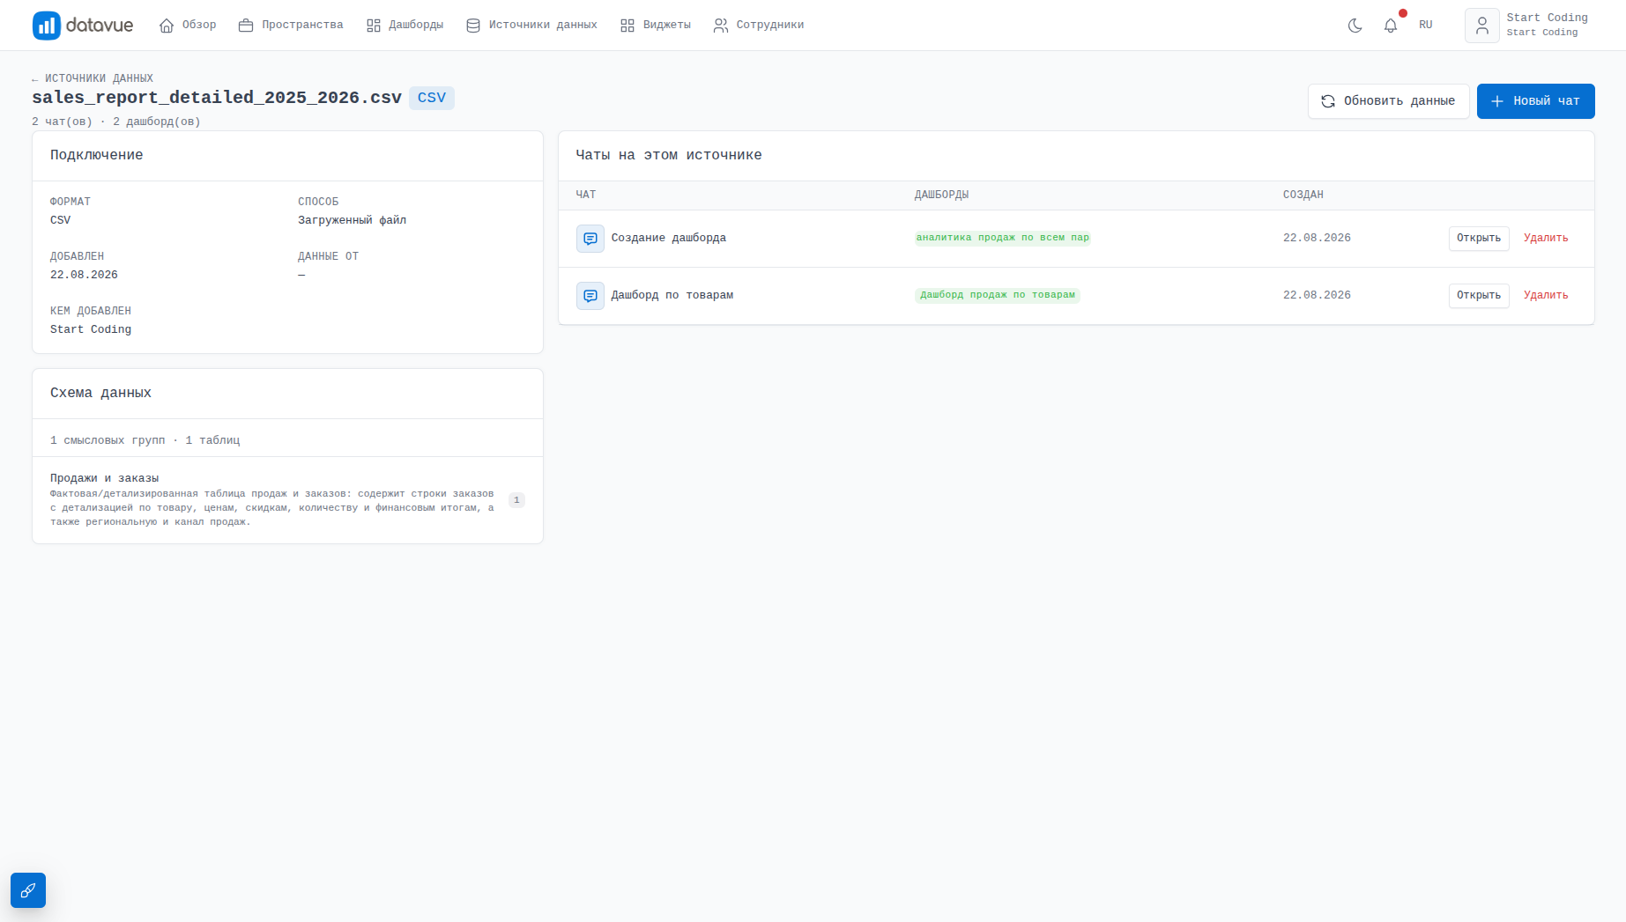
Figure 3. Progress of automatic grouping of data source tables
Workspaces. A data source by itself is not a place to work: the user formalizes a specific task — "Sales," "Inventory" — as a workspace. A workspace has a name, one data source, as many dashboards as needed, and one conversation with the AI agent. Several workspaces can reference the same source if different tasks are being solved on its data.
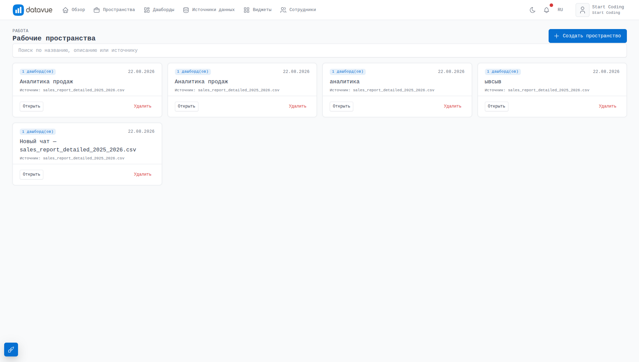
Figure 4. List of the company’s workspaces
Chat with the AI agent. Inside the workspace, the user sees a dashboard switcher, a button to toggle the "View ↔ Builder" mode, and a side chat panel with the AI agent — all on one page, with no navigation between sections.
In the chat, the user describes in natural language what dashboard they need or what to fix in an existing one: "show revenue by month and the top 10 customers," "add a chart by country," "translate the titles into English." The agent itself determines the type of task — building a dashboard from scratch or refining an existing one — and shows the status along the way: setting the task, generating the schema, calculating widgets, checking the result, done.
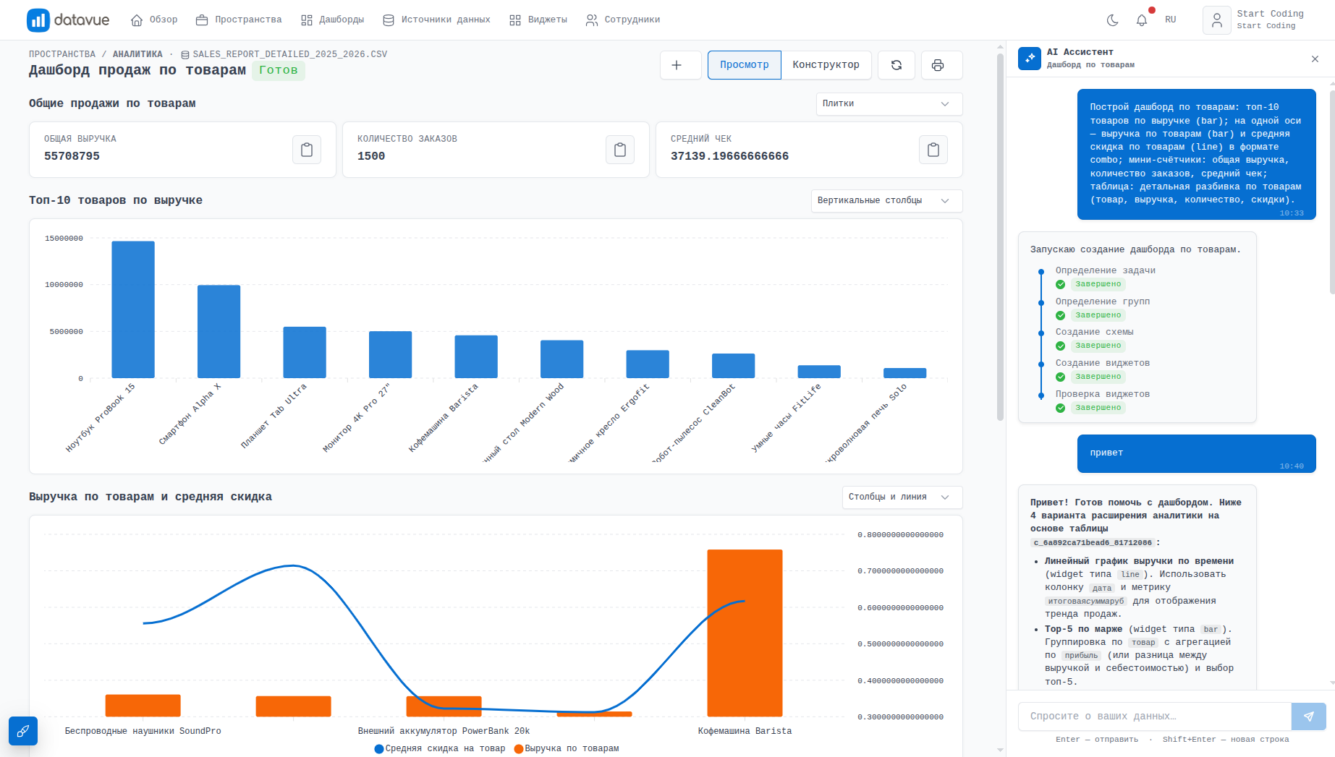
Figure 5. Dialogue with the AI agent and dashboard generation status in the side chat panel
Viewing the dashboard. The result of the agent’s work is a dashboard made of widgets: counters, line and bar charts, pie and radial charts, heatmaps, funnels, geographic maps and tables. Each widget calculates its metric using code that the AI agent generated and verified — if the calculation fails, the system rewrites the code itself, without waiting for the user to complain.
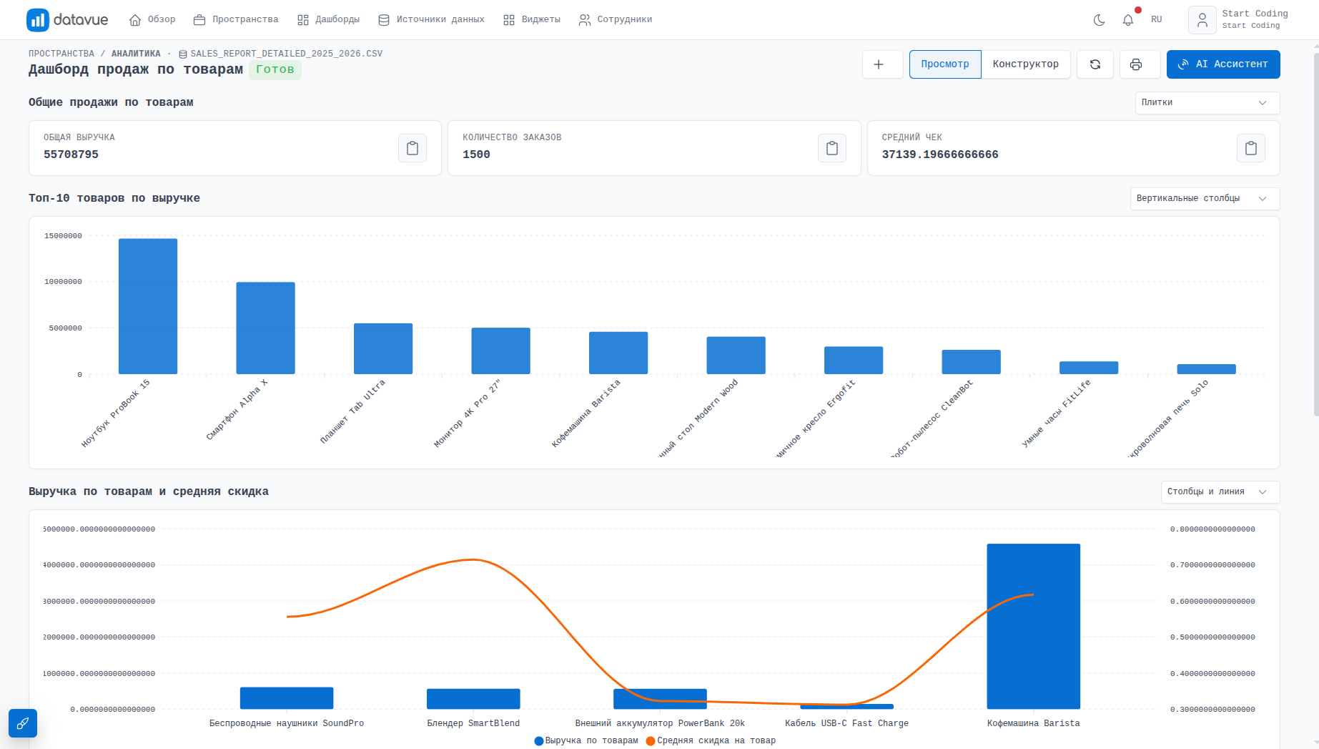
Figure 6. A finished dashboard with a set of widgets
Dashboard builder. A dashboard doesn’t have to be assembled only through chat — the builder mode lets you add widgets manually from a palette of ready-made types, drag them to change the order, configure each widget’s title and data source in a separate panel, and, with the "write widget code" permission, open and edit the generated Python code directly.
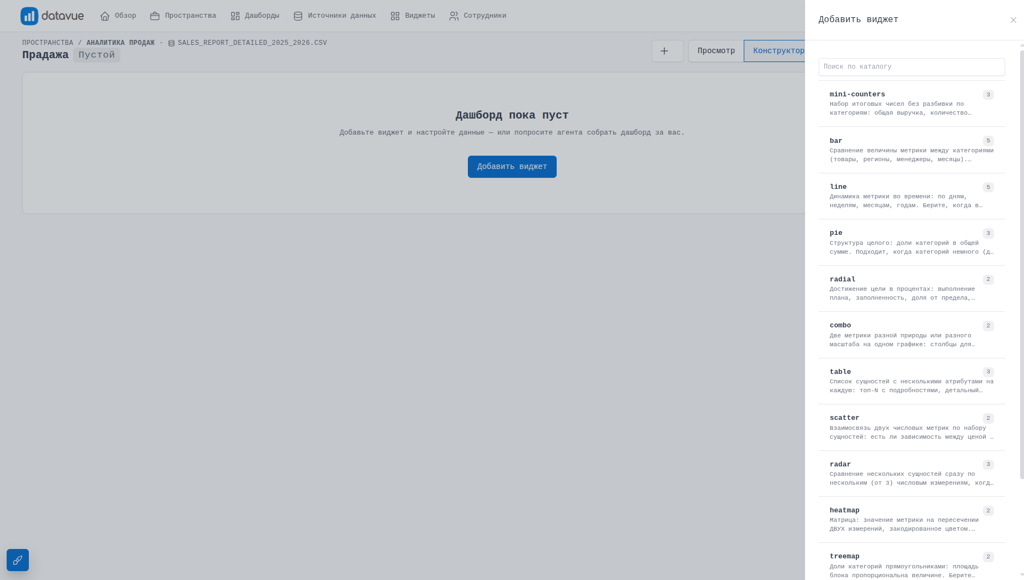
[вставьте изображение экрана сюда]
Figure 7. Builder mode — widget palette and settings panel
A manually built dashboard is not cut off from the agent: the "AI Assistant" button starts a conversation for it the same way it does for a dashboard that grew out of chat — from then on, it can be worked with the same way, regardless of how it came about.
Widget gallery. A dedicated gallery page shows all widget types available in the system, using demo data in the same shape as real dashboards — a reference of capabilities for users and developers, with an "AI-selectable only" filter for widget types the agent can suggest on its own.
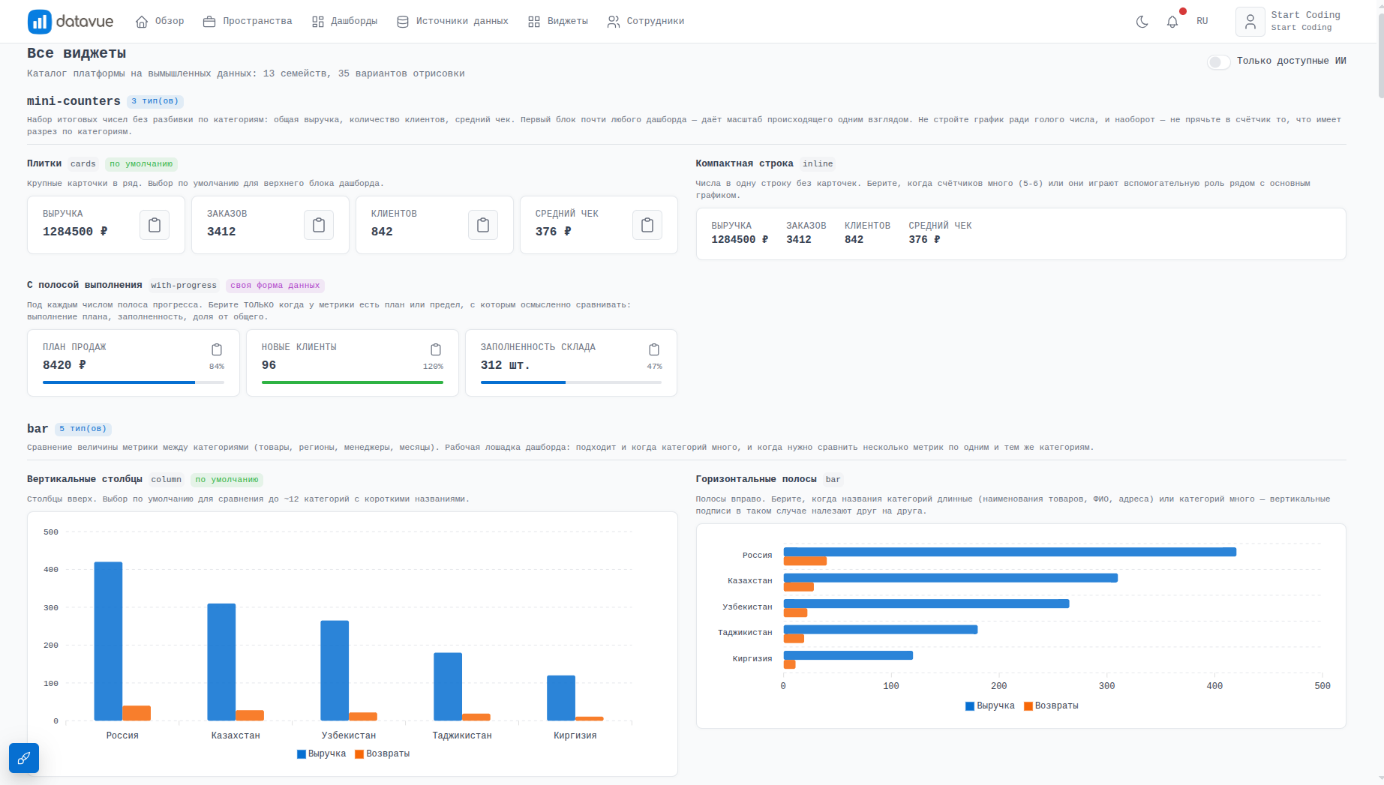
Figure 8. Gallery of all widget types on demo data

System Implementation and Results
Deploying Datavue in a company’s work shortens the path from question to answer: an employee with no SQL or programming skills gets a finished dashboard in minutes, instead of waiting in line for an analyst or developer. The regeneration and automatic code-repair mechanism reduces the influence of human error — calculation mistakes are found and fixed by the system before the dashboard ever reaches the user.
Support for several types of data sources — from a local Excel file to an industrial-scale PostgreSQL database — allows the system to be used both for a one-off task on an exported file and for ongoing work with the company’s live database, without needing to prepare the data in advance for a specific BI tool.

Technical Part of the Project
The system’s backend is built on Laravel 13 (PHP 8.3+) with job queues and Laravel Reverb for delivering generation status updates in real time. The frontend consists of three independent Vue 3 applications (the public part, the company workspace, and the admin panel), built with Vite. Connections to data sources are handled by dedicated providers for MySQL, PostgreSQL, SQLite and DuckDB, and the analytical code the agent generates for a specific request runs in an isolated Python environment (pandas, duckdb, mysql-connector-python). The AI agent relies on the OpenAI API.
Deploying the system requires a server with PHP 8.3+, Node.js, Python 3, MySQL (or another store for queues and cache), and internet access to reach the OpenAI API; the scale of the infrastructure and terms of use are determined by agreement, depending on the volume of data and the number of company employees.

Conclusion
As decisions are increasingly made based on data rather than intuition, the speed of getting analytics becomes a competitive advantage. The Datavue system removes the main barrier on this path — the need to bring in a developer for every new report — and turns building BI dashboards into a matter of a single dialogue with an AI agent in natural language.
The system’s architecture, where the data source, the workspace, and the conversation with the agent are clearly separated, allows the platform to keep growing: adding new source types and providers without frontend changes, expanding the widget catalog, and teaching the agent new editing scenarios — without revisiting dashboards that have already been built.
The system’s ability to independently check and rewrite generated code makes it suitable not only for one-off reports but also for ongoing analytical work where reliability and objectivity in calculating metrics matter. Such a tool can be useful for a company of any size — from a small team to an organization with several data sources and dozens of employees.

