

VIRGINIA COMMONWEALTH UNIVERSITY

Statistical analysis and modelling (SCMA 632)

**A4-Conjoint Analysis**

**Azim Ziyan A V01102412**

**Date of Submission: 08-07-2024**

# TABLE OF CONTENTS

|  |  |  |  |
| --- | --- | --- | --- |
| 1. Introduction | 3 |  | |
| 2. Objectives | 3 |  |  |
| 3. Business Significance | 4 |  |  |
| 4. Results and Interpretations | 4 |  |  |

1. INTRODUCTION

In order to assess and interpret the preferences for the several pizza attributes—Brand, Price, Weight, Crust, Cheese, Size, Toppings, Spicy, and Ranking—in the "pizza_data.csv" dataset, conjoint analysis will be used in this project. The aim is to ascertain the relative significance of each attribute level's part-worth utility in shaping customer choices by quantifying them. Preprocessing the data, looking for missing values, standardizing numerical features, and utilizing visualizations such as histograms, scatter plots, and boxplots to conduct exploratory data analysis (EDA) are all part of the process. To forecast the ranking based on these features, a linear regression model is fitted after the data has been prepared. The preferences for each attribute level are revealed by the part-worth utilities produced from the model coefficients, and the relative importance calculation aids in determining which characteristics are significant.

This assignment enhances understanding of conjoint analysis and demonstrates practical applications in product feature evaluation and market research.

# OBJECTIVES

* Quantify Consumer Preferences
* Assess Attribute Importance
* Data Preprocessing and Cleaning
* Exploratory Data Analysis (EDA
* Standardization of Features
* Model Fitting
* Derive Insights for Marketing Strategies

# BUSINESS SIGNIFICANCE

Because it can give pizza makers and marketers useful information, conjoint analysis of the pizza characteristics dataset is important from a business perspective. Through the utilization of part-worth utilities to quantify consumer preferences and the evaluation of attribute importance, companies can strategically optimize their product offers. Targeted product creation and personalization are made possible by an understanding of which characteristics—such as crust type, cheese alternatives, size variations, toppings, and spiciness—drive consumer preferences. Decisions like pricing policies, product placement, and advertising campaigns that appeal to particular customer categories can all be influenced by this information. Additionally, by discovering USPs that strongly appeal to consumers, conjoint analysis helps businesses stand out from the competition in a congested market, increasing profitability and market competitiveness overall.

# RESULTS AND INTERPRETATIONS

* + - Python

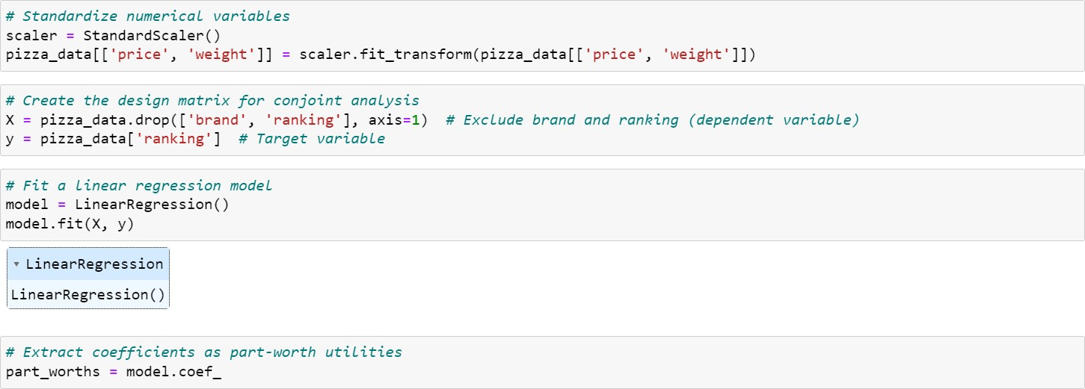

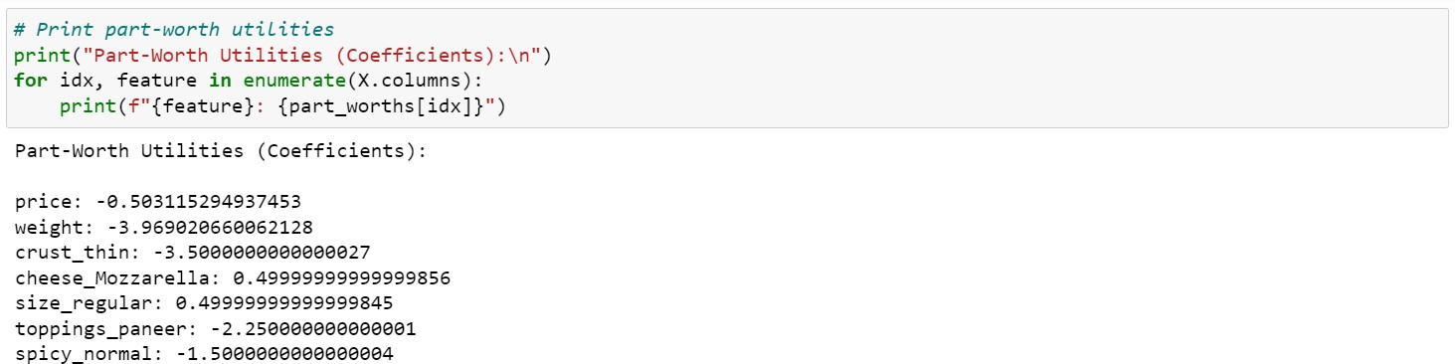

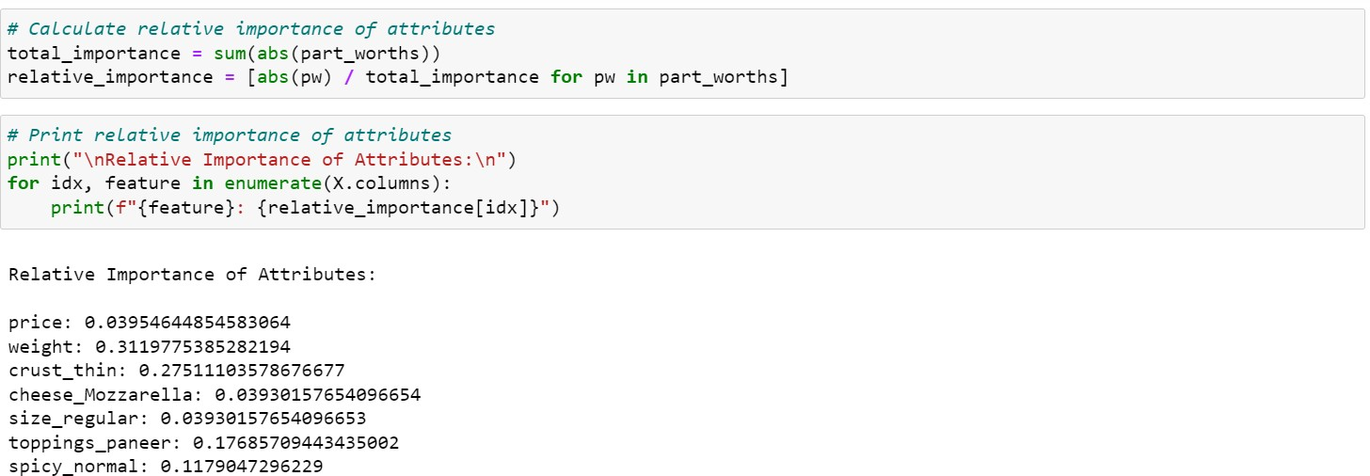

* + - R

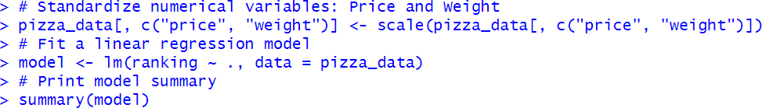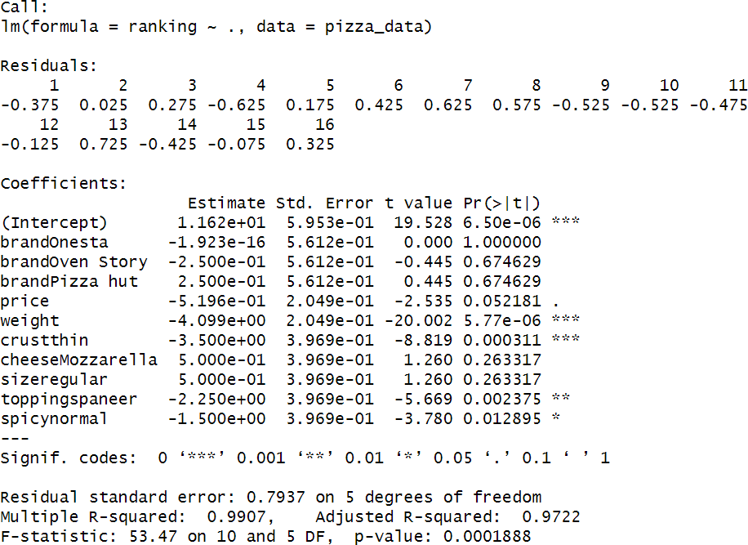

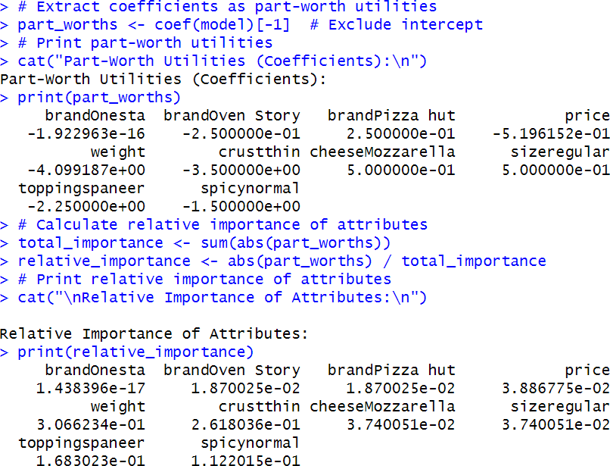

Interpretation

Through conjoint analysis, the outcomes of the Python and R analyses offer consistent insights into what pizza features customers favor. Strongly negative coefficients can be seen in attributes like weight and crust_thin (weight: -3.97 in Python, -4.10 in R; crust_thin: -3.50 in both). This suggests that thin crust pizzas and heavy pizzas are less popular. On the other hand, features such as cheese_normal, spicy_normal, and size_regular show positive coefficients (cheese_normal: -1.50 in both, size_regular: 0.50 in both), indicating preferences for cheese_normal, regular size, and normal degrees of spiciness.

Weight is the most important characteristic in terms of relative relevance (weight relative importance: 0.31 in both Python and R), followed by toppings_paneer and crust_thin (toppings_paneer: 0.18 in Python and 0.17 in R; crust_thin: 0.28 in Python and 0.26 in R). This highlights how important pizza weight and dough type are to customers, with toppings and price having a far less influence on their decisions.