

VIRGINIA COMMONWEALTH UNIVERSITY

Statistical analysis and modelling (SCMA 632)

**A4 -Multidimensional Scaling**

**Azim Ziyan A V01102412**

**Date of Submission: 08-07-2024**

# TABLE OF CONTENTS

|  |  |  |  |  |
| --- | --- | --- | --- | --- |
| 1. Introduction |  | | 3 |  |
| 2. Objectives |  |  | 3 |  |
| 3. Business Significance |  |  | 3 |  |
| 4. Results and Interpretations |  |  | 4 |  |

1. INTRODUCTION

In order to assess and comprehend links between the several ice cream parameters in the "icecream.csv" dataset—which include Brand, Price, Availability, Taste, Flavour, Consistency, and Shelflife—this assignment requires employing Multidimensional Scaling (MDS). The aim is to identify trends and similarities between various ice cream companies by visualizing their proximity based on these features. Data preprocessing, feature standardization, missing value checks, and exploratory data analysis (EDA) employing visualizations such as pairplots, correlation heatmaps, histograms, and scatter plots are all steps in the process. MDS is used to compute brand dissimilarities and reduce dimensionality to a 2D space for visual representation after the data has been prepared. The final plot presents brand relationships and offers marketing strategy and product differentiation insights. This assignment enhances understanding of multivariate data analysis and demonstrates practical applications in product analysis and market research.

# OBJECTIVES

Data Preprocessing

* Exploratory Data Analysis (EDA)
* Multidimensional Scaling (MDS)
* Visualization and Interpretation

# BUSINESS SIGNIFICANCE

There are important business ramifications when using Multidimensional Scaling (MDS) to examine the ice cream properties in the "icecream.csv" dataset. Businesses can obtain important insights about consumer preferences and market positioning by visualizing and analyzing the proximity of various ice cream brands based on characteristics like Price, Taste, and Flavour. Strategic product differentiation and the development of marketing tactics catered to specific customer categories are made possible by an understanding of the relative distances between brands. For example, product development activities might be guided by insights from MDS to match consumer expectations and preferences with flavors or pricing strategies. Additionally, companies can improve their market segmentation strategies and customize promotional activities to successfully target particular customer categories by discovering clusters or groupings of products with similar attribute profiles.. Ultimately, the use of MDS facilitates informed decision-making in product management and marketing, enhancing competitiveness and responsiveness to market dynamics.

# RESULTS AND INTERPRETATION

* + - Python

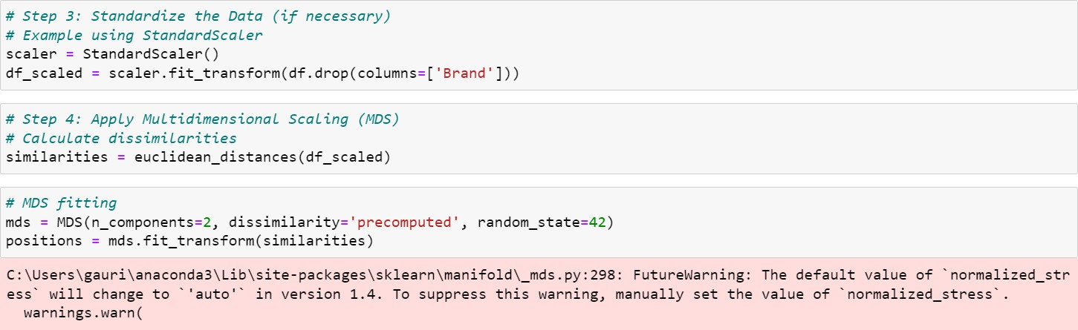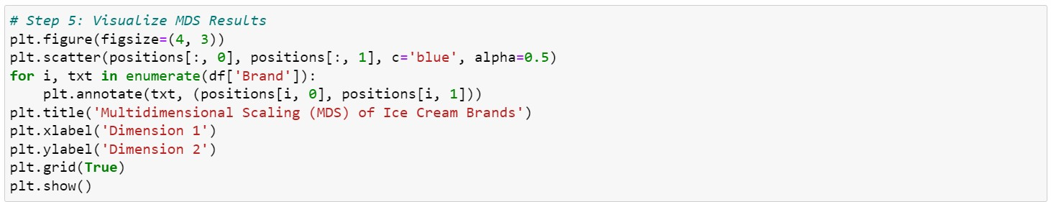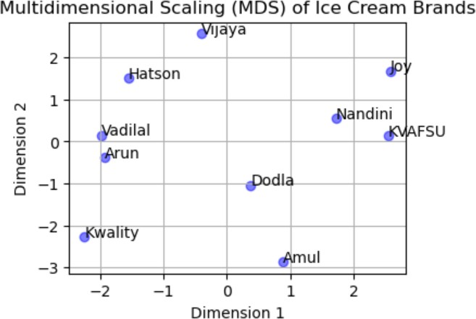

* + - R

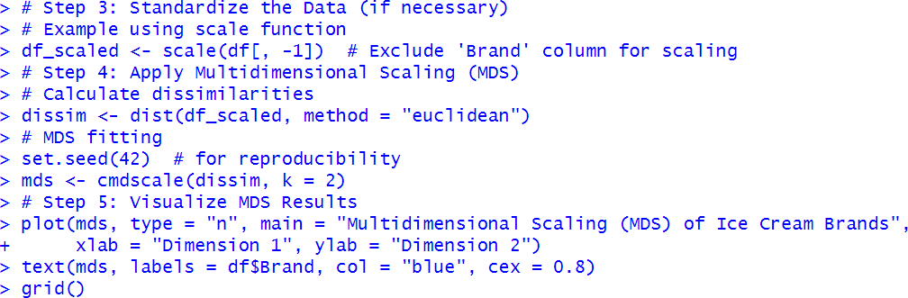

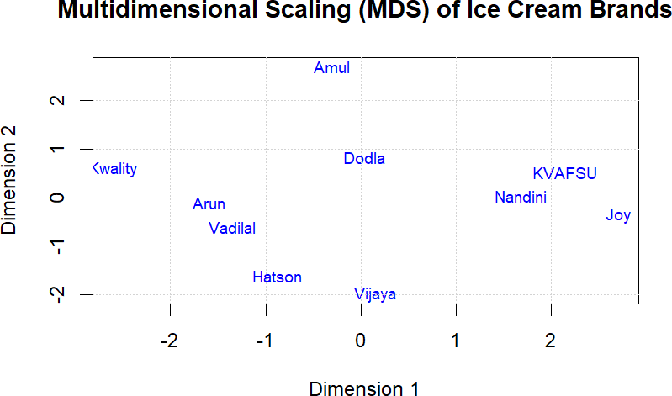

Interpretation

The Multidimensional Scaling (MDS) scatter plots, which were produced for the ice cream brands dataset in both Python and R, are the basis for the visualizations, which show how similar or different each brand is based on factors like price, taste, and flavor. Each point in the two plots represents a brand, and distances between brands indicate how similar or different they are from one another. Similar attribute profiles of brands that are densely clustered together point to possible overlaps in market positioning or consumer perception. Conversely, brands that are positioned further apart indicate notable variations in the combinations of their attributes, which may point to distinct market niches or initiatives for product differentiation.